NAME  EVANGELISTA JOHN VINCENT R |  | DATE  02/04/17 | SCORE
SCHEDULE  S 10:00-12:40 | SCORE |  | SCORE

LABORATORY EXERCISES
RECURSION

OBJECTIVES:
- Understand recursion and its parts
- Use recursion to solve programming problems

PROCEDURE:
- Encode the C++ program below.
- Save as rec1.cpp,and rec2.cpp, respectively.
- Compile and run the program by pressing Ctrl + F9.
- For each syntax or logical error encountered in the given program, do the following:
- Correct the error
- Recompile the program
- Repeat step 4 until no errors are encountered in the program.
- Illustrate the output of the modified program.

Program No. 1

#include <iostream>
using namespace std;

void numberFunction(int i) {
cout << "The number is: " << i << endl;
i++;
if(i<10) {
numberFunction(i);
}
Output:

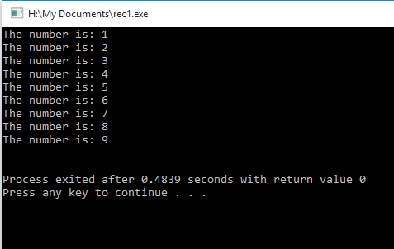

}

int main() {

int i = 1;
numberFunction(i);

return 0;
}

Program No. 2

#include <iostream>
using namespace std;

int factorial(int);

int main() {
int n;
cout<<"Enter a number to find factorial: ";
cin>>n;
cout<<"Factorial of "<<n<<" = "<<factorial(n);
return 0;
}

int factorial(int n) {
if (n>1)
return n*factorial(n-1);

else
return 1;

}
Output:

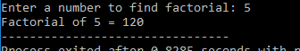

Supplementary Problem

- A recursive function that sums up the 10 integers in an array.

Program:

#include <iostream>
using namespace std;

int Sum(int array[], int i) {
if (i < 0) {
return 0;
}
else
return array[i] + Sum(array,--i);
}

int main() {
int array[] = {1,2,3,4,5,6,7,8,9,10};
int total;
total = Sum(array,9);
cout << "The sum of the numbers in the array is: " << total;

}

Output:

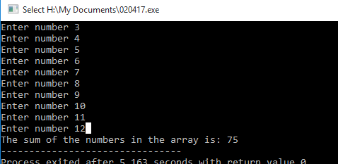

- A recursive function to produce the Fibonacci number for a given index in the series.
Use the function int fibonacci(int n)

Program:
#include <iostream>
using namespace std;

int fibonacci(int n) {
if (n < 2)
return n;
else
return fibonacci(n-1) + fibonacci(n-2);
}

int main() {

int n;
cout << "Enter number: ";
cin >> n;
cout << "The fibonnacci equivalence of " << n << " is " << fibonacci(n);

}

Output:



- A recursive function which raises its first parameter to the power of its second parameter.
Use the function int power(int number, int power)

Program:

#include <iostream>
using namespace std;

int power(int number, int raise) {
if (raise == 0)
return 1;
if (raise == 1)
return number;
else
return number * power(number, raise-1);
}

int main() {

int number,raise;
cout << "Enter number: ";
cin >> number;
cout << "Enter Power: ";
cin >> raise;
cout << power(number, raise);
}

Output:
