# «DC Motor with Load - Modeling, Control, and Optimization»

*Kotanov Ivane*

**Goals:**

Design a control system for a DC motor driving a mechanical load. The system should be modeled, simulated, and optimized to meet specific performance criteria. The task can be implemented using MATLAB, Python, or any other tool that supports dynamic system modeling (e.g., Simulink or Python’s control library).

**Input data:**

**DC Motor Parameters:**

– Voltage input: Vin(t) (in volts)

– Armature resistance: Ra = 2 Ω

– Armature inductance: La = 0.5 H

– Motor torque constant: Kt = 0.1 Nm/A

– Back EMF constant: Ke = 0.1 V/rad/s

– Rotor inertia: Jm = 0.01 kg.m2

– Rotor friction coefficient: Bm = 0.001 Nm.s/rad

**Load:**

The motor is driving an inertial load with inertia JL = 0.02 kg.m2

**Objective:**

The motor should achieve a target angular velocity of 100 rad/s within 2 seconds, with minimal overshoot and steady-state error

**System Modeling**

**1) M**otor dynamics are made of two components**:**

**a) Electric dynamics:**

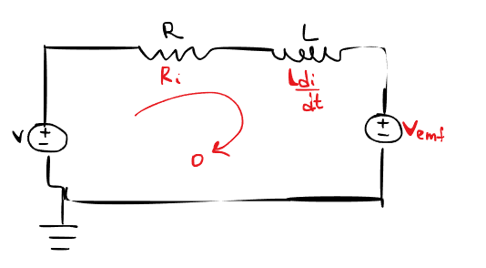

$V_{\text{in}}\left(t\right)=L_{a}\frac{dI_{a}\left(t\right)}{dt}+I_{a}\left(t\right)⋅R_{a}+$ $V_{emf}$

Де $V_{emf} =K_{e}⋅ω\left(t\right)$

hence, $V_{\text{in}}\left(t\right)=L_{a}\frac{dI_{a}\left(t\right)}{dt}+I_{a}\left(t\right)⋅R_{a}+$ $K_{e}⋅ω\left(t\right)$

The alternating current causes a change in the magnetic flux, which causes the induction of an electromotive force that is opposite to the direction of the current.

$$E_{i}=-\frac{dΦ}{dt}=-L\frac{dI}{dt}.$$

The rotational movement of the motor in the magnetic field creates an alternating magnetic field, which also creates an inverse emf, which is proportional to the angular velocity.

$$V_{emf} =K_{e}⋅ω\left(t\right)$$

According to Kirchhoff's rule, the algebraic sum of voltages in any closed circuit is zero.

**Mechanical part:**

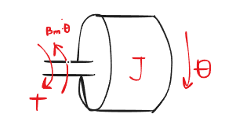

$$T-B_{m}*\dot{θ}=J*\ddot{θ}$$

$$T=K{}_{t}*I$$

Отже, $K{}_{t}*I-B_{m}*\dot{θ}=J*\ddot{θ}$

According to Newton's law, the sum of torques is equal to the moment of inertia multiplied by the angular acceleration.

J - total moment of inertia, the sum of the moments of inertia of the motor and the load.

2) Plant in Matlab:

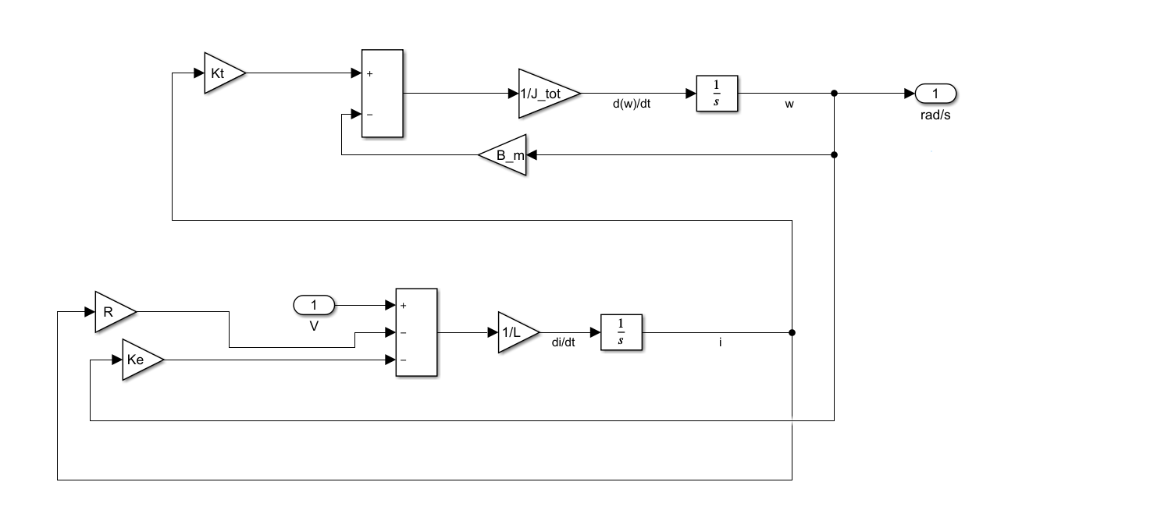

Transfer function:

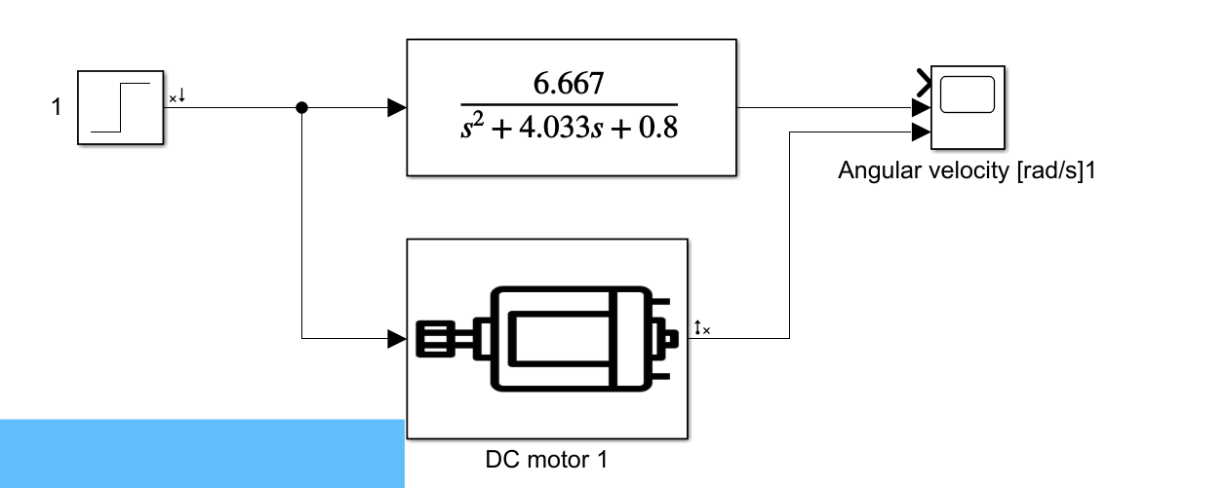

$$\frac{\dot{θ}}{V}=\frac{6.667}{s^{2}+4.033s+0.8}$$

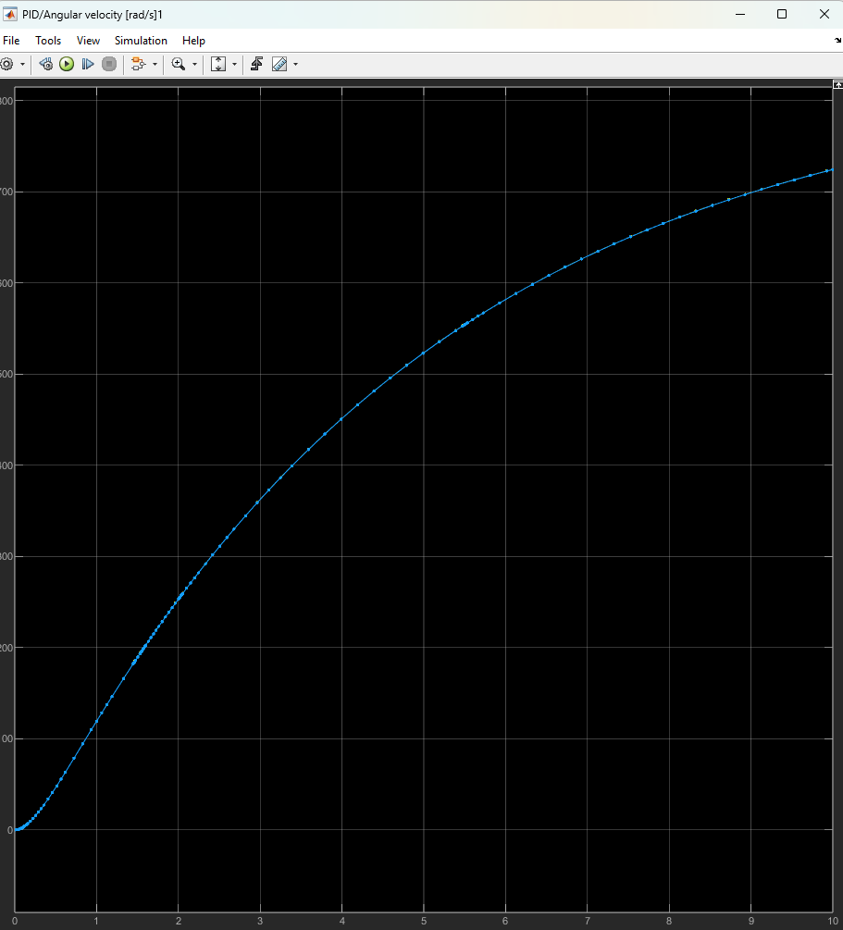**Step function of the transient link and the physical system, they are completely identical**

Controller Design

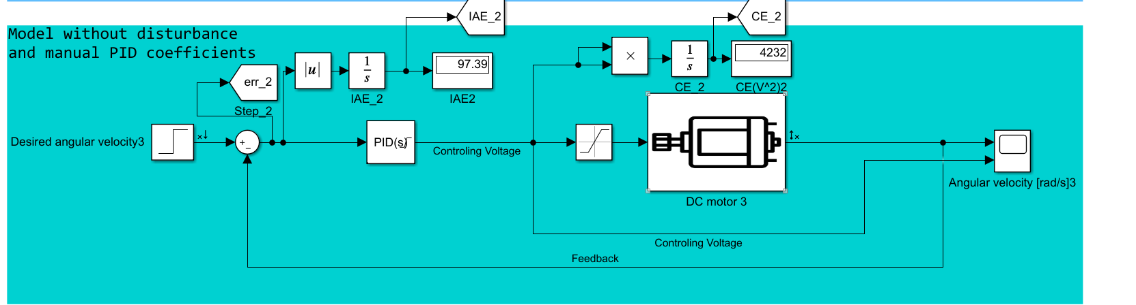

A PID controller was created to control the motor

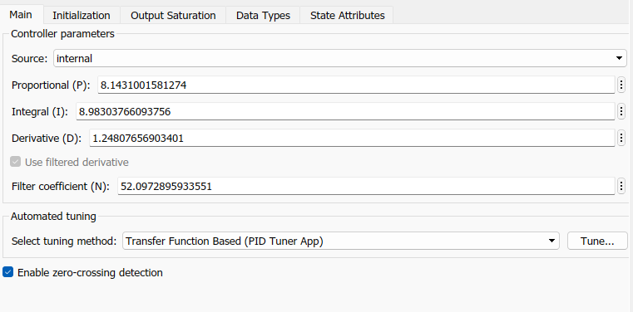

Also, to limit the initial voltage consumption, a limit of 44 volts was set (the initial values reached thousands of volts, which is not very realistic for a motor of such loads)

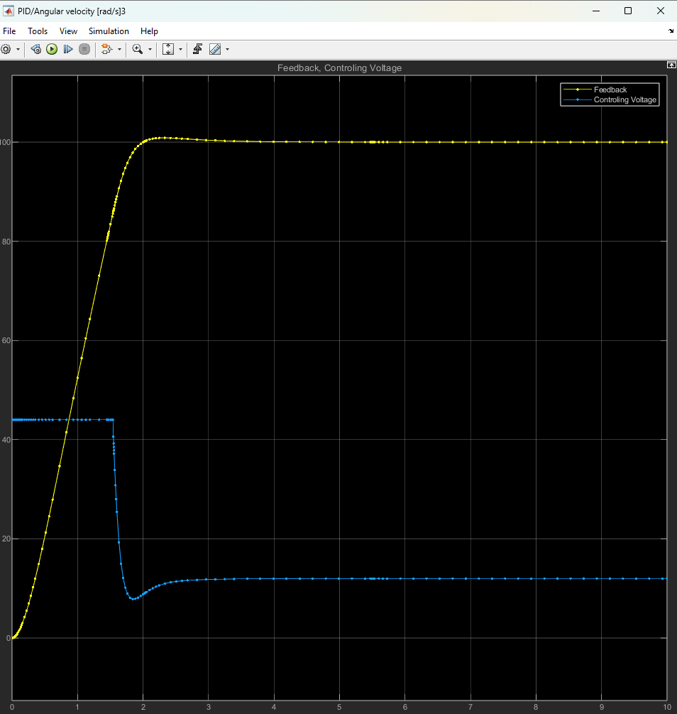

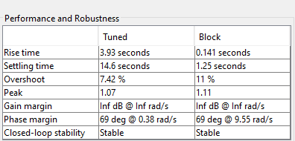

**Optimization**

**The integral value of the absolute error on the created controller is equal to 97.39 after 10 seconds of work.**

**The square of the input voltage for 10 seconds is 4232 Volts2.**

**To improve the performance, a genetic algorithm was used. The algorithm creates a population of random values for the controller, each of which is evaluated by a value function that dominates**

J = dt*sum((Q*(1-y(:)).^2) + R*u(:).^2)

**Where**

**1-y is the error value,**

**U^2 is the input cost**

**Q,R are the weight parameters for the error and input cost of the motor, respectively.**

**After that, the lowest-valued coefficients give rise to the next population, their values are crossed and subjected to random mutations. The algorithm has 30 representatives in one generation and is repeated for up to 30 generations.**

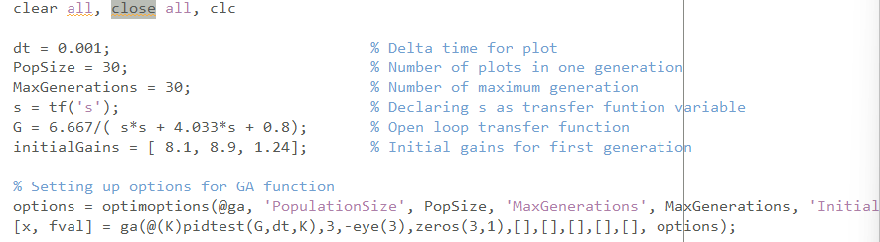

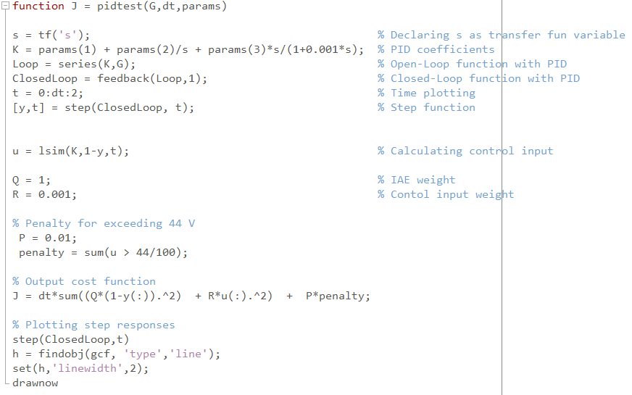

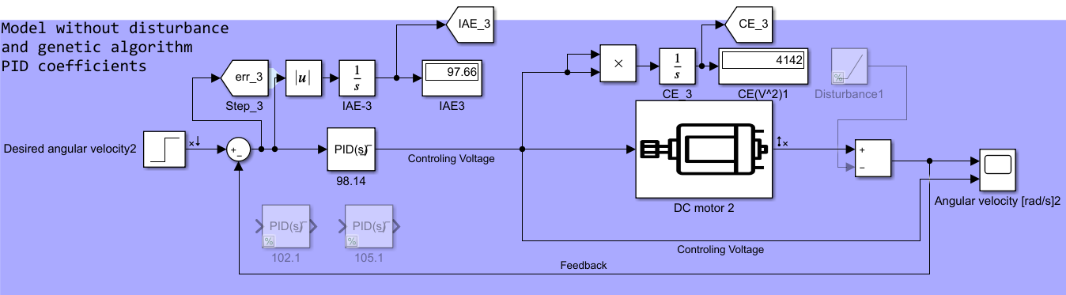 **As a result, the following PID controller was obtained**

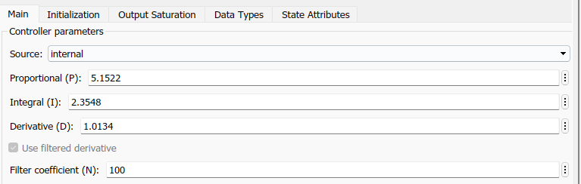

**The integral value of the absolute error on the created controller is 98.22 for 10 seconds.**

**The square of the input voltage for 10 seconds is 4142 Volts2.**

**The integral value of the absolute error has not improved, but the value of the amount of voltage required by the system has improved.**

**To improve the results of the algorithm, you can change the weight of the coefficients and increase the number of generations.**

**Disturbance**

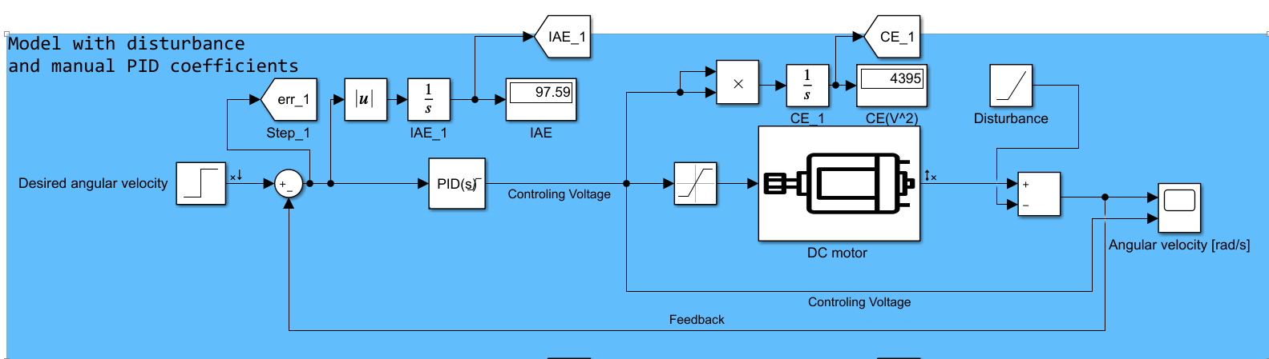

An additional task was to add a torque equal to 0.05 N*m to the system, effective from 1 second.

This was implemented using the Ramp block:

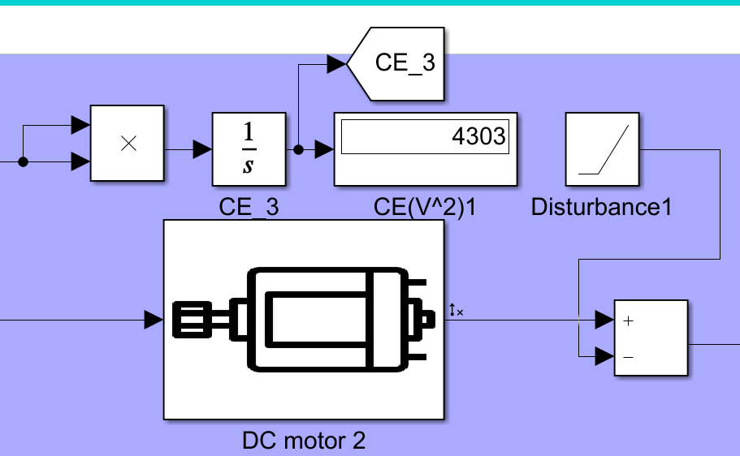

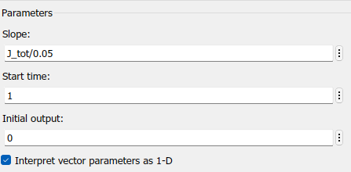

**Where the slope of the line is equal to the ratio of the moment of inertia to the torque.**

**Due to the additional load, the total number of volts consumed squared became 70 more in 10 seconds, and the integral error was 0.2 more in the same time.**

**Performance Evaluation**

**1) Plots of the motor angular velocity and input voltage (yellow graph - self-tuned PID controller with perturbation, blue - self-tuned PID controller without perturbation, orange - algorithm-generated controller with perturbation)**

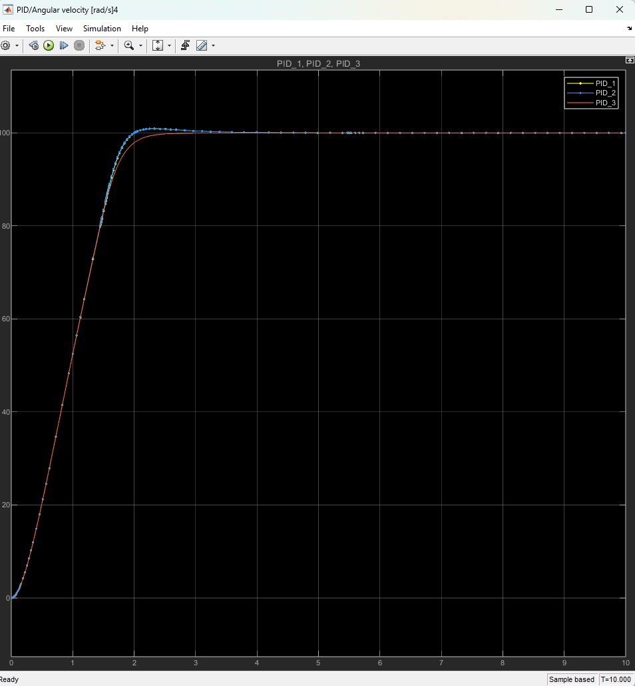

**3) Comparison of integral absolute errors:**

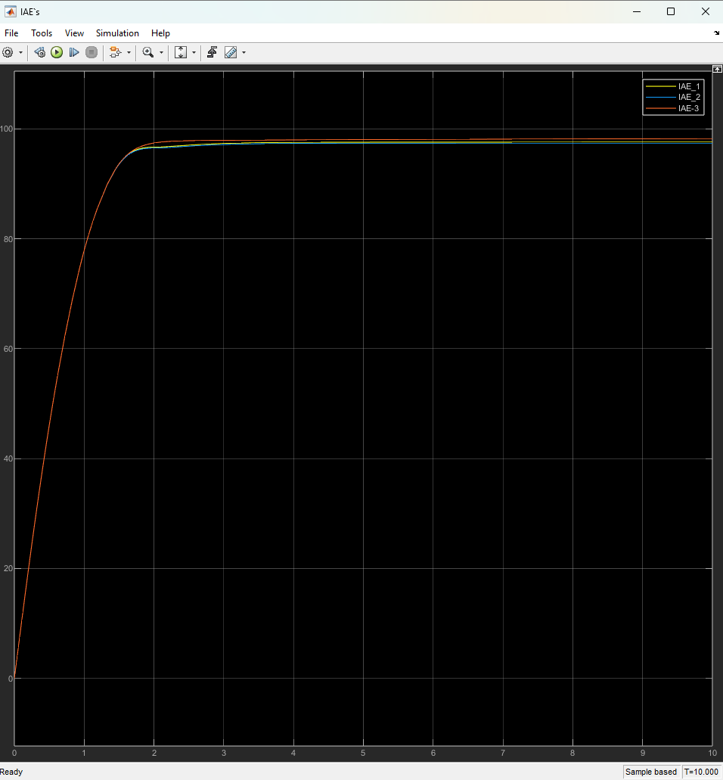

**4) Comparison of the integral of volts consumed versus time:**

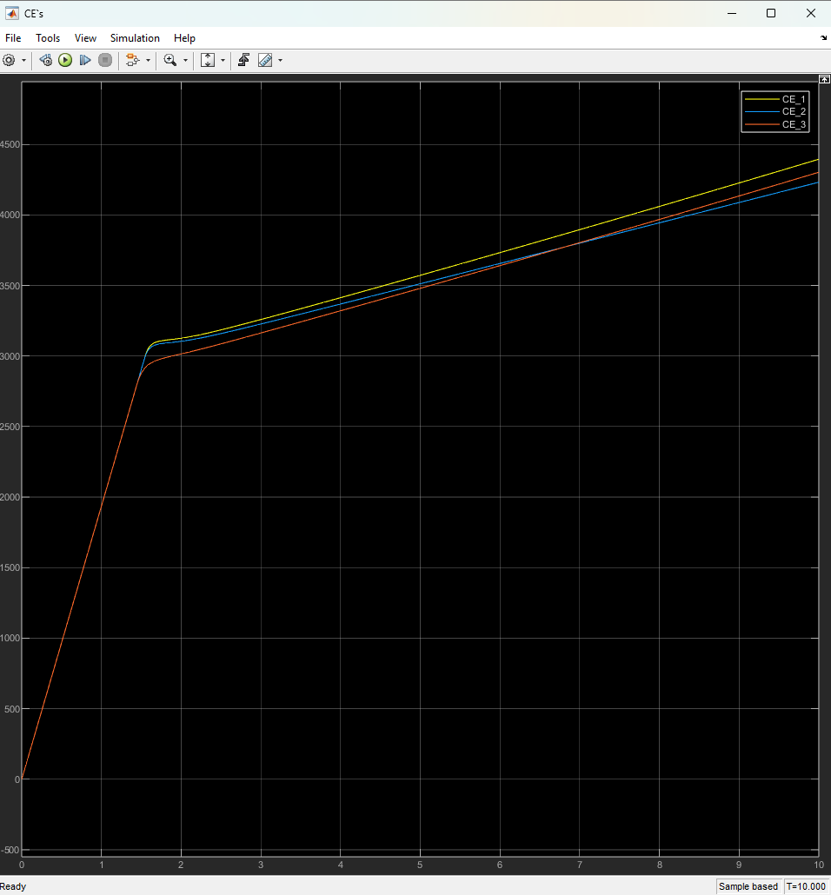

**Conclusion**

To control the motor to achieve this, a PID controller was created; this controller was further optimized by a genetic algorithm; later, input disturbances in the form of additional torque were added to the system.

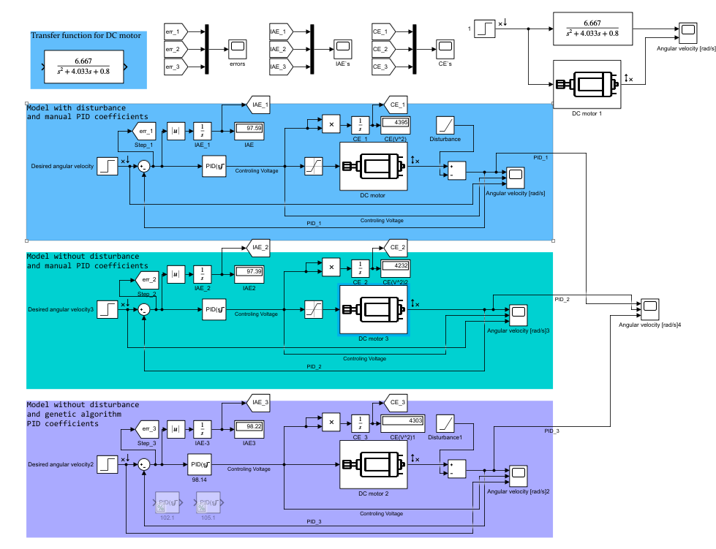Complete simulink model: