***Instructions & Da Rules***

*What each space does.*

The Starting Area: Place your Characters (Colored Piece) in this area to start the Game.

Blue Space: Land Here and take 1 Movement Card from the Pile.

Yellow Space/Super-Space: Land Here and take the Super Card from under the Yellow Space.

Green Space/Chance Space: Land Here and take 1 Chance Card from the Chance Card Pile.

Red Space: Land Here and put 2 of your Movement Cards at the bottom of the Movement Card Pile.

*How To Start*

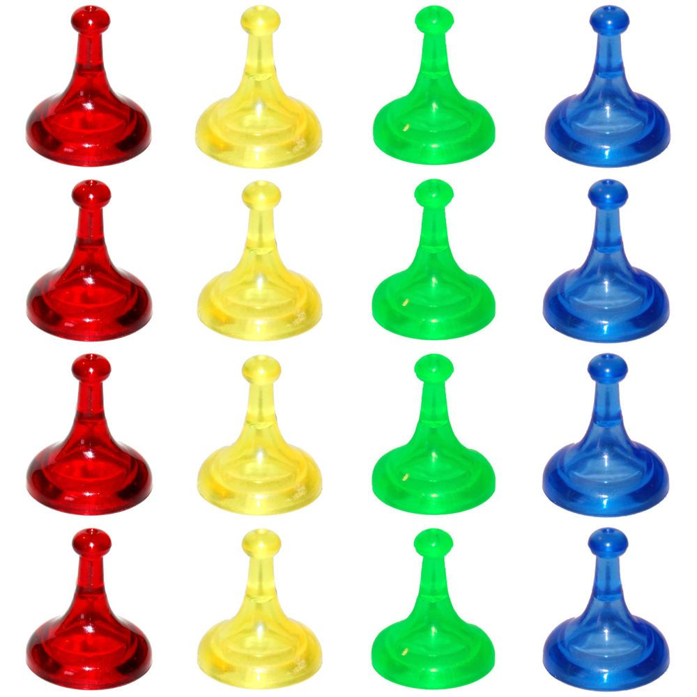

Place your Character (Colored Piece) in the Starting Area.

Youngest Goes First.

Youngest takes card from Movement Card Pile and leaves Start.

Continue Clockwise.

START!!

You start the game with 5 Movement Cards. Organize, Strategize, and Maximize with your cards to become victorious.

*You can get more Movement Cards from Duels, Chance Cards & Blue Spaces

*Movement Cards*

If you land on the same space as someone else, a Duel commences. You place down 4 Movement Cards facing downwards, Flip the last one. If your flipped card is higher than the opponent, if both of you have the same number, repeat until victorious, or until your movement cards run out.

*You can choose any cards to be used in a Duel. If you have a Super Card in your deck the opponent will receive it,

*How a Duel Works*

*ENJOY!*

You win the Game by collecting all 4 Super Cards.

*How to Win*

You get these cards from Green Spaces, you can do special things with them like: Four-Way Duels, Take 5 Movement Cards from any opponent, and more. Once used return to the bottom of the Chance Card Pile.

*Chance Cards*