Evaluation
Unit 6: Website Development | Criteria: P6, D2, D3

Your evaluation must be analytical, not descriptive. Do not just explain what you built — assess how well it meets the client requirements, what worked, what did not, and what you would do differently. Use your Development Log and test results as evidence.
Student Name: | Date:
Josh Francis | 08/05/2026

1. How well does the final website meet the client requirements?
Consider the prompts below, then write your response in the box:
→ Go back to your original user requirements — address each one directly.
→ What evidence do you have that the site meets them?
→ Were there any requirements you could not fully meet? Why?
I believe that that I have met the criteria due to the fact that I have added information about the company, this can be seen through the on the home and about us page as it highlights what the company is about and what they do. It also shows that they are hiring. I have also met the criteria though the use of the developer profiles. This can be seen due to the use of the dev page and the profiles that are on it. I have also met the requirements on the job roles as I have added a page speaking about the jobs and what they will do and the qualification that are needed to fill said role. This also links to my sign-up page as it has an option for jobs to sign up for. I have met the requirements of the one-line application form as I have added a form where a person can put their name email and more information. I have also added numerous links to different websites and development courses

2. Design — how effective were your design decisions?
Consider the prompts below, then write your response in the box:
→ Which design choices worked well and why?
→ Which design choices would you change if you started again?
→ How well did you respond to peer review feedback?
I believe that my design choices have worked well due many facts. One of which is the colours that I have used, this can be seen in my pages and how I have used a fairly similar colour palette yet I have changed them slightly so that they still fit the theme but also and different enough to the point that they don’t blend in and it is easy to reader the information and see the images on the website.
I also think that I have met the criteria due to the placement of the nav bar as I believe that it works well to the left as it makes it easy to see and that it doesn’t interfere with any information or any design for my website. I have also chosen to use things such as hover effects on different elements in my website as I believe that it gives it more life and makes it easier to navigate as you can see what a button is by hovering you mouse over the top. I have also met this by using headers in my website as it makes it clear to the user.
3. Build — how well did the development process go?
Consider the prompts below, then write your response in the box:
→ Which parts of the coding were most challenging?
→ How did you solve technical problems you encountered?
→ Is the code well-structured and easy to maintain?
The most challenging parts of my code was the alignment of different items and the placements of images and information. This was difficult due to the fact that I hade to make it so that images did not interfere with the information that was placed on the page and so that elements would not take up massive amounts of space. I have corrected this by using things like classes on the div boxes that have content in as I have used my CSS documents to design the classes to align the images and text so that they fit into their corresponding areas. A main example of this can be seen in the dev’s page as it has images and information in the same box corresponding top the person in the image. This was a problem when first coding the website as the image and text would be aligned completely wrong and take up room to the extent that the user would only be able to see one developer at a time. The code for this is very easily maintained due to the fact that it is all wrapped in a div which makes it easy to see what information and what profile is where. This is also due to the fact that is in one area, and each profile is one after the other
4. Testing and optimisation — how thorough was your testing?
Consider the prompts below, then write your response in the box:
→ What did testing reveal about your website?
→ What changes did you make as a result of testing and user feedback?
→ Were there any issues you could not resolve? Why?
Testing revealed that my website works well except for the fact that my sign up email does not work completely this is due to the fact that my JavaScript dose not entirely work this was brought up when I was testing due to the fact that I did not get an email with the information that had been inputted into the input boxes. I can resolve this issue by correcting my code and getting it to send the email through using email.js. another thing from my testing that I found is that I can add more interactivity to my website.
5. Self-management — how well did you manage yourself throughout the project?
Consider the prompts below, then write your response in the box:
→ Refer to your Development Log — what does it show about how you worked?
→ Did you manage your time effectively? What evidence supports this?
→ What would you do differently to manage yourself better on a future project?
I believe that I have managed my time effectively due to the fact that I have been working on different thing on each day. This can be seen in my developmental log as each day it has been something else. This is highlighted on the first and second day as on day one I was working on my plan and what I will do, how my website will look and what colour pallet I will use for the website. And on day 2 I have started building the website and creating a better designed compared to what the pan was, changing things such as the layout and colours that I have used. If I were to manage my time differently on different projects in the future, I will give myself more time to do writeups and to fill the documents. This is due to the fact that I normally have very little time to actually complete the documents because I spend lots of time on building the website
6. Overall evaluation — how successful is the final product?
Consider the prompts below, then write your response in the box:
→ Summarise the strengths and weaknesses of the finished site.
→ Would Hot Beans Web be satisfied with this as a real piece of work? Why?
→ What is the single most important thing you learned from this project?
My website has many strengths and weaknesses. This can be seen through the use of interactivity this can be seen on a number of different pages such as the home page with the navigation bar as the background of the buttons change colour when being hovered over. This can also be seen on the dev’s page as when you hover over the dev profile it activates the box-shadow to highlight the importance of the profile and the information within. Another example of this would be on the resources page. This can be seen through the changing background of the external link buttons this makes the website more interactable and also make it easier for the user to distinguish between what is a link button to what is header. I believe that another strength of my website would be the ease of use as it is very intuitive to navigate as the nav buttons stand out and also the interactivity of the website is a massive help as it shows what can be done and what is just for show or just information. One weakness in my website due to the fact the email dose not work making it the only part of my website that is not fully functional.

Justifying decisions

I have decided to change the colour scheme from the original due to the fact that I believe that the blue colour pallet dose not meet the design of the company and this dose intern not reflect the company image where as the second iteration of the colour pallet reflects the brand identity as it uses both darker an lighter browns. This works well as it matches the colours used in the logo and gives the whole company and website a brand identity. Another decision I have made is to use buttons for the navigation bar as it makes it easier for the use to use as they can se that this is the navigation bar at just a glance. This is good because it makes it extremely easy to use even for people that are not as well versed in websites and web apps. This is also highlighted through the buttons by them changing colour when hovering the mouse over the top, this is because this means that it is easily noticeable that this is a button that can be pressed due to the interactivity of the website 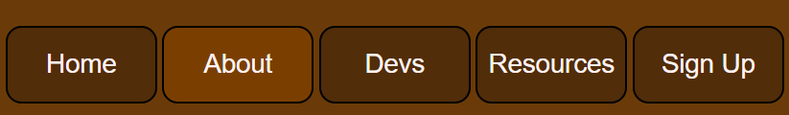which can also be 881111seen on multiple different parts of my website such as the resources page. This is seen with the external link buttons that highlight and add a box-shadow when hovered so that a user would know that they are links to websites instead of being a header.
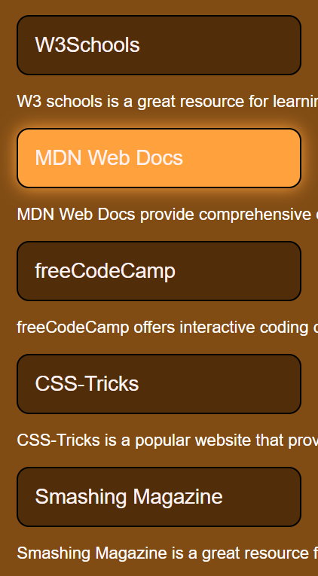
And again interactivity has also been used to highlight important information. This can be seen on the dev’s page as when hovering over a dev profile it will add a box-shadow to the div that will highlight all important information. Another designe that I have added which I think works well is the use of the dropdown box on my signup page as it works well letting the user chose the job that they are interested in and what job they want to apply for.

