Optimisation Log
Unit 6: Website Development | Criteria: M3, D2

Record every change you make to your website after testing and feedback. Each entry must include a before and after screenshot or code snippet — without evidence, it does not count. Aim for at least 3–5 meaningful optimisations.
Student Name: | Date:
Josh Francis

Optimisation 1
What was the issue / feedback? | the design of the form did not work for the intended use
What change did you make? | I have added a dropdown and also changed the design of the input boxes
BEFORE — screenshot / evidence | 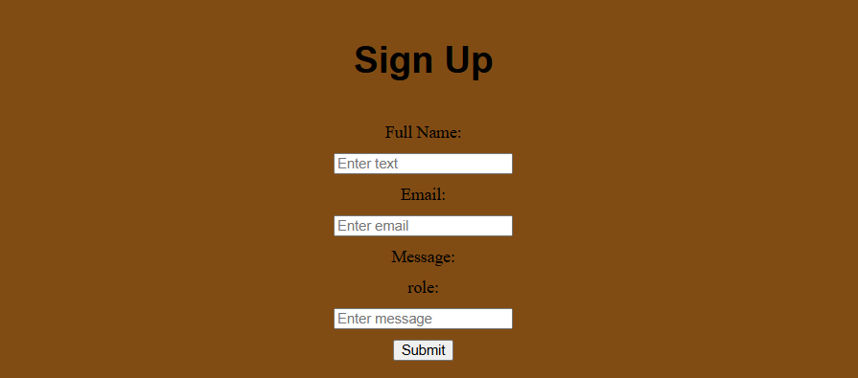
AFTER — screenshot / evidence | In 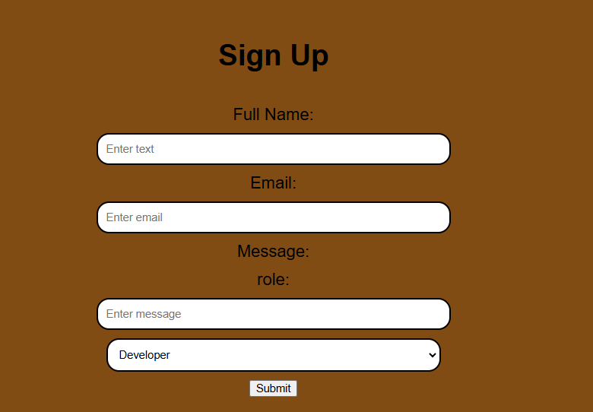
Why does this improvement make the site better? | This make the form not only look better but also work better for its intended use due to the use of the dropdown box

Optimisation 2
What was the issue / feedback? | The social media buttons were not interactive
What change did you make? | I added transitions 3
BEFORE — screenshot / evidence | width: auto;  height: 150px;  background-color: transparent;
AFTER — screenshot / evidence | width: auto;  height: 150px;  background-color: transparent;  transition: ease 0.6s;
Why does this improvement make the site better? | It makes the website more interactable

Optimisation 3
What was the issue / feedback? | Links were not interactive
What change did you make? | I added boxshadows
BEFORE — screenshot / evidence | 
AFTER — screenshot / evidence | 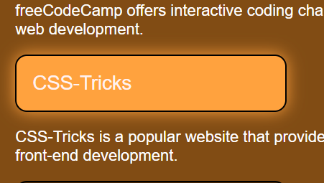
Why does this improvement make the site better? | This makes the website feel more lively and so people know what is a link and what isn’t

Optimisation 4
What was the issue / feedback? | The developer profile had no interactivity
What change did you make? | I have added box shadow
BEFORE — screenshot / evidence | 
AFTER — screenshot / evidence | 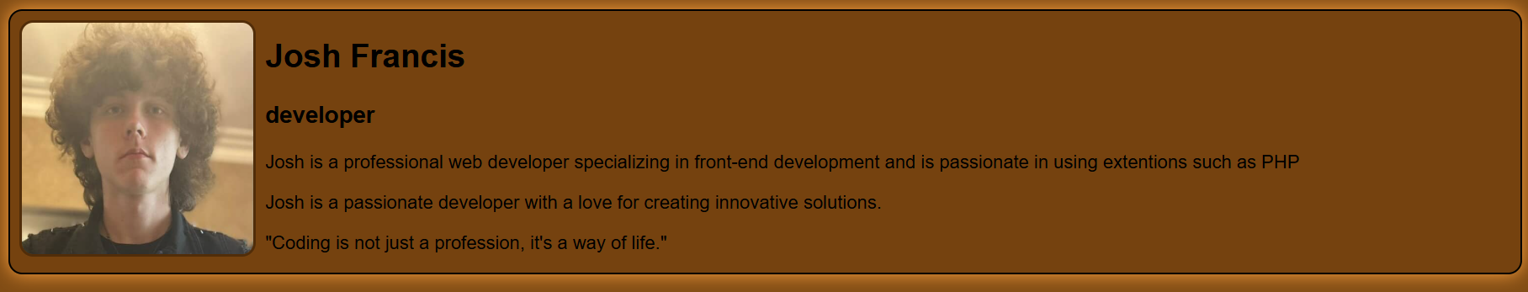
Why does this improvement make the site better? | This improves the image and information as it is no longer a stagnate area a d has more interactivity due to this

Optimisation 5
What was the issue / feedback? | There was very little information on the about page
What change did you make? | I added information to the page through images
BEFORE — screenshot / evidence | 
AFTER — screenshot / evidence | 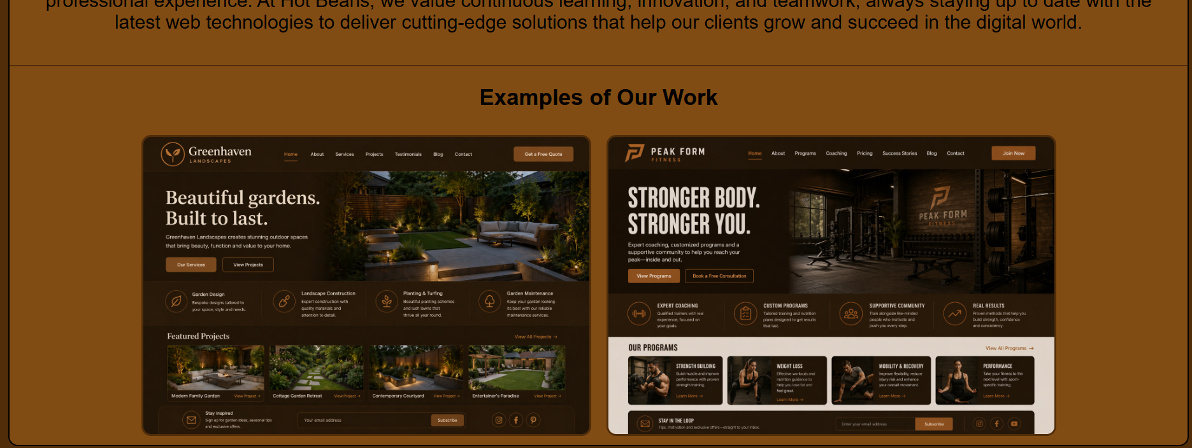
Why does this improvement make the site better? | This makes the website look more professional and more interesting for the user.

