Watopoly Demo:

Normal game mode:
The game will enter normal mode with no arguments specified.
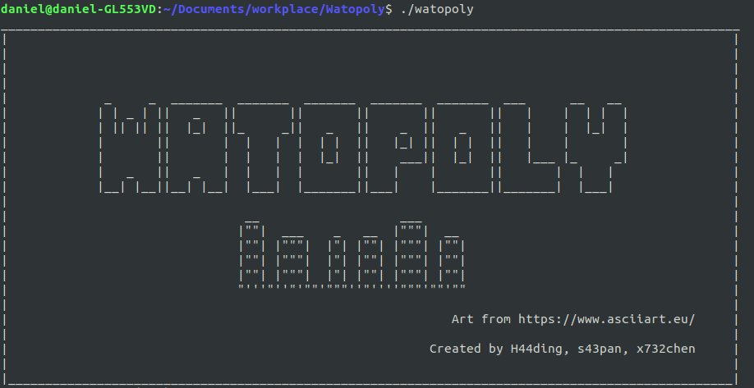
With argument "-load <filename>", the game will try to load the <filename> as the save file.
If the game successfully load the save, it will show "loading save data ...":
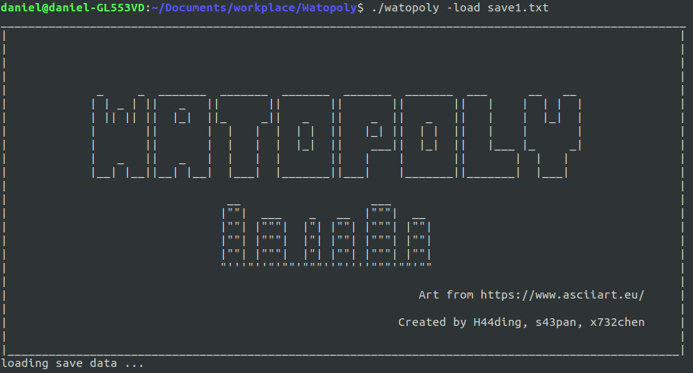

otherwise the game will show "Error loading save data." right at the beginning and start a new game:
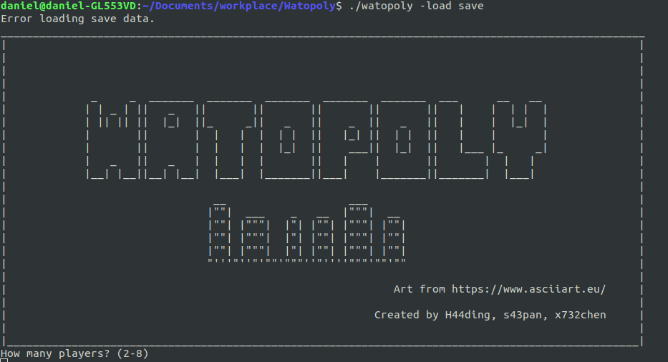

When a new game starts, it first asks the number of players and then asks each player's name and piece:
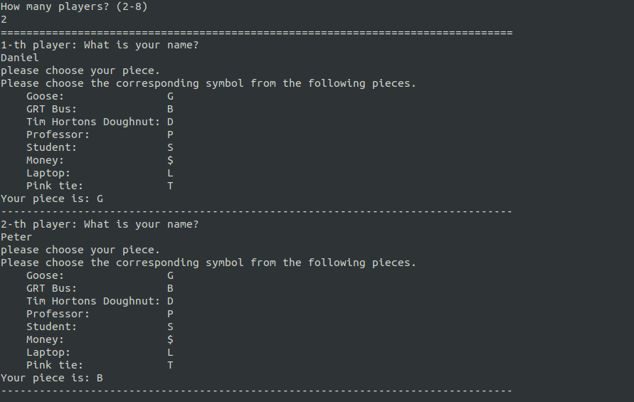
The above example is for 2 players. One player is named "Daniel" and the other is named "Peter".
Daniel chose to be a Goose and Peter chose to be a GRT Bus.

If any step above has invalid input, the game will output error messages as following:
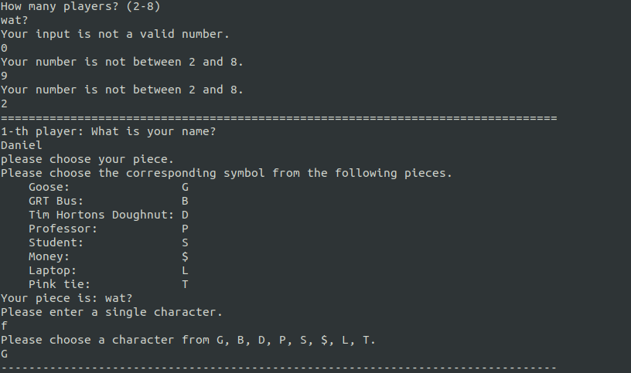
After creating players, the game begin. The gameboard will show up and the game will ask the first player to input a command:
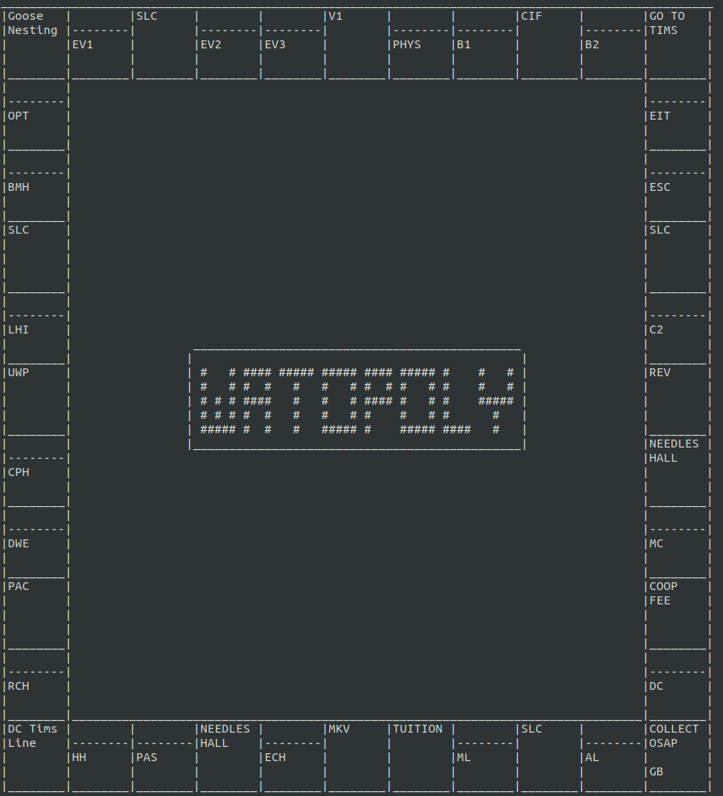

(The gameboard) Note that two players' pieces are at the bottom-right "COLLECT OSAP" square. "G" for Goose and "B" for GRT Bus.

(ask the player to input a command)

Now the player must input valid commands, otherwise the game will show all the valid commands:
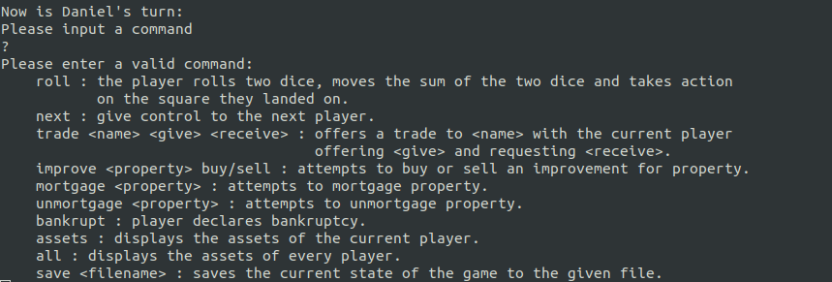
roll will let the player move around the board.
For example, when roll is entered we got:
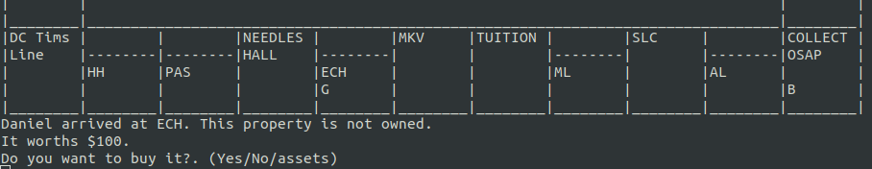

Then the piece "G" moves to the ECH square and since it is a building and not owned by any player, the game asks Daniel whether wants to buy it. Then Daniel can enter "yes" for buying or "no" for not buying or "assets" for checking what Daniel current has. If any command is not valid, the game will output warning messages and let the player input again.
For example:
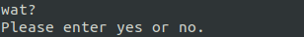

If Daniel entered "yes", and he has enough money to buy the property, then the game board will update and the ECH square will have "(G)" after the building name, meaning the building is owned by piece "G". Also the game will state that "Daniel bought ECH."
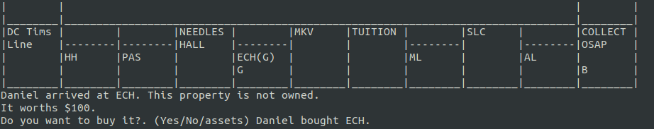

When arriving at other properties like gyms/residence, the game will have similar mechanics to let the player buy/not buy.

If Daniel entered "no", then an auction starts for the current property.
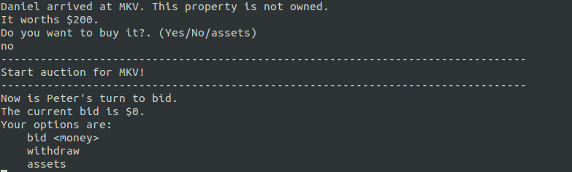

Then the players can do the auction with the given commands.
It could be like this:
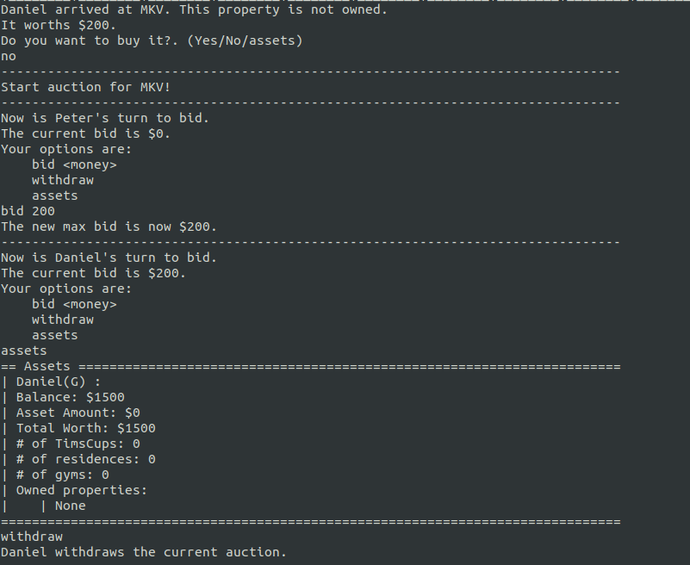

The auction ends when all players withdraw the auction except one. The last one player will pay the bid and own the property. If all players withdraw at the beginning, the auction fails.
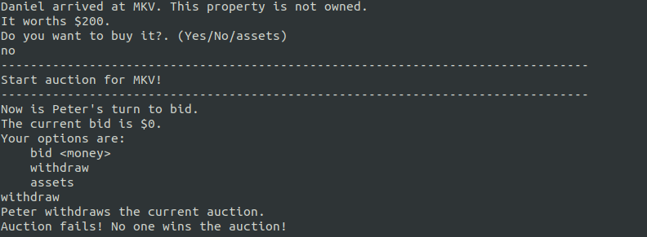

When the auction has a winner, the game will show:
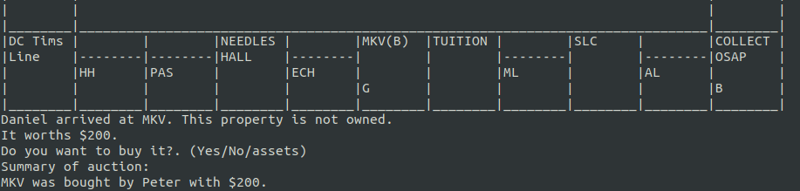

Note that the auctioned MKV square now is owned by "B" piece.

Testing game mode:
The game will enter testing mode with argument "-testing"
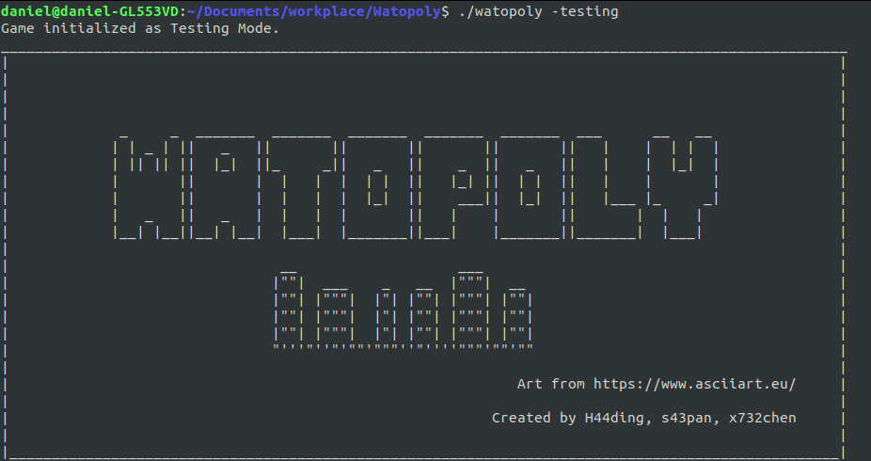
In testing mode, when using roll command, we need to enter two natural numbers afterwards as two dice results.
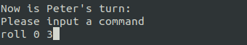

so then the player will move by the sum of two numbers.

Use different themes
Use "-theme <themeName>" to use different themes
Besides the default theme, we have two more built-in themes: christmas and bold

and then the game board will be different:
