Reflection of Lab Exercise week 2

**Web and Mobile Application Development**

In this week lesson we learnt how to use Mongodb compass and create database to insert a document, update a document, delete a document, and aggregation pipeline.

Some CRUDE command used for MongoDB are:

db.collection.insertOne() - Inserts a single document into a collection.

db.collection.insertMany() - Inserts multiple documents into a collection.

db.collection.insert() - Inserts a single document or multiple documents into a collection.

db.collection.UpdateOne() - Update a single document into a collection.

db.collection.UpdatesertMany() -Update multiple documents into a collection.

db.collection.deleteOne() - Delete a single document into a collection.

db.collection.deleteMany() - Delete multiple documents into a collection.

db.collection.Find() – Find document for asked query.

db.collection.Aggregate() – match and group data in pipeline

In MongoDB tables are referred as collections and rows as documents and columns as fields. Collection, Documents, Fields are the terms used in MongoDB.

Now to create the database we need to install a mongodb compass and mongodb shell and node js on the computer.

These are some screenshots which tells details about how mongodb compass is used to create the database and the initial collection.

This connection string allows to connect MongoDB

HOST NAME: localhost

Port: 27017

There is database at the left side. The name of the database is People and collection name peoples.

MongoDB engine is opened

Type a query in json {} bracket with key and value. Here I want to find the marital status of how many people are married and then click find button. You can see 98 people are married out of 200 people.

If you want to add data to the document, click on ADD DATA and select insert document to Insert data.

I want to insert a new document I need to clear the previous query

**Insert a document**

A default ID is generated when you want to insert a new document.

You can add a new field by pressing “add “button.

To check whether the document is inserted, type a query in the box {“First Name”: “Jhia”} and click Find button. It shows the new inserted document.

**Update a document**

To update the data, I have made some changes. I have updated the age as 30 and the marital status as married. You can see the data is updated.

I need to click this in order to update the data

**Delete a document**

To delete the data click delete button and the document is deleted.

No result for jia after I delete data

**Aggregation pipeline**

To generate aggregated results from the documents, aggregation is carried out in steps.   
Data is transformed and filtered through a series of steps in aggregation pipelines.

This stage is used to filter the data. In order to enter the new query, clear the old text.

Click ‘add stage’ to group

**Lab Task**

**Write MongoDB queries for the following using either command shell:**

1. **Repeat the same process to search Education for Master and .Find the avg,min,max age and avg min max Salary of the people group by Marital status.**

Here I am filtering the data for Master degree and age greater than 25. You can see there are 16 documents with master degree and age 25 and above.

There are two documents.

Here you have to group by Marital status, avg, min, max age and avg, min, max salary.

**2. Find min, max average salary of each age group of females.**

I have used match to filter all the females from all the 200 documents. 108 documents were for females.

All females with age group avg, min, and max salary

**3. Find min, max average salary of each age group of male.**

92 documents were showed

All males with age group avg, min, and max salary

**4. Count married and unmarried females and males.**

For this question first you need to filter all the female and male in separate pipeline then also group separately. To count married and unmarried females use count: {$sum:1}

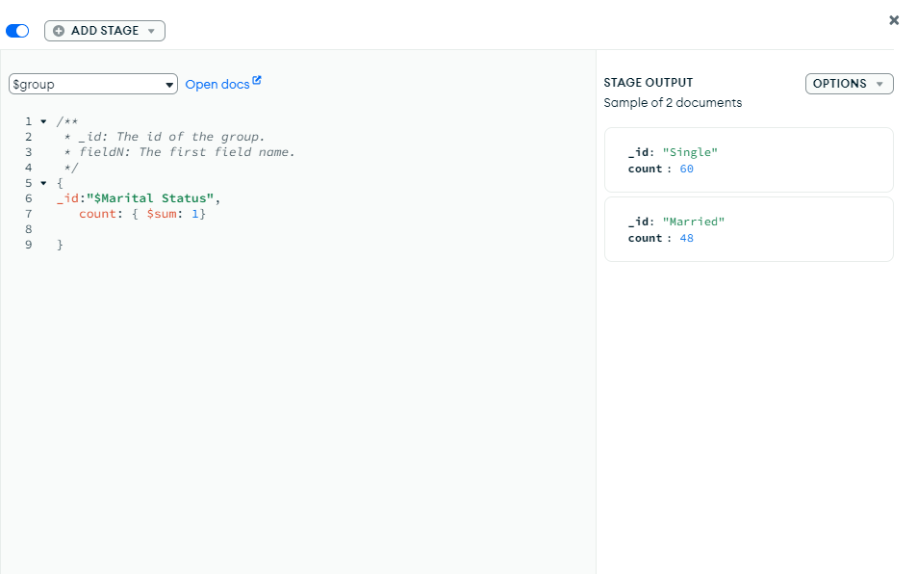

Females shows 60 counts for “single” and 48 for “Married”

Males shows 42 counts for “single” and 50 for “Married”