Rajeshwari Reddy Gummadi

U2276440

Reflection of Lab Exercise week 3

**Web and Mobile Development**

**Content**

**All the 6 task includes the following.**

* **How to create a React Application.**
* **How to change properties:**

**a) Change the text appearing into your React Application.**

**b) Change the background colour into your React Application.**

* **Creating stateless function component using React.**
* **Creating the Functional Component using properties.**
* **Adding Click Event for Functional Components.**

**For today’s Lab submission, After you complete the lab write down a word document answering following questions for your portfolio. (Page 13)**

**Task 1 Change the text appearing into your React Application.**

For the first task I have to change the text “Learn React”that is displaying on the React Application.

This is how the web page appears before changing the text.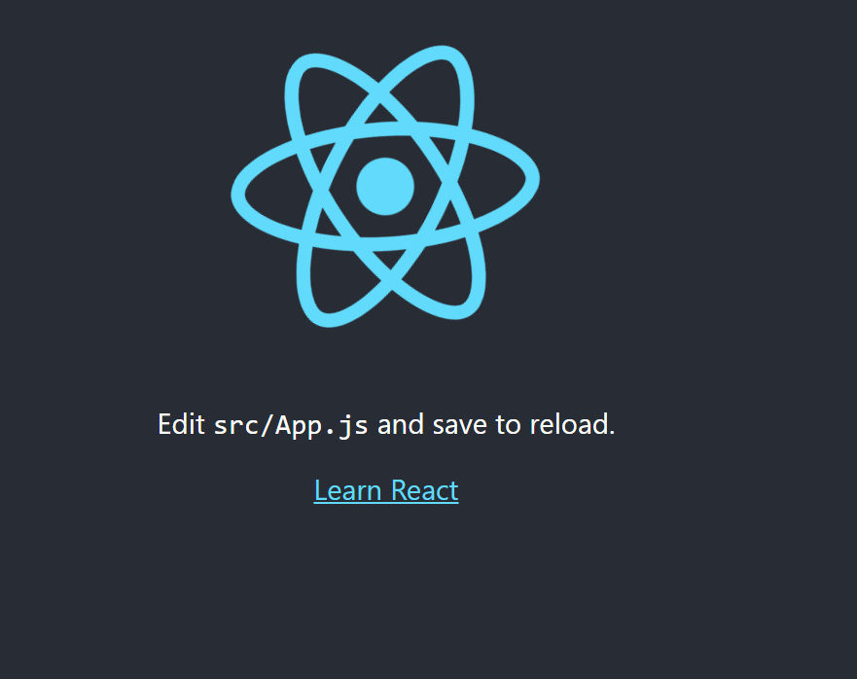

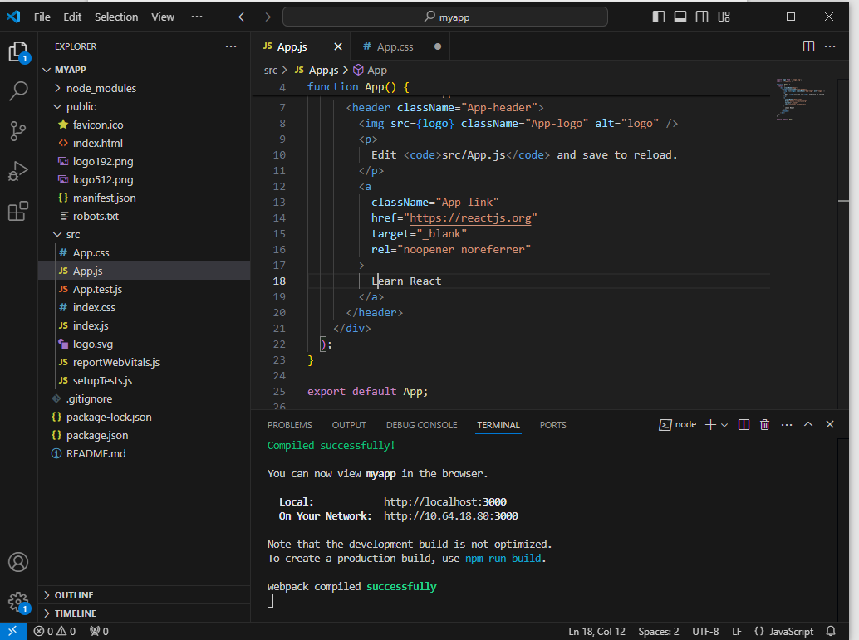

In App.js file line 18 has a text “Learn React” which I changed to “Welcome to the Page” and save the work then you will see the React application will automatically change the text .

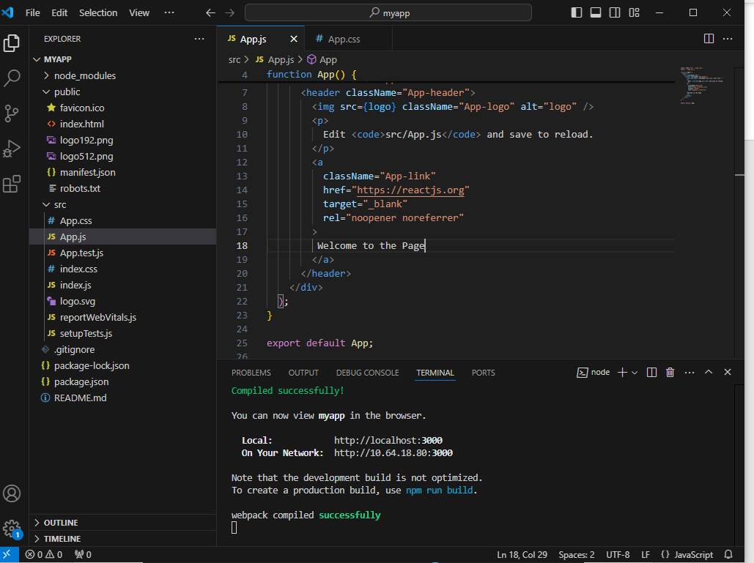

The web page after changing the text.

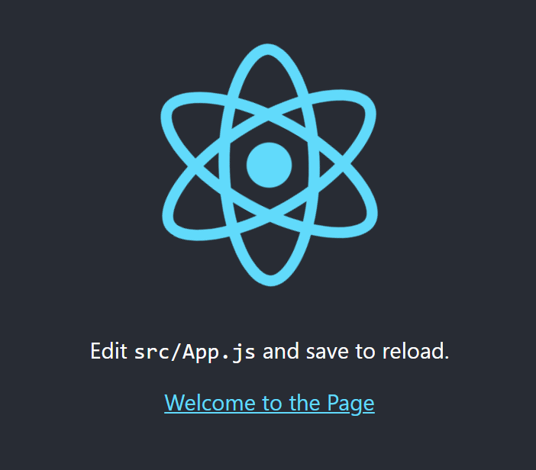

**Task 2 Change the colour in the background.**

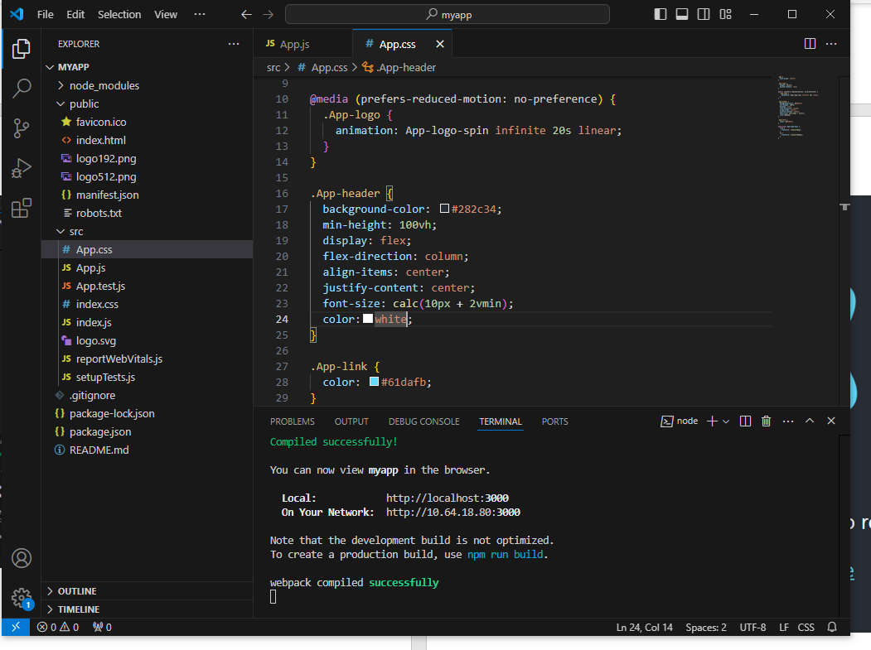

I have used CSS file for styling, here I have changed the font colour and the background colour of the web page.

After changing the background colour, the web page looks like this.

Learnt about JSX, it is a language used by React to create its elements. It stands for JavaScript and XML. JSX allows to write HTML in React. React elements are created using HTML tags that are converted by JSX. JavaScript is used inside HTML with curly brackets, JSX combines HTML and JavaScript. HTML Elements needs to be properly closed as JSX uses XML rules.

These are some examples when HTML is used within Javascript to create the React element.

1. When HTML tag h1 is assigned to java script variable using JSX. The elements are rendered in React Dom.



This is how the web page appear when I used the HTML tag h1.

1. When curly brackets are used inside the HTML tag. The variable will render using the ReactDom.render (myelement, document.getElementById(‘root)); command.



This is how the web page will look.



1. HTML tags should be properly closed /> otherwise the JSX will show the error. The variable will render using the ReactDom.render (Secondelement, document.getElementById(‘root’)); command.



The web page is displayed like this.

This is where you can take input from the user.

**Task 3 Creating Stateless function component using React**

Here we are going to create a functional component which will display the greeting messages. For this create a separate js file to code our greeting element in JSX and used this greeting element in the index .js

myGreetingApp.js file

Import the function GreetingElement() in Index.js file

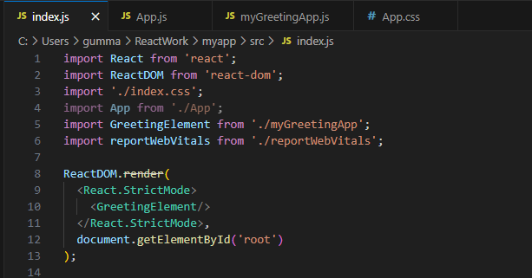

The web page is displayed in this way.

**Task 4 Creating the Functional Component using Properties**

For this separate file named mygreetingprop.js is created

Import the file Mygreetingprop.js in Index.js file

Here the property has been passed to the function which has the message that contains the String ”Hi its Monday”.

**Task 5 Use the same GreetingElement with Prop to display seven days of week greeting message.**

Change the code in the index.js

Used App.css file to style the font by changing its size and colour.

The web page displays the seven day of the week.

**Task 6 Functional Components using properties and HTML elements such as buttons**

AppbackgroundColor.js file is created. To create functional component using properties and HTML elements such as HTML tag button, text and labels. We need to create React component that will change the background colour when you click the button.

For the code we have used the button and added an event on Click. Here the function greetUser is in the curly bracket therefore when the button is clicked the function greetUser is activated and you will see the change in colour of the background using the command.

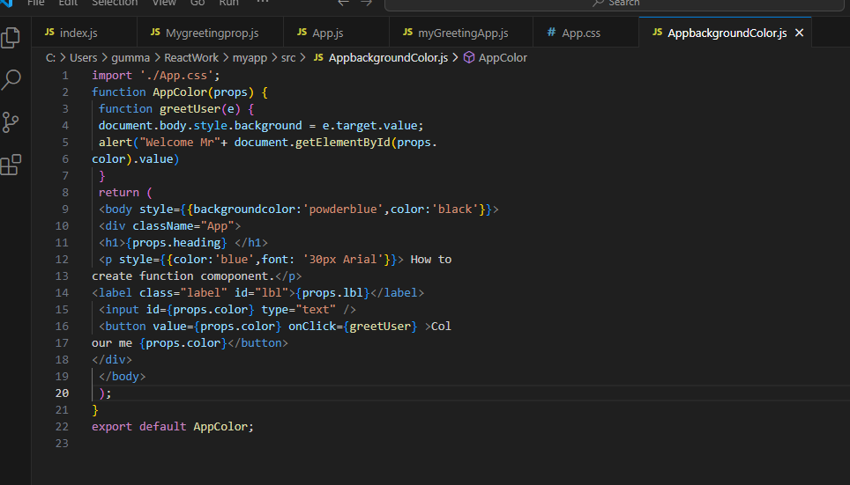

Import AppbackgroundColor.js in the index.js file.

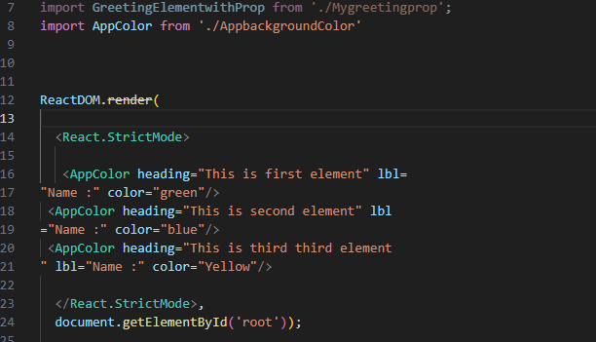

NOW save all the changes made and go to the React page, you will see the alert message “Welcome Mr”. when you click on the button colour me green, click ok for “Welcome Mr” you will see the page is changed to green colour. Similarly for the second element the page is changed for blue colour on clicking the button. For the third element the colour is changed to yellow colour.

**For today’s Lab submission, After you complete the lab write down a word document answering following questions for your portfolio:**

1. **What is React?**

React also known as React.js is a free open-source JavaScript library for creating user interfaces, particularly for single-page applications that let the user to interact with the web page without having to reload the entire page. React, developed and maintained by Facebook, has gained popularity for its declarative approach to designing UI components and efficient rendering through a virtual DOM.

1. **What do you understand by React component and what command do you use to create a React component with or without property?**

A React component can be written in one of two ways. In one, a class component is used, and in the other, a function component.

1. Functional component:

These are straightforward JavaScript functions that return JSX elements after receiving props as input. For presentational or stateless components, they are frequently employed.

Examples:

1. Class component:

The React Component classes are extensions of these ES6 classes. You can use JSX to specify the UI structure of your component utilizing their render() method. Components with lifecycle functions or the need to manage state are classified as class components.

A component is created with or without using the properties.

* Props are used to transmit data between parent and child components. In the preceding examples, props.name is used to display the name supplied to the component.
* If a component doesn't require any props, you may simply remove them.

1. **What command will you use to render the newly created component named as MyReact**

1. **Suppose the MyReact Component has a property heading, write down the code that could be used to render the MYReact Component, and pass the message to the property heading as “this is my first element”**

1. **Observe this code and answer the questions below**



1. What is the name of the React Component.

AppColor is the name of the React Component.

1. How many properties this component uses
2. heading
3. lbl
4. color
5. **The above answer is for questions 5 and 6.**
6. **Look at the following Code:**

export default GreetingElementwithProp

**Add a function that takes two properties as numbers, add these numbers on the click event of the button and display the sum.**

