Rajeshwari Reddy Gummadi

U2276440

Reflection of Lab Exercise week 9

**Web and Mobile Application Development**

**Task 1 Successfully created a class component to count emoji button clicks.**

**Objective**: Create a class component to count the number of times an emoji button is clicked.

**Implementation**:

1. **Component Name**: FacebookEmojiCounter
2. **State Management**:
   * number: Tracks the number of times the button is clicked.
   * pic: Stores the image to be displayed based on the type prop.
3. **Event Handler**:
   * increment(): Increments the number state each time the button is clicked.
4. **Render Method**:
   * Displays a button with an emoji image and the click count.

facebookemoji.js

Index.js

Imported component facebookcounter into index.js

Page before clicking, 0 value. After clicking the button there is increment in number.

**Observation**:

* Clicking the button increments the counter and updates the displayed count.
* The emoji image remains consistent with the type prop.

**Task 2 Successfully created a class component to toggle between happy and sad emojis.**

**Objective**: Create a class component that toggles the emoji on the button between happy and sad.

**Implementation**:

1. **Component Name**: toggleMode
2. **State Management**:
   * pic: Stores the current image (happy or sad).
3. **Event Handler**:
   * Toggle_Mode(): Toggles the pic state between happy and sad images.
4. **Render Method**:
   * Displays a button with the current emoji image.

togglemodecomponent.js

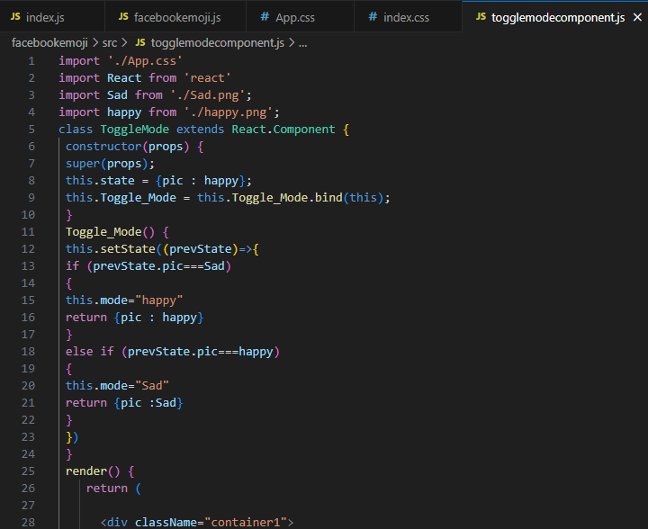

Index.js

Imported component togglemode into the index.js.

The happy emoji changes to sad emoji after clicking on the image button.

**Observation**:

* The FacebookEmojiCounter components display buttons with different emojis and counters.
* The ToggleMode component displays a button that toggles between happy and sad emojis.

**Functional component**

Functional elements are more straightforward. They are JavaScript functions that return React items after accepting props as an argument.

* They are simple to write and read.
* React Hooks have made it possible for functional components to handle state and side effects, something that was previously limited to class components.
* Because functional components are less complicated and do not require the overhead of class creation, they typically offer a minor performance advantage.

Example

**Class component**

React .Component is extended with ES6 classes called class components. They retain and can control their own lifespan and state mechanisms.

* For more complicated component logic, class components can benefit from having access to more lifecycle methods.
* Class components were the exclusive means of managing state and lifecycle in React prior to Hooks.

Example

