Sprint 1 Deliverable 3 Risk Register

  - 3.0 Risk Register
The development of the Social Tennis Set Maker involves several technical, project management, data security, and client-related risks. These risks were identified based on the current project requirements and discussions with the client Warren Vickers.
Each risk was assessed using Risk Assessment Matrix in Appendix A and the Impact of Risk Assessment in Appendix B, considering its likelihood of occurrence and potential consequence. Appropriate mitigation strategies have been identified to reduce either the likelihood or impact of each risk.

  - 3.0.1 Likelihood and Impact
By combining two standard risk assessment matrices, our team developed an integrated matrix to assess the risk associated with the project. Each risk is evaluated based on its likelihood and potential impact. The two factors are then help us determine the appropriate mitigation strategies for each identified risk. In addition, a risk owner is assigned to each risk to clear responsibility for monitoring and managing the risk throughout the project.

3.1 Identified risks
ID | Risk | Likelihood [1] | Impact [2] | Mitigation | Owner
1 | Generated doubles sets do not meet clients’ expectations | Low | Major | Regularly test generated sets using realistic club data and obtain Warren’s feedback throughout development Compare generated sets against pairings Warren would make manually | Algorithm Developer
2 | Requirements are misunderstood or change during development | Medium | Major | Regularly confirm requirements with the clients and document important decisions and changes | Developer  Team
3 | Insufficient communication with clients | Low | Moderate | Maintain regular meetings/email updates with Warren. Present the Scope of Work [3.0] to Warren for review and confirmation before commencing development. | Developer  Team
4 | Client data is leaked to external tools such as Github during development | Low | Moderate | Restrict access to team members. Avoid using real client data when unnecessary and verify commits and comments before push and pull into main branch. | Database Developer
5 | Delayed clients feedback causes development delays | Medium | Minor | Expecting client agrees on regular communication intervals and request feedback within an agreed timeframe for important decision. | Client
6 | Client requirements change significantly after development has begun | Low | Major | Confirm the Scope of Work before development and document any subsequent requirement changes. | Client
7 | Project scope becomes too large to complete within the time | Low | Major | Prioritise core requirements and put the low-priority functionality as optional or stretch goals. | Developer
8 | Algorithm processing time becomes too slow to produce doubles sets | Low | Moderate | Test algorithm using realistic data and larger dataset throughout the project. | Algorithm Developer
9 | Users interface difficult for players and administrator to read | Low | Moderate | Obtain client feedback and conduct usability testing before final delivery. | Frontend Developer
10 | Player/session data is lost or corrupted | Negligible | Major | Maintain regular backups and perform data migration carefully to ensure data is stored correctly and backed up in a timely manner. | Database Developer
11 | Team member schedule crash/unavailability delays important development task | Negligible | Moderate | Maintain accurate record in Book_Hours_Spreadsheet and schedule group meeting at least once per week to ensure all group member remain up to date with the project progress. | Developer
12 | Client-provided data is incomplete, outdated or inconsistent | Medium | Moderate | Ask client to review and provide valid dataset before use it as primary data for development. | Client
13 | Manual overrides are not carried forward correctly into later rounds | Medium | Major | Create test cases where an administrator changes a generated set, then verify that updated partner history, opponent history and sit-out counts are used by the next round. | Algorithm Developer
14 | Invalid session configuration produces incomplete or incorrect sets | Medium | Moderate | Validate court numbers, rounds, duration, start time, player availability and set format before generation. Test edge cases such as odd player numbers and unavailable courts. | Backend Developer
15 | Application behaves incorrectly on different browsers or devices | Medium | Moderate | Test the application on common browsers and desktop, tablet and mobile devices. Prioritise testing of the QR results page because it is intended for mobile access. | Frontend Developer
16 | Sit-out history or fairness statistics are calculated incorrectly | Medium | Major | Test sit-out calculations across multiple sessions, including players who join late, become unavailable and have different attendance frequencies. Compare calculated results against manually checked examples. | Algorithm Developer
17 | Database or application failure interrupts a live tennis session | Low | Major | Implement graceful error handling, clear error messages and regular backups. Test recovery from failed generation, database errors and interrupted requests before delivery. | Backend Developer
18 | Duplicate player records cause incorrect fairness or sit-out calculations | Medium | Major | Implement duplicate-player detection and test records with similar names. Verify that sit-out history is associated with the correct player record. | Database Developer
  - 3.2 References
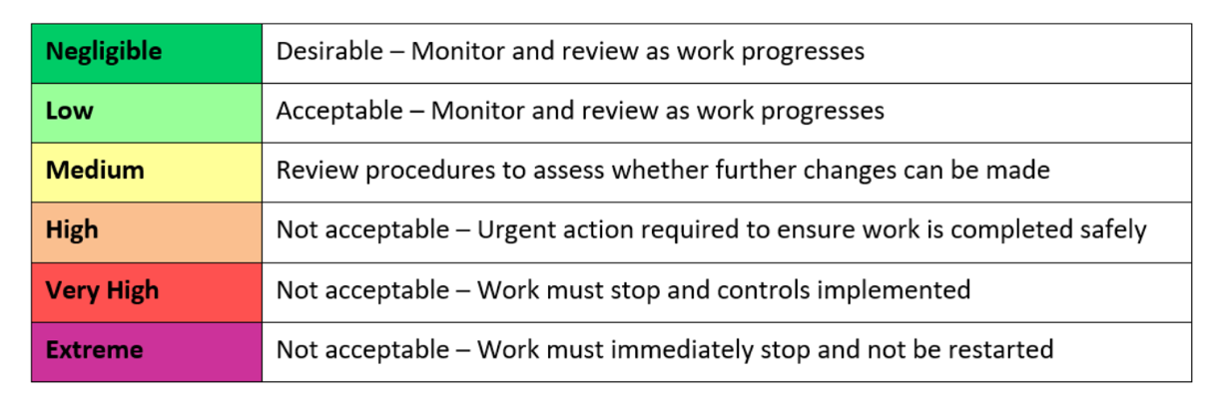
Appendix A: Likelihood of Risk Assessment Matrix [1]

Insignificant | Desirable - Very little impact on the project and can be fixed easily.
Minor | Acceptable – Small impact that may require some additional work.
Moderate | Acceptable – noticeable impact that may cause delays
Major | Review procedures to assess whether further changes can be made
Catastrophic | Not acceptable – Critical impact that may prevent the project from being successfully completed.

Appendix B: Impact of Risk Assessment [2]

