

**Activity 1.2.5 Clock Signals: The 555 Timer**

**Introduction**

Almost all development tools used today in digital electronics have an internal clock that can be integrated into your circuit design. There are times however, when you may want to generate your own simple clock signal and not depend on the internal clock of your development board or equipment like a function generator or digital writer.

The 555 Timer oscillator is one of the most common circuits used in introductory electronics. It is a favorite among beginners because of its low cost and ease of design. These are precisely the same reasons the 555 Timer is used in the Random Number Generator design.

In this activity you will simulate and create a 555 Timer oscillator. You will observe the effect that varying the value of its resistor and capacitor values has on the oscillation frequency and duty cycle.

**Equipment**

* Circuit Design Software (CDS)
* 555 timer Integrated Circuit (IC)
* Resistors and capacitors
* #22 Gauge solid wire
* Breadboard

**Procedure**

1. For the 555 Timer oscillator circuit shown below, calculate the frequency and duty cycle of the output signal based on the component values shown.

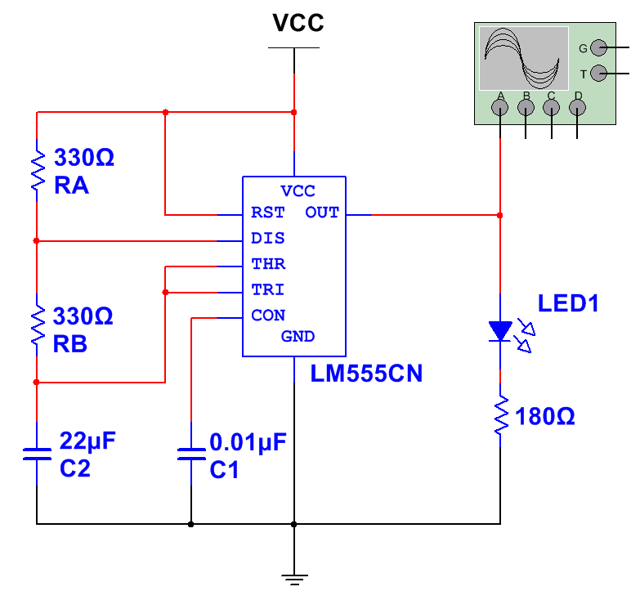

1. Use the CDS to enter and simulate the 555 Timer oscillator circuit. Use the oscilloscope’s markers to make the necessary measurements. Determine the frequency and duty cycle of the output signal. How do these values compare to the calculated values? 49.7Hz, 75% duty cycle, the values are very similar.
2. Repeat steps (1) and (2) for each set of component values in the table shown below. Note that the shaded areas are the values that were measured from the original circuit.

|  |  |  |  |  |  |  |  |
| --- | --- | --- | --- | --- | --- | --- | --- |
| RA | RB | C2 | Period(T) | Frequency(*f*) | tH | tL | Duty Cycle |
| 100 Ω | 330 Ω | 22 μF | 11.58ms | 86 | .00655 | .005 | 57 |
| 330 Ω | 330 Ω | 22 μF | 15.09ms | 66 | .010 | .005 | 66 |
| 560 Ω | 330 Ω | 22 μF | 18.6ms | 53 | .0135 | .005 | 73 |
| 330 Ω | 100 Ω | 22 μF | 8.08ms | 123 | .00655 | .0015 | 81 |
| 330 Ω | 330 Ω | 22 μF | 15.09ms | 66 | .010 | .005 | 66 |
| 330 Ω | 560 Ω | 22 μF | 22.11ms | 45 | .0135 | .0085 | 61 |
| 330 Ω | 330 Ω | 10 μF | 5.86ms | 145 | .00457 | .0023 | 67 |
| 330 Ω | 330 Ω | 22 μF | 15.09ms | 66 | .010 | .005 | 66 |
| 330 Ω | 330 Ω | 47 μF | 32.25ms | 31 | .021 | .0107 | 65 |

1. Review the results of the data collected in step (3) of the procedure.

* What effect did varying the RA have on the frequency and duty cycle?

The higher the RA, the lower the frequency, and the higher the duty cycle.

* What effect did varying the RB have on the frequency and duty cycle?

The higher the RB, the lower the frequency, and the lower the duty cycle.

* What effect did varying the C2 have on the frequency and duty cycle?

The higher the C2, the lower the frequency and duty cycle.

In the previous activity you created a 4-bit counter that counted from 0-15 in binary. We used a provided clock source. (Internal clock in the development board or a software generated clock source).

Using what you have learned about the relationships between RA, RB, C2 and how they impact the frequency output of the clock signal, create your own 555 Timer oscillator circuit on your development board.

(Note: The simulation was helpful in determining how RA, RB, and C2 impact the 555 Timer oscillator design. However, the software simulated frequency can be affected by the processor on your computer. The frequency rate may appear slightly different in your actual design compared to your simulated design. Also, your design may be limited by the resistors and capacitors available.)

**Simulation**

1. Once you have your 555 Timer circuit functioning, use the clock signal to trigger the 4-bit binary counter you created previously.

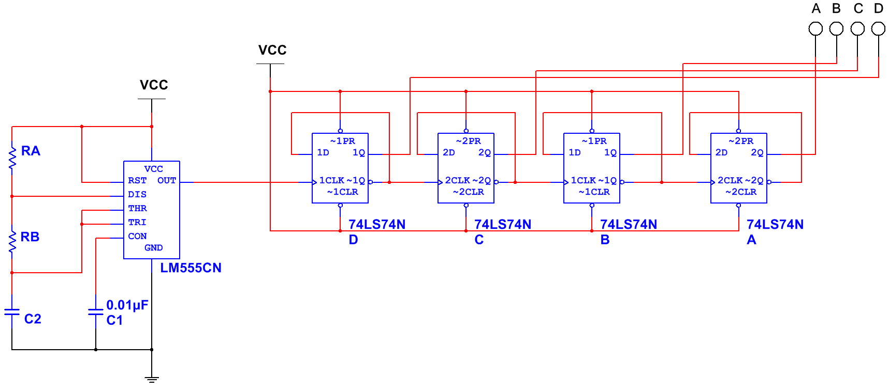

The 555 and binary counter combination makes a counter where X1 goes on and off and X2 goes off for every 2 blinks on X1, to create a counter up to fifteen.

**Breadboard**

1. Create the circuit on your breadboard. (Remember you may need to use different resistor and capacitor values to find a clock signal rate you are comfortable with.  
   You will need to locate the datasheets for the 555 timer and 74LS74 D Flip-flop.