Part one

1、（1）their families

（2）what they know about their family, their similarities with parents or siblings, and what they know about their family history

2、（1）come from

（2）most of my family

（3）talking to people

3、c-e-a-f-b-d

4、（1）height

（2）same traits

（3）think about things

（4）my sister

（5）similar to

（6）mathematical

（7）a younger version

（8）organized

（9）louder

（10）quite calm

（11）my brothers

（12）quite different

5、2，6正确

Part two

2

（1）1689

（2）advisor

（3）soldiers

（4）sailors

（5）dull

（6）incredibly

（7）surname

（8）great fun

Part three

2、

（1）islands

（2）There are no rules

（3）an account

（4）a digital

（5）male

（6）half animal

（7）edit

（8）short

（9）face

（10）features

（11）pick

（12）personality

（13）online stores

（14）over three million

（15）chat

Role Playing

2.1

Conversation 1

1、speaking and listening

2、speaking and listening

Conversation 2

1、summer camp

2、Different ages

Conversation 3

1、online classes

2、demanding

2.2

Conversation 1

(1) So for me the most important thing is to

Conversation 2

(2) I suppose I'd have to say

(3) In my opinion

Conversation 3

(4) One thing I'd like to say is that

Presenting

（1）

1.1

1、BBC breakfast TV

2、 hair color

3、businesswoman

4、personality

5、building

1.2

正确：1、3、4、5、6

（2）

Step2

建议不要抄这个

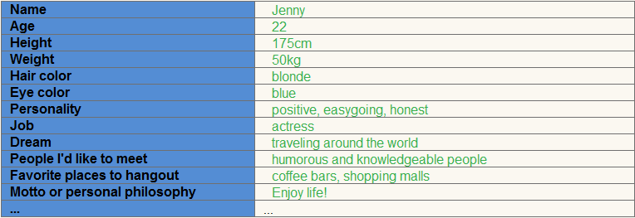

Step3

建议不要抄……….

I'm a 22-year-old girl studying in a Chinese university.   
I want to create a new image of myself. One thing I decide to alter is my appearance. I hope I can be 175cm tall, and my weight is about 50kg. I want to make my eyes blue and my hair blonde. I want to become a fashionable and attractive girl so that I can become a good actress and a charming cover girl. I want to be famous.  
I won't change my personality much. I will still be a positive, easy-going and honest girl as I am now. But I hope I can be more outgoing.   
The things that haven't changed are my perception of perfect happiness and my dream. For me, perfect happiness means perfect health, lots of money in my wallet and lots of love in my heart. Traveling around the world has long been my dream. I want to have enough money and time to go traveling, and I want to go to different places in the world and meet a lot of humorous and knowledgeable people. And when I come back home, I want to hang out with my friends at coffee bars and shopping malls. I long for that exciting and fun life, and I bet I'll enjoy it.

Conversations

1、

|  |  |  |  |  |  |
| --- | --- | --- | --- | --- | --- |
| 题号 | 1 | 2 | 3 | 4 | 5 |
| 答案 | B | C | C | D | A |

2、

C、D、A、B

Passages

1、

C、C、A、B

2、

（1）infancy

（2）assumed

（3）inherited

（4）rooted in

（5）fairs

（6）compensate for

（7）cement

（8）witness

（9）exposed to

（10）contributed to

Unite Test

Part1

B\B\C\C\B

Part2

B\D\A\A

Part3

B\C\C\A\D

Part4

(1)kicked out of

(2)hang out

(3)involved

(4)useless

(5)failure

(6)fell in love with

(7)positive

(8)especially

(9)took off

(10)succeed