**“Gesture based Web-Browser”**

***A***

***Project Report***

*submitted in partial fulfillment of the*

*requirements for the award of the degree of*

**BACHELOR OF TECHNOLOGY**

**in**

**COMPUTER SCIENCE & ENGINEERING**

**by**

|  |  |
| --- | --- |
| **Name** | **Roll No.** |
| **PAWAN CHATURVEDI** | **R164217036** |
| **PRADEEP YADAV** | **R164217038** |
| **PRANJAL RAI** | **R164217039** |
| **RAGHWANDRA SINGH** | **R164217046** |

***under the supervision of***

**Ms. Roohi Sille**

**Assistant Professor**

**in**

**Department of Systemics**



**SCHOOL OF COMPUTER SCIENCE**

**UNIVERSITY OF PETROLEUM & ENERGY STUDIES**

**Bidholi, Via Prem Nagar, Dehradun, UK**

**November – 2020**

**CANDIDATE’S DECLARATION**

We hereby certify that the project work entitled **“ Gesture based Web-Browser”** in partial fulfilment of the requirements for the award of the Degree of BACHELOR OF TECHNOLOGY in COMPUTER SCIENCE AND ENGINEERING with specialization in Internet of Things and Smart Cities and submitted to the Department of Systemics at School of Computer Science, University of Petroleum & Energy Studies, Dehradun, is an authentic record of our work carried out during a period from **August**, **2020** to **November**, **2020** under the supervision of **Ms. Roohi Sille, Assistant Professor in Department of Systemics**.

The matter presented in this project has not been submitted by us for the award of any other degree of this or any other University.

**Pawan Chaturvedi, 36**

**Pradeep Yadav, 38**

**Pranjal Rai, 39**

**Raghwandra Singh, 46**

This is to certify that the above statement made by the candidate is correct to the best of my knowledge.

Date: 07-11-2020

**Dr. Neelu Jyoti Ahuja Ms. Roohi Sille**

Department of Systemics Project Guide

**ACKNOWLEDGEMENT**

We wish to express our deep gratitude to our guide **Ms. Roohi Sille**, for all advice, encouragement and constant support she has given us throughout our project work. This work would not have been possible without her support and valuable suggestions.

We sincerely thank to our respected Program Head of the Department, **Dr. Neelu Jyoti Ahuja**, for her great support in doing our project in **Area (like IoT, Electronics etc.)** at **SoCS**.

We are also grateful to **Dr. Manish Prateek Dean SoCS**, UPES for giving us the necessary facilities to carry out our project work successfully.

We would like to thank all our **friends** for their help and constructive criticism during our project work. Finally, we have no words to express our sincere gratitude to our **parents** who have shown us this world and for every support they have given us.

|  |  |  |  |  |
| --- | --- | --- | --- | --- |
| **Name** | **Pawan Chaturvedi** | **Pradeep Yadav** | **Pranjal Rai** | **Raghwandra Singh** |
| **Roll No.** | **R164217036** | **R164217038** | **R164217039** | **R164217046** |

**ABSTRACT**

These days scientists around the globe are effectively occupied with improvement of vigorous and productive sign language framework, all the more extraordinarily, hand gesture based human-machine interface for different applications. No matter how solid and incredible, we should be near machines and working alongside them. Also, that is the prime explanation hand gesture has become vital piece of non-verbal correspondence for individuals.

Internet Browsers is an exceptionally regular programming application which we utilize each day, consistently. Utilization of innovation can utilize internet browsers more and simpler.

The Internet is developing at an exceptionally quick pace. The utilization of internet browser is likewise developing. The Internet is an answer for everything. Presently, everybody has at any rate 2-3 most often visited site. Presently, imagine a scenario in which visits on those destinations can be made more straightforward. Gesture recognition helps in the environment known to be HMI (humans communication with the machine and interact) and that does not include touch of mechanical devices. Our project aims to address the current situation and tried to make the use of a web browser easier.

**Keywords:** Gestural interaction, Hand gesture recognition, Vehicular automation's, HCI (Human Computer Interaction), FEMD, gesture vocabulary, HMI(Human-machine Interface).

**TABLE OF CONTENTS**

**S.No. Contents Page No**

1. **Introduction 7**
   1. Hand gesture 7
   2. Objectives 7
   3. Motivation 7
   4. Pert Chart Legend 9
2. **System Analysis 10**
   1. Existing System 10
   2. Proposed System 11
   3. System Architecture 12
3. **Design 13**
   1. System Modelling 13

3.1.1. Flow Chart 13

1. **Hand Gesture based Web-Browser 14**
   1. Hand Gesture Web-Browser 14
2. **Implementation 15**
   1. Python OpenCV: Capture Video from Camera 15
3. **Output screens 16**

**Appendix A: Software Source Code 17**

**References 18**

**LIST OF FIGURES**

**S.No. Figure Page No**

1. **Chapter 1**

Fig. 1.1 Hand Gesture Detection System 8

Fig. 1.2 Pert Chart 9

1. **Chapter 2**

Fig. 2.1 Pattern Recognition 12

1. **Chapter 3**

Fig. 3.1 Flow Chart 13

1. **Chapter 6**

Fig. 6.1 Frame Snapshot 16

1. **INTRODUCTION**

**1.1. Hand gesture**

Hand gesture detection systems are one of the hottest fields of research since it is of great significance in designing artificially intelligent Human-computer interfaces (HCI) [1] for vehicular applications. Gestures help to communicate a great deal. Seals, Regulators, Adapters, Metamorphic are particular sorts of gestures which are into training. A hand gesture driven system could bring in more naturalness and innovation for the increasingly popular gaming industry as demon-started by Nintendo’s ‘Wii’ controller.[8] Such a hand gesture driven interface can free the users from using remote controllers for simple tasks such as issuing a command to a home entertainment system which may need start and play a music track or perhaps skip the current track.[9] Emerging technologies now make it possible to create gestural-interfaces for vehicles that make it easier for the driver to carry the tasks effectively.

**1.2. Objectives**

The Objective of our project is to design a robust and efficient system which will be able to control the browser via hand gestures i.e. different hand gestures will be assigned to different sites. So, if we show a particular hand gesture, a particular site will open up in a new tab.

**1.3. Motivation**

In today’s world where technology is evolving so fast, Human can easily reduce its additional extra work using some interesting technology. One of the interesting application of this type of technology is ‘Hand Gesture’ . Think about your day to day life where you have to always opens up some common websites whenever you open your computer like Email, Facebook, Whats App, etc and for this you type URL in your web browser what is we can make this process a little bit easy like whenever you open your computer you just have to show different hand gestures in

front of your camera and it opens up all regular websites for you like you can show one finger for Email, two finger for Facebook and three finger for Whats App it works. Think about a robot

where you give a common task to a robot and as per your command it do its work same like this you give some command with your hands to your web browser and it do thinks according to that command.

This process does not requires any keyboard input and and makes quick access to all those common websites which takes extra time when you open them manually with your keyboard.

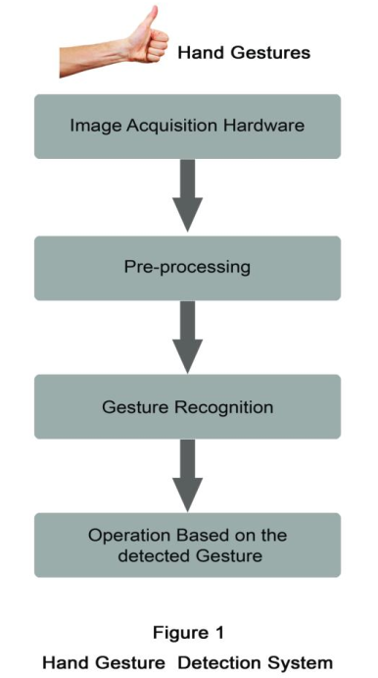

**Fig 1.1 Hand Gesture Detection System**

**1.4. Pert Chart Legend**

Task 5- Implementation of Algorithm And Coding

Start Date – 20/10/2020

End Date – 09/11/2020

Duration- 20 days

End

Task 7- Deployment

Start Date – 20/11/2020

End Date – 29/11/2020

Duration-10 days

Task 6- Testing of Code and Connect code with Cloud

Start Date – 10/11/2020

End Date - 19/11/2020

Duration- 10 days

Task 3- Organize project resources

Start Date - 09/09/2020

End Date - 18/09/2020

Duration – 10 days

Task 4- Designing of Algorithm and selection of Algorithm

Start Date – 19/09/2020

End Date – 19/10/2020

Duration- 31 days

Task 2- Manage project related data

Start Date - 30/08/2020

End Date - 08/09/2020

Duration- 10 Days

Task 1- Project initiation And title submission

Start Date - 20/08/2020

End Date - 29/08/2020

Duration – 10 Days

Start

**Fig 1.2 Pert Chart**

1. **SYSTEM ANALYSIS**

**2.1. Existing System**

* Almost all the hand gesture detection systems mostly follow the mentioning steps in detecting and recognizing the gestures. Image acquisition, pre-processing and hand gesture recognition. [5] Image acquisition involves fetching the movements of the hands by any image acquisition hardware and the captured gestures are then moved to the second pre-processing segment. Pre-processing methods [4, 5] are mainly based on the combinations of several processing operations. Pre-processing is a process that receives the data obtained from image acquisition steps and then prepares the data for the following procedures. This is done in a particular way as that the data can be more easily and effectively processed by the next detection steps.
* Different pre-processing steps involve filtering, edge detection, histogram equalization, thresholding, etc.[5] Pre-processing is the step which determines the accuracy of the system. Image acquisition modules are different related to different detection systems. The modules can be an accelerometer sensor or a data glove or a in vision based approach a camera replaces the above mentioned modules. The data fed from the image acquisition section may be mostly error affected .Therefore pre-processing is the step which enhance the quality of the information from acquisition step and ultimately improves the accuracy of the detection systems.
* Recognition step identifies the processed hand movements as a particular gesture and then determines what the operation should be executed for a particular hand gesture [6]. Recognition step involves different algorithms for individual detection systems. In this paper it is described some of the gesture detection systems and the related algorithms used, results obtained, challenges faced etc. Rest of the paper is organized as follows. Section 2 describes the motivation and related work and section 3 presents some of the hand gesture detection systems, their recognition methods, applications and design challenges etc. Section 4 discusses a performance evaluative study and a hand gesture vocabulary is proposed and section 5 concludes the paper. This paper actually makes a

comparative analysis between the different existing hand gesture detection systems and finally on comparing these systems pointing out the features of Kinect sensor based vision gesture detection systems in detail in the conclusion section of the paper.

* Many gesture detection systems have been applied successfully to different fields with some good results. The reason for choosing hand as the gesture detection input in vehicular automation is, the hand is more flexible than any of the body part and more no gestures that a hand can be generated than that can be generated by the head or face [1]. So gesture ‘vocabulary’ will be more if hand movements as the gesture. In many of the areas gestures replaces some of the conventional input devices as they are found more feasible than the conventional types in some particular areas or applications.
* In 1987 a commercially available data glove was introduced, equipped with 15 or more sensors with different gesture tracking abilities. Power Glove was developed in 1989 which was commercialized by Mattel Intellivision as control device for the video game console. The P5 glove an updated version of the power glove in 2002 provides users intuitive interaction with 3D and virtual environments. Robert Wang and Papovic [7] proposed a colored glove based hand tracking system with the custom pattern imprinted on it. The proposed system was in expensive and which simplified the pose estimation problem. Feng Wang and Chong Wah [5] proposed a real time gesture detection system for lecture videos. Daeho Lee and Park [6] presented a universal remote control system based on computer vision. The motion and skin color of the hands are utilized to detect the waving hands and requesting control commands.

**2.2. Proposed System**

Recognition of human gestures comes within the more general framework of pattern recognition. In this framework, systems consist of two processes: the representation and the decision processes. The representation process converts the raw numerical data into a form adapted to the decision process which then classifies the data (see Fig 2.1).

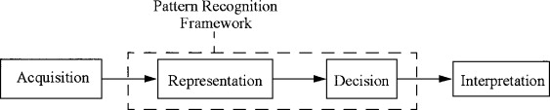

**Fig 2.1** **Pattern Recognition**

We plan to design a system to solve above problem using image processing techniques and controlling the browser using hand gestures. At, first the user needs to enter the sites which he/she frequently visits and needs to control those sites using hand gestures. A user needs to enter the site names for the particular hand gestures. That’s all, the user can now control the browser, open sites in new tabs using hand gesture and can even close the browser using the hand gesture. Thus, a hand gesture controlled browser is made. In this way a user can easily open the sites which he/she wants in the new tab using the hand gesture.

**2.3 System Architecture**

Two types of gesture modes includes at Offline and Online gestures modes where Online Gestures are primarily aimed at rotation of tangible object While Offline Gestures includes the gestures and get involve and processed with object after interaction of user, for instance we say menu activation HGR system involves different types of four phases.

* **Data Acquisition**
* **Pre-processing and Hand Segmentation**
* **Feature Extraction**
* **Recognition**

**3. DESIGN**

**3.1. System Modelling**

**3.1.1. Flow Chart** 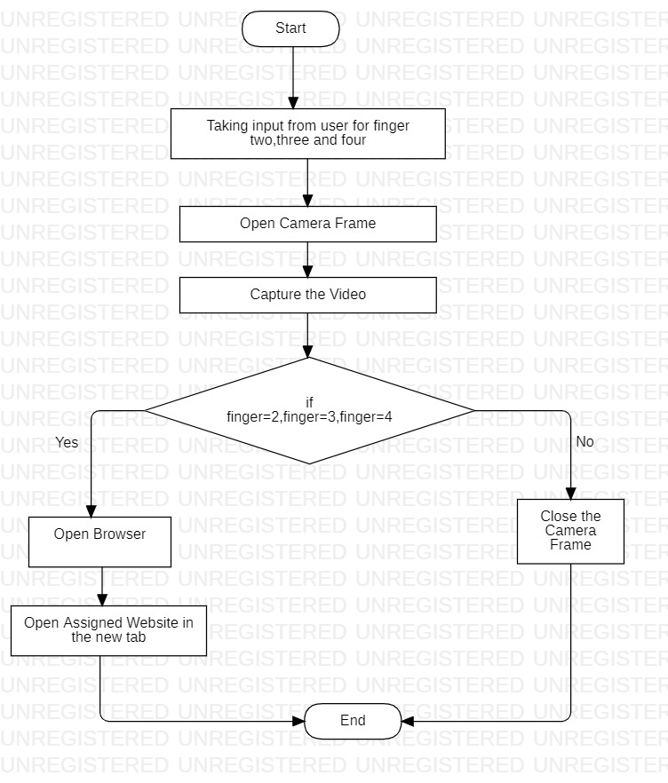

**Fig. 3.1 Flow Chart**

1. **Hand Gesture based Web-Browser**
2. **Hand Gesture based Web-Browser**

**4.1. Hand Gesture Web-Browser**

This project is able to open your favourite websites using image processing techniques and controlling your browser using the hand gestures like two finger, three finger, four finger. First we are taking the variable and then user needs to enter the name of his favourite websites for the three of the variable and with the help of opencv library a frame will opens up and user have to show the particular hand gesture for which he wants to open the website on showing the hand gesture browser will automatically opens the assigned website in the new tab.

1. **IMPLEMENTATION**

**5.1. Python OpenCV: Capture Video from Camera**

1) First we import opencv library

2) Then we use cv2.VideoCapture() to capture a video from camera.

3) We use a infinite loop using while(True)

4) The read() method to read frames using the defined object

5) imshow() method is used to show the frames in the video

6) If the user wants to break the infinite loop then he has to click on a specific key.

1. **OUTPUT SCREENS**

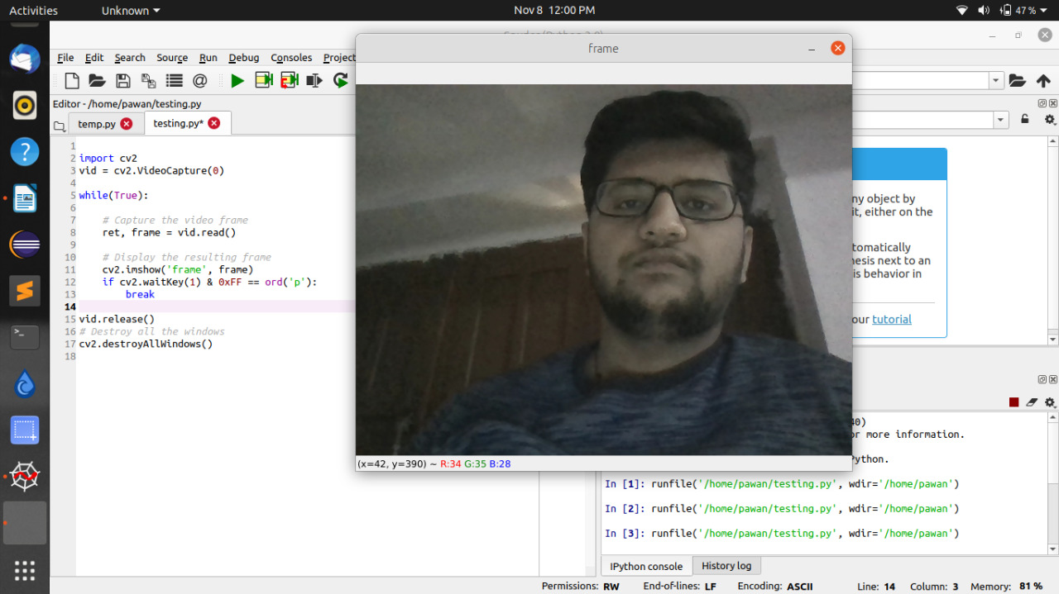

**Fig. 6.1 Frame Snapshot**

**Appendix A**

**Software Source Code**

# import the opencv library

import cv2

# define a video capture object

vid = cv2.VideoCapture(0)

while(True):

# Capture the video frame

# by frame

ret, frame = vid.read()

# Display the resulting frame

cv2.imshow('frame', frame)

# the 'p' button is set as the

# quitting button you may use any

# desired button of your choice

if cv2.waitKey(1) & 0xFF == ord('p'):

break

# After the loop release the cap object

vid.release()

# Destroy all the windows

cv2.destroyAllWindows()

**References**

[1] Zhou Ren, Jingjing Meng and Zhengyou Zhang, “Robust Part-Based Hand Gesture RecognitionUsing Kinect Sensor”, IEEE Transactions on multimedia, vol. 15, no. 5, august 2013

[2] Hand posture recognition with the fuzzy glove Author links open overlay panel T.Allevard, E.BenoitL.Foulloy LISTIC-ESIA, Université de Savoie, B.P. 806, 74016 Annecy, France online 9 May 2007 <https://www.sciencedirect.com/science/article/pii/B9780444520753500352>

[3] Jobin Francis,Anoop B K,”Significance of Hand Gesture Recognition Systems in

Vehicular Automation- A Survey” International Journal of Computer Applications (0975 – 8887) Volume 99– No.7, August 2014

[4] Juan P. Wachs, Helman Stern and Yael Edan, “Cluster Labeling and Parameter Estimation for the Automated Setup of a Hand-Gesture Recognition System”, IEEE Transactions on Systems, Man, and Cybernetics—part a: Systems and Humans, vol. 35, no. 6, november 2005

[5] Regina Lionnie, Ivanna K. Timotius & Iwan Setyawan, “Performance Comparison of Several Pre-Processing Methods in a Hand Gesture Recognition System based on Nearest Neighbor for Different Background Conditions” ITB J. ICT, Vol. 6, No. 3, 2012, 183-194

[6] Yuan Yao and Yun Fu, “Contour Model based Hand-Gesture Recognition Using Kinect Sensor”, 10.1109/TCSVT.2014.2302538, IEEE Transactions on Circuits and Systems for Video Technology.

[7] Robert Y. Wang and Jovan Popovic, “Real-Time Hand- Tracking with a Color Glove”,

[8] International Journal of Engineering and Technical Research (IJETR)ISSN: 2321-0869, Volume-3, Issue-5, May2015

[9] Premaratne P., Nguyen Q., Premaratne M. (2010) Human Computer Interaction Using Hand Gestures. In: Huang DS., McGinnity M., Heutte L., Zhang XP. (eds) Advanced Intelligent Computing Theories and Applications. ICIC 2010. Communications in Computer and Information Science, vol 93. Springer, Berlin, Heidelberg. https://doi.org/10.1007/978-3-642-14831-6_51