**SYNOPSIS REPORT**

**on**

**A WEB APPLICATION FOR GESTURE BASED BROWSING**

**Submitted by**

PAWAN CHATURVEDI (Enroll No. R164217036)

PRADEEP YADAV (Enroll. No. R164217038)

PRANJAL RAI (Enroll. No. R164217039)

RAGHWANDRA SINGH (Enroll. No. R164217046)

**Under the guidance of**

Ms. Roohi Sille

Assistant Professor, Dept. of Systemics



**SCHOOL OF COMPUTER SCIENCE**

UNIVERSITY OF PETROLEUM & ENERGY STUDIES

Bidholi Campus, Energy Acres, Dehradun – 248007.

**August - 2020**

 **School of Computer Science**

**University of Petroleum & Energy Studies, Dehradun**

**Project Proposal Approval Form (2020-21)**



I

**Minor Major**

**PROJECT TITLE:** **Gesture based - Web-Browser**

Controlling Web Browser via different hand gestures

**ABSTRACT**

We know about hand gestures. Why not try hand gestures to control the browser itself?

Internet Browsers is an exceptionally regular programming application which we utilize each day, consistently. Utilization of innovation can utilize internet browsers more and simpler.

The Internet is developing at an exceptionally quick pace. The utilization of internet browser is likewise developing. The Internet is an answer for everything. Presently, everybody has at any rate 2-3 most often visited site. Presently, imagine a scenario in which visits on those destinations can be made more straightforward. Our project aims to address the current situation and tried to make the use of a web browser easier.

**Keywords:** Gestural interaction, Hand gesture recognition, Vehicular automations, HCI (Human Computer Interaction), FEMD, gesture vocabulary.

**INTRODUCTION**

Hand gesture detection systems are one of the hottest fields of research since it is of great significance in designing artificially intelligent Human-computer interfaces (HCI) [1] for vehicular applications. Emerging technologies now make it possible to create gestural-interfaces for vehicles that make it easier for the driver to carry the tasks effectively.

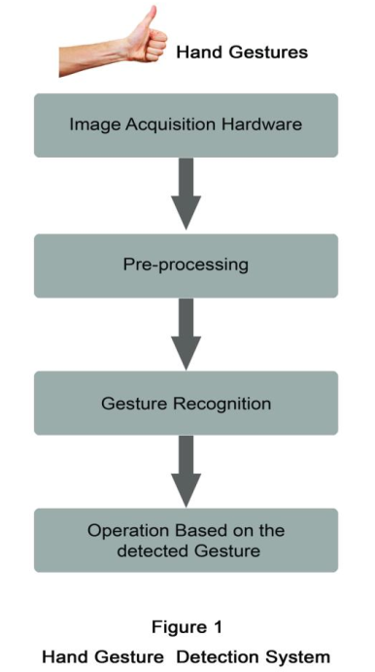

**Fig.1** **Hand Gesture Detection System**

Recognition of human gestures comes within the more general framework of pattern recognition. In this framework, systems consist of two processes: the representation and the decision processes. The representation process converts the raw numerical data into a form adapted to the decision process which then classifies the data (see Fig. 2).

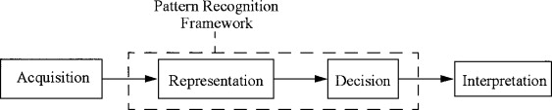

**Fig.2** **Pattern Recognition**

We plan to design a system to solve above problem using image processing techniques and controlling the browser using hand gestures. At, first the user needs to enter the sites which he/she frequently visits and needs to control those sites using hand gestures. A user needs to enter the site names for the particular hand gestures. That’s all, the user can now control the browser, open sites in new tabs using hand gesture and can even close the browser using the hand gesture. Thus, a hand gesture controlled browser is made. In this way a user can easily open the sites which he/she wants in the new tab using the hand gesture.

**PROBLEM STATEMENT**

* Everyone has some sites which are used very frequently. For example:- If someone is fond of social media, he/she can assign different hand gestures for sites such as Facebook, Instagram, and YouTube.
* Time consumption to search is quite long when one has to type and enter to go to that particular website.
* Hardware Input

**LITERATURE REVIEW**

* Almost all the hand gesture detection systems mostly follow the mentioning steps in detecting and recognizing the gestures. Image acquisition, preprocessing and hand gesture recognition. [5] Image acquisition involves fetching the movements of the hands by any image acquisition hardware and the captured gestures are then moved to the second pre- processing segment. Pre-processing methods [4, 5] are mainly based on the combinations of several processing operations. Pre-processing is a process that receives the data obtained from image acquisition steps and then prepares the data for the following procedures. This is done in a particular way as that the data can be more easily and effectively processed by the next detection steps.
* Different pre-processing steps involve filtering, edge detection, histogram equalization, thresholding, etc.[5] Pre-processing is the step which determines the accuracy of the system. Image acquisition modules are different related to different detection systems. The modules can be an accelerometer sensor or a data glove or a in vision based approach a camera replaces the above mentioned modules. The data fed from the image acquisition section may be mostly error affected .Therefore pre-processing is the step which enhance the quality of the information from acquisition step and ultimately improves the accuracy of the detection systems.
* Recognition step identifies the processed hand movements as a particular gesture and then determines what the operation should be executed for a particular hand gesture [6]. Recognition step involves different algorithms for individual detection systems. In this paper it is described some of the gesture detection systems and the related algorithms used, results obtained, challenges faced etc. Rest of the paper is organized as follows. Section 2 describes the motivation and related work and section 3 presents some of the hand gesture detection systems, their recognition methods, applications and design challenges etc. Section 4 discusses a performance evaluative study and a hand gesture vocabulary is proposed and section 5 concludes the paper. This paper actually makes a comparative analysis between the different existing hand gesture detection systems and finally on comparing these systems pointing out the features of Kinect sensor based vision gesture detection systems in detail in the conclusion section of the paper.
* Many gesture detection systems have been applied successfully to different fields with some good results. The reason for choosing hand as the gesture detection input in vehicular automation is, the hand is more flexible than any of the body part and more no gestures that a hand can be generated than that can be generated by the head or face [1]. So gesture ‘vocabulary’ will be more if hand movements as the gesture. In many of the areas gestures replaces some of the conventional input devices as they are found more feasible than the conventional types in some particular areas or applications.
* In 1987 a commercially available data glove was introduced, equipped with 15 or more sensors with different gesture tracking abilities. Power Glove was developed in 1989 which was commercialized by Mattel Intellivision as control device for the video game console. The P5 glove an updated version of the power glove in 2002 provides users intuitive interaction with 3D and virtual environments. Robert Wang and Papovic [7] proposed a colored glove based hand tracking system with the custom pattern imprinted on it. The proposed system was in expensive and which simplified the pose estimation problem. Feng Wang and Chong Wah [5] proposed a real time gesture detection system for lecture videos. Daeho Lee and Park [6] presented a universal remote control system based on computer vision. The motion and skin color of the hands are utilized to detect the waving hands and requesting control commands.

**OBJECTIVES**

The Objective of our project is to design a robust and efficient system which will be able to control the browser via hand gestures i.e. different hand gestures will be assigned to different sites. So, if we show a particular hand gesture, a particular site will open up in a new tab.

**SYSTEM REQUIREMENTS**

**Hardware requirements:**

One personal computer with:

* + - * Minimum 4 gigabytes of RAM
      * Graphics card of 2 gigabytes
      * WIFI for Active Internet Connection

Software requirements**:**

* Anaconda(Spyder IDE)
* OpenCV (Open Source Computer Vision Library)
* Web-browser module

**SCHEDULE**

Task 2- Manage project related data

Start Date - 30/08/2020

End Date - 08/09/2020

Duration- 10 Days

Task 1- Project initiation And title submission

Start Date - 20/08/2020

End Date - 29/08/2020

Duration – 10 Days

Task 7- Deployment

Start Date – 14/10/2020

End Date – 18/10/2020

Duration- 5 days

Task 6- Testing of Code

Start Date – 09/10/2020

End Date -13/10/2020

Duration- 5 days

Task 5- Implementation of Algorithm And Coding

Start Date – 24/09/2020

End Date – 08/10/2020

Duration- 15 days

Task 4- Designing of Algorithm and selection of Algorithm

Start Date – 19/09/2020

End Date – 23/09/2020

Duration- 5 days

Task 3- Organize project resources

Start Date - 09/09/2020

End Date - 18/09/2020

Duration – 10 days

**REFERENCES**

[1] Zhou Ren, Jingjing Meng and Zhengyou Zhang, “Robust Part-Based Hand Gesture RecognitionUsing Kinect Sensor”, IEEE Transactions on multimedia, vol. 15, no. 5, august 2013

[2] Hand posture recognition with the fuzzy glove Author links open overlay panel T.Allevard, E.BenoitL.Foulloy LISTIC-ESIA, Université de Savoie, B.P. 806, 74016 Annecy, France online 9 May 2007

<https://www.sciencedirect.com/science/article/pii/B9780444520753500352>

[3] Jobin Francis,Anoop B K,”Significance of Hand Gesture Recognition Systems in

Vehicular Automation- A Survey” International Journal of Computer Applications (0975 – 8887) Volume 99– No.7, August 2014

[4] Juan P. Wachs, Helman Stern and Yael Edan, “Cluster Labeling and Parameter Estimation for the Automated Setup of a Hand-Gesture Recognition System”, IEEE Transactions on Systems, Man, and Cybernetics—part a: Systems and Humans, vol. 35, no. 6, november 2005

[5] Regina Lionnie, Ivanna K. Timotius & Iwan Setyawan, “Performance Comparison of Several Pre-Processing Methods in a Hand Gesture Recognition System based on Nearest Neighbor for Different Background Conditions” ITB J. ICT, Vol. 6, No. 3, 2012, 183-194

[6] Yuan Yao and Yun Fu, “Contour Model based Hand-Gesture Recognition Using Kinect Sensor”, 10.1109/TCSVT.2014.2302538, IEEE Transactions on Circuits and Systems for Video Technology.

[7] Robert Y. Wang and Jovan Popovic, “Real-Time Hand- Tracking with a Color Glove”,

**Synopsis Draft verified by**

**Ms. Roohi Sille Dr. Neelu Jyoti Ahuja**

**(Project Guide) (Head of Department)**