**Context :**

* SysAdmins tasks are often repetitive:
  + Deploying hosts
  + Creating users
  + Managing applications
  + Configuring daemons
  + Monitoring services
* We always try to automate them with scripts but,
  + They Become complex
  + Poorly documented
  + Customized to each environment
  + Rarely scale to large platforms

Puppet Overview:

* Puppet is a configuration management framework and tools with an object-oriented model.
* Ruby based
* Luke Kanies began developing tool in 2001.
* In 2005 he founded PuppetLabs.

Puppet Benefits:

* Benefits to Puppet users include increases in:
  + Consistency
    - Caused by decrease in human error.
  + Efficiency
    - Caused by increase in automation.
  + Availability
    - Caused by decrease downtime.

Puppet Installation

* + Packages are available for the various flavors of Linux/Unix.
    - On CentOS/RHEL, install is as simple as the following command (once the machine has been pointed at the [EPEL](https://fedoraproject.org/wiki/EPEL) repository):
      * yum install puppet (for clients)
      * yum install puppet-server (for server)
  + Mac OS X packages are available, as well.
  + You can always install from source to get the bleeding edge version.

Puppet Configuration

* 1. Open TCP/UDP 8140 on server.
  2. Edit/create the necessary files:
     + /etc/puppet/puppet.conf
       - Main Puppet daemon(s), both client and server, configuration file.
     + /etc/puppet/manifests/site.pp
       - Central manifest capable of configuring an entire site.
     + /etc/puppet/manifests/nodes.pp
       - Contains node definitions.
     + /etc/puppet/manifests/templates.pp (optional)
       - Contains template class definitions.
  3. Start the central daemon (Puppet Master):
     + /etc/init.d/puppetmaster start

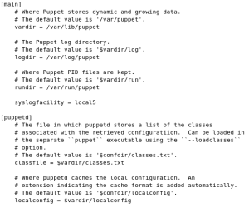

Configuration (contd.)

* Puppet.conf

Configuration (contd.)

* Site.pp

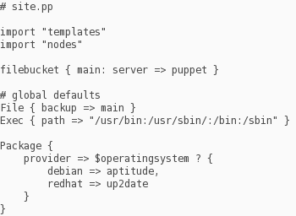

* Verifying Installation
  + - On client, run:
      * Puppet agent --test --server myserver.domain.com --waitforcert 60 --test
    - On server, run:
      * Puppet cert --list
      * Puppet cert --sign myclient.domain.com

Configuration (contd.)

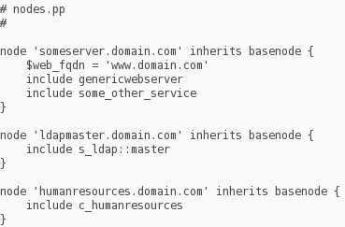

Nodes.pp

Puppet Architecture

* Puppet usually uses an agent/master (client/server) architecture for configuring systems, using the**puppet agent** and **puppet master** applications. It can also run in a self-contained architecture with the**puppet apply** application.
* 2 Stages for Configuration Management
  + Compile a Catalog
  + Apply the Catalog

A catalog is a document that describes the desired system state for one specific computer. It lists all of the resources that need to be managed, as well as any dependencies between those resources.

Puppet Communication and Safety

* Puppet agent nodes and puppet masters communicate via HTTPS with client-verification.
* Client-verified HTTPS means each master or agent must have an identifying SSL certificate, and will examine their counterpart’s certificate to decide whether to allow an exchange of information.
* Puppet includes a built-in certificate authority (CA) for managing certificates. Agents can automatically request certificates via the master’s HTTP API, users can use the **puppet cert** command to inspect requests and sign new certificates, and **agents can then download the signed certificates**.

Puppet Commands

* Puppet agent
* Puppet master
* Puppet cert
* Puppet resource
* Puppet module
* Puppet config
* Puppet help
* Puppet man
* Puppet master and Puppet cert commands doesn’t work on windows.

Relationship Metaparameters

* Before
  + Causes a resource to be applied **before** the target resource.
* Require
  + Causes a resource to be applied **after** the target resource.
* Notify
  + Causes a resource to be applied **before** the target resource. The target resource will refresh if the notifying resource changes.
* Subscribe
  + Causes a resource to be applied **after** the target resource. The subscribing resource will refresh if the target resource changes.

Agent Provided Data

1. Their **name,** which is embedded in the request URL. (e.g. /production/catalog/web01.example.com) This is almost always the same as the [certname](https://docs.puppetlabs.com/puppet/latest/reference/config_important_settings.html).
2. Their **certificate,** which contains their [certname](https://docs.puppetlabs.com/puppet/latest/reference/config_important_settings.html) and possibly some [extra information](https://docs.puppetlabs.com/puppet/latest/reference/ssl_attributes_extensions.html). (This is the one item not used by puppet apply.)
3. Their [**facts.**](https://docs.puppetlabs.com/puppet/latest/reference/lang_facts_and_builtin_vars.html)
4. Their requested [environment](https://docs.puppetlabs.com/puppet/latest/reference/environments.html), which is embedded in the request URL. (e.g./production/catalog/web01.example.com) Before requesting a catalog, agents will ask the master which environment they should be in, but they will use the environment in their own config file if the master doesn’t have an opinion.

What’s new in Puppet Enterprise 3.7?

* Next generation puppet server
  + Faster – performance increased over 3x
  + Built on JVM stack
* Puppet Node manager
  + Classify and manage infrastructure based on its job, rather than identity.
* Role-Based Access Control
  + Granular role-based access control for delegation of management capabilities across teams and individuals
* Puppet Server Reporting
  + A profiler and metrics service tracks key metrics associated with puppet server health & performance
* Puppet Language Updates
  + Major enhancements to the Puppet Language that make it easier to write and maintain Puppet code.
* **What are Provider?**
  + Providers implement the same resource type on different kinds of systems. They usually do this by calling out to external commands. Although Puppet will automatically select an appropriate default provider, you can override the default with the provider attribute. (For example, package resources on Red Hat systems default to the yum provider, but you can specify provider => gem to install Ruby libraries with the gem command.)
* Creating custom modules
  + Puppet module generate <author-name>/<module-name>