VPC Creation:
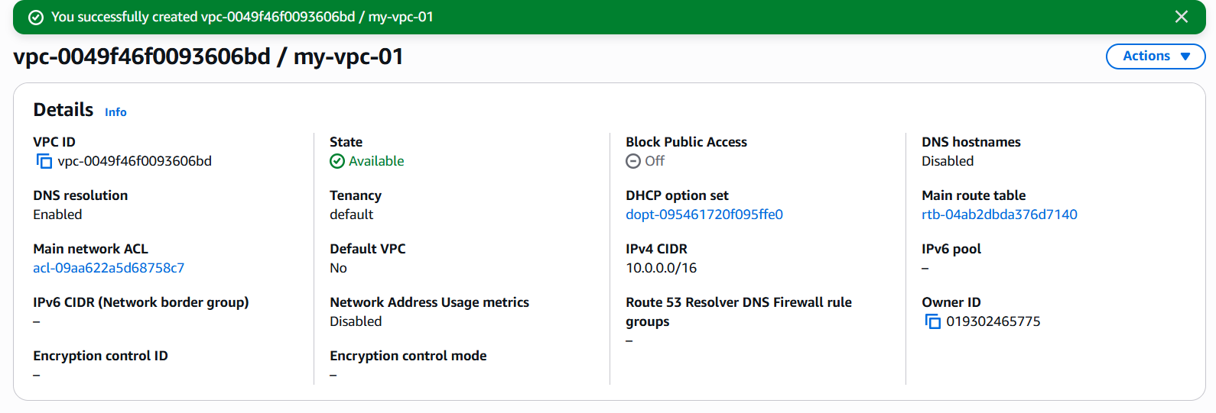
Public Subnet:
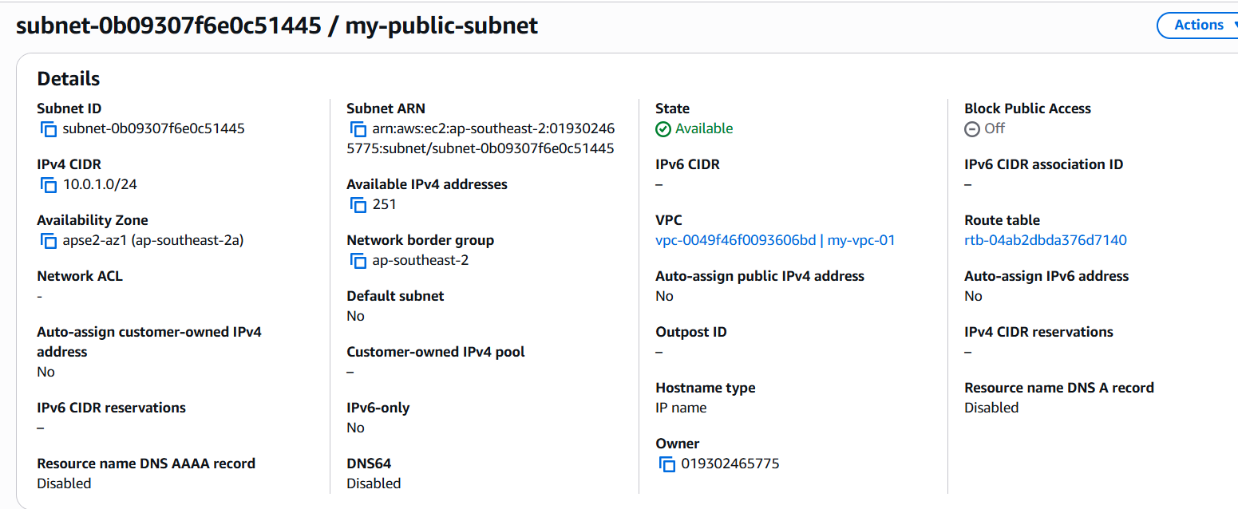

Private Subnet:
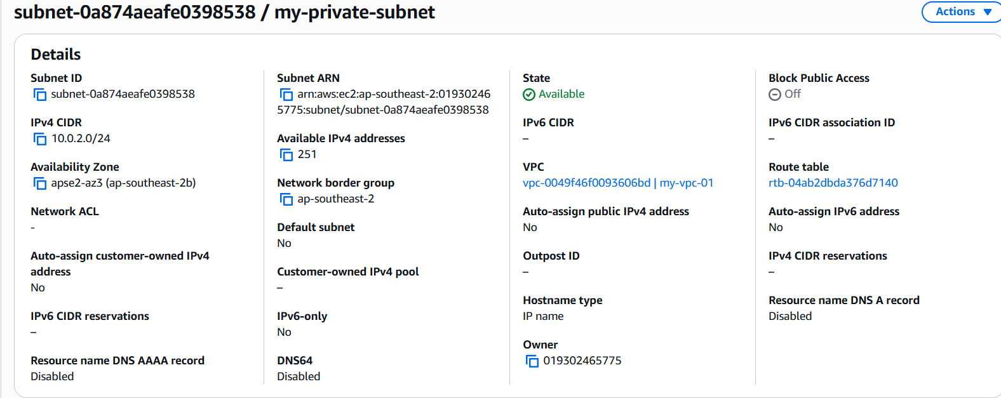

Internet gateway created and attached to VPC
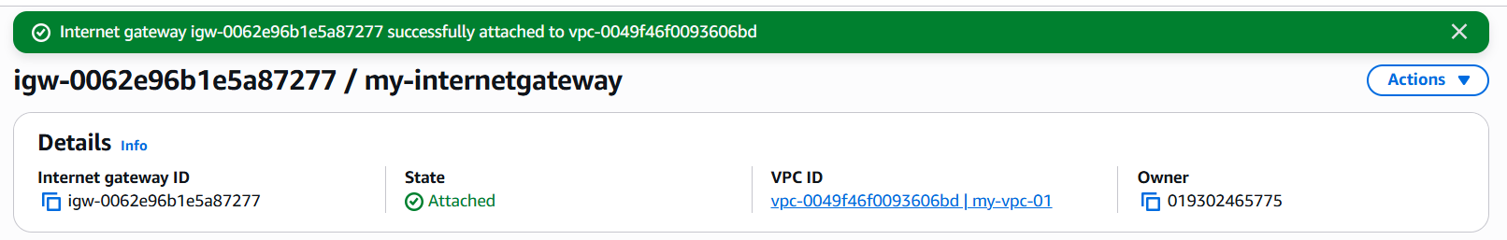

Route Table for public subnet created and added internet gateway
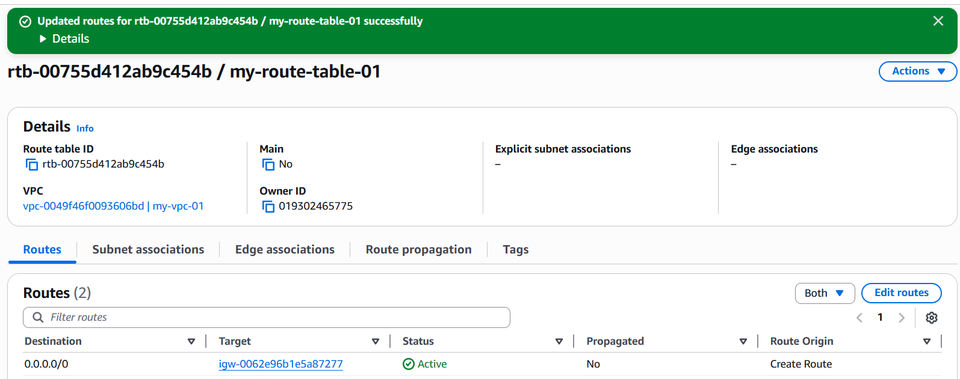
Created Security group
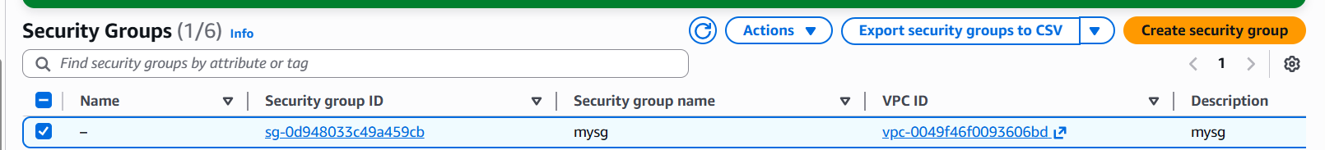

launch a Linux EC2 instance by using the above VPC and public subnet.
