Create a simple script file and push it to repo. Create a project in Jenkins connected to your GitHub repository. When a commit is made to your repo, automatically build must get triggered from Jenkins and the output must be shared to me via email.

Py script created pushed to github.

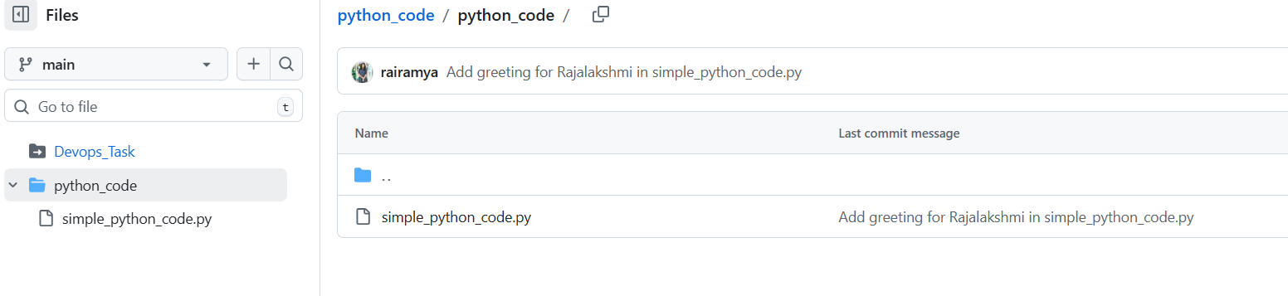
Webhook added in github:
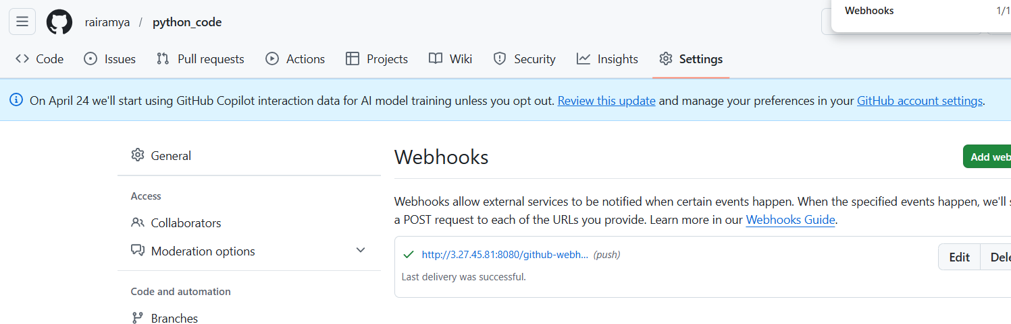

Committed simple changes in the repo:
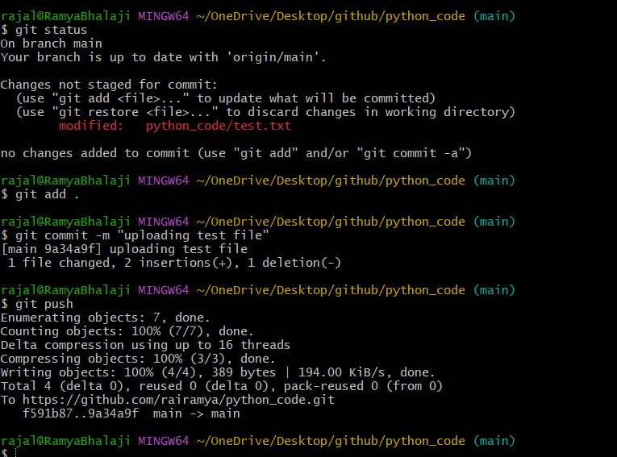

After commit build created automatically in Jenkins:
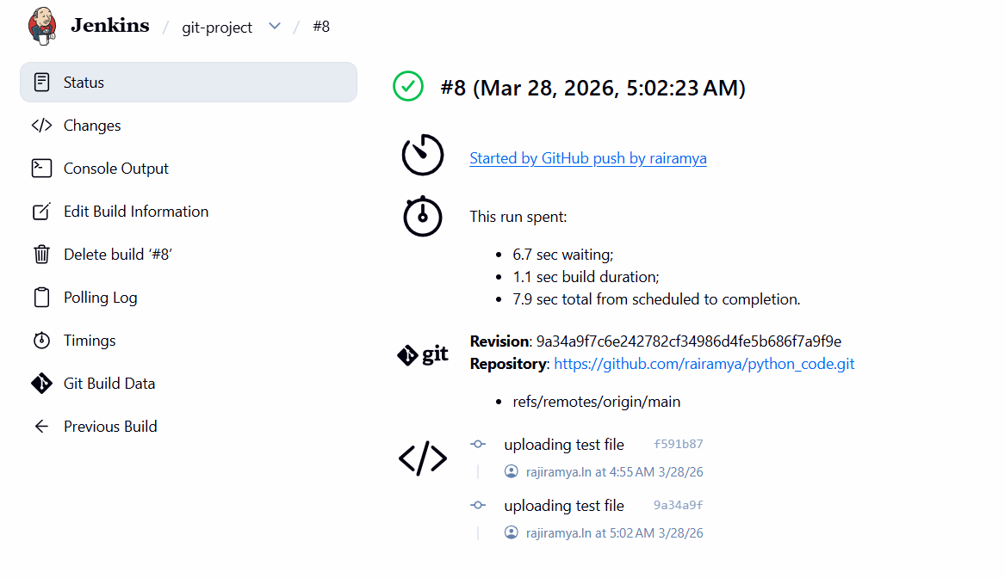

Console output:
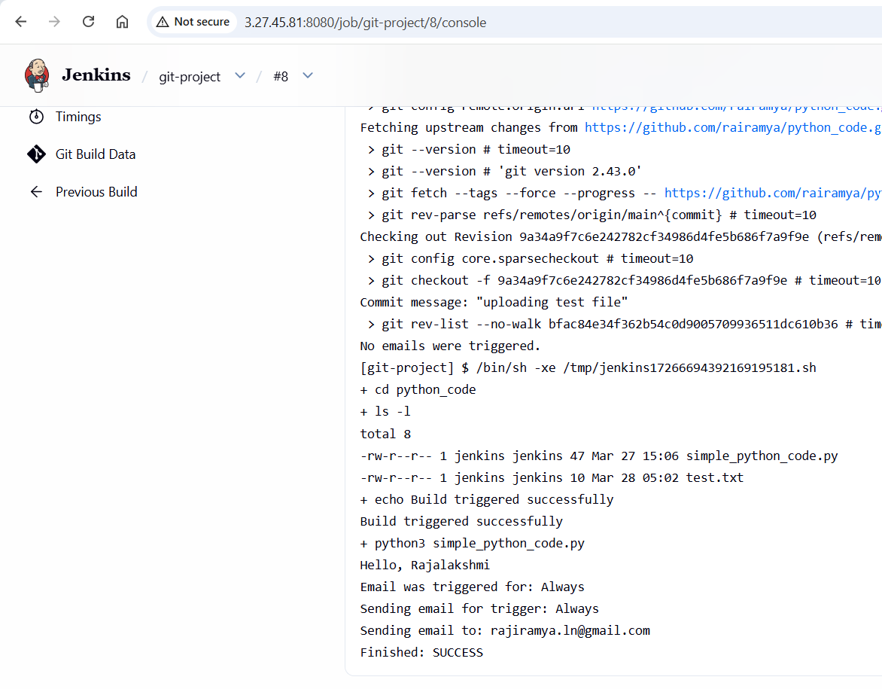

Email received on my account:
