Create 2 EC2 instances on 2 different regions and install nginx using terraform

terraform successfully initialized
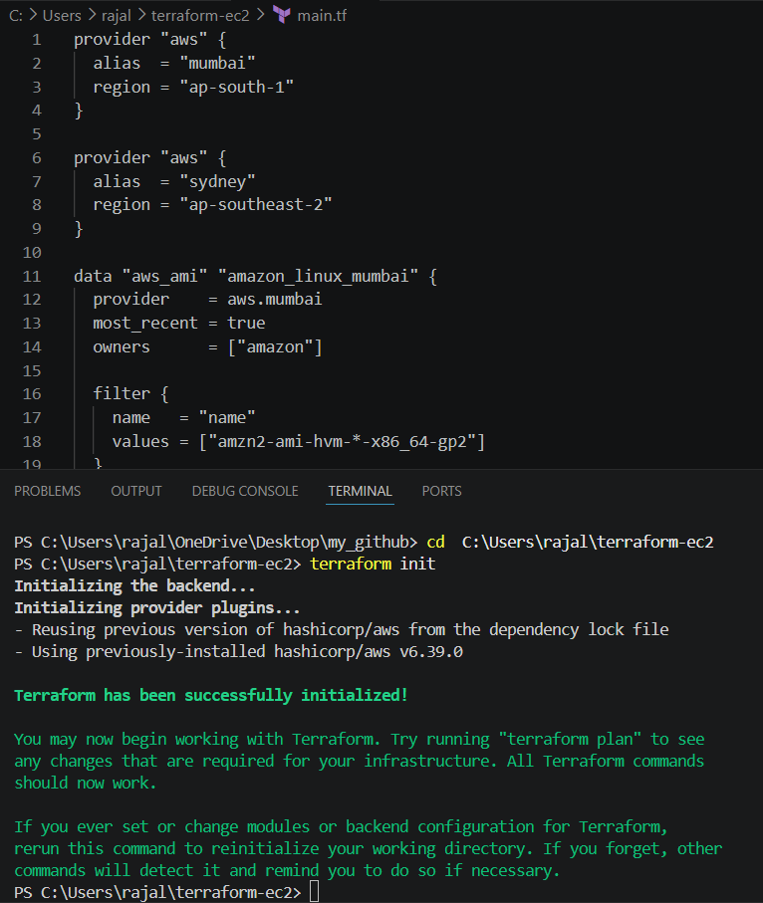

Terraform apply completed
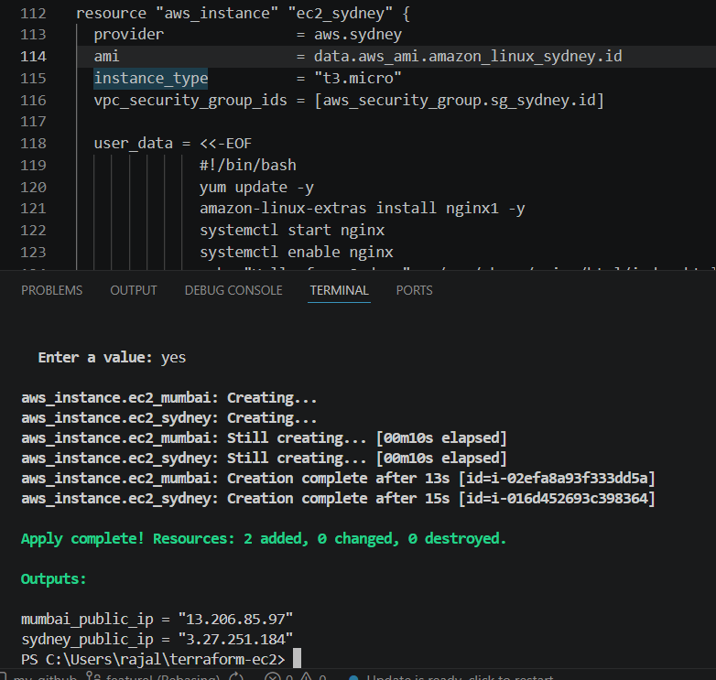
2 Instances created
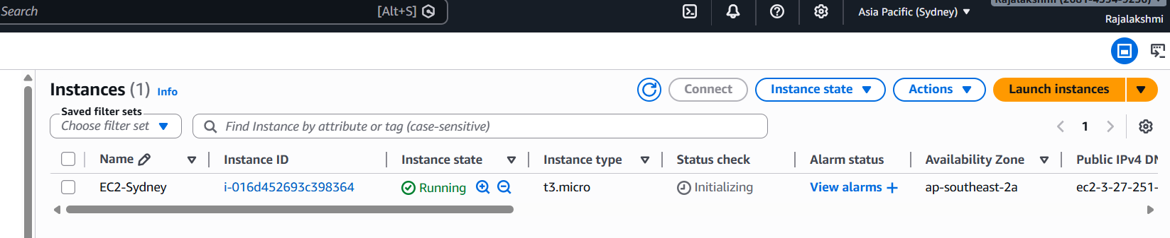

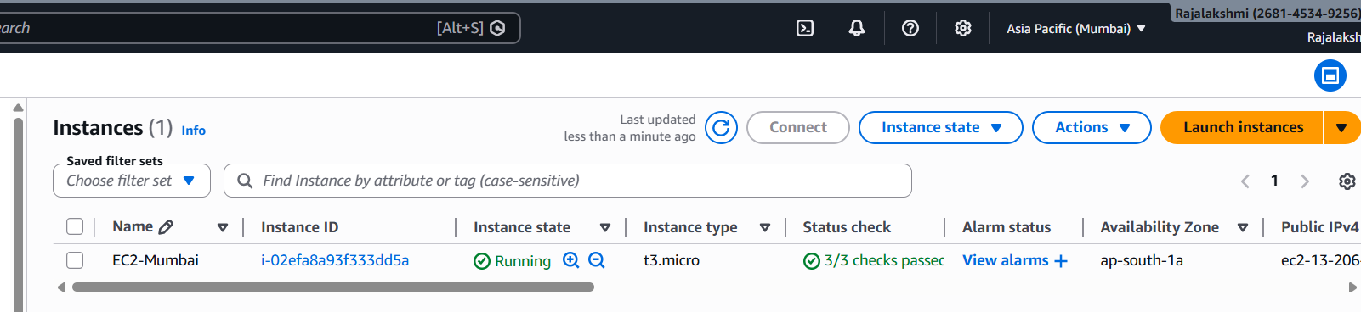

Nginx installed on both instance:



