Get me the IP address of a particular domain (guvi.in) nslookup guvi.in
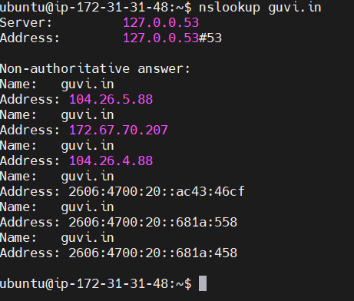

How do I find my CPU/memory usage of my server?
top
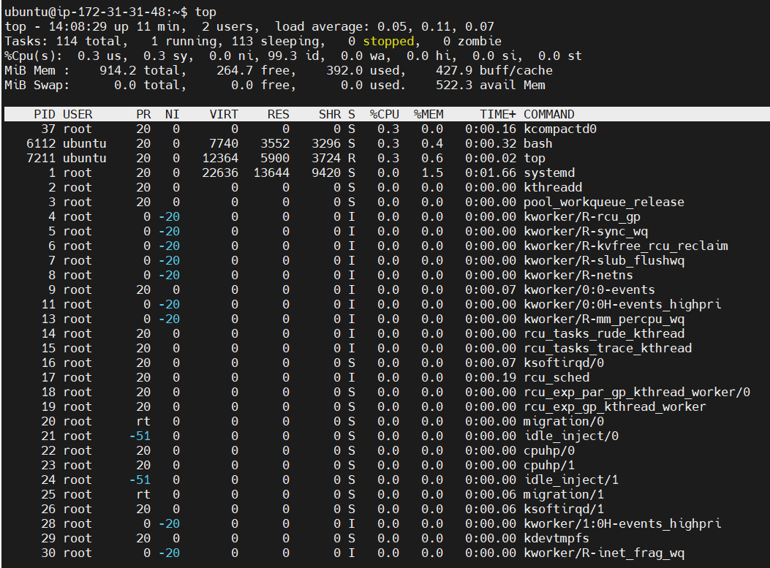

Test the connectivity between 2 nodes?
ping IP addr
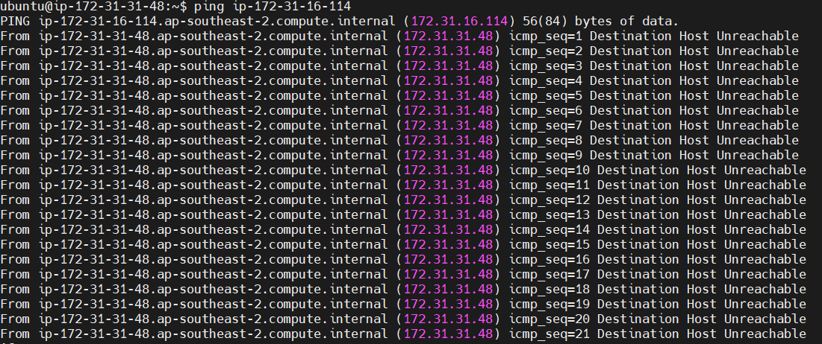

I have deployed an application in guvi.com:9000, and logs show my app is running, but I’m unable to view the page. Check whether my port is open or not ?
netstat -tuln
netstat -tuln | grep 9000
