Launch jenkins and explore creating projects and users.
Installation:
VM for Jenkin server:
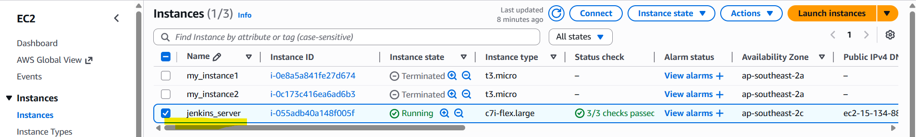

Java Installation on VM:
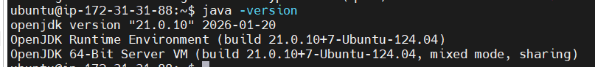

Jenkins set up is completed:
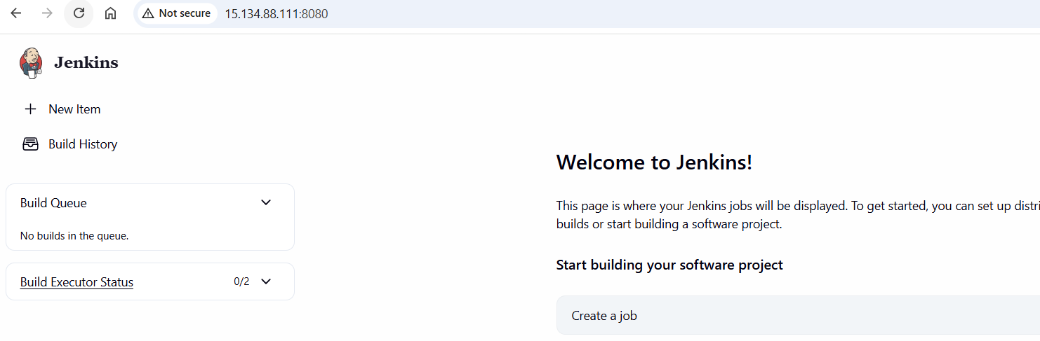

Success Build:
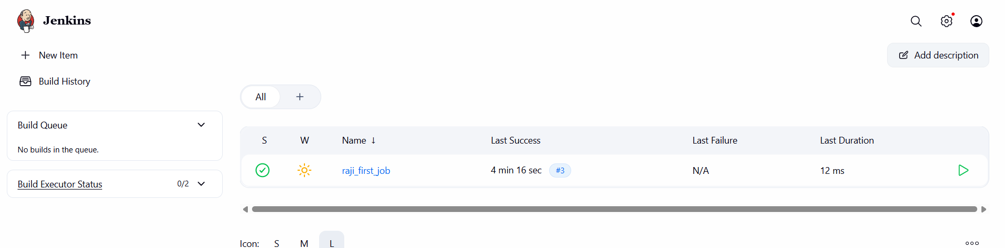
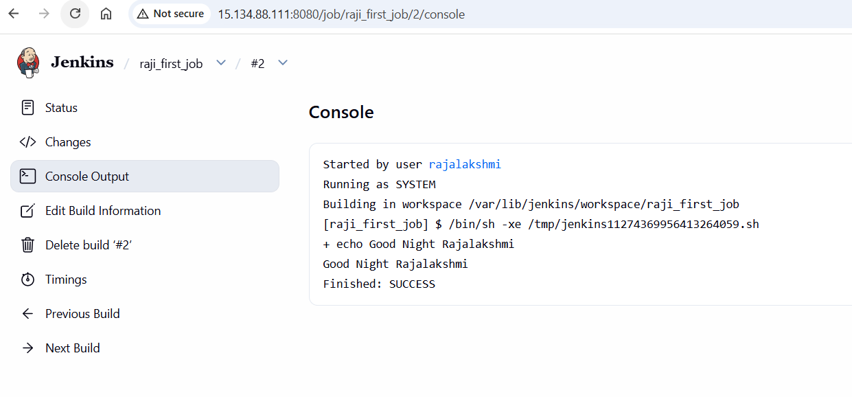

Build success Git cloned to Jenkins server
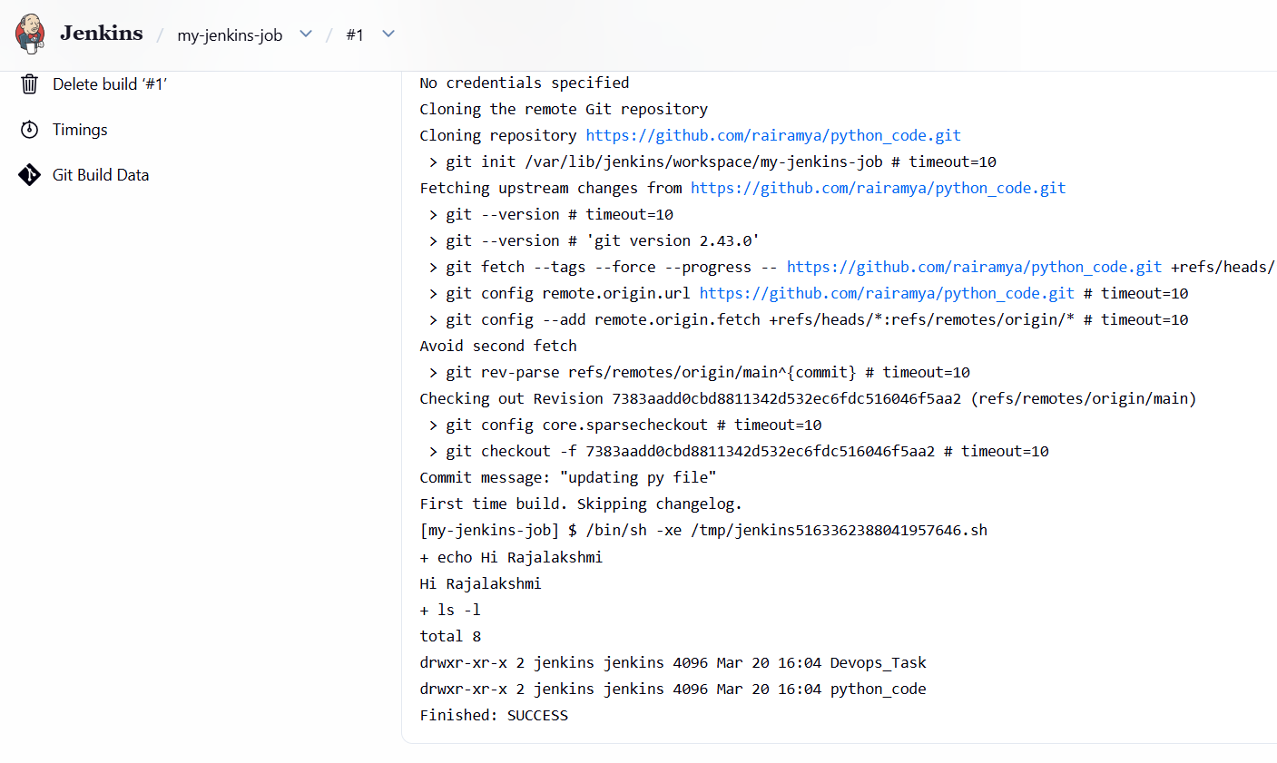
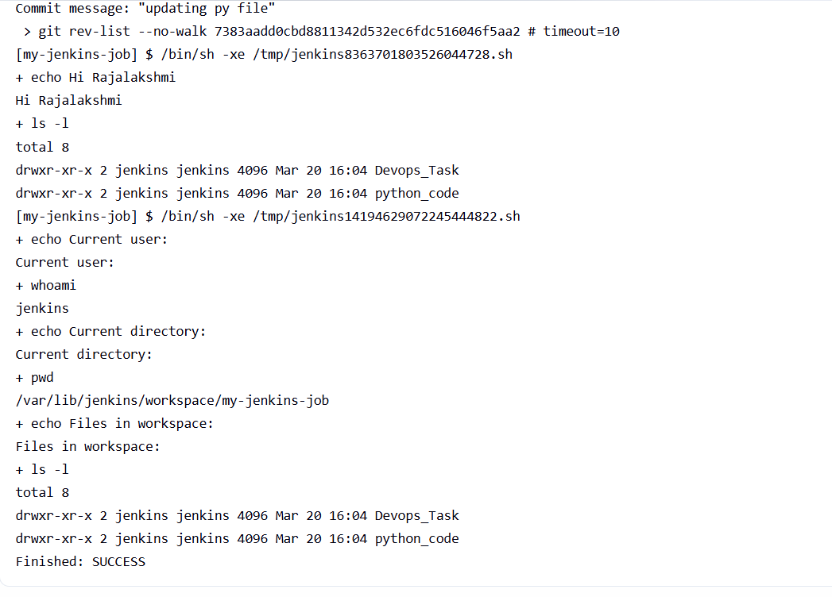
Listing my jobs in VM:
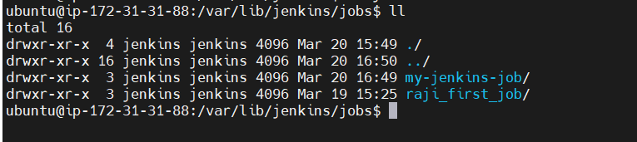
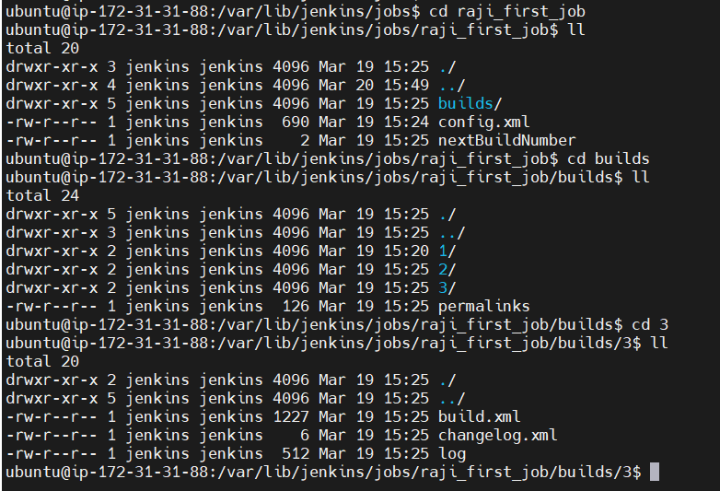

Executing Git py script from jenkin:
