Establish a new directory, populate it with script files, initiate an empty repository on GitHub, convert the local directory into a Git repository, and link it to GitHub for pushing the code into the repository
github local directory created:

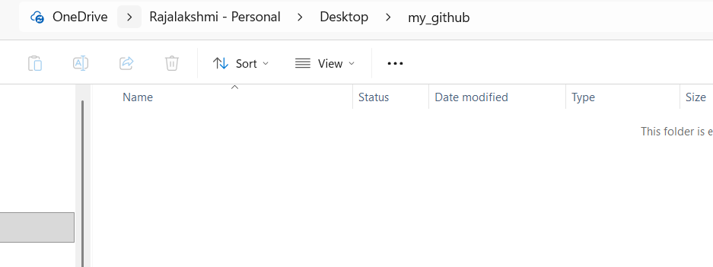
Git clone:
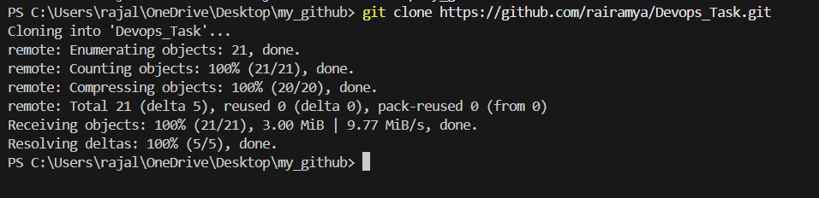

Committing the code into the repository:
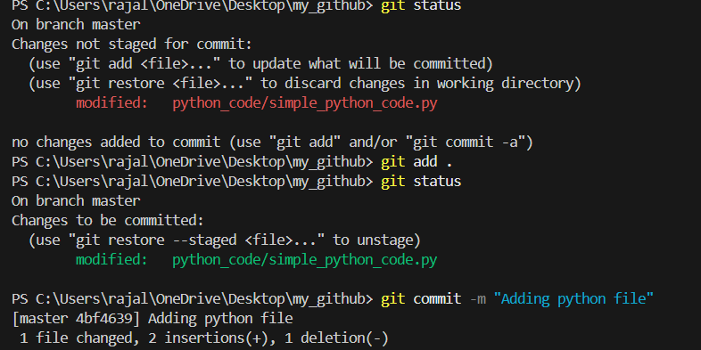
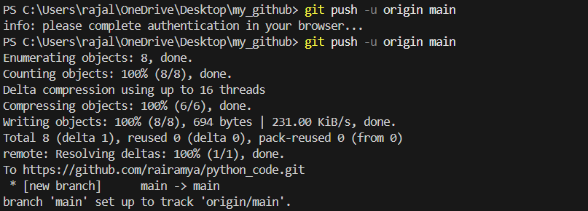
GitHub
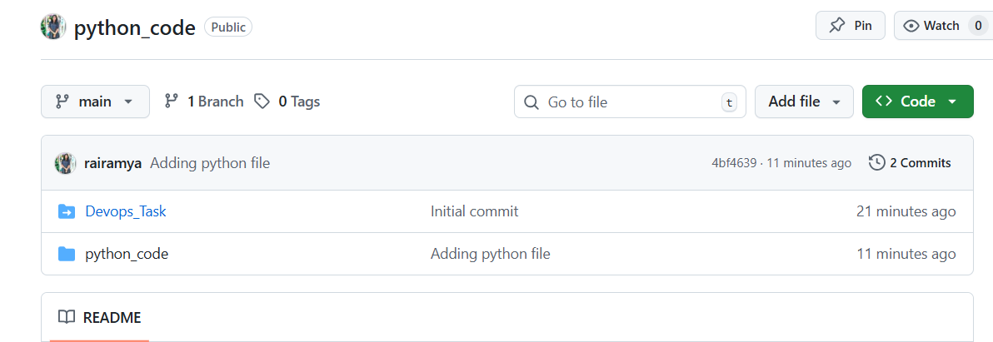
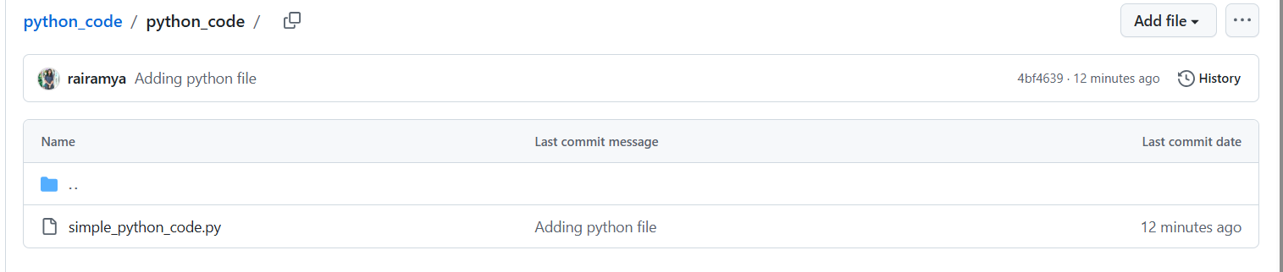
Creating new branch:
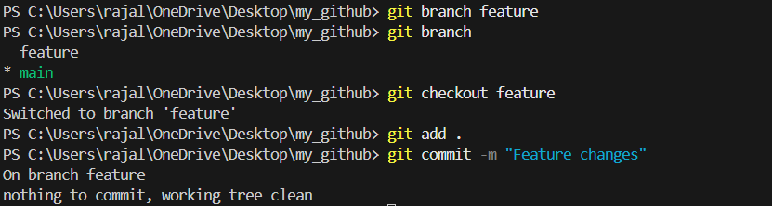
Merging branch:
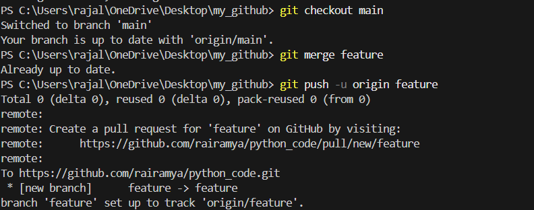
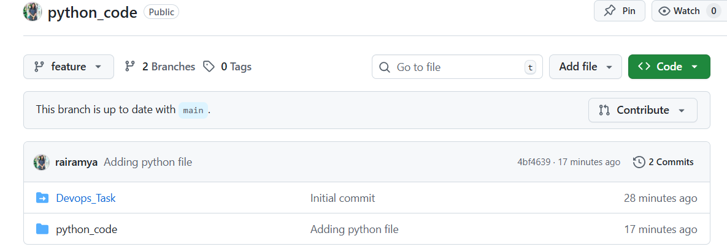

Git rebase:

Modified py file in main branch
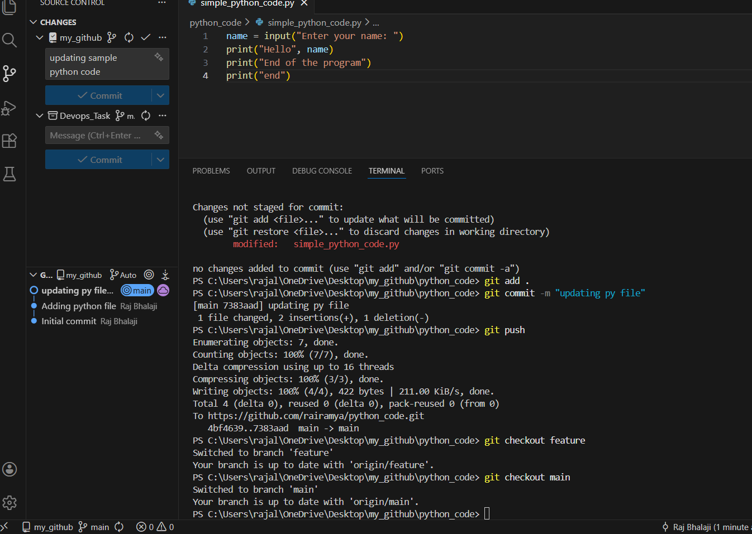

Modified py file in feature branch:
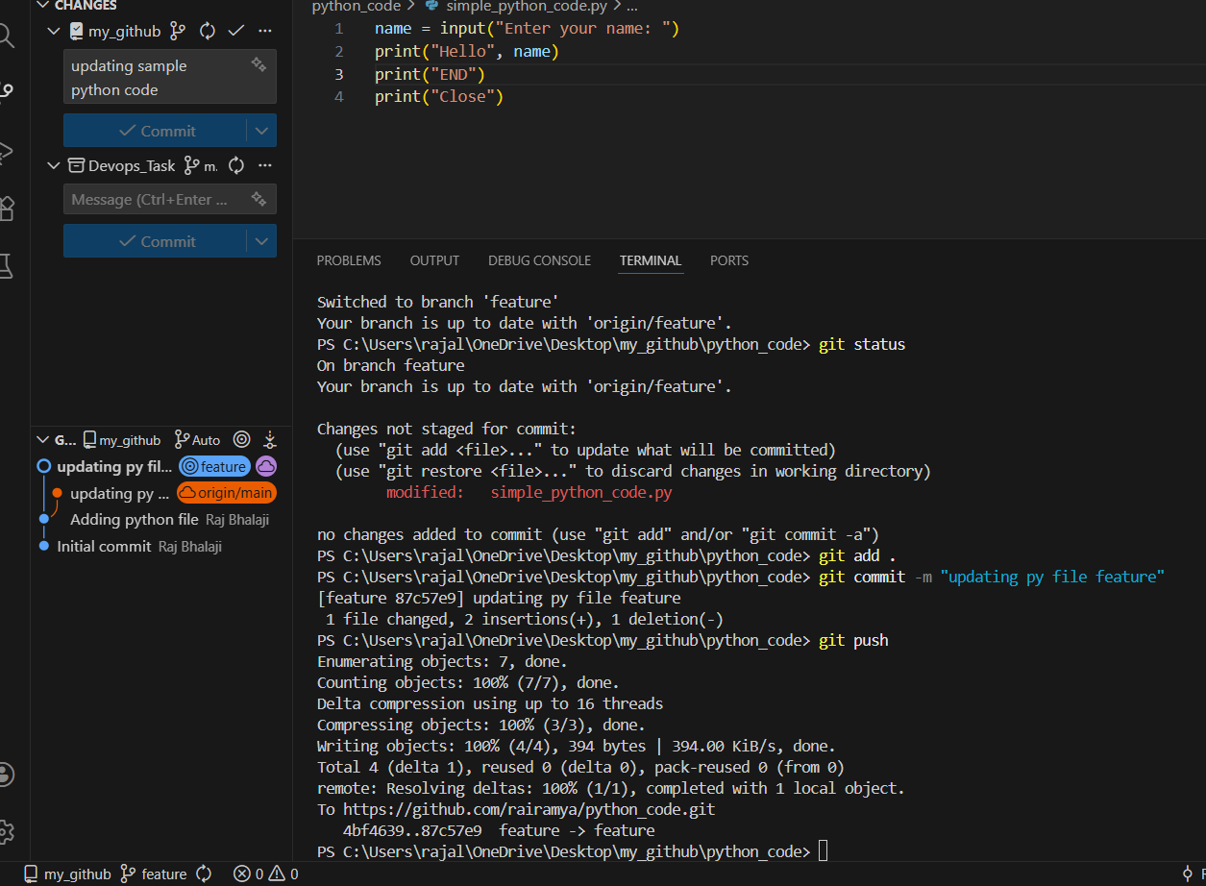
Conflict:
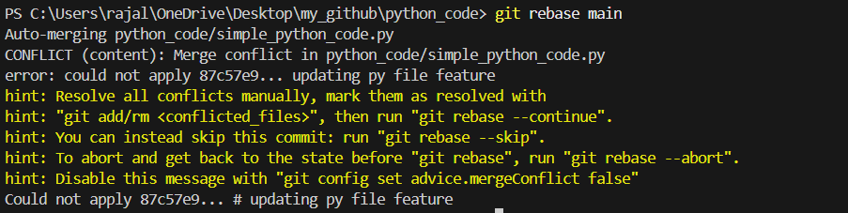
Fixed conflict:
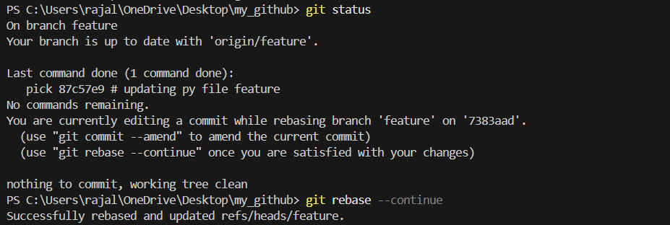

Git stash:
