Launch Linux EC2 instances in two regions using a single Terraform file.
Installed Terraform and Aws CLI
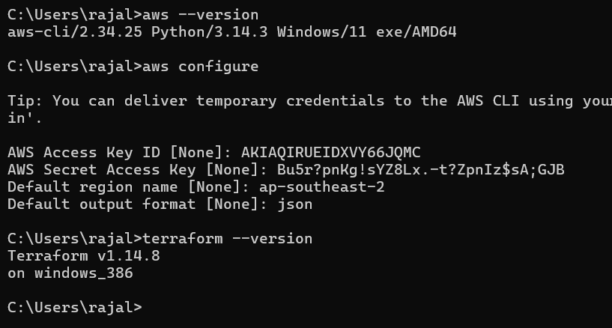

Added terraform code
Initialize terraform
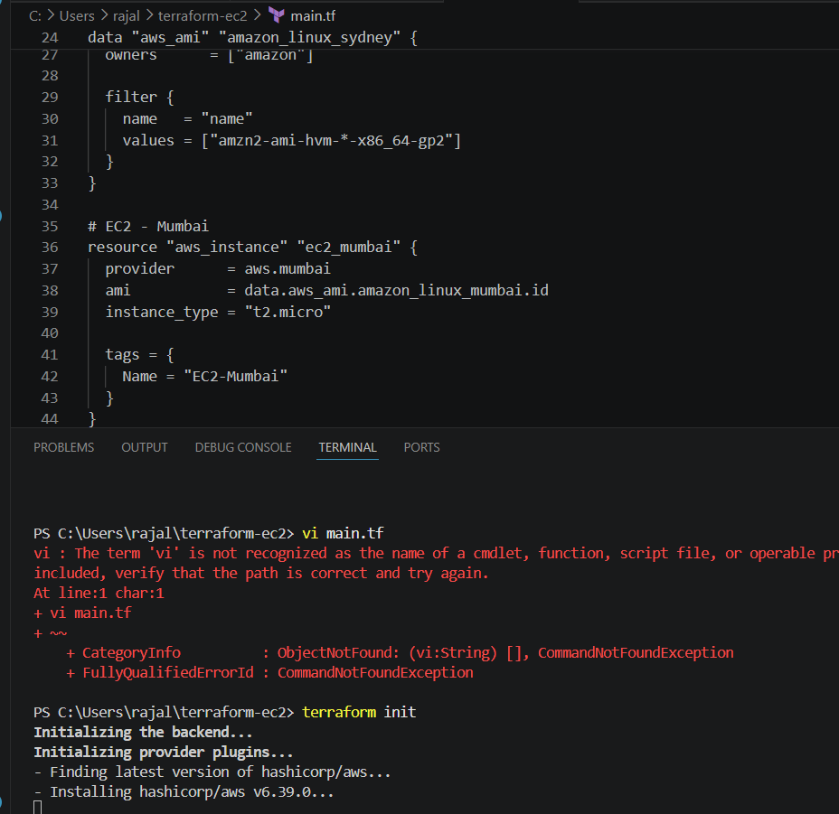
terraform successfully initialized
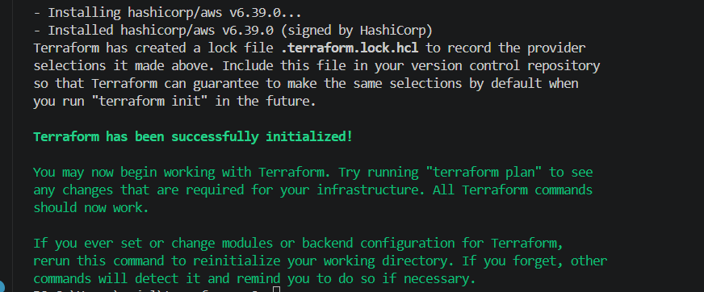
Creating EC2 instance in different region
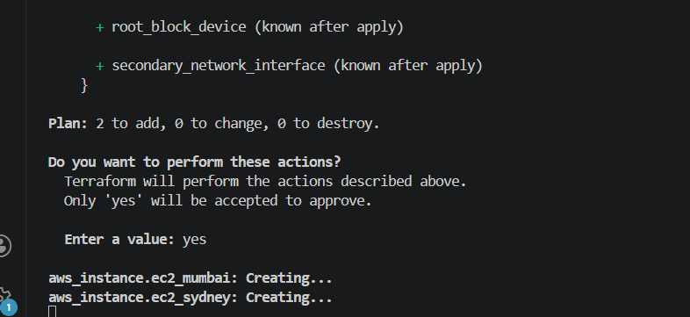

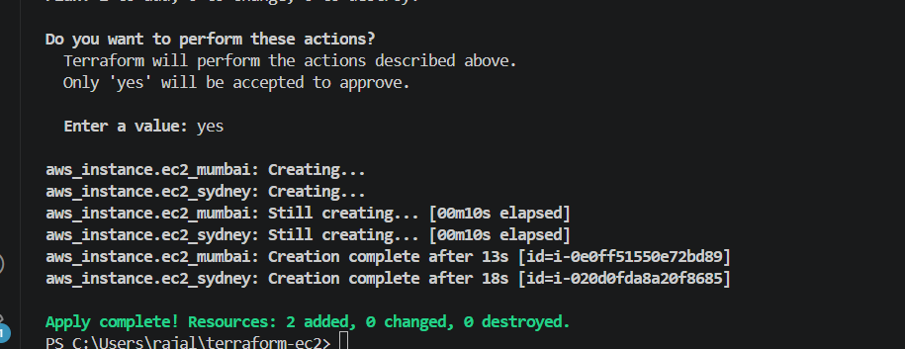
ap-south-1
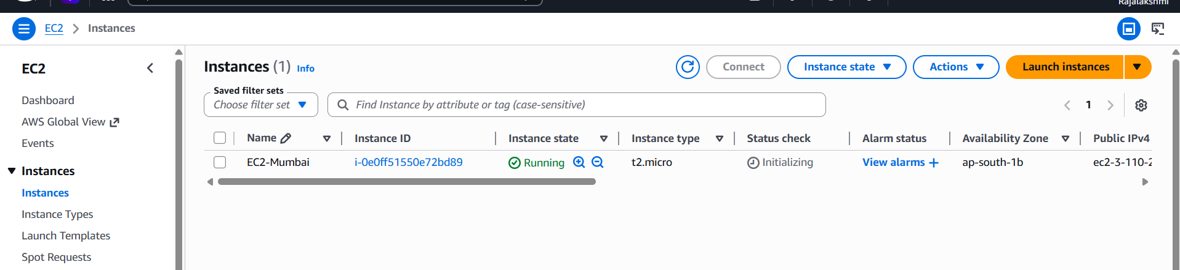

ap-southeast-2
