Create the K8s EKS,further you have to do the deployment of the Nginx application and access the application outside the cluster.
Installed Kubectl and awscli
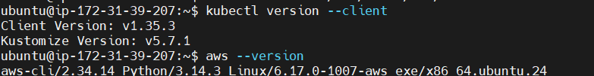

AWS configure:
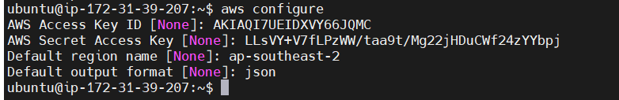

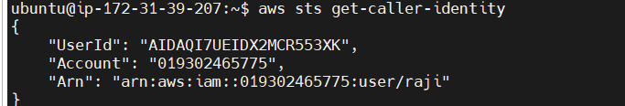
Cluster Created:
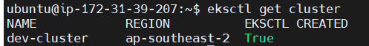
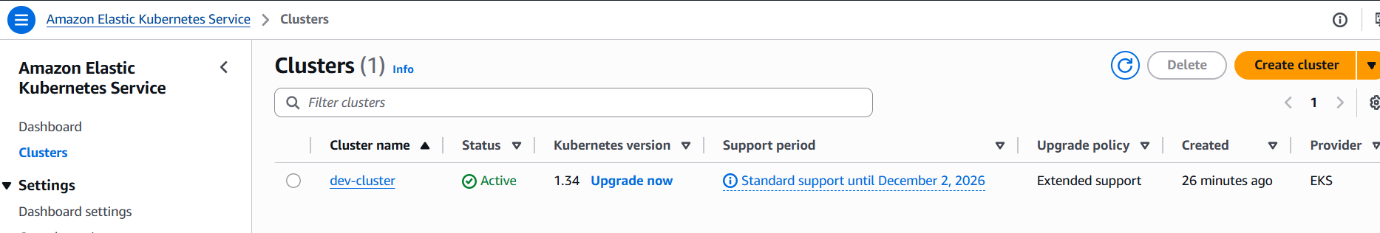
Connect to aws cluster:
Nodes:
Deployment:
Pod:

Expose application

access the application outside the cluster.
