Create a custom docker image for nginx and deploy it using docker compose, where the volume bind mount should be at /var/opt/nginx location. Push the created custom docker image to your docker-hub.

Docker File:
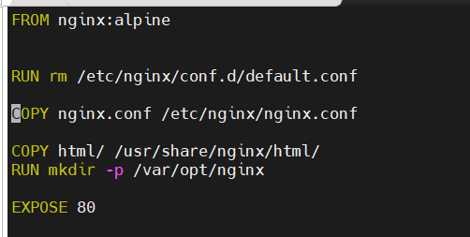

Docker Compose yml:
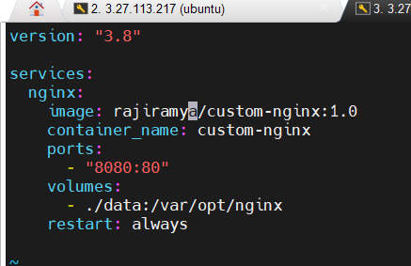

Container Creation
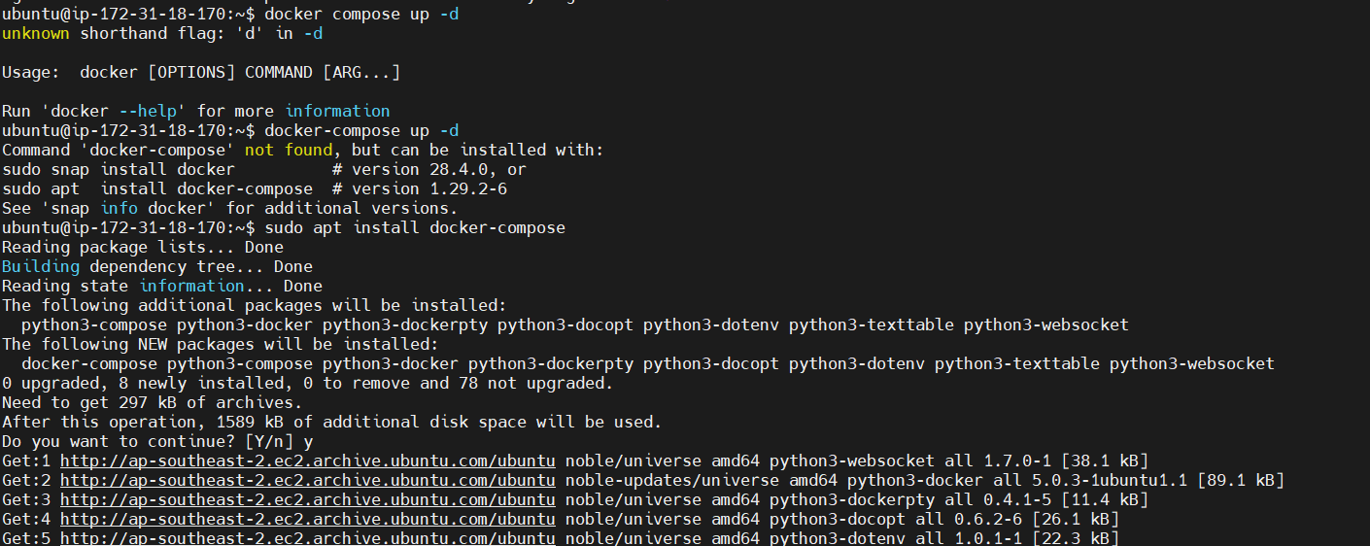
Index.html file:


Verify Docker Containers:
Verify Mounts:
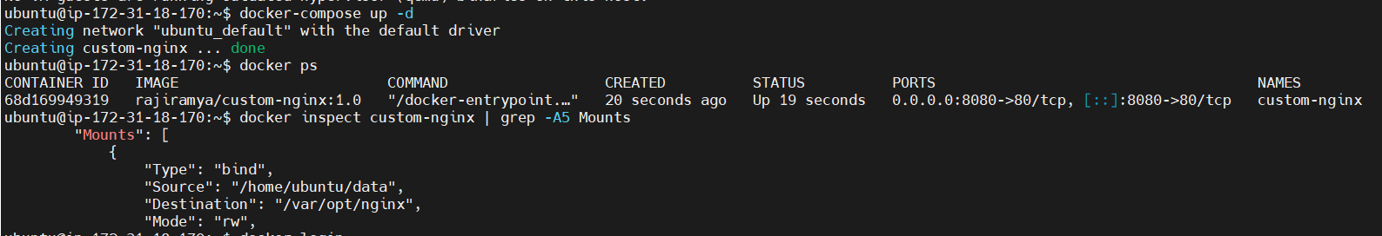

Docker Login:
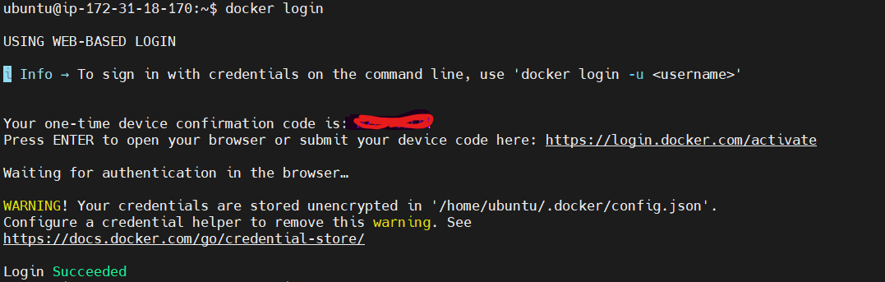
Push the created custom docker image to your docker-hub
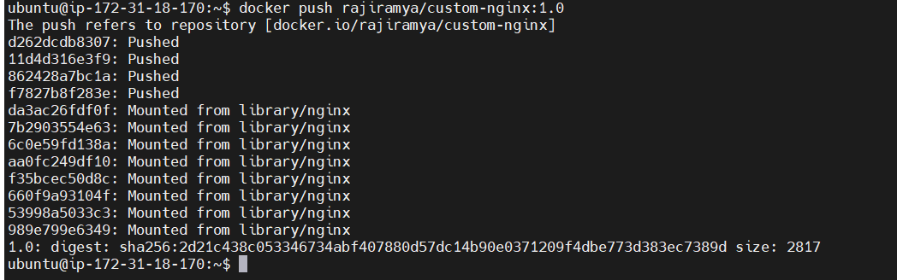

My docker Hub:
