Create a S3 bucket, with no public access and upload files to the bucket & view the logs using cloudwatch for the uploaded files.

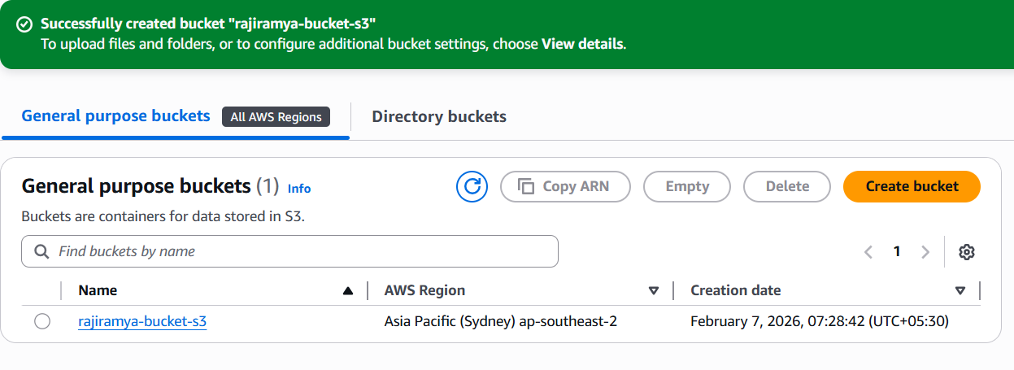

upload files to the bucket
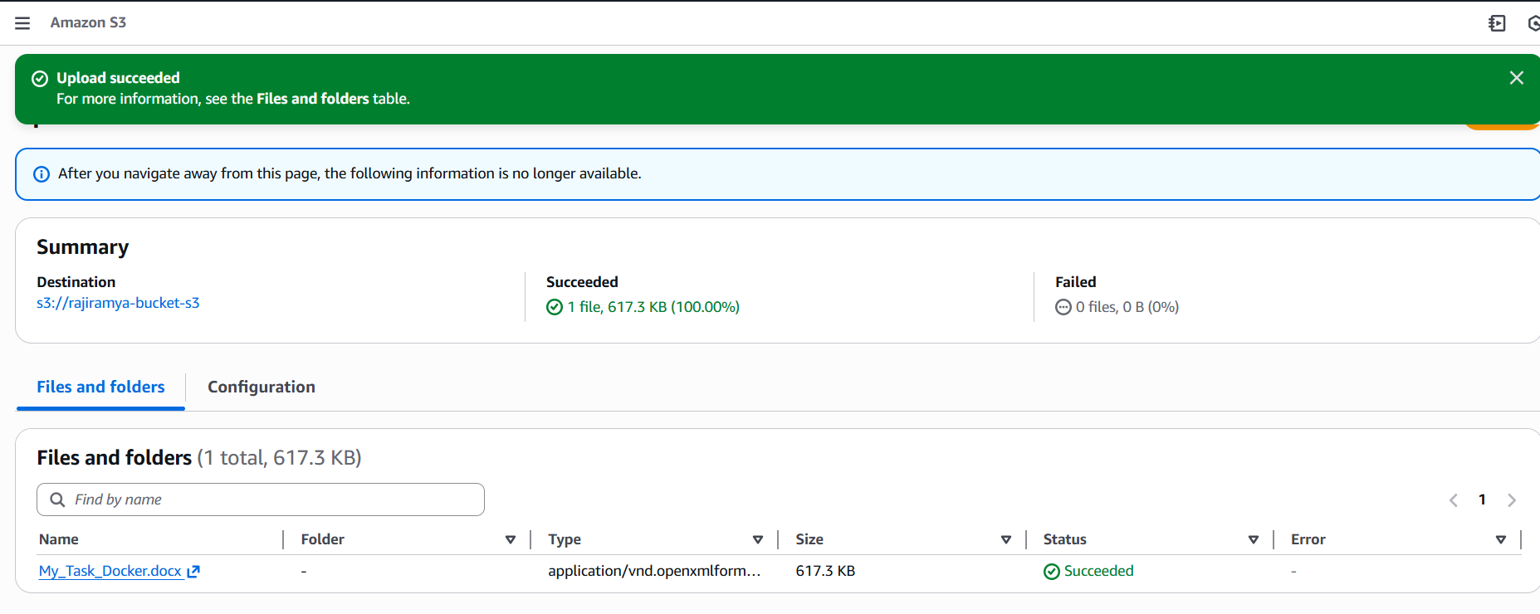

Cloud trail:
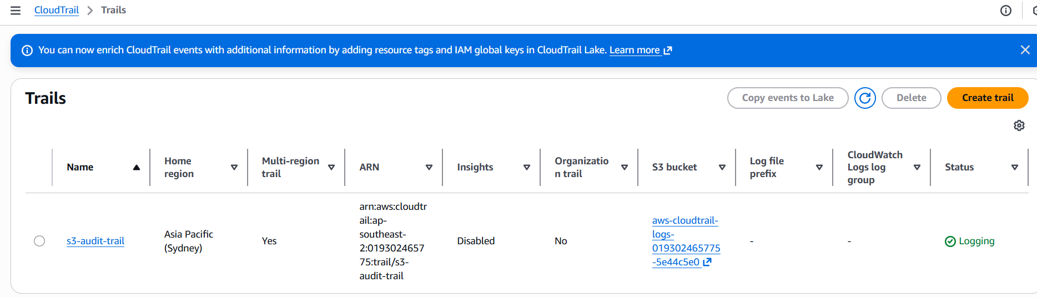
We can check the logs in cloud watch:

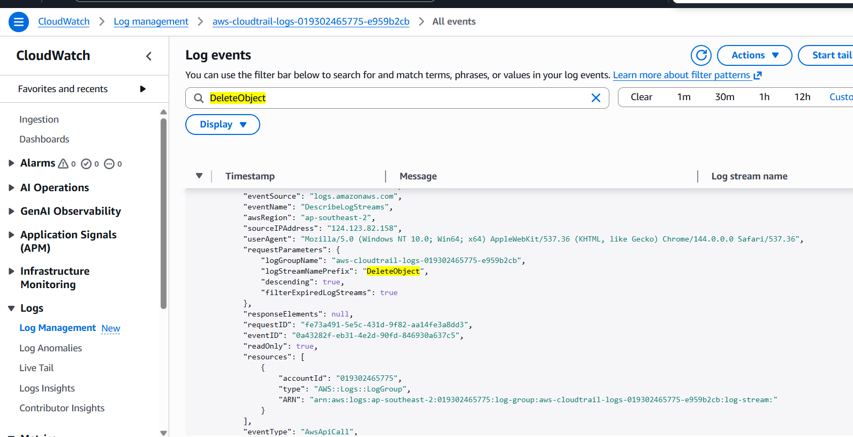

Launch two ec2-instances and connect it to a application load balancer, where the output traffic from the server must be an load balancer IP address

Launch two ec2-instances

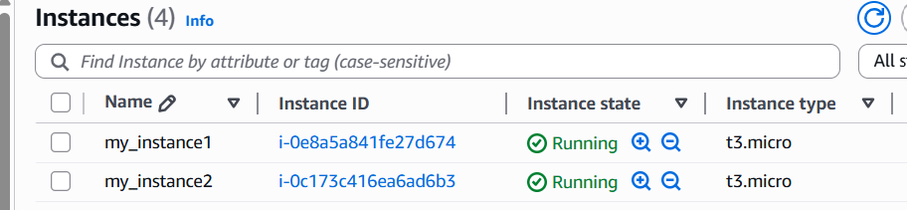
Application Load balancer
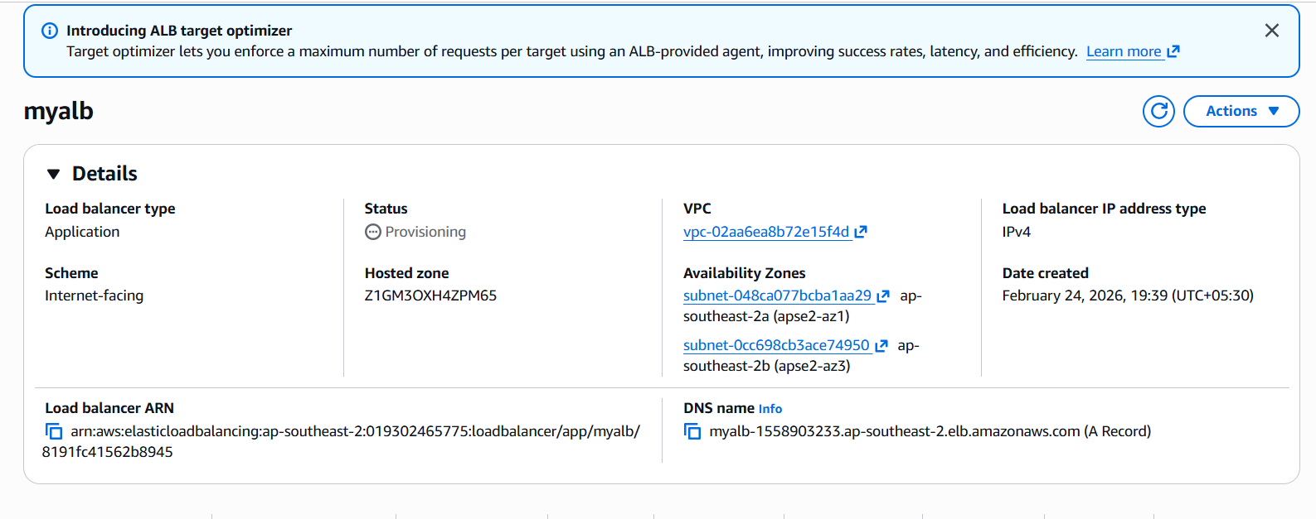
Intance2:
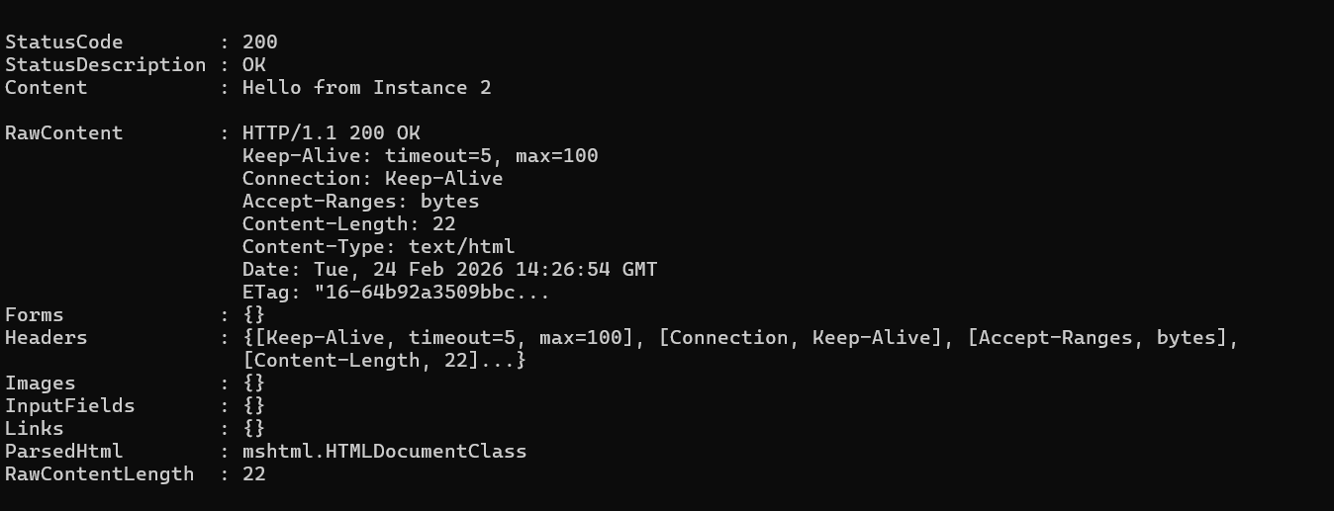
instance 2:
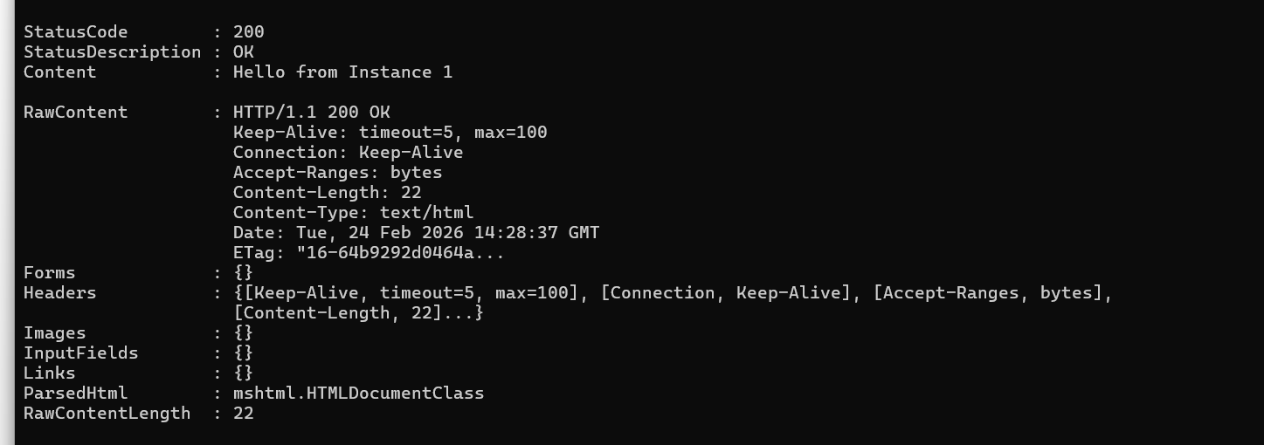

output traffic from the server must be an load balancer IP address

ALB DNS:

Configured two EC2 instances behind an Application Load Balancer. Verified load balancing by observing alternating responses and validated security by restricting direct instance access.
