Install docker on EC2
New server for docker
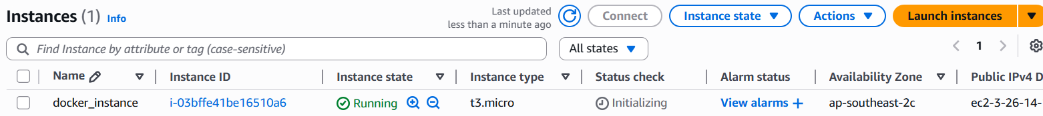
Installing Docker
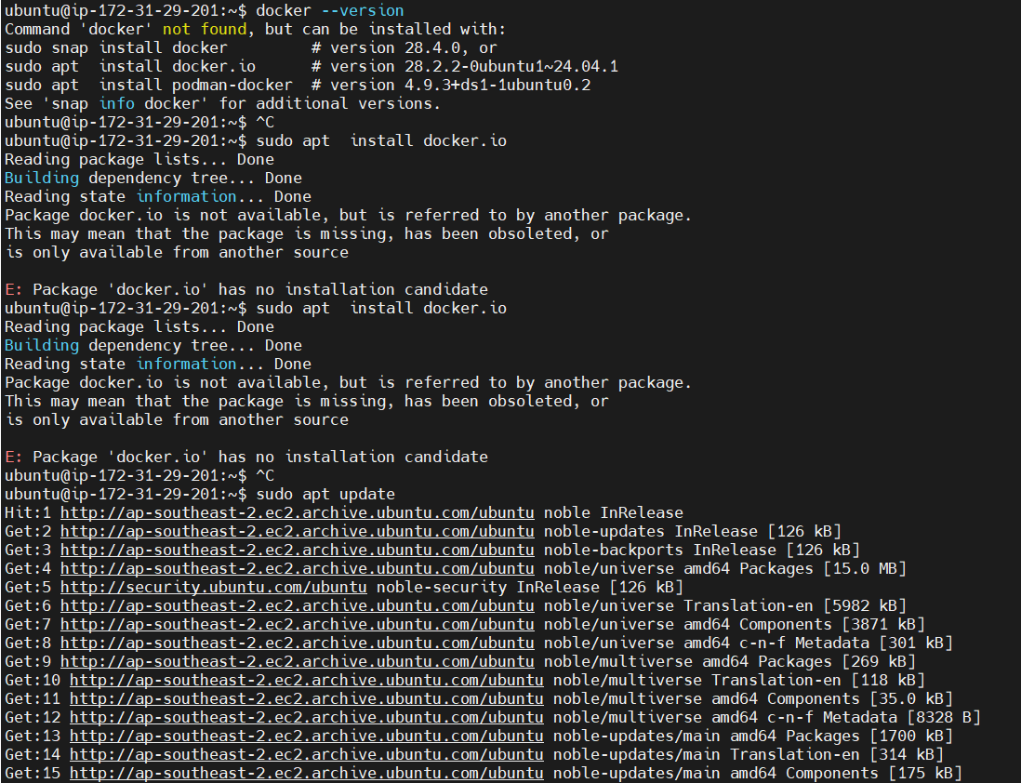

Docker installed after update package list
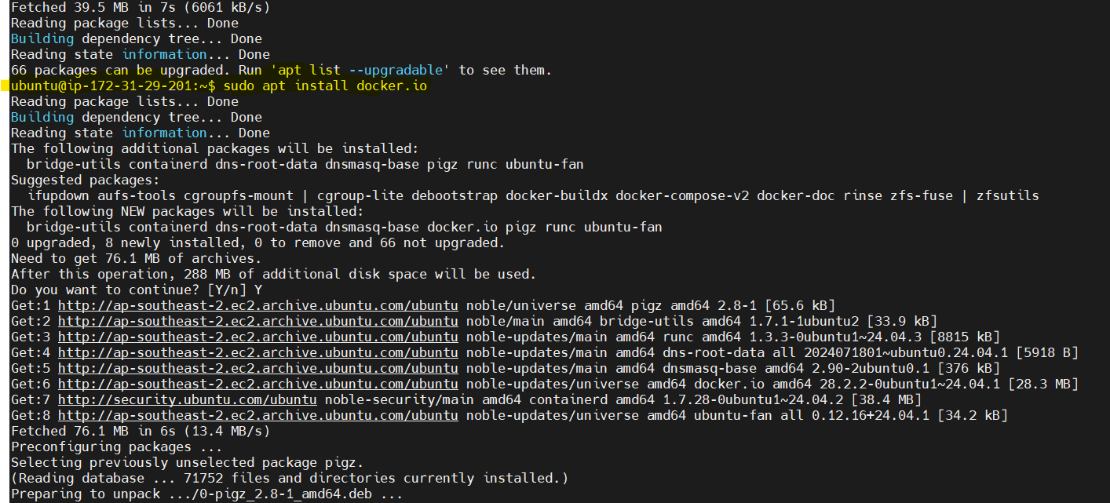

Docker Version:
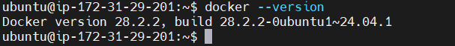

Verifying Docker is running or not:
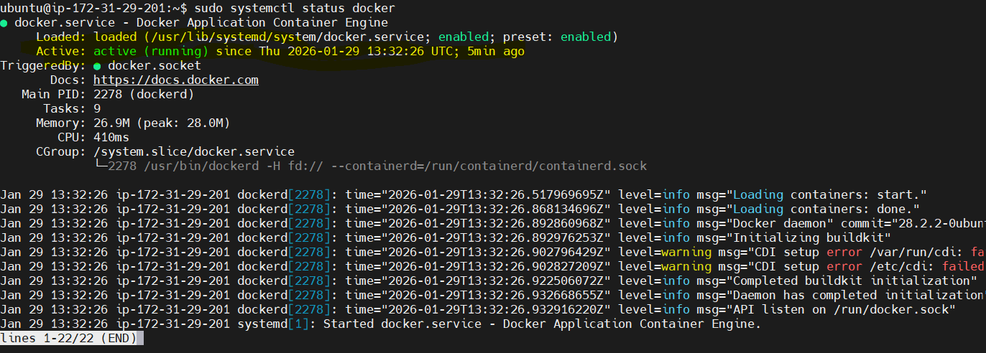

Docker Command to check images:
Permission denied so tried with sudo.no images found
Another way we need to add the ubuntu user to docker docker group
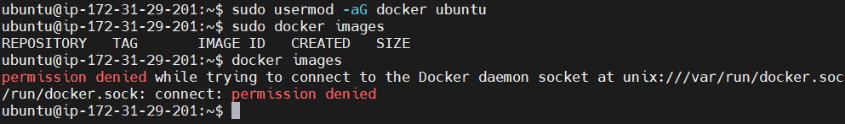
But still am getting permission denied error so going to relogging and run the docker image cmd.
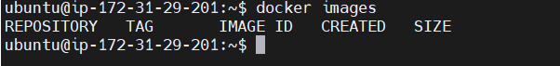
Downloading docker image:
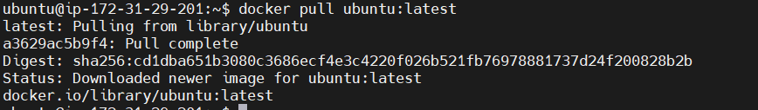
Now one image is available
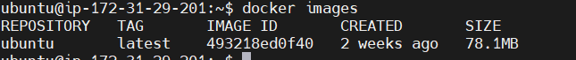
Run the docker image:
Now inside of the new container
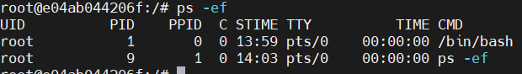
List the running containers on my server:
Stop the container & verify whether it stopped:
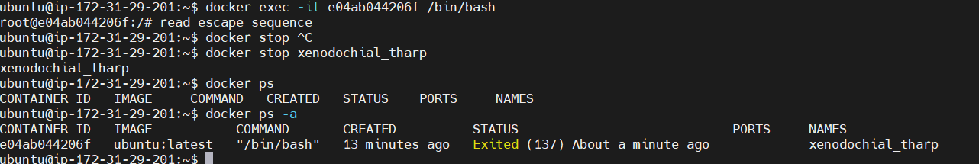

Restart the container
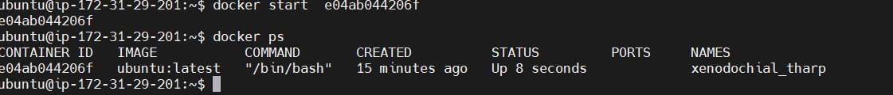

To remove the container:
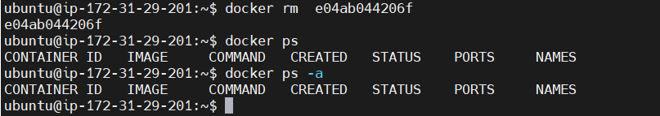

NOTE:
Volume and Network still not covered

