Setup minikube at your local and explore creating namespaces (Go through official documentation).

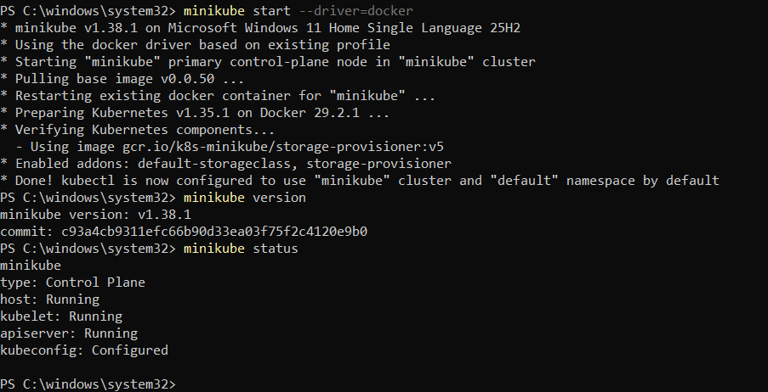
Nodes:
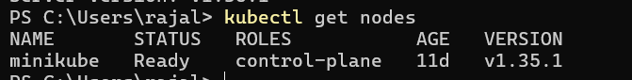

Pod:
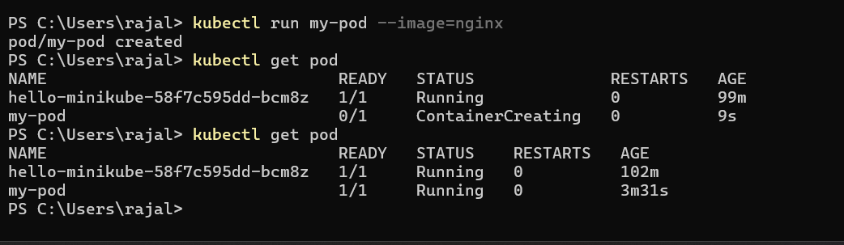

Deployment:
To check existing namespace:
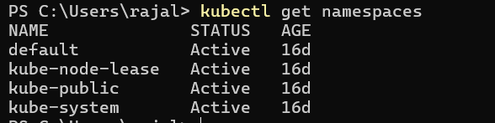
Creation of new namespace:
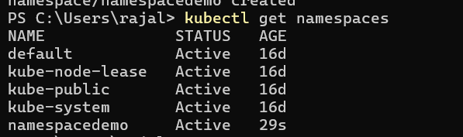

Deploy a Pod Inside a Namespace:
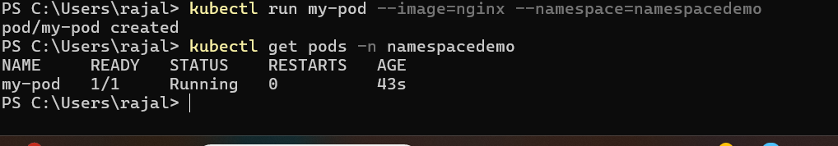

Delete Namespace:

