Create a dockerfile, docker-compose file which when executed must display your basic details in the website.
Taks Explanation:
In my task, I tried accessing the Amazon website using Selenium and Python.
Selenium runs in headless mode, and I captured the output as a screenshot and saved it in my folder.
My Docker File:
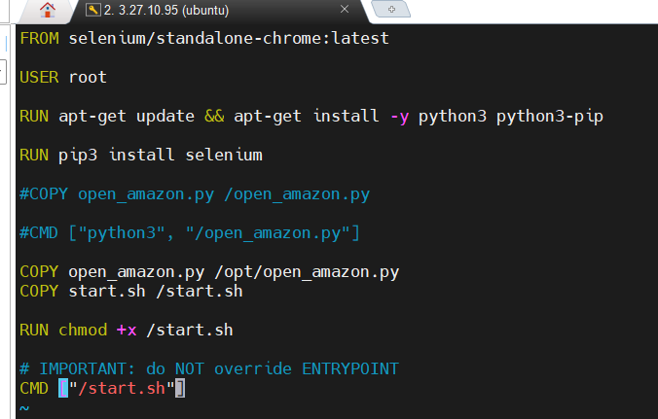

Docker Compose File:
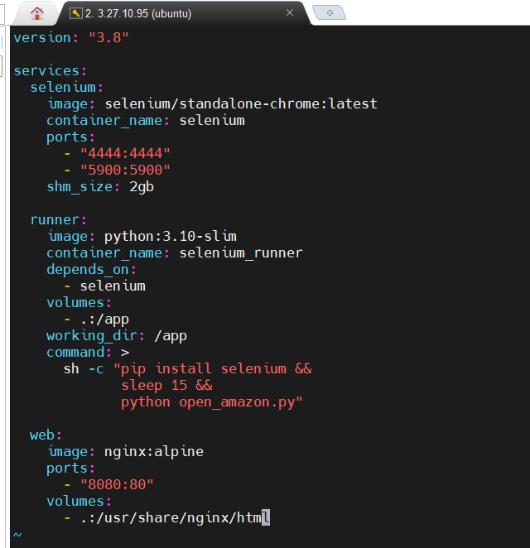

My python file:

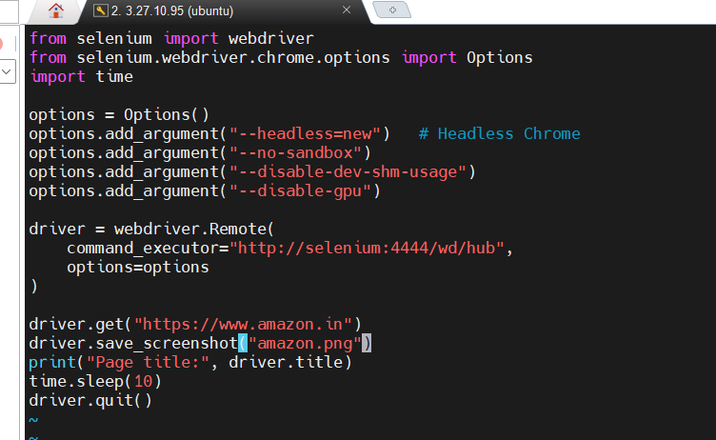
Output:

