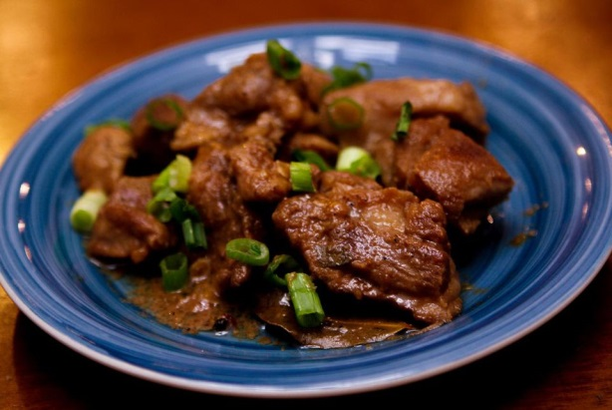

1. Adobo

No list of Filipino food would be complete without adobo. A ubiquitous dish in every household in the Philippines, it's Mexican in origin. But Filipinos found that cooking meat (often chicken and pork) in vinegar, salt, garlic, pepper, soy sauce and other spices was a practical way to preserve it without refrigeration. This cooking style can be applied to different meats or even seafood.

It's best sample it in a Filipino home, but the garlicky version of the lamb adobo can be found at Abe restaurant in Taguig.

[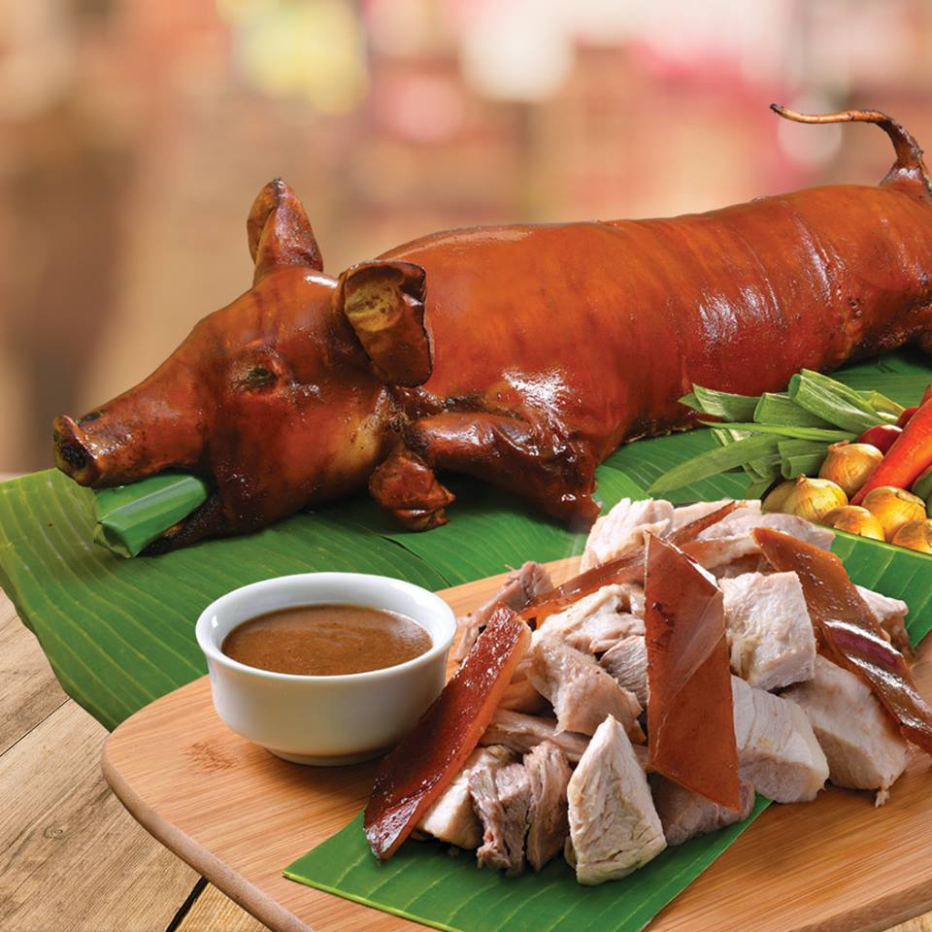](http://www.google.com.ph/url?sa=i&rct=j&q=&esrc=s&frm=1&source=images&cd=&cad=rja&uact=8&ved=2ahUKEwj1xO7Ch-3ZAhUDJZQKHah9BLkQjRx6BAgAEAU&url=http://store.lydiaslechon.ph/product/whole-lechon/&psig=AOvVaw2XCA2roJZef7v6lDwwr6DH&ust=1521159487454357)

2. Lechon

The lechon is the most invited party guest in the Philippines. The entire pig is spit-roasted over coals, with the crisp, golden-brown skin served with liver sauce, the most coveted part. In Cebu, the stomach of the pig is stuffed with star anise, pepper, spring onions, laurel leaves and lemongrass resulting in an extremely tasty lechon, which needs no sauce. In Manila, folks can get their piggy from Elar's Lechon, while in Cebu, the best is CnT Lechon.

[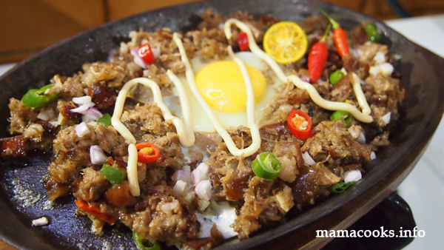](http://www.google.com.ph/url?sa=i&rct=j&q=&esrc=s&frm=1&source=images&cd=&cad=rja&uact=8&ved=2ahUKEwi56v-oiO3ZAhVJupQKHTuKA3QQjRx6BAgAEAU&url=http://www.mamacooks.info/lechon-sisig-for-that-leftover-lechon-head/&psig=AOvVaw0bDS9dP0nFuP6VpNkGUiKy&ust=1521159765331625)

3. Sisig

Nothing goes to waste in Filipino food. In the culinary capital of Pampanga, they turn the pork's cheeks, head and liver into a sizzling dish called Sisig.The crunchy and chewy texture of this appetizer is a perfect match for a cold beer. Serve with hot sauce and Knorr seasoning to suit the preference of you and your buddies. Credit goes to Aling Lucing, who invented this dish at a humble stall along the train railways in Angeles City, Pampanga. While Sisig can be found in many restaurants, try the original version at Aling Lucing Sisig.

[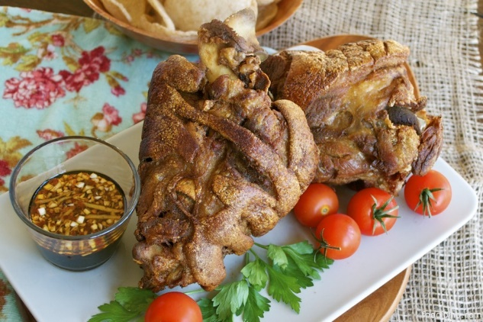](http://www.google.com.ph/url?sa=i&rct=j&q=&esrc=s&frm=1&source=images&cd=&cad=rja&uact=8&ved=&url=http://foodipino.com/2012/06/09/crispy-pata-2/&psig=AOvVaw2K2M6gCPKf1SOxUOFrmGuN&ust=1521159917571909)

4. Crispy pata

Not for the easily spooked, this pork knuckle is simmered, drained and deep fried until crisp. The meat is tender and juicy inside, with a crisp, crackling exterior. Served with vinegar, soy sauce and chili.

[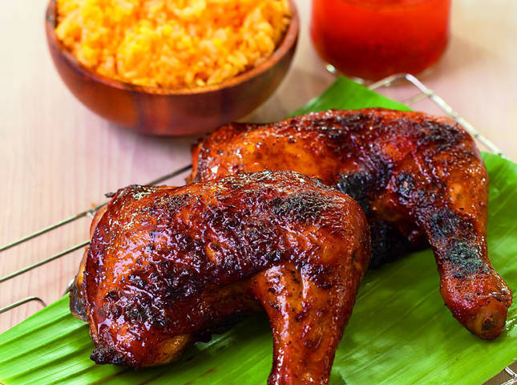](https://www.google.com.ph/url?sa=i&rct=j&q=&esrc=s&frm=1&source=images&cd=&cad=rja&uact=8&ved=2ahUKEwic5fq_ie3ZAhVGjJQKHV1iB68QjRx6BAgAEAU&url=https://www.yummy.ph/recipe/sari-jorge-s-chicken-inasal-a460-20130926&psig=AOvVaw1I6UxGTvomx-X54tdKfHla&ust=1521160122659588)

5. Chicken inasal

Yes, it's grilled chicken. But in Bacolod, this is no ordinary grilled chicken. The meat is marinated in lemongrass, calamansi, salt, pepper and garlic and brushed with achuete (annatto seeds) oil. Every part of the chicken is grilled here from the paa (drumstick), pecho (breast), baticulon (gizzard), atay (liver), pakpak (wings) and corazon (heart). It must be eaten with a generous serving of garlic rice, with some of the orange oil used to marinade the chicken poured over the rice. You can go chicken crazy at Manokan Country where there is a row of authentic Inasal restaurants.

[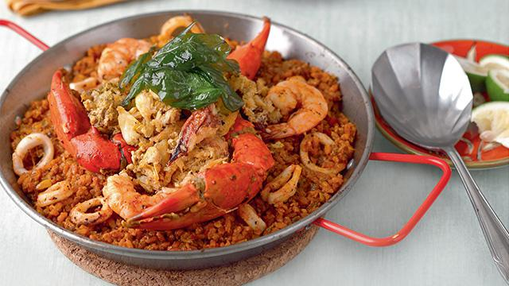](https://www.google.com.ph/url?sa=i&rct=j&q=&esrc=s&frm=1&source=images&cd=&cad=rja&uact=8&ved=2ahUKEwiw0en4ie3ZAhXGl5QKHfi5B2IQjRx6BAgAEAU&url=https://www.yummy.ph/recipe/taba-ng-talangka-rice&psig=AOvVaw2D1WjL2xe5XYAsa87OPi5A&ust=1521160222987449)

6. Taba ng talangka

[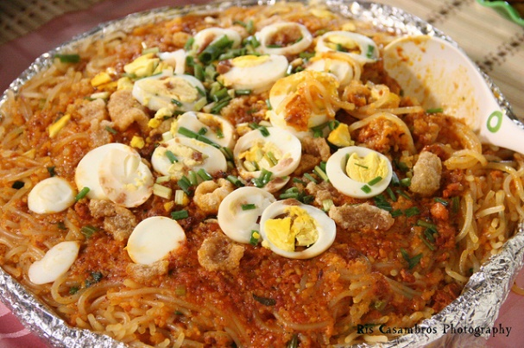](http://www.filipinofoodsrecipes.com/pancit-palabok-pancit-recipe/)The fat of a small variety of crabs are pressed and sauteed in garlic. This cholesterol-laden Filipino food is often used as a sauce for prawns or eaten with fried fish and rice. The best taba ng talangka comes from the provinces of Pampanga, Tarlac and Bulacan.

7. Pancit Palabok

When Filipinos have guests, they don't skimp. The pancit palabok served on most birthday parties oozes with flavors and textures. The noodle dish is layered with rice noodles, a rich orange sauce made from shrimp broth, pork, hard boiled eggs, shrimps, chicharon (pork rinds) and sometimes oysters and squid.

[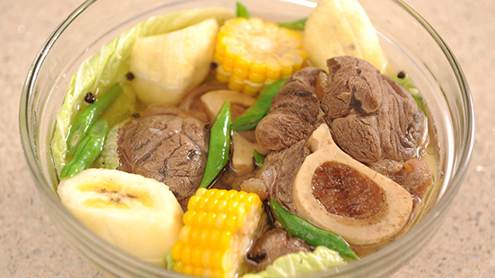](https://www.google.com.ph/url?sa=i&rct=j&q=&esrc=s&frm=1&source=images&cd=&cad=rja&uact=8&ved=2ahUKEwiRk6mOi-3ZAhWFupQKHeeaANIQjRx6BAgAEAU&url=https://www.knorr.com/ph/recipe-ideas/hearty-beef-bulalo-recipe.html&psig=AOvVaw3pBrzOb3gmceeTcPU3ga_U&ust=1521160595687495)

8. Bulalo

Despite the perennial heat, Filipinos often enjoy sipping piping hot bulalo soup made with from freshly slaughtered Batangas beef. The broth is rich with flavors seeped from the beef after boiling for hours. The bones are big, meaning more bone marrow to enjoy. In Santo Tomas, Batangas, there's a row of restaurants along the highway serving bulalo.

[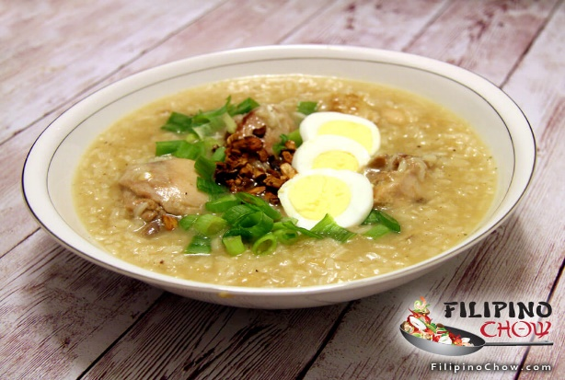](http://www.google.com.ph/url?sa=i&rct=j&q=&esrc=s&frm=1&source=images&cd=&cad=rja&uact=8&ved=2ahUKEwjWmvT3i-3ZAhXGlZQKHQj6AM8QjRx6BAgAEAU&url=http://www.filipinochow.com/arroz-caldo/&psig=AOvVaw2hREIug0PpY9cupS3dwaEG&ust=1521160690263206)

9. Arroz Caldo

While chicken soup soothes sick Westerners, Filipinos turn to arroz caldo, a thick chicken rice porridge. Cooked with ginger and sometimes garnished with a hard-boiled egg, toasted garlic and green onions, this Filipino food is sold in street-side stalls. If dining al fresco doesn't suit, there's the Via Mare outlets around Manila.

[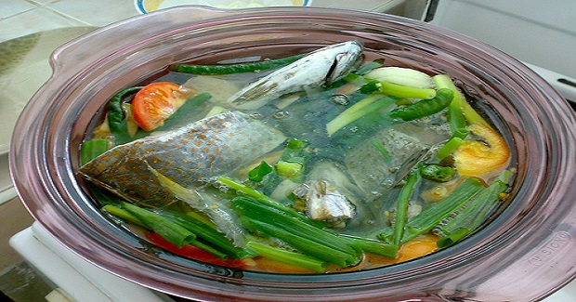](http://www.google.com.ph/url?sa=i&rct=j&q=&esrc=s&frm=1&source=images&cd=&cad=rja&uact=8&ved=2ahUKEwjzuuykjO3ZAhVCUZQKHY7eB9MQjRx6BAgAEAU&url=http://www.panlasangpinoyrecipes.com/fish-tinola-recipe/&psig=AOvVaw0eo9szmlmrZmg9WWtv-4Xb&ust=1521160871905958)

10. Fish tinola

The freshness of Cebu's rich marine life can be tasted in its fish tinola. The simple sour broth is flavored with onions, tomatoes and sambag (tamarind) and cooked over coco-lumber firewood for hours. Cebuanos know to go to A-One, a small hole in the wall known, cooking up to 200 kilos of fish daily.

[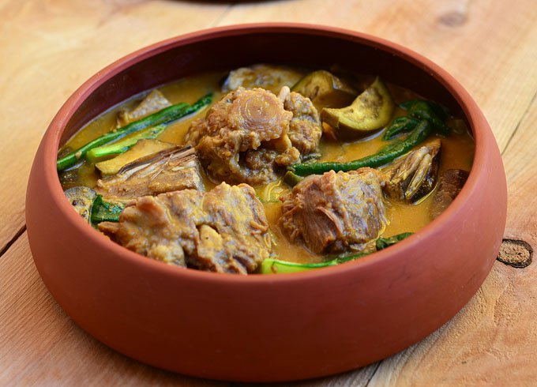](https://www.google.com.ph/url?sa=i&rct=j&q=&esrc=s&frm=1&source=images&cd=&cad=rja&uact=8&ved=2ahUKEwiMoPHGjO3ZAhUKJ5QKHR_bBBcQjRx6BAgAEAU&url=https://www.kawalingpinoy.com/kare-kare/&psig=AOvVaw1Ocdebfzy0lXdfIrq2LiV3&ust=1521161004395647)

11. Kare-kare

This stew of oxtail has the most delicious sauce made from ground toasted rice and crushed peanuts. Banana blossom, eggplants and string beans add more interesting textures, making it a complete meal on its own. It's eaten with steamed rice and bagoong (shrimp paste). While mom's kare-kare is always best, the version at Cafe Juanita is authentic.

[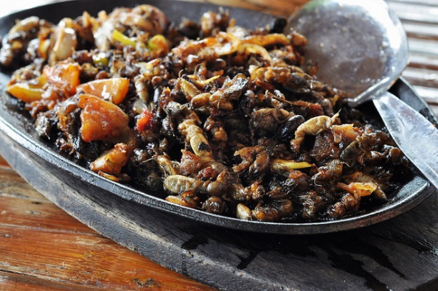](https://www.google.com.ph/url?sa=i&rct=j&q=&esrc=s&frm=1&source=images&cd=&cad=rja&uact=8&ved=2ahUKEwinxuWRje3ZAhWMKZQKHcXCBncQjRx6BAgAEAU&url=https://www.pinterest.com/pin/370772981796847092/&psig=AOvVaw029rOHd4bpOwHbsYjJSiue&ust=1521161144458699)

12. Kamaro

Serious gourmands know the best cooks come from Pampanga.So do kamaro, these mole crickets they cook into a delicious appetizer.

What makes this delicacy special? Well, if catching these bugs is tough, so is cooking them. Legs and wings must be removed, then the body is boiled in vinegar and garlic. It's then sautéed in oil, onion and chopped tomatoes until they turn chocolate brown. These bite-size appetizers are crunchy on the outside and moist on the inside. Sample Kamaru at Everybody's Cafe, an authentic Pampango dining institution for many decades now.

[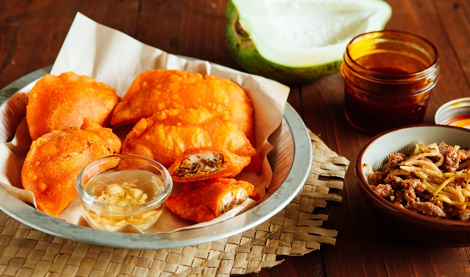](http://www.google.com.ph/url?sa=i&rct=j&q=&esrc=s&frm=1&source=images&cd=&cad=rja&uact=8&ved=2ahUKEwi-qqT1je3ZAhVBOZQKHY53Ci0QjRx6BAgAEAU&url=http://www.pepper.ph/make-ilocos-empanadas-home-stuff-chorizo-puti-quail-eggs-change/&psig=AOvVaw2w-eap1ocXqC47JzzN15RM&ust=1521161241537025)

13. Ilocos empanada

Yes, its name reveals its Spanish origins. But its ingredients are all local. Grated unripe papaya or bean sprouts, egg and loganiza (pork sausage) are stuffed in the empanada and deep fried, accompanied with a spicy vinegar sauce. Get this staple Filipino food from stalls beside the cathedrals in Vigan and Laoag.

[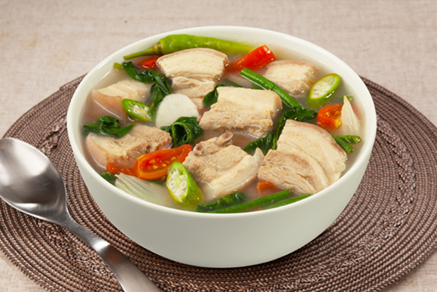](https://www.google.com.ph/url?sa=i&rct=j&q=&esrc=s&frm=1&source=images&cd=&cad=rja&uact=8&ved=2ahUKEwjh3raUju3ZAhVMEpQKHVrwCSUQjRx6BAgAEAU&url=https://www.maggi.ph/recipes/view/377/sinigang-na-baboy-sa-mangga&psig=AOvVaw37xQ1vC4J0rN3uV-E9Lm_n&ust=1521161408301772)

14. Sinigang

Sinigang is a stew of fish, prawns, pork or beef soured by fruits like tamarind, kamias or tomatoes. Often accompanied by vegetables like kangkong, string beans and taro, this stew is eaten with rice. A modern, but delicious spin on Sinigang is Sentro 1771's version called Sinigang Corned Beef.

[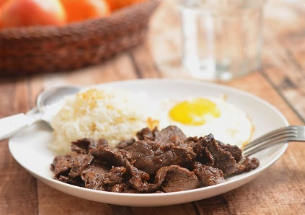](https://www.google.com.ph/url?sa=i&rct=j&q=&esrc=s&frm=1&source=images&cd=&cad=rja&uact=8&ved=2ahUKEwjCleDGju3ZAhUKl5QKHYxPAbAQjRx6BAgAEAU&url=https://www.kawalingpinoy.com/filipino-beef-tapa/&psig=AOvVaw3gWQ4RNGkCbSNk5mXm7E1j&ust=1521161479685803)

15. Tapa

Filipinos are huge rice eaters, and breakfast is no exception. A tap-si-log consists of thin slices of dried marinated beef served with fried egg and garlic rice. While it is breakfast fare, it's also a quick, satisfying meal you can eat anytime and available in most places. Making it accessible all the time and even available for deliveries, Tapa King serves it in the classic, sweetish and spicy versions.

<video width="320" height="240" controls>

<source src="/assets_tutorials/media/Shaun-the-Sheep-The-Movie-Official-Trailer.mp4" type="video/mp4">

<source src="/assets_tutorials/media/Shaun-the-Sheep-The-Movie-Official-Trailer.ogg" type="video/ogg">

Your browser does not support the video tag.

</video>