**Name : Jyothi**

**USN : 01fe20mca059**

**CRUD operations in mongoose**

**Register:**

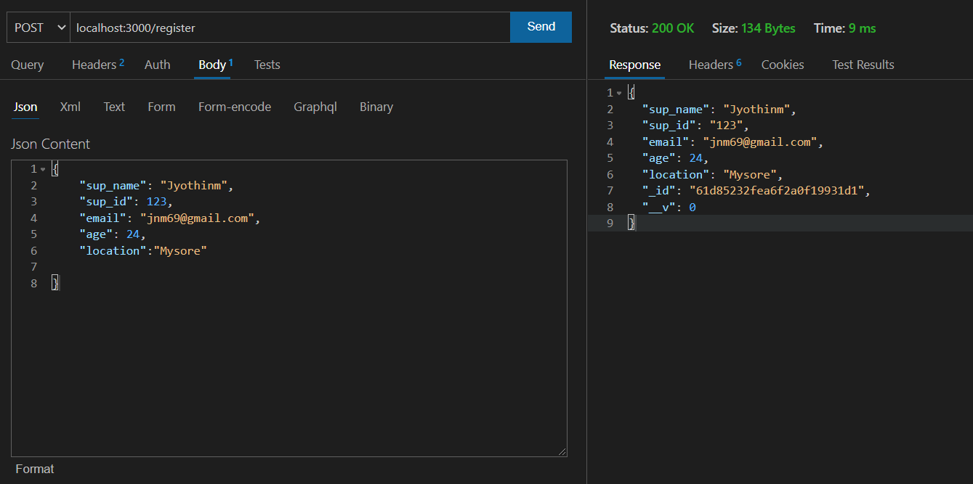

**Update:**

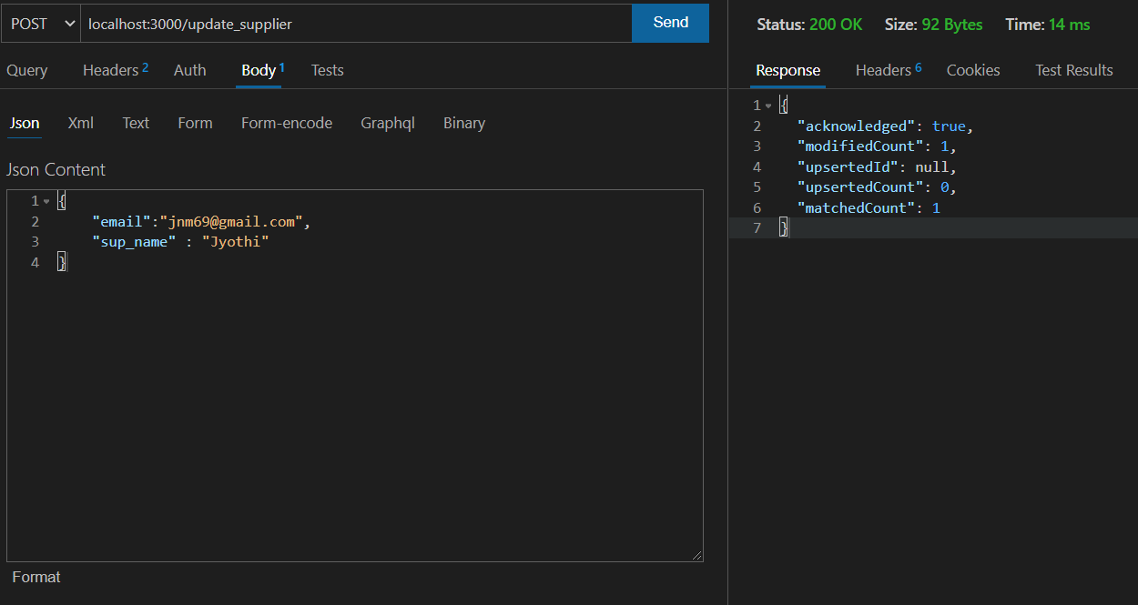

**Delete :**

