Delivery Portal Project
Multi-Tenancy, User Management, and Account Lifecycle Design
Version 1.0
Date – 02-01-2026

Revision History
Version | Date | Prepared By | Description of Change | Approved By
1.0 | 02-01-26 | Saurabh Rai

1. Purpose
This document explains how the Delivery Portal supports multiple client organizations on a shared platform (multi-tenancy), while keeping each organization’s data and access fully separated. It also explains how users are created, invited, authenticated, authorized, and how a client organization account moves through Active, Expired, Archived, and Deleted states.
It is written in simple technical terms so that a semi-technical reader can understand the main decisions, the reasons behind them, and the trade-offs.

2. Key terms and abbreviations
Key terms used throughout this document:
- Organization (Org): A customer company using the Delivery Portal. Each Organization is a tenant.
- Tenant: A customer that shares the platform with others, but must be isolated (separated) from others.
- OrgId (Organization Identifier): A unique identifier for an Organization. It is the main security boundary.
- Project: A workspace inside an Organization. Project data is also isolated within the Organization.
- ProjectId (Project Identifier): A unique identifier for a Project.
- User: A person who logs in to the platform.
- Role: A named set of permissions (for example, Client Admin or Client User).
- Permission: A specific allowed action (for example, ‘Upload file’ or ‘Invite user’).
Common abbreviations (short name with full form):

3. High-level overview
The platform uses a shared infrastructure model: many Organizations use the same application and databases. To keep data safe, every request and every stored record is tied to an OrgId (Organization Identifier). Services must never read or write data without validating the OrgId.
High-level components:
- Delivery Portal Web Application: the user interface in the browser.
- API Gateway (Application Programming Interface Gateway): the single entry point for web requests; validates tokens and enforces tenant context.
- Keycloak (Identity Provider): handles login, passwords, and optional One-Time Password (OTP) verification.
- Tenant and User Management Service: stores Organization, user, role, seat, and invitation data in PostgreSQL (Postgres).
- Notification Service: sends emails and (optionally) text messages (Short Message Service, SMS) for invitations and admin notifications.
- Business Services: project, file, dashboard, report, and Artificial Intelligence (AI) related services that store tenant-scoped data.
Diagram: high-level multi-tenancy and data isolation (block diagram)
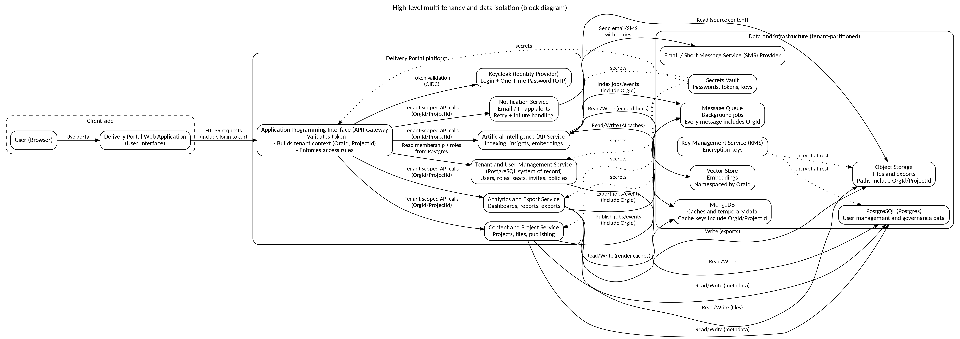
High-level multi-tenancy and data isolation .

4. Tenancy boundaries (what is isolated from what)
We use ‘Organization-as-tenant’. This means the Organization is the primary boundary for security and data separation.
- OrgId (Organization Identifier) is the primary isolation boundary. Data must never cross Org boundaries.
- ProjectId (Project Identifier) is a secondary boundary inside an Organization. A user must have access to the Project to access Project-scoped data.
- Some data is Organization-scoped (for example, users, roles, subscription settings, audit logs). This data is not separated by ProjectId.

5. Users, roles, and who can do what
Roles are used to control what a user can do. This is Role-Based Access Control (RBAC). Roles and permissions are stored in PostgreSQL so that all services use the same source of truth.
- JC Admin (Platform Admin): manages client Organizations, account expiry, archiving, and deletion; can access cross-tenant views only for support with strict auditing.
- JC Project Manager: manages projects, content, and coordination for assigned Organizations and Projects.
- Client Admin: manages users inside their own Organization (invite users, change roles, deactivate users, view seat usage).
- Client User: uses the platform features based on assigned role (view, upload, edit, download) inside their Organization and Projects.

6. Authentication (login)
Authentication proves who a user is. The platform uses Keycloak (Identity Provider) for authentication. After a successful login, Keycloak issues a signed token (for example, a JSON Web Token (JWT)) that the API Gateway validates on every request.

6.1 Two-step login (One-Time Password)
For additional security, the platform supports two-step login using a One-Time Password (OTP). A user logs in with email and password, then confirms using an OTP (for example, via email or authenticator).

6.2 Login fallback and failure handling
The system should handle login problems in a predictable and secure way:
- Incorrect credentials: allow only a limited number of retry attempts. After too many failures, the account is locked for non-admin personas. Support can unlock the account.
- JC Admin exception: the JC Admin account is never locked due to failed login attempts (this avoids platform lockout), but all failed attempts are logged and monitored.
- Forgot password: allow password reset via a secure email link.
- Server or network issues: show a clear maintenance message and do not expose internal errors to the user.
- Multi-Factor Authentication (MFA) issues: offer a backup authentication method such as Short Message Service (SMS) or security questions (recovery questions).

7. Authorization (permissions)
Authorization decides what the authenticated user is allowed to do. The platform uses Role-Based Access Control (RBAC): a user is assigned one or more roles, and roles grant permissions.
- Roles and tenant membership are stored in PostgreSQL (Postgres). This is the system of record for user management.
- Keycloak stores only authentication data (login identity and password policies). It does not decide tenant membership.
- The API Gateway and backend services check permissions before allowing actions such as viewing a project, uploading files, or managing users.

8. How OrgId and ProjectId are enforced
Tenant isolation fails if a service processes a request without a trusted OrgId (Organization Identifier). Therefore, the platform treats OrgId and ProjectId as mandatory security context.
- The API Gateway validates the login token and determines the UserId (user identifier).
- The gateway looks up the user’s Organization membership and roles in PostgreSQL and builds a trusted context (OrgId, ProjectId, Role).
- Client-supplied OrgId or ProjectId values are not trusted. If the client sends them, the gateway either rejects the request or overwrites them with validated values.
- Background jobs and events must carry OrgId in the message payload. Workers verify OrgId before processing.
Diagram: tenant context propagation and validation
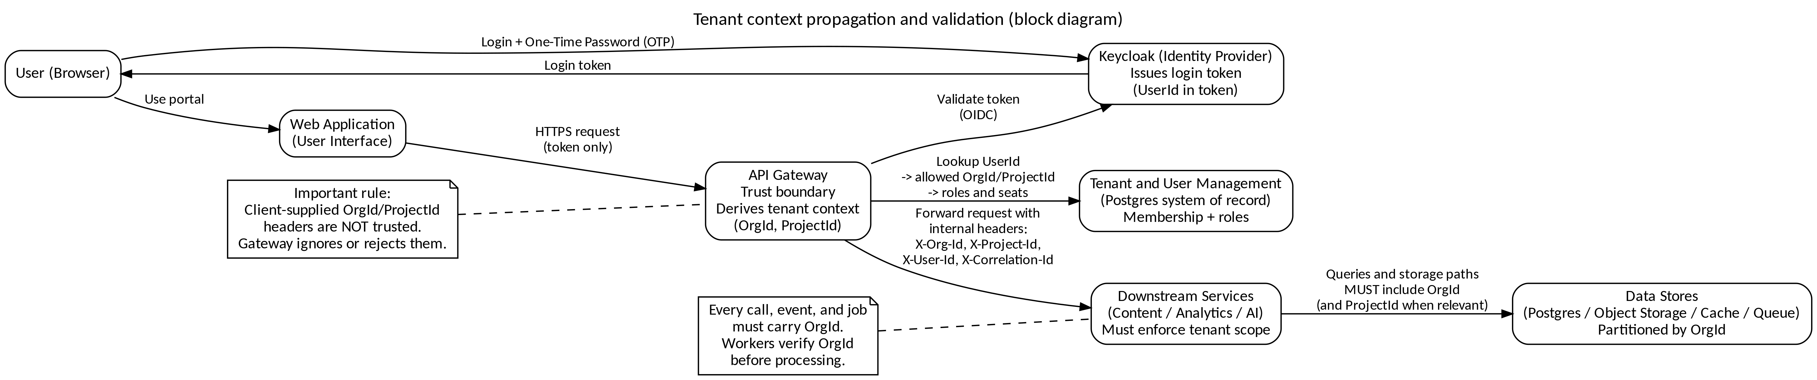
Tenant context propagation and validation .

9. Data isolation (how we keep tenant data separated)

9.1 PostgreSQL (Postgres) data model approach
PostgreSQL stores all user management and tenant governance data. A shared database is used, but every tenant-owned row includes OrgId.
- Every tenant-owned table includes OrgId as a mandatory column.
- All queries include OrgId filters, and indexes include OrgId to keep queries fast.
- Optional database protection: Row-Level Security (RLS) can be enabled to enforce OrgId filtering at the database level as an extra safety net.

9.2 Object storage (files and media)
Files (for example, deliverables and datasets) are stored in object storage. The storage path is partitioned by OrgId and ProjectId.
- Storage keys include OrgId and ProjectId (for example, org/<OrgId>/project/<ProjectId>/...).
- Downloads use time-limited signed links (presigned Uniform Resource Locator (URL)).
- Every upload and download is authorized before a link is issued.

9.3 Caches and background processing
- Caches always include OrgId (and ProjectId when needed) in the cache key to avoid cross-tenant mixing.
- Message queues (for background jobs) include OrgId in each message. Workers reject messages missing OrgId.

10. User onboarding (invitation-based)
Users (except JC Admin) are onboarded through invitations. This ensures users are linked to the correct Organization before they access any data.

10.1 Standard invitation flow
- Client Admin creates an invite for an email address within their Organization.
- The Tenant and User Management Service stores the invite and its expiry time in PostgreSQL.
- The Notification Service sends the invite via email (and optionally via Short Message Service (SMS)).
- The invited user opens the link and sets a password using Keycloak (Identity Provider).
- On first successful login, the platform confirms Organization membership, assigns roles, and activates the user (only if seat limits allow).

10.2 Notifications for onboarding and role updates
- When an invitation is accepted, the system notifies the relevant administrator (for example, Client Admin) that the user is now active.
- When a user’s role is changed, the system records an audit event and can notify the user and/or administrator, depending on configuration.

10.3 Invitation delivery failure handling
Invitation delivery is treated as a critical flow. If email delivery fails, the system must not silently lose the invitation.
- Notification queue: failed email sends are logged and retried automatically after a predefined interval.
- Email retry queue: retry sending emails every few hours, up to a small fixed number of attempts (for example, 3 attempts).
- Manual resend option: if automated retries fail, an administrator can manually trigger a resend from an activity log screen.
- Alternative notification: if email fails repeatedly, provide an in-system notification and/or a shareable invite link that the admin can copy.
- Admin notification: after repeated failures, notify the administrator that manual follow-up may be needed.

10.4 System downtime during user management
- Deferred execution: store user management actions (invite, deactivate, role change) in a queue and execute them when the system is back online.
- Offline mode (limited): allow certain changes to be staged as ‘Pending’ and synchronized later when the system is restored.
- Status update mechanism: if a user addition or removal fails, mark it as Pending and retry automatically after restoration.

11. Tenant account lifecycle (Organization subscription)
A tenant account represents a client Organization’s commercial access (for example, contract period). The platform supports controlled expiry, archiving, and deletion to reduce risk and support compliance.
Diagram: tenant account lifecycle (block diagram)
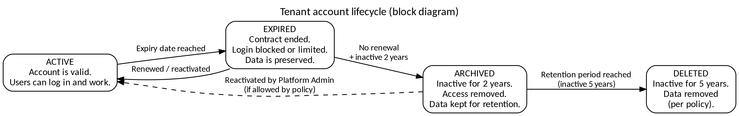
Tenant account lifecycle states .

11.1 Active accounts
- JC Admin can view a list of active Organization accounts.
- JC Admin can open an account to view details such as Organization name, client contact details, activation date, expiration date, and current status.
- JC Admin can review historical account activity logs (audit logs).
- If the platform supports it, JC Admin can extend the account’s active period (contract extension).
- JC Admin can report account issues for follow-up (support workflow).

11.2 Expired account details
Expired accounts are accounts that reached the expiration date or have been marked as expired by an administrator. Expired accounts are visible in an ‘Expired Accounts’ view for tracking and decision-making.
- The view shows key fields such as Organization, activation date, expiration date, and status.
- Filters can be applied (for example, by Organization name, activation date, or expiration date).
- Pagination is supported so the administrator can browse large lists without performance issues.

11.3 Archiving accounts (inactive for two years)
Archiving removes access but keeps the data. This is used when an Organization has been inactive for a long period, but data must be preserved for business or compliance reasons.
- Eligibility rule: an account is considered for archiving after two years of inactivity.
- Warnings: the system sends at least two warnings to the client before archiving.
- Confirmation: before archiving, the JC Admin must confirm the action.
- Result: access is restricted, but the account data is preserved and can be restored if needed.
- Audit and notification: the system records the event in audit logs and sends a confirmation notification to the client.

11.4 Deleting accounts (inactive for five years)
Deletion is permanent removal. It is used for accounts that have been inactive for a very long period and are beyond the retention window.
- Eligibility rule: an account can be deleted after five years of inactivity.
- Confirmation: the JC Admin must confirm deletion. The system should clearly show that deletion is irreversible.
- Safety checks: the system should block deletion of an active account and raise an alert if such a request is attempted.
- Audit: deletion actions are recorded in audit logs for traceability.

12. Audit logging, monitoring, and support
Audit logs are critical in multi-tenant systems because they provide evidence of ‘who did what’ for each Organization.
- Every audit event includes OrgId, UserId, action name, timestamp, and outcome (success or failure).
- User and tenant administration actions are always audited (invite creation, role changes, archiving, deletion).
- File access and export downloads are logged for compliance and troubleshooting.
- Log access is restricted to authorized administrators. Logs can be exported for investigation when required.

