Delivery Portal Project - Data Flow Diagrams (DFD)
Version 2.0 | Date: 2026-01-20 | Aligned to New 5-Microservice Boundaries

1. Purpose of this document
This document explains how data moves through the Delivery Portal platform for the most important user journeys. Each section includes a Data Flow Diagram (DFD) and a step-by-step explanation in simple technical terms. This version (v2) aligns all flows and diagrams to the new 5-microservice boundaries.

2. Scope (DFDs included)
- Login and session establishment
- Invite user and account activation
- File upload and downstream processing
- AI indexing and AI insights
- Export generation and download
- Multi-tenancy context and data isolation

3. Executive Overview

3.1 Roles and usage patterns
- JC Admin - platform governance and full workspace oversight (orgs, users, RBAC, subscriptions, incidents, tickets).
- JC PM - project execution and publishing; no platform governance.
- Client Admin - org-scoped governance (invites, seat usage) and full content/reporting access within tenant scope.
- Client Editor - create/edit content and run analytics; restricted destructive actions as per FRD.
- Client Reviewer - review and comment workflows where applicable; limited edit rights (capability-gated).
- Client Viewer - read-only access to permitted content and outputs.

3.2 Key non-functional constraints
- On-prem Keycloak integration for authentication (Keycloak setup out of scope).
- Tenant isolation enforced using OrgId as primary boundary and ProjectId for project-scoped resources.
- Seat caps and subscription entitlements enforced centrally at the edge (MS1).
- Standardized errors, retries, DLQ handling and redrive semantics for background jobs and notification delivery.
- Operational visibility: access logs, audit logs, job failures, queue errors, AI prompt failures, uploads in progress.

4. Key platform components (simple overview)
The Delivery Portal platform is built as a set of services. The names below are used in the diagrams:
- MS1 - Access Gateway + Tenant/User Governance: front door for all API calls; token validation, tenant guard, RBAC/entitlements/seats enforcement; governance system-of-record (orgs, users, invites, RBAC, subscriptions, incidents, tickets) with audit/access logs.
- MS2 - Workspace & Content: projects, folders, file metadata and lifecycle; issues pre-signed upload/download URLs for object storage; publishes content lifecycle events.
- MS3 - Analytics & Reporting: dataset ingest/transform/analyze; dashboards/reports; export jobs (PDF, CSV, Excel) and async orchestration.
- MS4 - Notifications: consumes domain events; applies templates/preferences; delivers in-app and email notifications with retries/DLQ.
- MS5 - AI Assist + Document Intelligence: indexing (extract/chunk/embed), semantic retrieval and insight generation; stores citations/traces and telemetry.
- Keycloak (Identity Provider): handles login security such as passwords and MFA; issues access tokens.
- PostgreSQL (Database): authoritative store for governance, workspace metadata, job state and delivery state.
- Object Storage: stores file bytes and export files, using tenant-prefixed paths.
- Event Bus / Queue: delivers events and background jobs reliably between services, including DLQ for failures.

4.1 External dependencies
Dependency | Purpose | Notes
Keycloak (on-prem) | Token issuance, login/MFA, password reset | Integration only; platform does not implement its own credential store.
JC Employee Directory / HR DB | Optional provisioning attributes for JC users | Used by MS1 governance flows if enabled.
Email provider | Invitations, notifications, alerts | Delivery adapters in MS4; in-app inbox is always available.
LLM provider/runtime | AI inference for insights and summaries | Used by MS5; can be model API or on-prem runtime.

4.2 Container responsibilities (strict)
Container | Responsibilities | Key data/integrations
UI (Admin Portal + Client Portal) | Single web app: role-aware navigation, dashboards/report studio UI, in-app inbox, invite onboarding, file upload via pre-signed URLs. | Calls MS1 for APIs; direct upload/download to Object Storage via pre-signed URLs from MS2/MS3.
WAF/Edge | Perimeter protection, baseline rate shaping, TLS policy enforcement. | Feeds edge metrics to observability.
MS1 - Access + Governance | Auth facade, session controls, schema validation, tenancy guard, RBAC/entitlements/seats enforcement, IP/concurrency enforcement, standardized errors, access logging; governance SoR: orgs/users/invites/RBAC/seats/subscriptions/incidents/tickets. | Keycloak; PostgreSQL; Redis (optional); publishes governance events to Event Bus.
MS2 - Workspace & Content | Projects/folders/files, upload lifecycle, publish/visibility rules, activity/comments, Intel Grid metadata; pre-signed URLs for files. | PostgreSQL; Object Storage; Mongo cache; publishes file_ready/content_updated events.
MS3 - Analytics & Reporting | Dataset ingest/transform/analyze, dashboards/reports, exports, job orchestration, render caching. | PostgreSQL; Object Storage; Mongo export cache; queue/workers; publishes export_ready/job_completed events.
MS4 - Notifications | Notification orchestration, templates, preferences, delivery state, retries/DLQ; email + in-app inbox delivery. | PostgreSQL; Email provider; Event Bus subscription; optional Redis buffer.
MS5 - AI Assist + DI | Document extraction/chunking/embeddings, RAG retrieval, insight generation with citations, feedback + AI telemetry. | Object Storage (read); MongoDB; Vector DB; PostgreSQL (meta); LLM provider; consumes file_ready events.

5. DFD Level 0 - System overview
This diagram provides a single view of the major actors, microservices, and data stores under the new 5-microservice architecture.
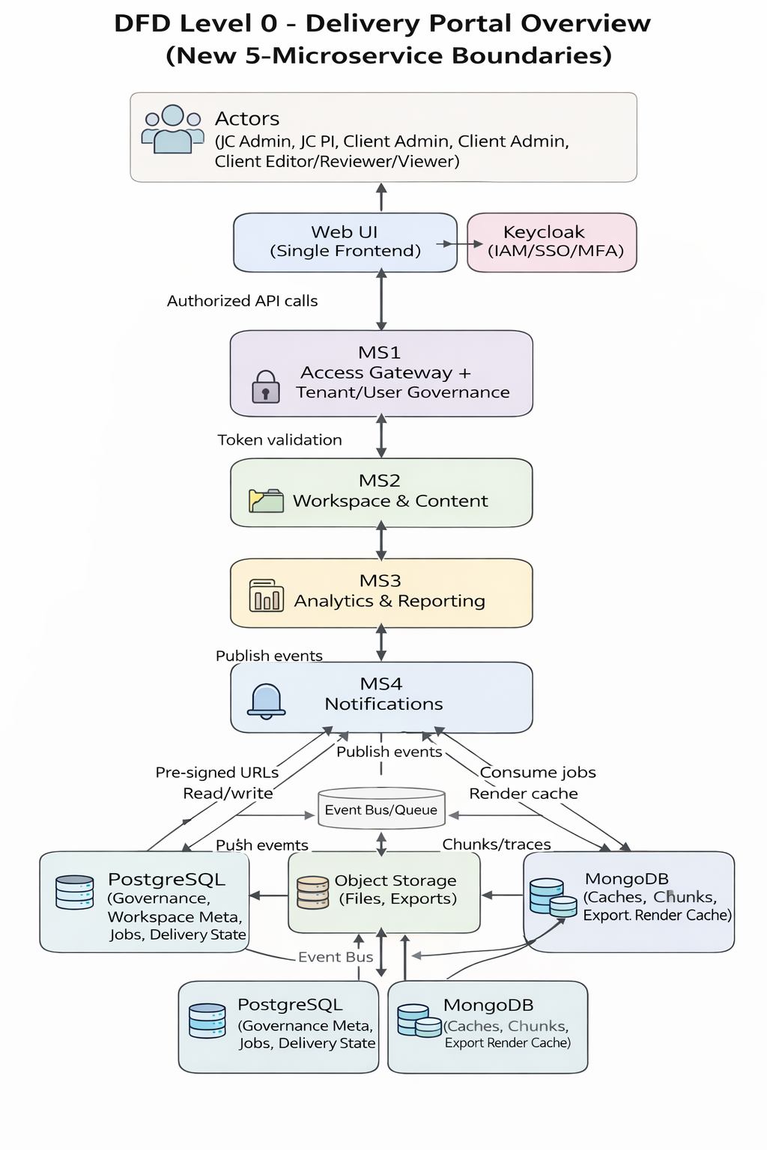
Figure 5-1. DFD Level 0: Delivery Portal Overview (New 5MS)

DFD 01. Login and session establishment
Key points
- Keycloak is the identity provider: it checks passwords and MFA and issues tokens.
- MS1 is the system of record for membership, roles, seats, and entitlements (governance merged into MS1).
- MS1 derives OrgId and ProjectId from governance data; it does not trust browser-provided tenant headers.
- Login and access events are written to audit/access logs for compliance and troubleshooting.
Diagram
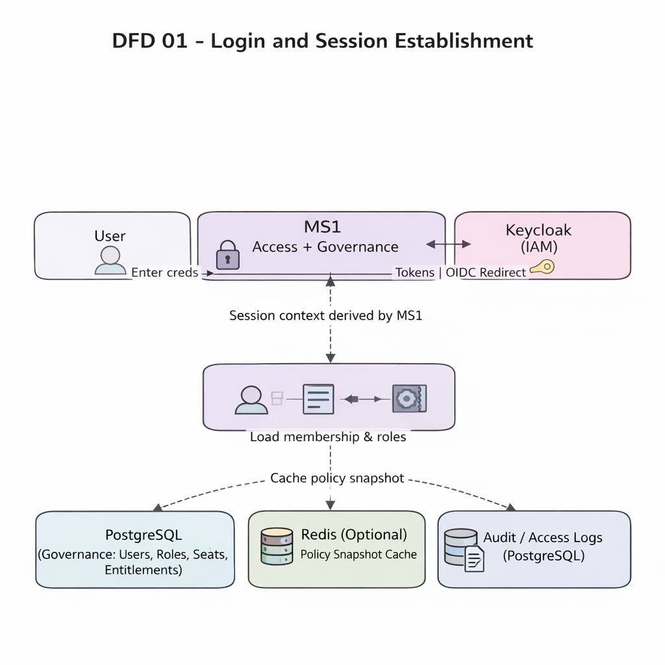
Figure DFD 01: Login and session establishment (DFD)
Step by step flow
- The user enters email and password in the Web UI.
- The Web UI initiates OIDC authentication against Keycloak (via MS1).
- Keycloak validates credentials, applies MFA if required, and returns tokens.
- MS1 validates the token and resolves the user membership, roles, seat caps, and entitlements from PostgreSQL.
- MS1 builds the session context (OrgId, ProjectId, roles, entitlements) and optionally caches a policy snapshot.
- MS1 applies session policies (expiry, forced logout rules where applicable), IP rules, and concurrency rules.
- MS1 writes login audit/access events to PostgreSQL.
- MS1 returns success to the Web UI; the UI uses the bearer token for future API calls.

DFD 02. Invite user and activate account
Key points
- Invites, roles, seat limits, and subscription entitlements are managed in MS1 and stored in PostgreSQL.
- MS4 sends notifications (email and in-app) and handles retries/DLQ for delivery failures.
- Password setup occurs in Keycloak. The platform does not store user passwords.
Diagram
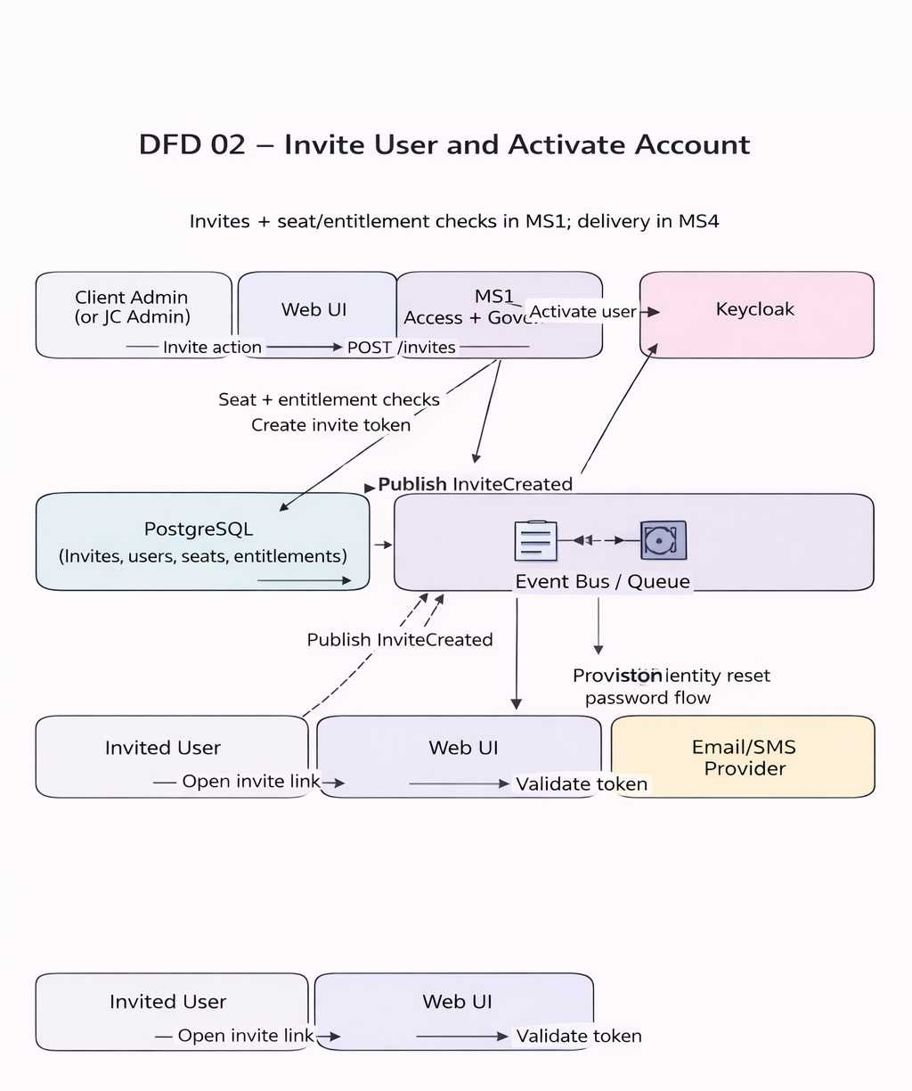
Figure DFD 02: Invite user and activate account (DFD)
Step by step flow
- A Client Admin (or JC Admin) enters the new user email and role in the Web UI and clicks Invite.
- The Web UI sends the invite request to MS1; MS1 authorizes the action and validates seat/entitlement constraints.
- MS1 stores the invite record and token in PostgreSQL and writes an audit log entry.
- MS1 publishes an InviteCreated event to the Event Bus / Queue.
- MS4 consumes the event and sends the invite link to the email/SMS provider (and optionally an in-app notification).
- The invited user opens the invite link in the Web UI.
- The Web UI submits the invite token to MS1 for validation.
- MS1 validates the token and provisions the identity in Keycloak (or links an existing identity).
- The invited user sets a password in Keycloak and completes MFA if required.
- MS1 activates the membership, consumes the seat allocation, writes audit logs, and publishes UserActivated.
- MS4 may send a welcome notification based on UserActivated.

DFD 03. File upload and downstream processing
Key points
- File bytes are uploaded directly to Object Storage using a time-limited pre-signed URL.
- MS2 stores file metadata and lifecycle state in PostgreSQL and controls upload finalization.
- After upload finalization, file_ready events trigger analytics ingestion (MS3) and AI indexing (MS5).
Diagram
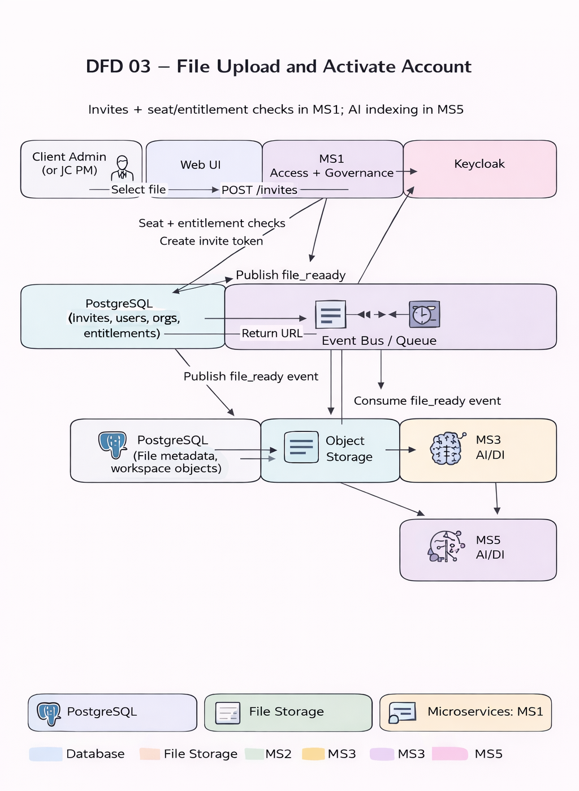
Figure DFD 03: File upload and downstream processing (DFD)
Step by step flow
- A user selects a file in the Web UI and clicks Upload.
- The Web UI sends a create-upload request to MS1 with the bearer token.
- MS1 validates access and tenant context, then routes the request to MS2 (Workspace & Content).
- MS2 creates a file metadata record in PostgreSQL with status UPLOADING.
- MS2 returns a pre-signed upload URL to the Web UI.
- The Web UI uploads file bytes directly to Object Storage using the pre-signed URL.
- The Web UI notifies MS2 that upload is complete (file identifier and optional checksum).
- MS2 finalizes the upload, verifies object presence (optional), and sets status to READY/AVAILABLE.
- MS2 publishes a file_ready event to the Event Bus / Queue with OrgId and ProjectId context.
- MS3 and MS5 consume the event to start analytics ingestion and AI indexing respectively.

DFD 04. AI indexing and AI insights
Key points
- MS5 performs indexing (extract, chunk, embed) and stores embeddings in a tenant-scoped vector store.
- MS5 stores chunks/traces and conversation metadata for traceability and audits.
- AI actions are scoped by OrgId and ProjectId and are allowed only when the user has required entitlements.
Diagram
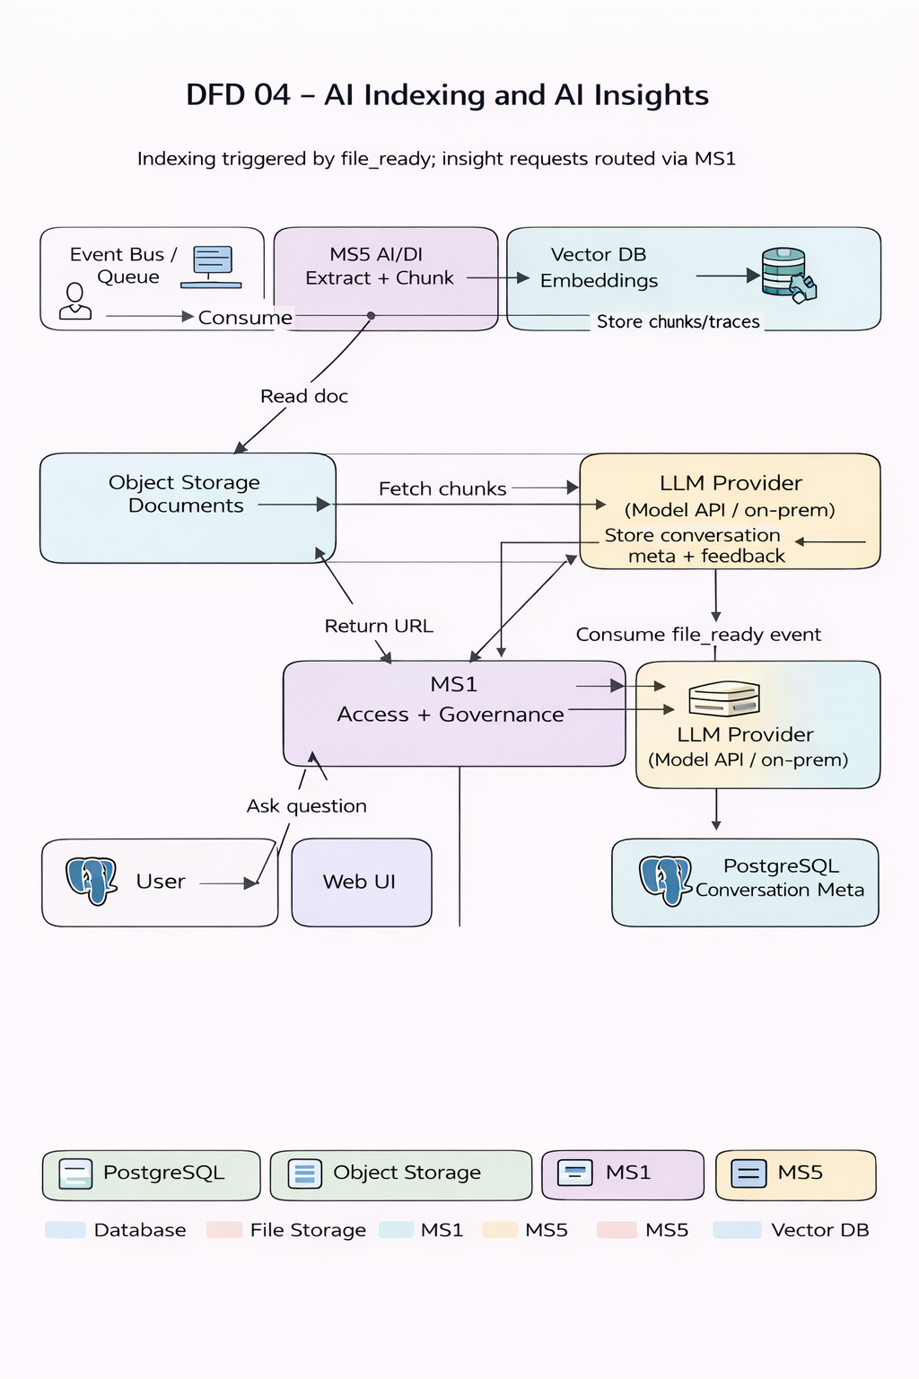
Figure DFD 04: AI indexing and AI insights (DFD)
Step by step flow
- A file_ready/content_updated event arrives on the Event Bus / Queue including OrgId and ProjectId.
- MS5 reads the file from Object Storage and extracts text/structure as needed.
- MS5 splits content into chunks and generates embeddings; vectors are stored under the tenant namespace.
- MS5 stores chunk references and indexing status in MongoDB/PostgreSQL.
- Later, a user submits an insight question in the Web UI.
- MS1 validates the token, tenant context, and entitlements, then routes the request to MS5.
- MS5 retrieves relevant chunks from the vector store (RAG) and constructs a prompt with grounded context.
- MS5 calls the LLM provider/runtime and receives an answer.
- MS5 stores answer metadata and citations/traces and returns the response to the Web UI.

DFD 05. Export generation and download
Key points
- Exports run as background jobs to avoid blocking the Web UI.
- MS3 owns export job state and writes the final file to Object Storage.
- MS4 can notify users when exports are ready (in-app and email).
Diagram
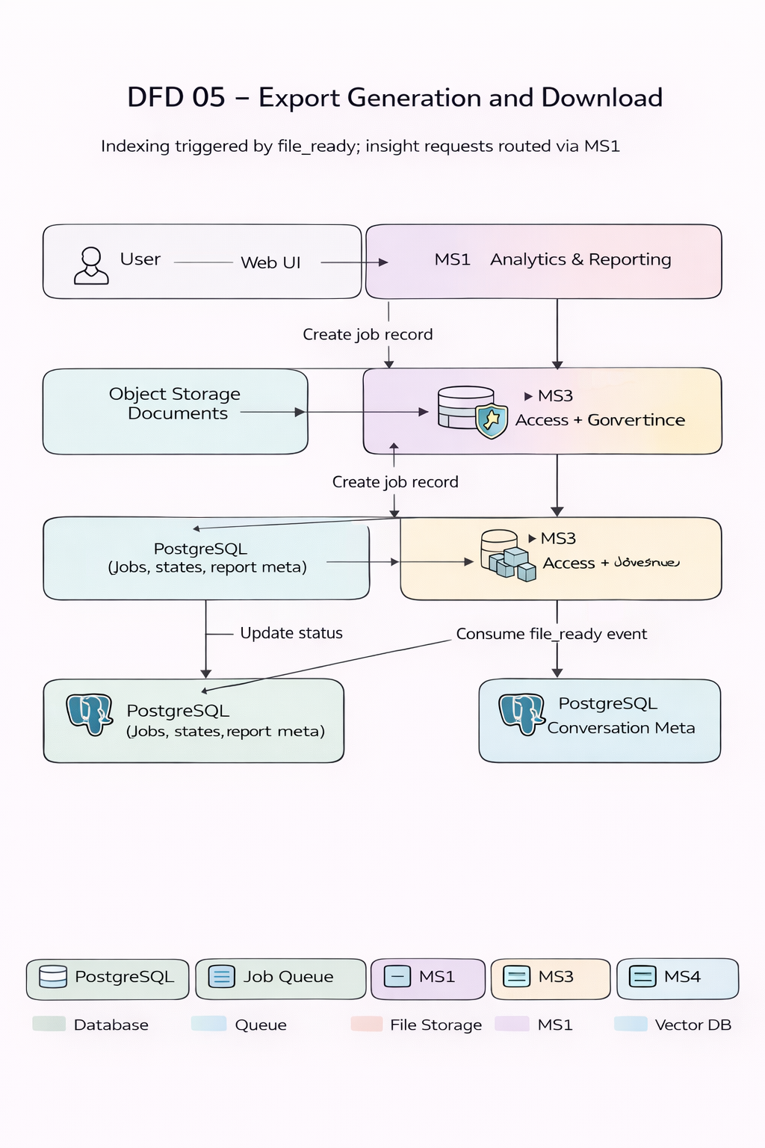
Figure DFD 05: Export generation and download (DFD)
Step by step flow
- A user selects export options in the Web UI and submits an export request.
- MS1 validates token and tenant context and routes the request to MS3.
- MS3 creates an export job record in PostgreSQL with status QUEUED and enqueues a job message.
- An export worker picks up the job, generates the export file, and writes the output to Object Storage.
- The worker updates job status to COMPLETED or FAILED in PostgreSQL.
- MS3 publishes export_ready/job_completed to the Event Bus.
- MS4 may send an in-app/email notification that the export is ready.
- The Web UI polls export status; when ready, MS3 returns a pre-signed download URL.
- The Web UI downloads the export file directly from Object Storage using the pre-signed URL.

DFD 06. Multi tenancy context and data isolation
Key points
- OrgId is the primary tenant boundary; ProjectId is enforced for project-scoped resources.
- MS1 does not trust tenant identifiers from the browser. MS1 resolves tenant context from governance membership data.
- Every data store and message includes OrgId (and ProjectId where relevant) to prevent cross-tenant access by design.
Step by step flow
- The user makes an API call from the Web UI using a bearer token issued by Keycloak.
- MS1 validates the token and resolves OrgId, ProjectId, roles, and entitlements from governance data.
- MS1 routes the request to downstream services (MS2, MS3, MS4, MS5) with internal tenant context.
- Each service enforces isolation by filtering all database queries by OrgId and ProjectId as applicable.
- Object Storage access uses tenant-prefixed paths; pre-signed URLs are generated only within tenant scope.
- Caches (Redis/Mongo) and AI embeddings (Vector DB) are tenant-scoped using OrgId in keys and namespaces.
- Events and background jobs include OrgId and ProjectId so consumers always operate in the correct tenant scope.

6. Microservice supporting block diagrams
The diagrams below provide a compact internal view of each microservice. They are intended to complement the DFDs with implementation-ready boundaries and integrations.
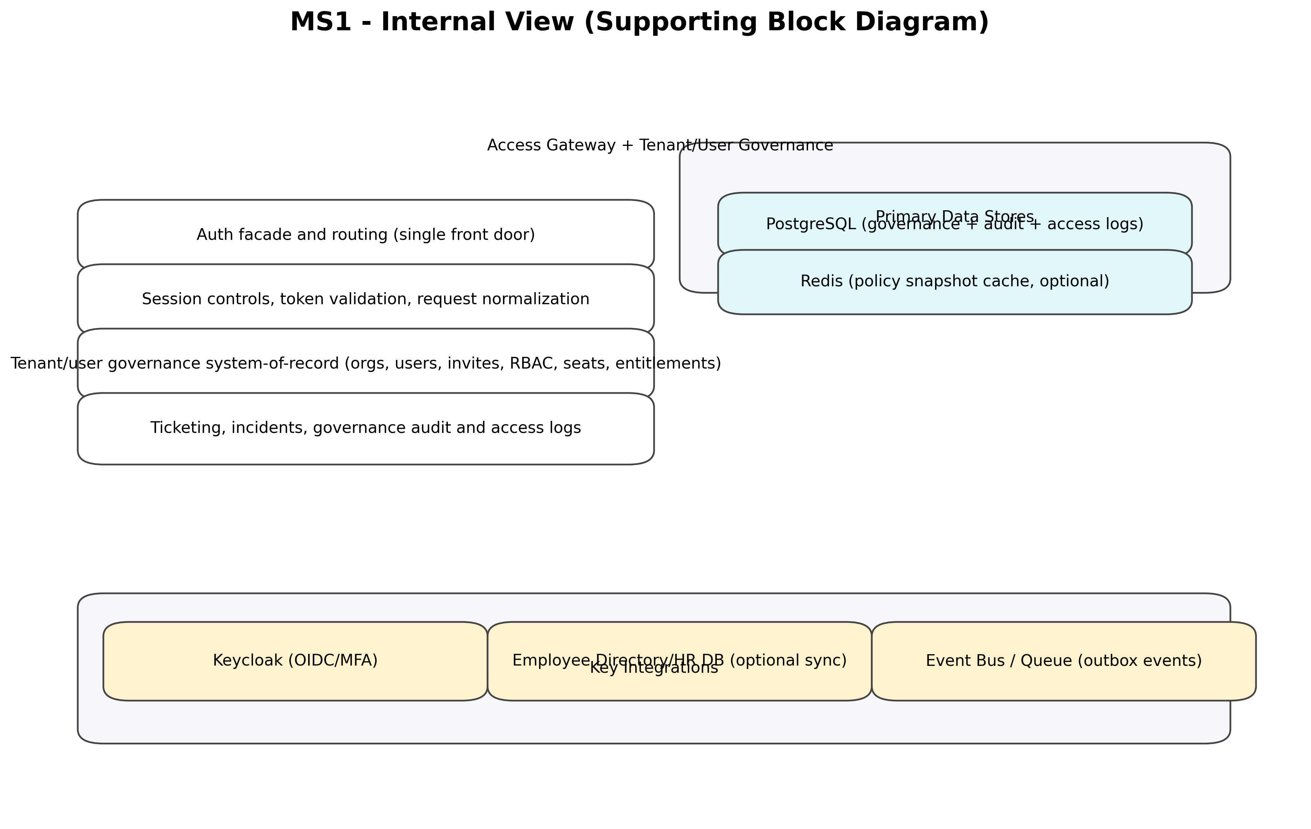
Figure 6-1. MS1 internal view
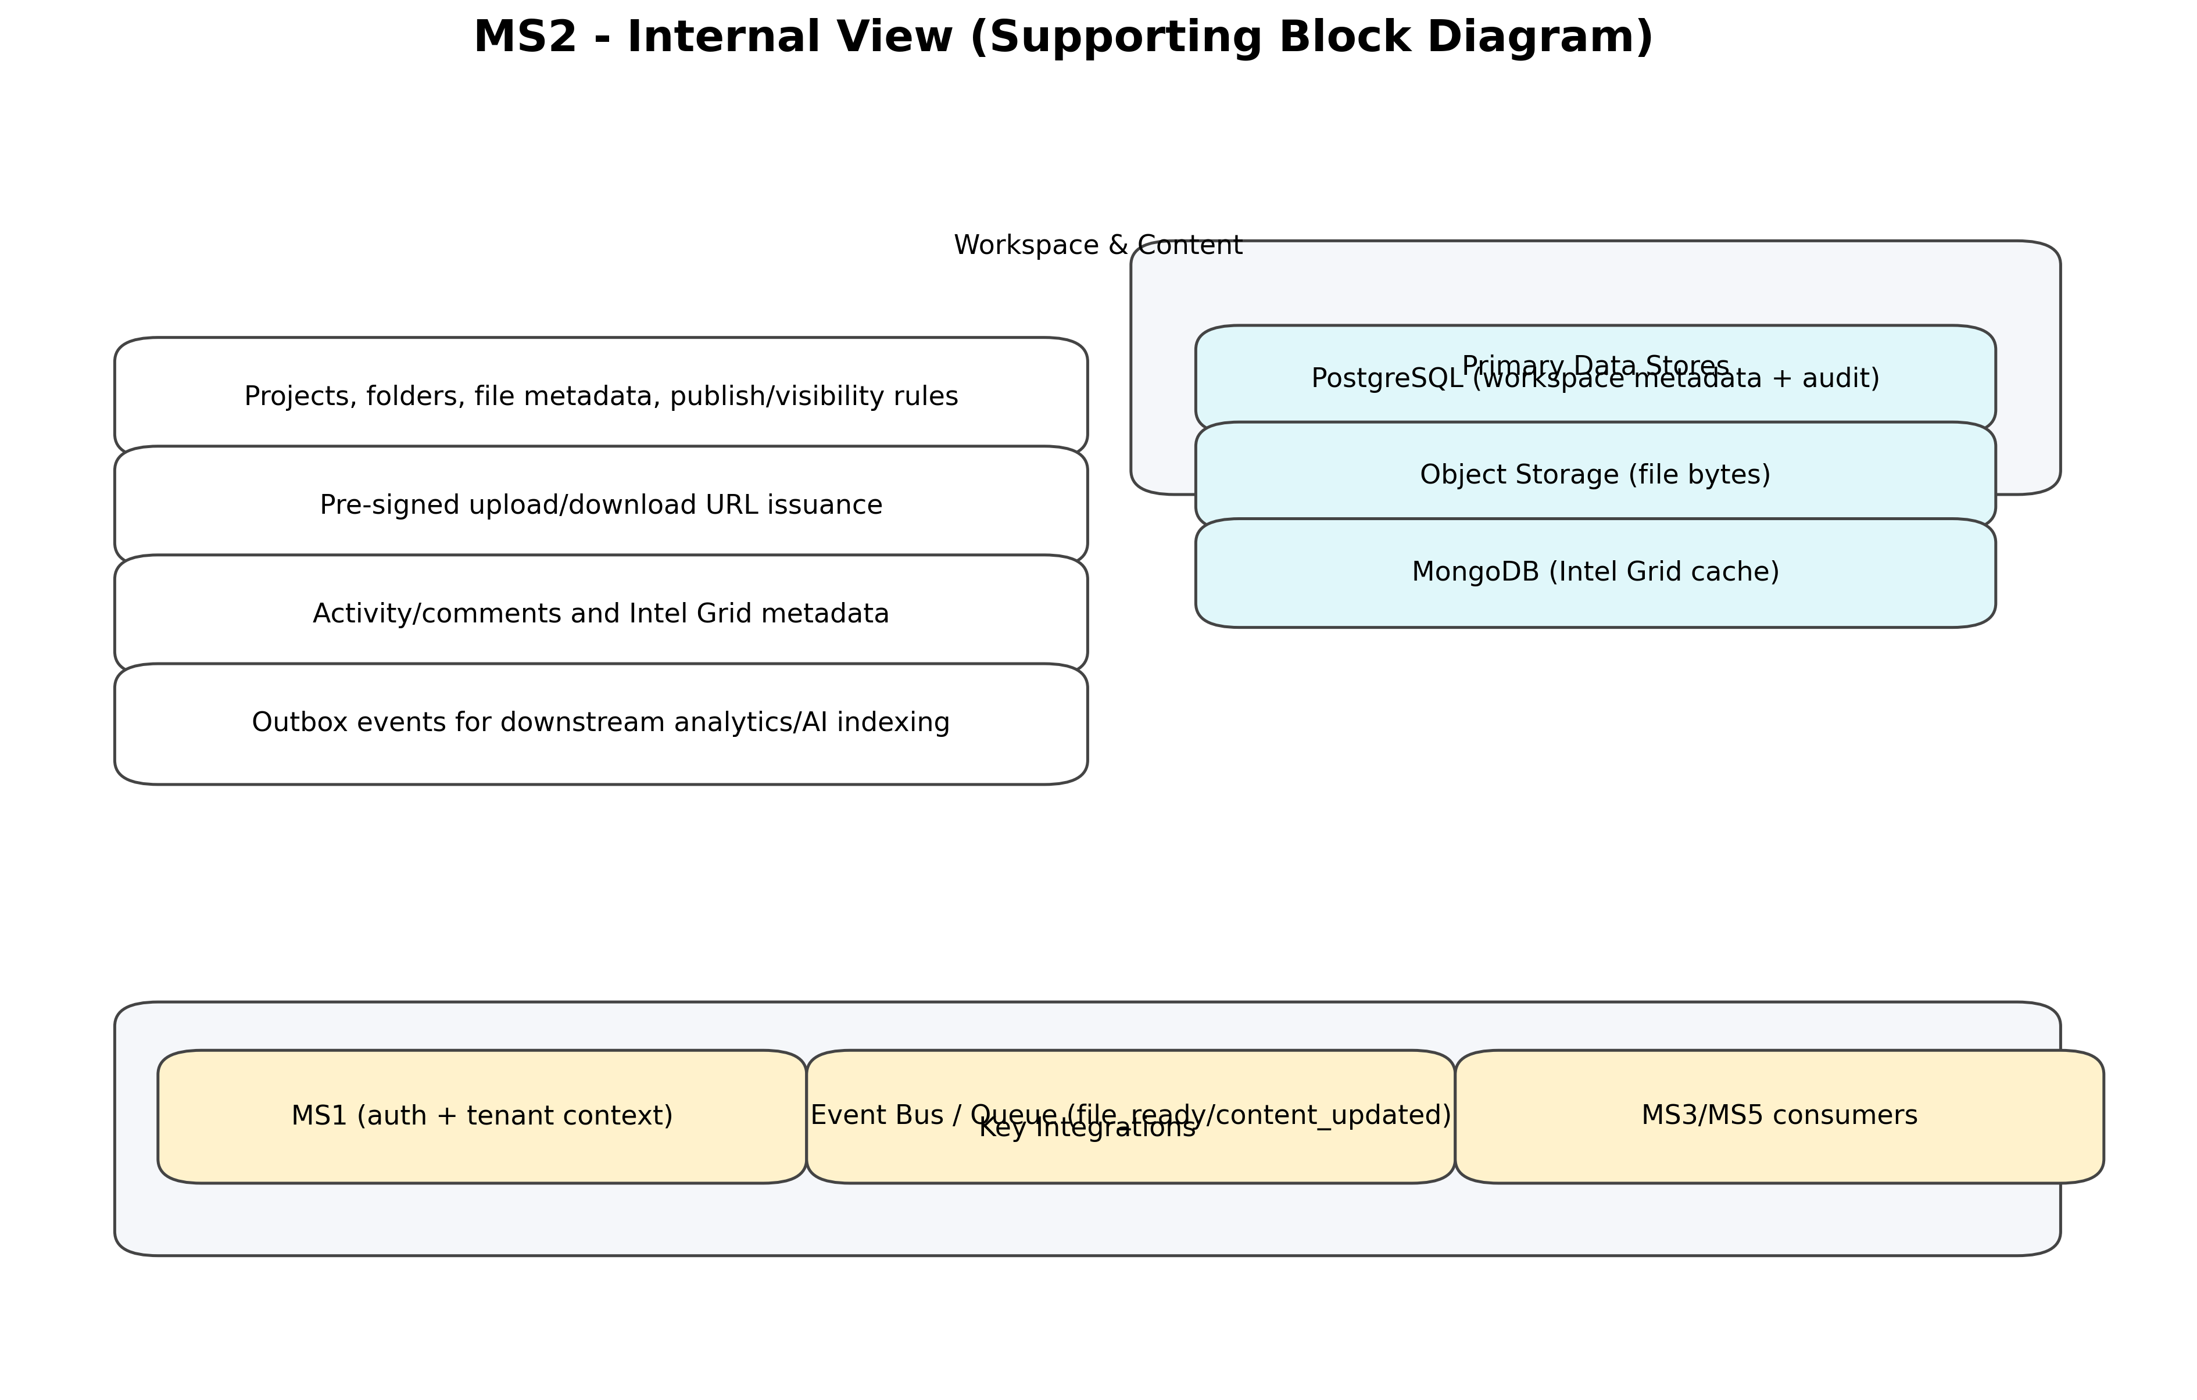
Figure 6-2. MS2 internal view
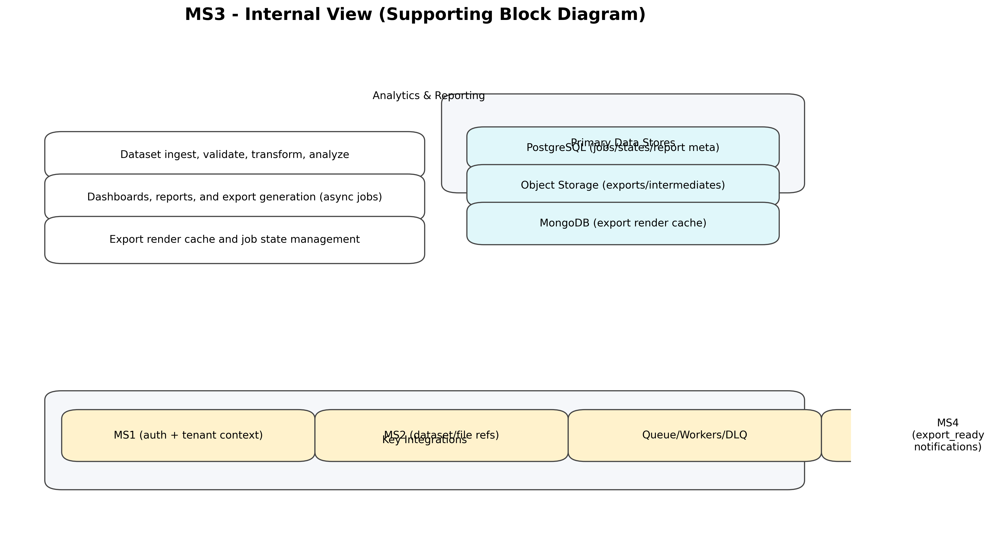
Figure 6-3. MS3 internal view
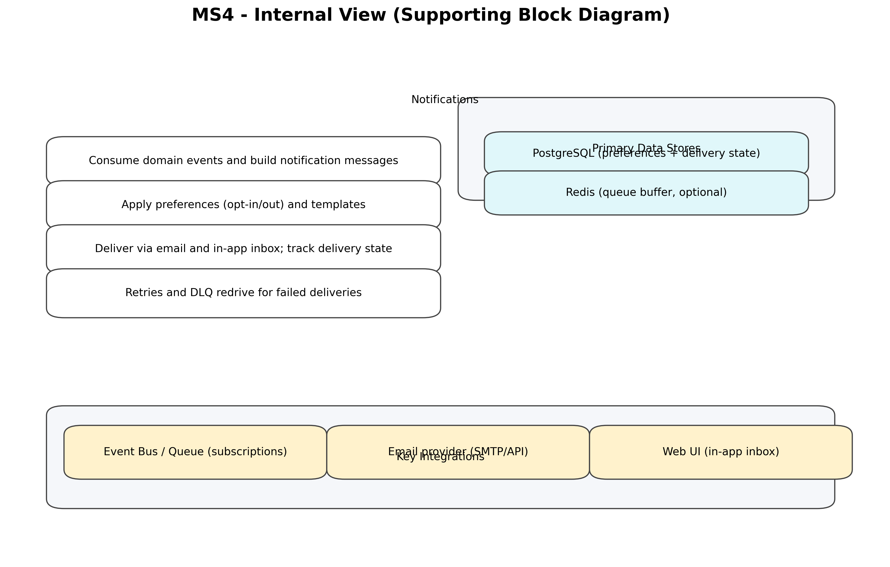
Figure 6-4. MS4 internal view
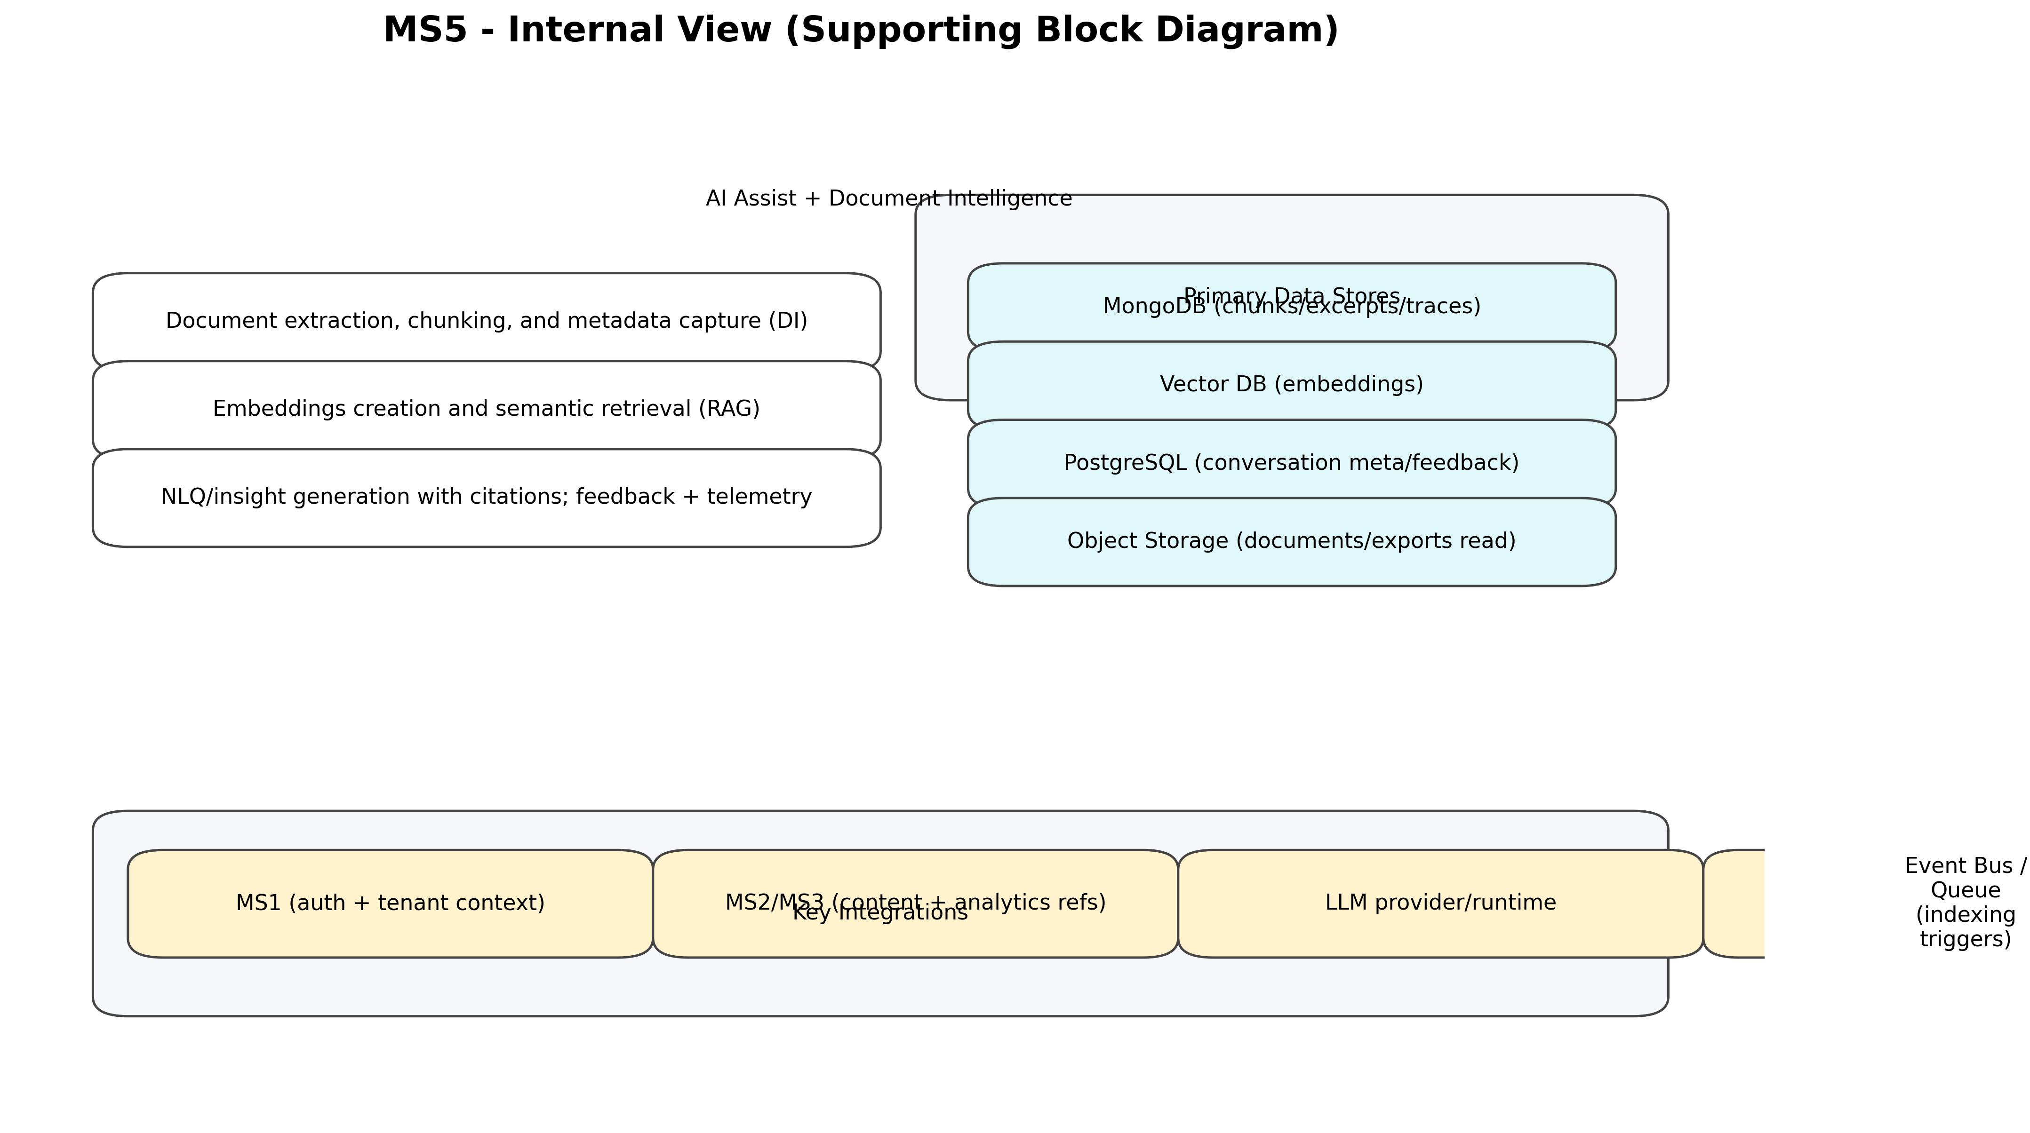
Figure 6-5. MS5 internal view

Appendix A - Revision History
Version | Date | Prepared By | Description of Change | Approved By
2.0 | 20-01-26 | Saurabh Rai | Realigned to new 5-microservice boundaries and added supporting diagrams.
1.0 | 02-01-26 | Saurabh Rai | Initial version (legacy boundaries).

