API Sequence Flows – Version 2.0 (New 5-Microservice Architecture)

Scenario 0 – App Bootstrap & Tenant Context
- Common entry point for all roles, establishes tenant and project scope for downstream calls.
- Authorization and entitlement checks are enforced at MS1 using governance policy data and cached policy snapshots.

Data footprint
- PostgreSQL (MS1): tenants/organizations, subscriptions/entitlements, users, roles/permissions, policy snapshots
- PostgreSQL (MS2): projects, folders (for default structure lookup), published visibility
- PostgreSQL (MS1): access_logs/audit_logs (request stamping and auditability)

Sequence steps (tabular)
Step | Initiator | API / Event (representative) | Service Interaction | Data/Queue Interaction | Output
0.1 | User → UI | Open app / select Organization + Project | UI → MS1: GET /me, UI → MS1: GET /organizations, UI → MS1 → MS2: GET /projects (scoped) | PG(MS1): users/orgs/roles/subscriptions, PG(MS2): projects | UI shows org/project selector applies default selection rules filters by role + subscription entitlement.
0.2 | UI → MS1 | GET /session/context | UI → MS1: GET /session/context , MS1 validates token and returns effective tenant + policy snapshot | PG(MS1): users/orgs/roles/subscriptions , cache: policy snapshot | If org/project not selected, UI must prompt selection (FRD fallback).

Sequence diagram
The following diagram is a visual representation of the step table above (actors, services, and key async events).
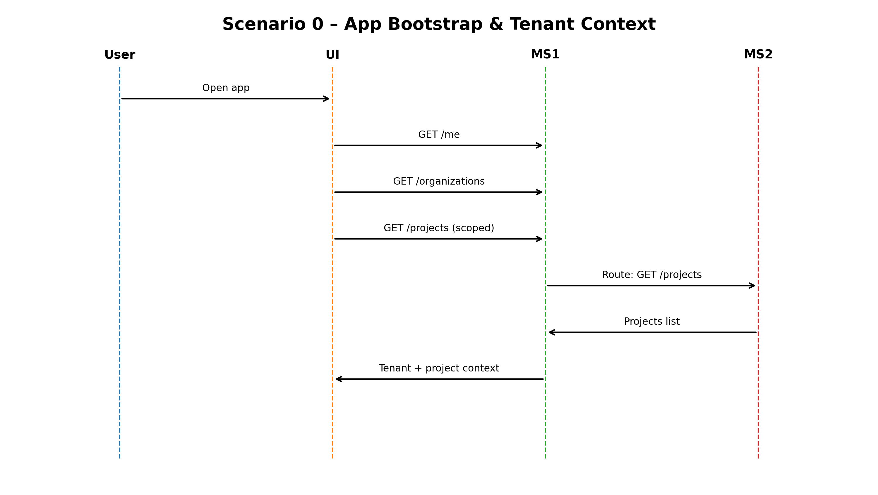
Figure: Scenario 0 – App Bootstrap & Tenant Context – Sequence Diagram

Scenario 1 – Invitation-based Onboarding, Login & Session Establishment (Keycloak)
- Covers invite creation, invite validation/expiry, acceptance, Keycloak login/MFA, and session establishment.
- Invite lifecycle and login audit are recorded in MS1, notification delivery is handled by MS4.

Data footprint
- PostgreSQL (MS1): user_invitations (token, expiry, resend count, status)
- PostgreSQL (MS1): users (status: active/locked/expired/archived), access_logs, audit_logs
- PostgreSQL (MS4): notifications, notification_preferences, Queue/Workers for email delivery

Sequence steps (tabular)
Step | Initiator | API / Event (representative) | Service Interaction | Data/Queue Interaction | Output
1.1 | JC Admin/Client Admin → UI | Invite user | UI → MS1: POST /users/invitations (governance) , MS1 publishes invite_created event | PG(MS1): user_invitations, audit_logs , Event Bus → MS4 , Queue: email_notifications | Invite email generated invitation expiry and resend supported.
1.2 | Invited user → UI | Open invite link | UI → MS1: GET /invitations/{token} , MS1 validates token/expiry and returns invite context | PG(MS1): user_invitations | If link expired/invalid → show error allow resend through admin per FRD.
1.3 | Invited user → UI | Create password + proceed | UI redirects to Keycloak (on‑prem) via MS1 OIDC flow (accept invite / set password if applicable) | Keycloak: credential/MFA policy (IdP-owned) | Keycloak setup is out-of-scope integration is in-scope.
1.4 | User → UI | Login + MFA (OTP) | UI → MS1: /auth/start , MS1 ↔ Keycloak: token exchange , MS1 enforces lock/MFA/session policies | PG(MS1): access_logs/audit_logs , cache refresh | Account lock policy enforced at MS1 (3 attempts temporary, 5 permanent JC Admin exempt).
1.5 | MS1 → MS2 | POST /auth/session | UI → MS1: POST /auth/session , MS1 records login event and returns role/tenant context | PG(MS1): access_logs/audit_logs , users status updated if needed | Session established, UI receives effective roles/permissions and tenant context

Sequence diagram
The following diagram is a visual representation of the step table above (actors, services, and key async events).
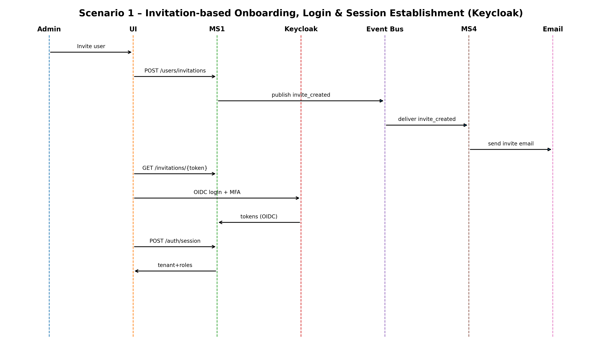
Figure: Scenario 1 – Invitation-based Onboarding, Login & Session Establishment (Keycloak) – Sequence Diagram

Scenario 2 – Authorization/Entitlements (RBAC + Subscription + Seat + IP/Concurrent Controls)
- Cross-cutting checks applied to all scenarios: RBAC, entitlements/subscription, seats, IP restrictions, and concurrent sessions.
- Seat enforcement applies to Client Admin invitations (e.g., Editor/Viewer caps) and is enforced in MS1.

Data footprint
- PostgreSQL (MS1): roles, permissions, role_permissions, user_roles (RBAC matrix)
- PostgreSQL (MS1): subscriptions/entitlements (feature gating, expiry)
- PostgreSQL (MS1): access_logs/audit_logs (IP/concurrency and security telemetry)

Sequence steps (tabular)
Step | Initiator | API / Event (representative) | Service Interaction | Data/Queue Interaction | Output
2.1 | UI → MS1 | Any protected API call | MS1 validates JWT + tenant context, loads RBAC/entitlements from MS1 policy store/cache (no cross-service call) | PG(MS1): RBAC + entitlements , cache: policy snapshot | Returns allow/deny with reason (role, seat, subscription, IP rule, concurrent rule).
2.2 | MS1 | IP restriction check | MS1 applies IP restrictions (admin portal + client portal) per SOW, logs deny reasons | PG(MS1): access_logs | If IP not allowed → deny log event optional incident creation.
2.3 | MS1 | Concurrent login check | MS1 enforces concurrent session limits per user type (SOW) using session telemetry | PG(MS1): access_logs/session telemetry | On violation → deny or force logout older session (policy-defined).
2.4 | Client Admin → UI | Invite Editor/Viewer | MS1 enforces seat caps before allowing Client Admin to invite Editors/Viewers | PG(MS1): seat_allocations/usage , audit_logs | Invite accepted/rejected with seat-limit reason

Sequence diagram
The following diagram is a visual representation of the step table above (actors, services, and key async events).
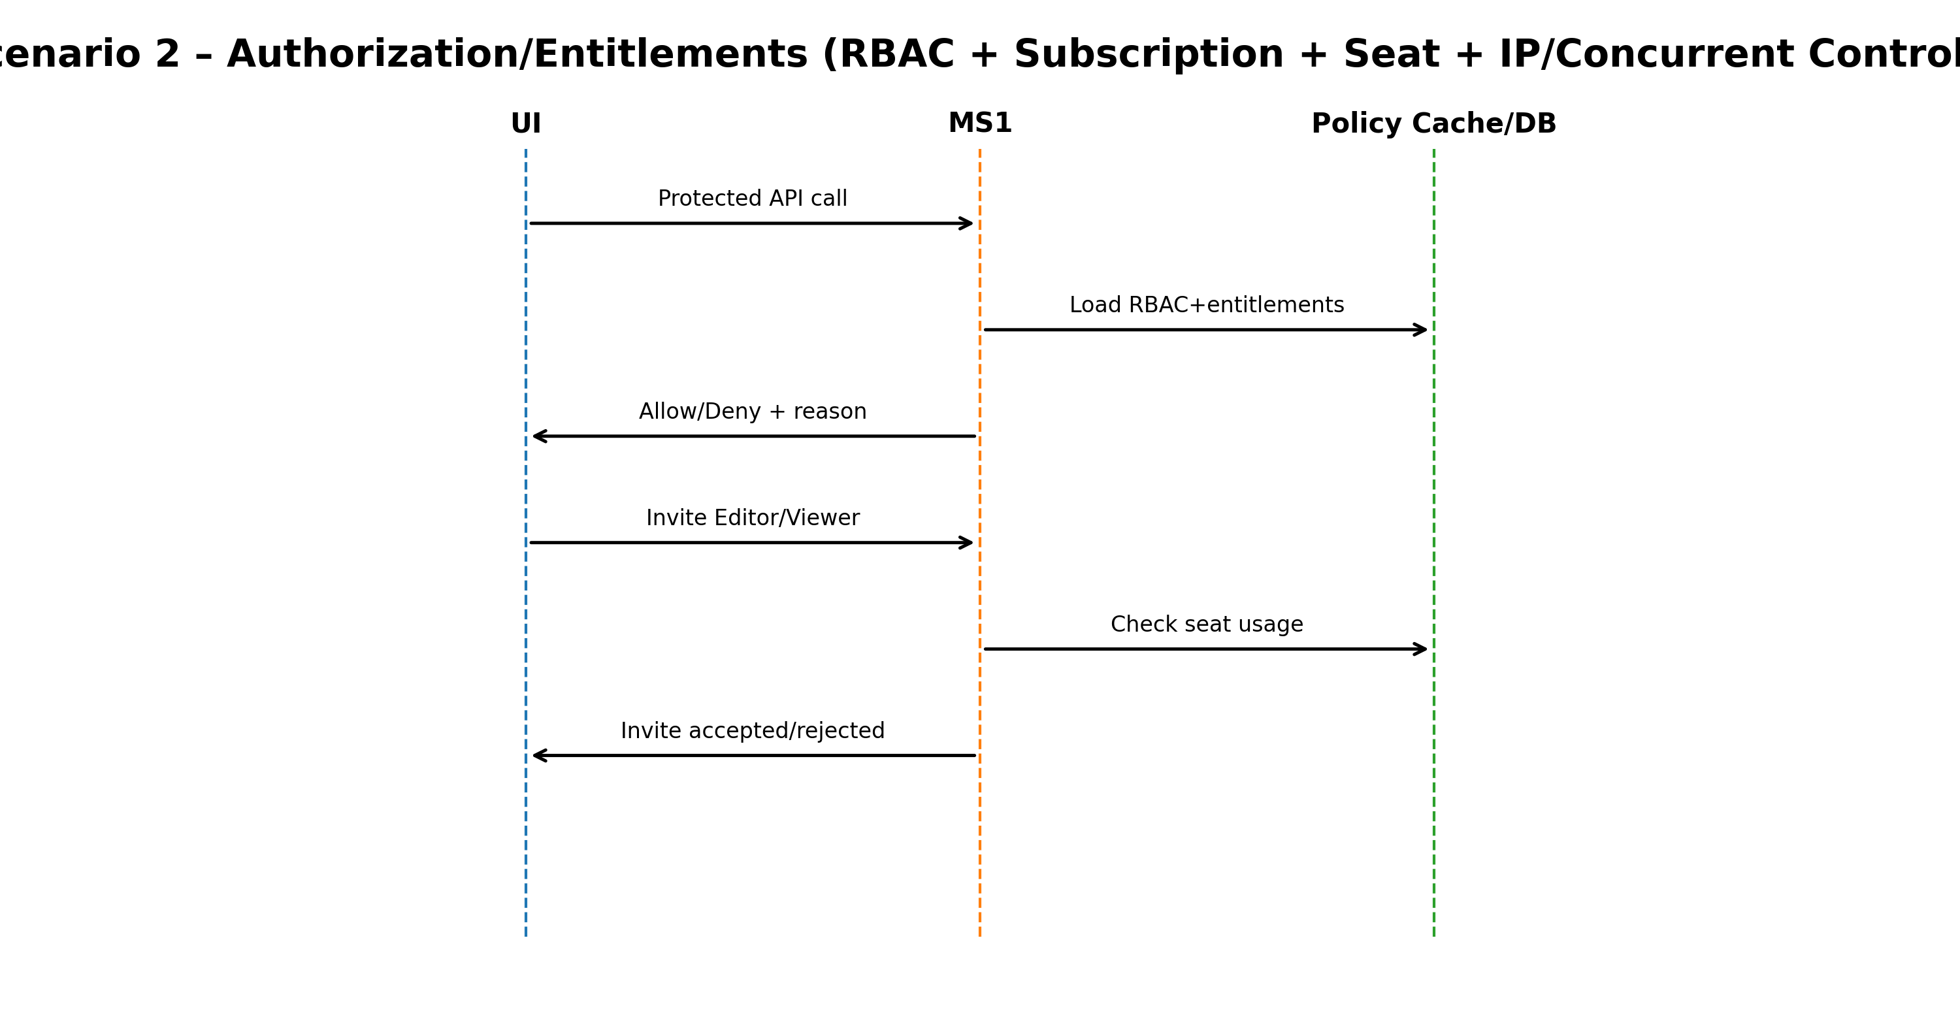
Figure: Scenario 2 – Authorization/Entitlements (RBAC + Subscription + Seat + IP/Concurrent Controls) – Sequence Diagram

Scenario 3 – Company, User, Ticketing, and Incident Administration (JC Admin + Client Admin)
- Covers company/org administration, user lifecycle and invitations, ticketing/pending requests, and incident workflows (governance operations).
- RBAC, entitlements, seat constraints, and auditability are enforced centrally in MS1.

Data footprint
- PostgreSQL (MS1): organizations, users, user_invitations, roles, user_roles, subscriptions, tickets, incidents, audit_logs
- PostgreSQL (MS4): notifications (for governance lifecycle events)

Sequence steps (tabular)
Step | Initiator | API / Event (representative) | Service Interaction | Data/Queue Interaction | Output
3.1 | JC Admin → UI | Create Company/Client | UI → MS1: POST /companies | PG(MS1): organizations PG(MS1): audit_logs | Stores company name, domain, logo metadata appears in company list.
3.2 | JC Admin → UI | Edit/Delete Company | UI → MS1: PATCH/DELETE /companies/{id} | PG(MS1): organizations PG(MS1): audit_logs | Edit/delete affects company record only (not users).
3.3 | JC Admin → UI | Create/Invite Client Users | UI → MS1: POST /client-users/invite | PG(MS1): users, user_invitations, user_roles audit_logs | Supports Active/Expired/Revoked state management and audit tracking.
3.4 | JC Admin → UI | Create/Invite JC Users | UI → MS1: POST /jc-users/invite | PG(MS1): users, user_invitations employee-code lookup audit_logs | Employee code provided remaining details fetched from DB per FRD.
3.5 | Client Admin → UI | Invite Editors/Viewers | UI → MS1: POST /org-users/invite | PG(MS1): users, user_invitations, user_roles seat validation audit_logs | Org-scoped user administration only editor/viewer roles assigned by client admin.

Sequence diagram
The following diagram is a visual representation of the step table above (actors, services, and key async events).
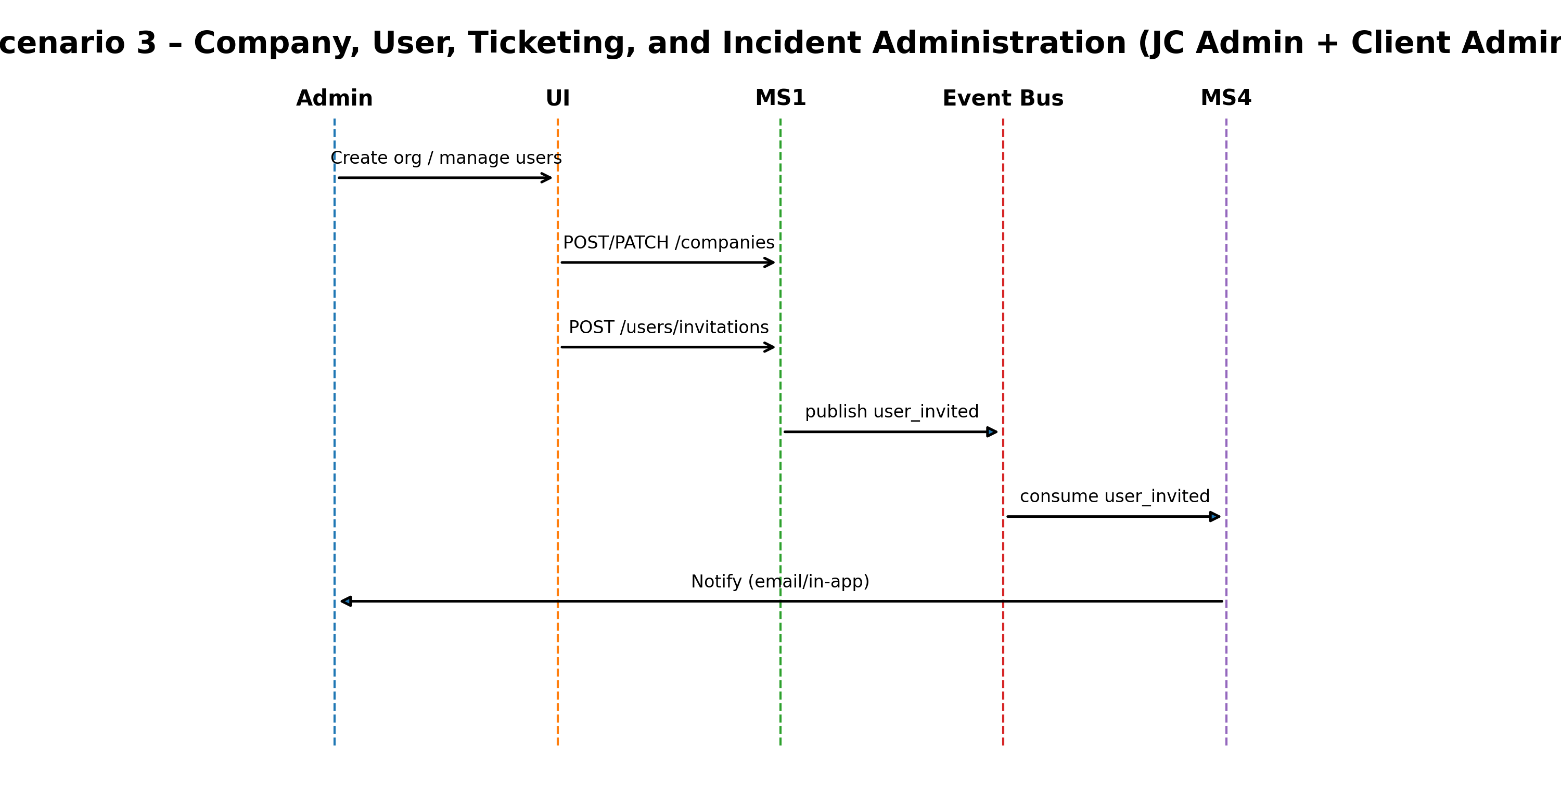
Figure: Scenario 3 – Company, User, Ticketing, and Incident Administration (JC Admin + Client Admin) – Sequence Diagram

Scenario 4 – Project Lifecycle, Publish Visibility, and Client My Project Page
- Covers project create/edit/delete/publish and the publish visibility rule driving client access to published projects.
- Default folder structure and My Project Page browsing are handled within MS2 (Workspace & Content).

Data footprint
- PostgreSQL (MS2): projects, project_members (if used), folders, files, content_activity_logs, recycle_bin_items
- PostgreSQL (MS3): dashboards/reports metadata (for card routing), export job references (where linked)
- PostgreSQL (MS1): audit_logs (governance and publish actions)

Sequence steps (tabular)
Step | Initiator | API / Event (representative) | Service Interaction | Data/Queue Interaction | Output
4.1 | User → UI | Create Project | UI → MS1 → MS2: POST /projects | MS1 → MS1 entitlement check PG: projects PG: content_activity_logs audit_logs | Creates project with metadata role-based restrictions apply.
4.2 | User → UI | Edit Project metadata | UI → MS1 → MS2: PATCH /projects/{id} | PG: projects content_activity_logs | Updates project name/description/POC etc (where permitted).
4.3 | User → UI | Delete Project | UI → MS1 → MS2: DELETE /projects/{id} | PG: projects recycle_bin_items (soft-delete where applicable) activity logs | Delete allowed for JC Admin/JC PM/Client Admin disallowed for Client Editor/Viewer.
4.4 | JC Admin/JC PM/Client Admin/Editor → UI | Publish Project | UI → MS1 → MS2: POST /projects/{id}/publish | PG: projects (publish flag) content_activity_logs | FRD rule: project not visible to clients until published (publish controls My Project Page).
4.5 | Client user → UI | Open My Project Page | UI → MS1 → MS2: GET /published-projects MS3 for linked analytics/report artifacts | PG: projects folders/files dashboards/reports activity logs | Cards route to Report Studio/Dataset Viewer/Media Viewer/internal tools default folders visible.

Sequence diagram
The following diagram is a visual representation of the step table above (actors, services, and key async events).
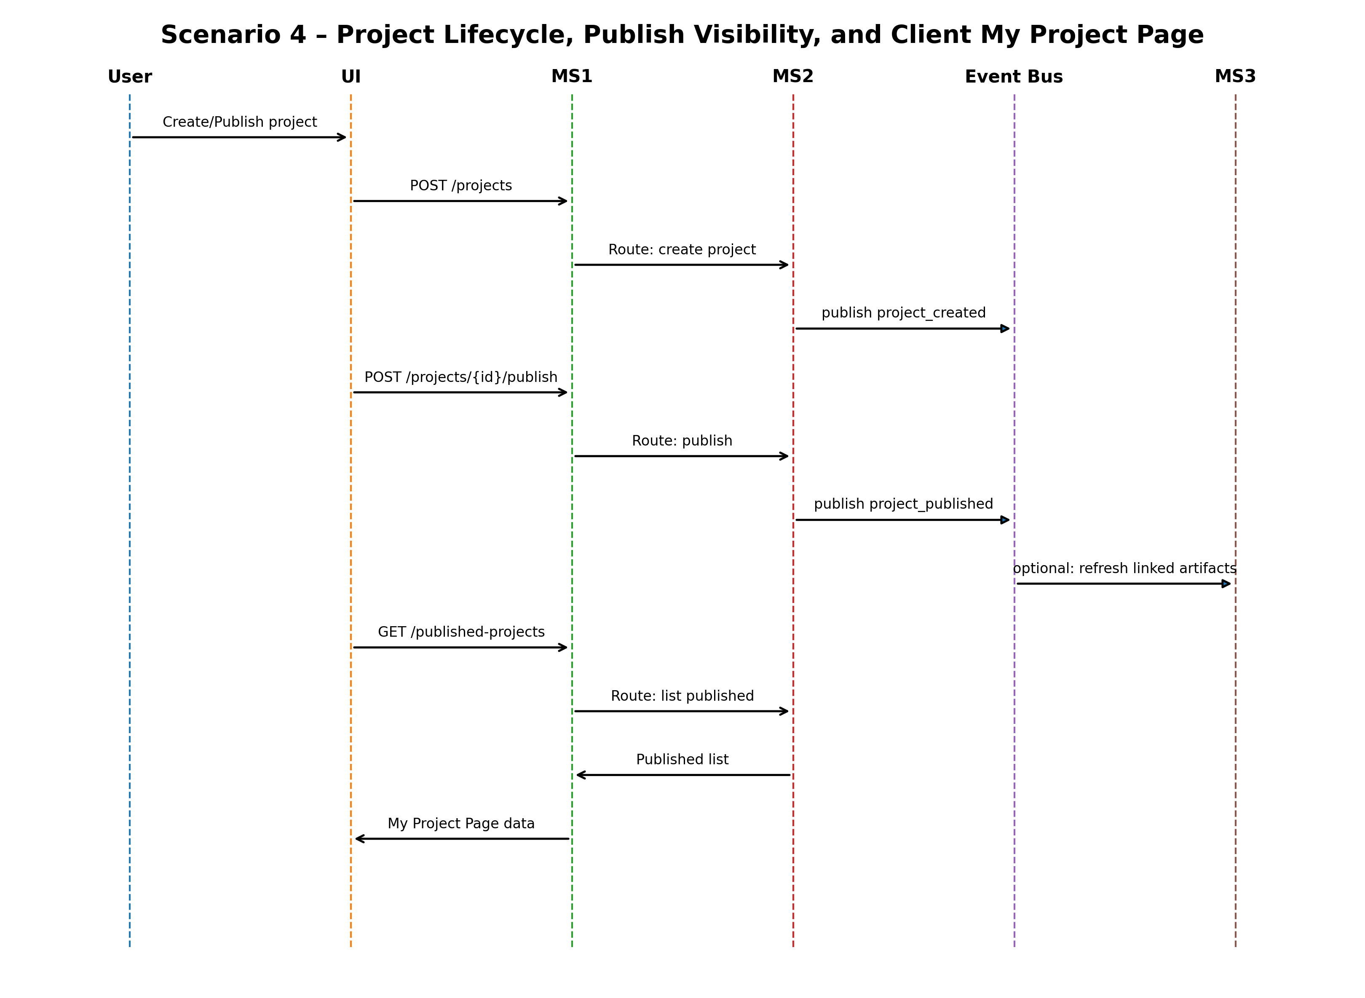
Figure: Scenario 4 – Project Lifecycle, Publish Visibility, and Client My Project Page – Sequence Diagram

Scenario 5 – Folder & File Operations (Uploads, Integrations, Versioning, Activity Logs)
- Includes folder/file lifecycle, versioning, soft delete/recycle bin patterns, and content activity logging.
- Integrations (cloud drives/URL/survey sources) are orchestrated by MS2, downstream pipelines consume content events.

Data footprint
- PostgreSQL (MS2): folders, files, file_versions, tags/file_tags, content_activity_logs, recycle_bin_items, audit_logs
- Object Storage: file binaries (uploads/downloads via pre-signed URLs)
- MongoDB (MS5 optional): file_text_extractions, Vector Store: vector_chunks (embeddings) , caches for intel grid/extracts
- Queues/Event Bus: content events (file_ready/content_updated) to MS3/MS5

Sequence steps (tabular)
Step | Initiator | API / Event (representative) | Service Interaction | Data/Queue Interaction | Output
5.1 | User → UI | Create/Rename/Delete Folder | UI → MS1 → MS2: POST/PATCH/DELETE /folders | PG: folders content_activity_logs audit_logs | Folder CRUD allowed per role delete restricted for Client Editor/Viewer.
5.2 | User → UI | Upload files (drag-drop / bulk) | UI → MS1 → MS2: POST /files/upload/init | PG: files file_versions content_activity_logs Object Storage: presigned upload | Supports 10GB per file, supported format checks, progress tracking.
5.3 | UI → Object Storage | PUT object (binary) | Direct upload using pre-signed URL | Object Storage: store binary MS3 receives completion callback | On failure → retry/resume per fallback logs maintained.
5.4 | MS3 → MS4 | Dataset ingestion trigger (async) | MS2 publishes file_ready/content_updated → Event Bus → MS3 starts dataset ingest job | Event Bus/Queue: ingest_jobs , MS3 reads from Object Storage , stores artifacts in PG(MS3) | Dataset ingest queued, job status available in Analytics
5.5 | MS3 → MS5 | Text extraction / indexing (async) | MS2 publishes file_ready/content_updated → Event Bus → MS5 runs DI extraction/chunking/embedding | Queue: ai_jobs , Mongo/Vector Store updates | Content becomes searchable in AI Assist with citations
5.6 | User → UI | Download file | UI → MS1 → MS2: GET /files/{id}/download-url | Object Storage: presigned download access logged | Download allowed for all client roles view-only roles cannot edit/delete.
5.7 | User → UI | Edit/Delete file metadata | UI → MS1 → MS2: PATCH/DELETE /files/{id} | PG: files file_versions recycle_bin_items content_activity_logs | Delete restricted for Client Editor/Viewer versioning maintained.

Sequence diagram
The following diagram is a visual representation of the step table above (actors, services, and key async events).
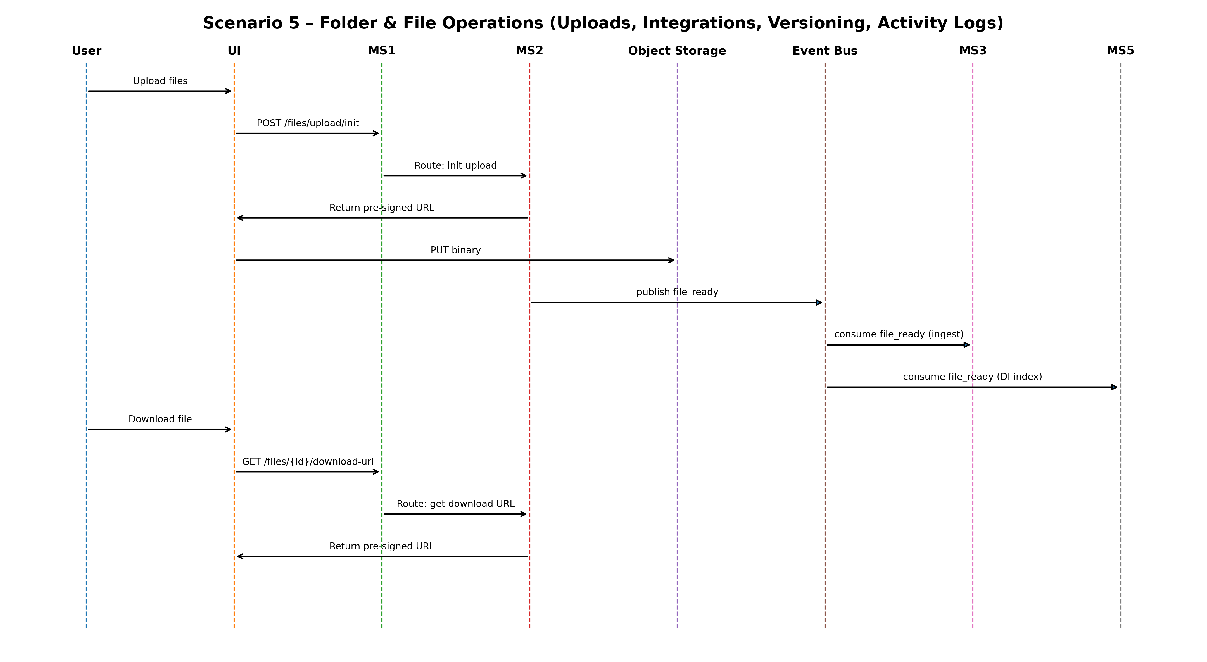
Figure: Scenario 5 – Folder & File Operations (Uploads, Integrations, Versioning, Activity Logs) – Sequence Diagram

Scenario 6 – Analytics, Dashboards, Report Studio, and Exports
- Long-running analytics and exports run asynchronously via jobs/queues, UI polls job status or consumes completion notifications.
- Export formats include Excel, PowerPoint, CSV, Raw data, PDF, JPEG, PNG as per FRD.

Data footprint
- PostgreSQL (MS3): dashboards, dashboard_widgets, reports, report_sections, export_jobs, job_status, audit_logs
- MongoDB (MS3): export_render_cache (large render payloads) (if used)
- Object Storage: exported artifacts (PDF/PPTX/XLSX/PNG etc.)
- Queues/Workers: analysis_jobs, export_jobs

Sequence steps (tabular)
Step | Initiator | API / Event (representative) | Service Interaction | Data/Queue Interaction | Output
6.1 | User → UI | Run analysis / cleaning | UI → MS1 → MS3: POST /analysis/run | MS2 reads dataset from MS2 stores artifacts | Supported: correlation/regression/factor/time-series/ranking/advanced analytics.
6.2 | MS4 | Persist results | Internal | PG: dashboards, reports, analysis artifacts audit_logs | Results available for visualization and reporting.
6.3 | User → UI | Create/Edit Dashboard | UI → MS1 → MS3: POST/PATCH /dashboards | PG: dashboards, dashboard_widgets audit logs | Edit allowed for JC Admin/JC PM/Client Admin/Client Editor viewer read-only.
6.4 | User → UI | Report Studio – Generate report | UI → MS1 → MS3: POST /reports/generate | PG: reports, report_sections export_jobs | Structured research outputs templates supported (as per design).
6.5 | User → UI | Export (PDF/PPT/Excel/CSV/PNG/JPEG/Raw) | UI → MS1 → MS3: POST /exports | Queue: export_jobs Mongo: export_render_cache Object Storage: export files | Async export UI polls job status job failures surfaced on dashboard.

Sequence diagram
The following diagram is a visual representation of the step table above (actors, services, and key async events).
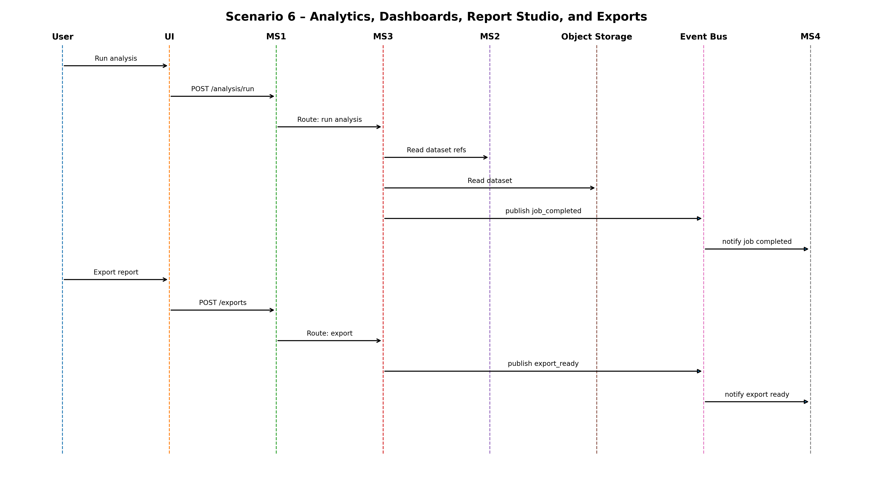
Figure: Scenario 6 – Analytics, Dashboards, Report Studio, and Exports – Sequence Diagram

Scenario 7 – AI Assist / Insight Engine + Document Intelligence (NLQ, Sources, AI Reports, Feedback)
- MS5 provides AI Assist + DI (extraction, chunking, embeddings, RAG) and enforces safety/guardrails and tenant scoping.
- Fallback patterns: if AI cannot interpret the question or no relevant data exists, return guidance and next steps.

Data footprint
- PostgreSQL (MS5): ai_conversations, ai_messages, ai_queries, insights, insight_sources, feedback
- MongoDB (MS5): extraction traces/chunks (if used), intel_grid_cache (if used)
- Vector Store: vector_chunks (semantic search/RAG) , Queue: ai_jobs (index/query pipelines)
- Object Storage: source documents and derived artifacts referenced by citations

Sequence steps (tabular)
Step | Initiator | API / Event (representative) | Service Interaction | Data/Queue Interaction | Output
7.1 | User → UI | Ask a question (NLQ) | UI → MS1 → MS5: POST /ai/query | MS5 stores conversation retrieves relevant sources via vector store + metadata | Returns answer + sources + further reading. Safety boundaries enforced.
7.2 | MS5 ↔ Stores | Retrieve content | MS5 performs vector search (Vector Store) + fetches source docs (Object Storage) + validates scope via MS1 claims, may query MS2/MS3 metadata | Vector Store + Object Storage + PG(MS5) traces | Explainability: maintain link between answer and source documents.
7.3 | User → UI | Promote to Insight | UI → MS1 → MS5: POST /insights | PG: insights, insight_sources audit logs | Stores insight with confidence scoring and traceability.
7.4 | User → UI | Generate AI report from insights | UI → MS1 → MS5: POST /ai/report-from-insights | Queue: ai_jobs PG: reports/report_sections Object Storage export optional | Async status surfaced failures handled via fallback mechanisms.
7.5 | User → UI | Feedback / rating | UI → MS1 → MS5: POST /ai/feedback | PG/Mongo: ai_queries/ai_messages audit logs | Feedback loop stored for governance and improvement.

Sequence diagram
The following diagram is a visual representation of the step table above (actors, services, and key async events).
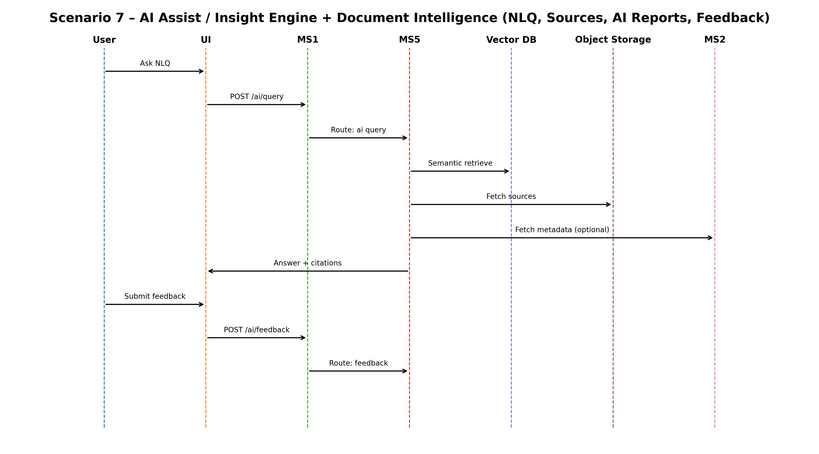
Figure: Scenario 7 – AI Assist / Insight Engine + Document Intelligence (NLQ, Sources, AI Reports, Feedback) – Sequence Diagram

Scenario 8 – Notifications (In-app + Email) and Operational Widgets
- Notifications cover: invitations, link expiry, account expiry warnings, account deletion, login events, troubleshooting updates, payment status changes, incident alerts, job failures/queue errors.
- Operational widgets (AI activity logs, queue/job failures, data upload progress) are fed by domain events and job status data.

Data footprint
- PostgreSQL (MS4): notifications, notification_preferences, delivery_attempts
- Queue/Workers: email_notifications + retry/DLQ
- PostgreSQL (MS1/MS3/MS5): operational telemetry sources (access logs, job failures, AI failures) surfaced via widgets

Sequence steps (tabular)
Step | Initiator | API / Event (representative) | Service Interaction | Data/Queue Interaction | Output
8.1 | MS2/MS3/MS4/MS5 | Publish domain event (invite accepted / expiry / deletion / job failure) | Producer service writes Outbox → Event Bus , MS4 consumes event and creates notification | Outbox tables in producer DBs , PG(MS4): notifications , Queue: email_notifications | Notification created (in-app) and/or queued for email
8.2 | MS5 Worker | Send email | MS4 Worker → Email Provider (SMTP/API) , updates delivery status | PG(MS4): delivery_attempts , Queue/DLQ: retries | FRD fallback: retries, manual resend, and status visibility.
8.3 | UI → MS5 | Notification center | UI → MS1 → MS4: GET /notifications (paged) , mark read/unread | PG(MS4): notifications/notification_preferences | Shows unread/read links to relevant module (project, incident, invoice, report).

Sequence diagram
The following diagram is a visual representation of the step table above (actors, services, and key async events).
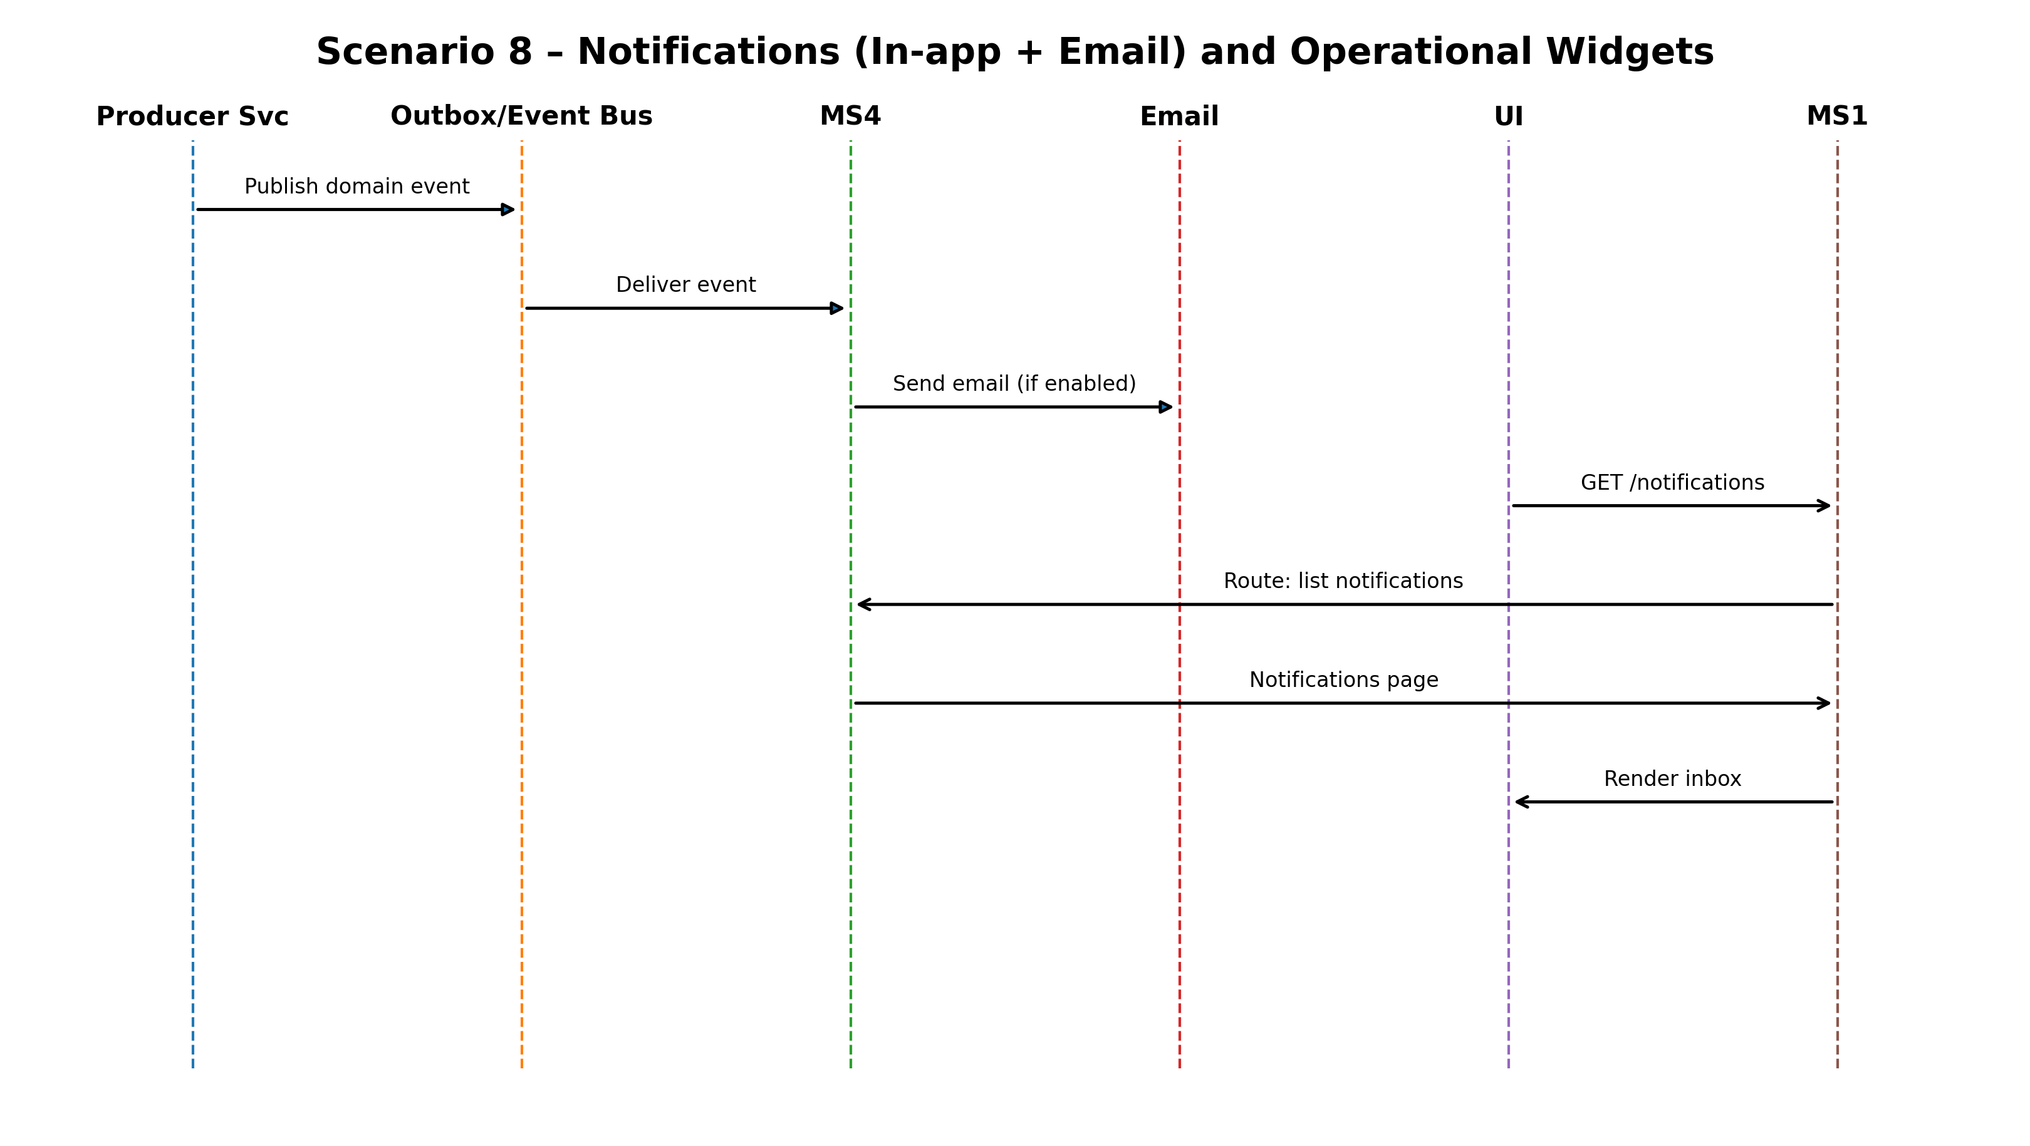
Figure: Scenario 8 – Notifications (In-app + Email) and Operational Widgets – Sequence Diagram

Scenario 9 – Security & Incident Monitoring (Detection, Review, Action)
- Security events are driven by login failures, exports/downloads, IP anomalies, and policy violations.
- Blocking an IP affects MS1 access enforcement, incident state changes can trigger MS4 notifications.

Data footprint
- PostgreSQL (MS1): access_logs, audit_logs, incidents, tickets, ip_blocklist (if used)
- PostgreSQL (MS4): notifications (incident alerts/updates) (if enabled)

Sequence steps (tabular)
Step | Initiator | API / Event (representative) | Service Interaction | Data/Queue Interaction | Output
9.1 | MS1/MS2 | Security telemetry | MS1 stamps every request (user/tenant/IP) and persists access telemetry, governance/security signals are recorded in MS1 | PG(MS1): access_logs, audit_logs | Inputs for anomaly detection and incident investigation.
9.2 | JC Admin → UI | View security alerts | UI → MS1: GET /security/alerts (incidents/tickets) | PG(MS1): incidents, tickets, access_logs | Alert types include failed login, bot activity, data export, location anomaly.
9.3 | JC Admin | Take action (block IP / open ticket) | UI → MS1: POST /security/actions (block IP / open ticket / update incident) , MS1 publishes incident_updated | PG(MS1): ip_blocklist/incidents/tickets , Event Bus → MS4 (optional notify) | Action applied, enforcement takes effect immediately at MS1 edge

Sequence diagram
The following diagram is a visual representation of the step table above (actors, services, and key async events).
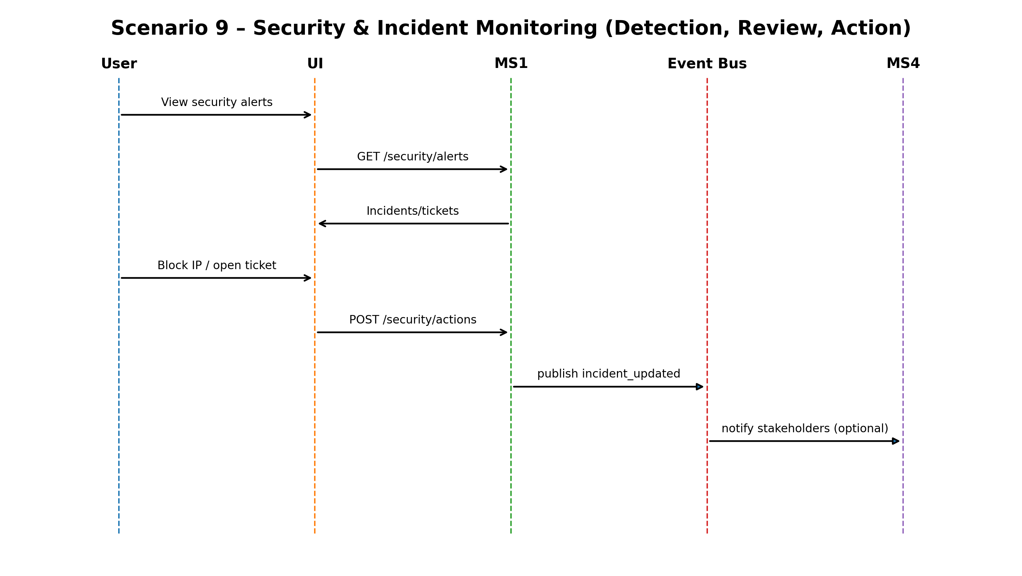
Figure: Scenario 9 – Security & Incident Monitoring (Detection, Review, Action) – Sequence Diagram

Scenario 10 – Billing & Subscriptions (Plans, Payments, Notifications, Exports)
- Billing/subscription management is JC Admin only, clients are notified as needed.
- Subscription expiry triggers access gating and advance notifications.

Data footprint
- PostgreSQL (MS1): subscription_plans, subscriptions, invoices, payments, audit_logs
- PostgreSQL (MS4): notifications (payment status / expiry / deactivation notices)
- Object Storage: billing exports (if generated) , optionally MS3 export pipeline for heavy rendering

Sequence steps (tabular)
Step | Initiator | API / Event (representative) | Service Interaction | Data/Queue Interaction | Output
10.1 | JC Admin → UI | Manage subscriptions/plans | UI → MS1: POST/PATCH /subscriptions (plans, entitlements, expiry) | PG(MS1): subscription_plans, subscriptions, audit_logs | Enables module access and expiry enforcement.
10.2 | JC Admin → UI | Track invoices and payments | UI → MS1: GET /invoices , POST /payments (manual tracking) | PG(MS1): invoices, payments, audit_logs | Statuses include Paid, Past due, Partial Payment, Trial partial payments supported.
10.3 | MS2 → MS5 | Payment status changed | MS1 publishes payment_status_changed → Event Bus → MS4 notifies stakeholders | Event Bus , PG(MS4): notifications , Queue: email_notifications | Email/in-app notification sent per preference
10.4 | JC Admin | Export billing reports | UI → MS1: GET /billing/export (or POST /billing/export) , MS1 may delegate rendering to MS3 export pipeline | PG(MS1): billing data , Object Storage: export artifact , optional MS3 export_jobs | Download link to export artifact (pre-signed)

Sequence diagram
The following diagram is a visual representation of the step table above (actors, services, and key async events).
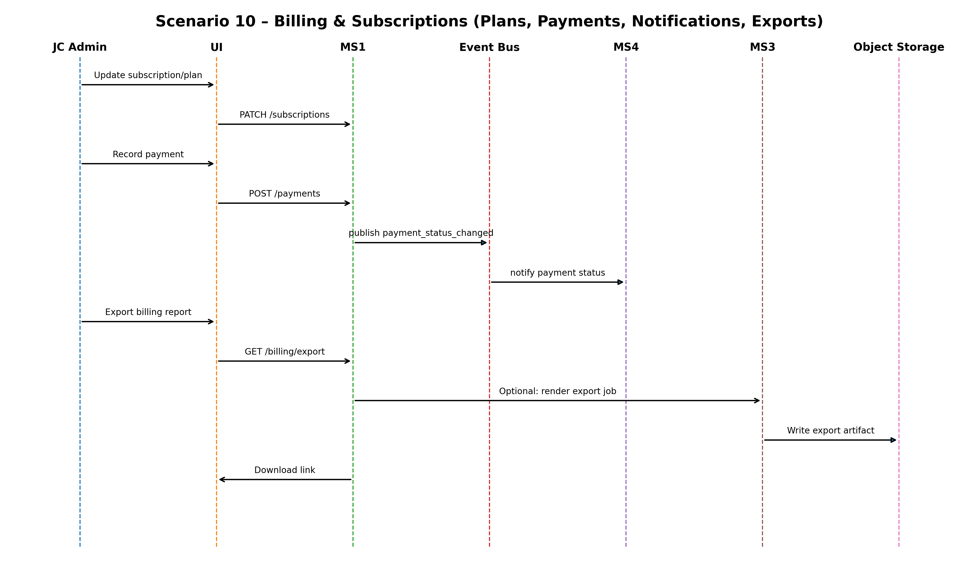
Figure: Scenario 10 – Billing & Subscriptions (Plans, Payments, Notifications, Exports) – Sequence Diagram

Appendix – Data Stores and Key Collections/Tables Referenced

PostgreSQL (Transactional)
- organizations/tenants, users, user_invitations, roles, permissions, role_permissions, user_roles, seat_allocations, subscriptions/subscription_plans, entitlements
- audit_logs, access_logs, incidents, tickets, ip_blocklist (if used)
- projects, project_members, folders, files, file_versions, tags, file_tags, recycle_bin_items, content_activity_logs
- dashboards, dashboard_widgets, reports, report_sections, export_jobs, job_status
- invoices, payments
- ai_conversations, ai_messages, ai_queries, insights, insight_sources, feedback
- notifications, notification_preferences, delivery_attempts (MS4)

MongoDB (Unstructured / AI Optimized)
- file_text_extractions (parsed/OCR content for AI pipelines, if used)
- intel_grid_cache (cached external research content, if used)
- export_render_cache (temporary render payloads for exports, if used)

Vector Store
- vector_chunks (chunked embeddings for semantic search / RAG)

Object Storage
- File binaries (uploads)
- Exported artifacts (PDF/PPTX/XLSX/PNG/JPEG etc.)

