AITHOR – API

1. Purpose and Audience
This document provides a stakeholder-friendly API MindMap for the AITHOR platform. It groups the API surface (as defined in the API Contract) into aligned capability domains, maps each domain to the owning microservice, and overlays inbound SLO targets and outbound dependency expectations (Keycloak, databases, object storage, queues, event bus, vector store, and notification providers).

2. MindMap Notation and Standards
Element | Meaning | Notes
Domain Node | Business capability group | Example: Billing & Subscriptions, Workspace & Content.
Owner | Service responsible for business logic and system-of-record data | MS1 is gateway; MS2–MS5 own domain data.
Roles | Primary role visibility for this domain | Derived from role-wise split (JC Admin/JC PM/Client Admin/Editor/Viewer).
Ops | Representative HTTP methods | Diagrams are representative; Appendix contains full inventory.
Inbound SLO | Target latency/availability for inbound API calls | Engineering targets only; not contractual SLAs.
Outbound SLA | Assumed behavior of dependencies | Used to set timeouts, retries, and circuit breakers.

3. End-to-End API Surface (MindMap)
Domain grouping with ownership and primary role visibility:
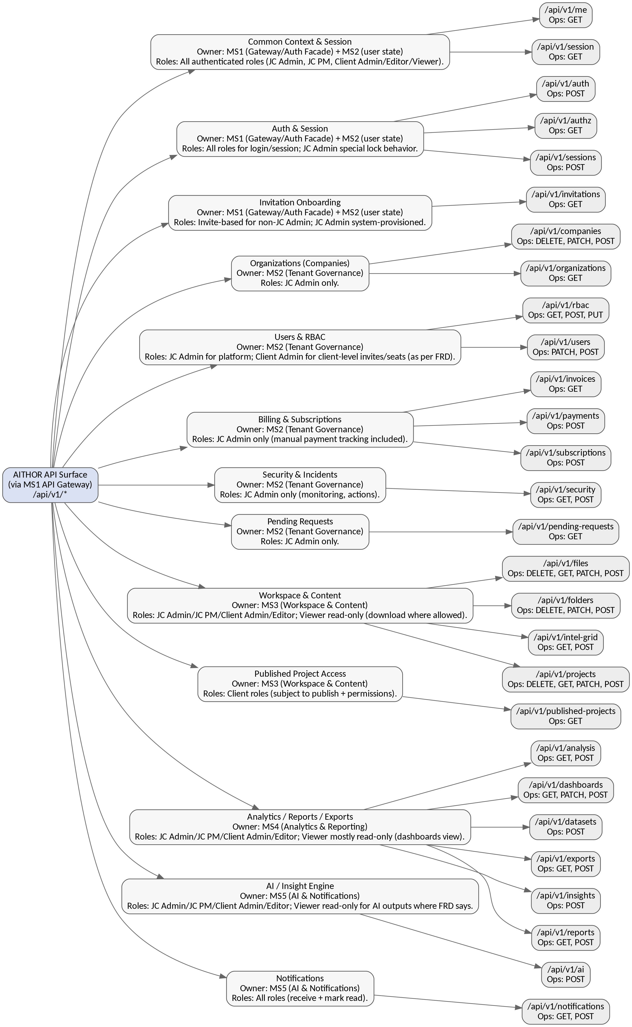
Figure 1. Overall AITHOR API MindMap (domains, ownership, role visibility)

4. Dependency Model (Inbound/Outbound) with SLA/SLO Targets
This dependency mindmap includes both functional dependencies (Keycloak, databases, storage, bus/queues) and platform dependencies needed for symmetry (secrets vault, KMS, backup/DR tooling, CI/CD).
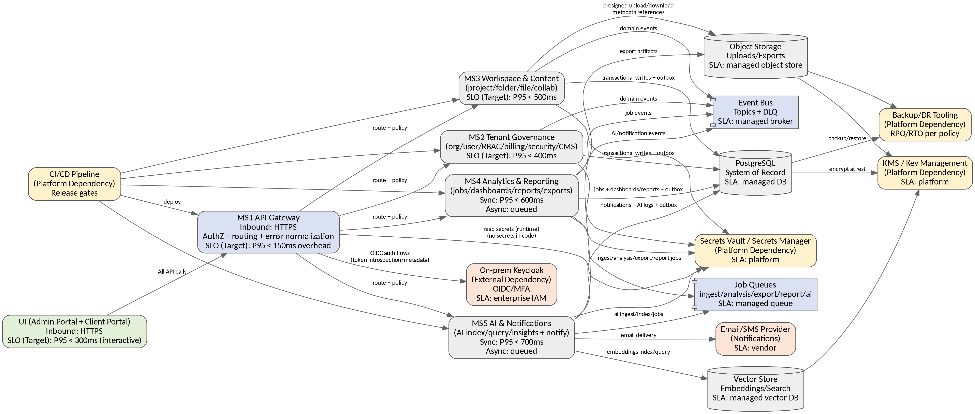
Figure 2. Inbound/Outbound dependency model with SLA/SLO targets (design goals)

6. Domain API MindMaps with Role Visibility (by Microservice)

6.1 MS1 – Gateway / Session Context / Onboarding
- Common Context endpoints: /api/v1/me, /api/v1/session/context (all roles).
- Auth/session: /auth/*, /sessions/* (all roles; JC Admin lock exemption).
- Invitation onboarding: /invitations/{token} (invite-based onboarding for non-JC Admin).
- Cross-cutting enforcement: tenant context, RBAC/entitlements, IP restrictions, concurrency, standardized errors, correlation IDs.

6.2 MS2 – Tenant Governance (JC Admin + Client Admin governance scope)
- Organizations (Companies) — Roles: JC Admin only.
- DELETE /api/v1/companies/{orgId}
- GET /api/v1/organizations
- PATCH /api/v1/companies/{orgId}
- POST /api/v1/companies
- Users & RBAC — Roles: JC Admin for platform; Client Admin for client-level invites/seats).
- GET /api/v1/rbac/roles
- PATCH /api/v1/users/{userId}/status
- POST /api/v1/rbac/roles
- POST /api/v1/users/invitations
- PUT /api/v1/rbac/roles/{roleId}/permissions
- Billing & Subscriptions — Roles: JC Admin only (manual payment tracking included).
- GET /api/v1/invoices
- POST /api/v1/payments
- POST /api/v1/subscriptions
- Security & Incidents — Roles: JC Admin only (monitoring, actions).
- GET /api/v1/security/alerts
- POST /api/v1/security/actions
- Pending Requests — Roles: JC Admin only.
- GET /api/v1/pending-requests

6.3 MS3 – Workspace & Content
- Workspace & Content — Roles: JC Admin/JC PM/Client Admin/Editor; Viewer read-only (download where allowed).
- DELETE /api/v1/files/{fileId}
- DELETE /api/v1/folders/{folderId}
- DELETE /api/v1/projects/{projectId}
- GET /api/v1/files/search
- GET /api/v1/files/{fileId}
- GET /api/v1/files/{fileId}/download-url
- GET /api/v1/intel-grid/items
- GET /api/v1/projects
- GET /api/v1/projects/{projectId}/my-project-page
- PATCH /api/v1/files/{fileId}
- PATCH /api/v1/folders/{folderId}
- PATCH /api/v1/projects/{projectId}
- POST /api/v1/files/upload/complete
- POST /api/v1/files/upload/init
- POST /api/v1/folders
- POST /api/v1/intel-grid/items/{itemId}/bookmark
- POST /api/v1/projects
- POST /api/v1/projects/{projectId}/duplicate
- POST /api/v1/projects/{projectId}/pin
- POST /api/v1/projects/{projectId}/publish
- Published Project Access — Roles: Client roles (subject to publish + permissions).
- GET /api/v1/published-projects

6.4 MS4 – Analytics / Reports / Exports
- Analytics / Reports / Exports — Roles: JC Admin/JC PM/Client Admin/Editor; Viewer mostly read-only (dashboards view).
- GET /api/v1/analysis/{jobId}
- GET /api/v1/dashboards/{dashboardId}
- GET /api/v1/exports/{jobId}
- GET /api/v1/exports/{jobId}/download
- GET /api/v1/reports/{reportId}
- PATCH /api/v1/dashboards/{dashboardId}
- POST /api/v1/analysis/run
- POST /api/v1/dashboards
- POST /api/v1/datasets/{fileId}/ingest
- POST /api/v1/exports
- POST /api/v1/insights
- POST /api/v1/reports/generate

6.5 MS5 – AI / Notifications
- AI / Insight Engine — Roles: JC Admin/JC PM/Client Admin/Editor; Viewer read-only for AI outputs.
- POST /api/v1/ai/feedback
- POST /api/v1/ai/ingest/file
- POST /api/v1/ai/query
- Notifications — Roles: All roles (receive + mark read).
- GET /api/v1/notifications
- POST /api/v1/notifications/events
- POST /api/v1/notifications/{notificationId}/read

7. Inbound SLO Targets (API Categories)
Targets below are non-contractual design goals and must be validated by load testing and infra SLAs.
Category | Examples | Target P95 Latency (Design Goal) | Availability Target (Design Goal) | Notes
Interactive Read APIs | GET lists/details (org/projects/files/dashboards) | ≤ 300–500ms | ≥ 99.9% | Indexed queries; warm caches; pagination required.
Interactive Write APIs | Create/update metadata (projects/folders/roles) | ≤ 500–800ms | ≥ 99.9% | DB write + audit + outbox in same transaction.
Auth/session APIs | /auth/start, /sessions/revoke | ≤ 400–700ms | ≥ 99.9% (excluding Keycloak outages) | Depends on Keycloak. Circuit breaker required.
Job initiation APIs | POST ingest/run/export/generate | ≤ 600ms (202 response) | ≥ 99.9% | Long work async; return jobId and initial state.
Status polling APIs | GET /jobs/{id} | ≤ 300ms | ≥ 99.9% | Cacheable; prevent DB hotspots with indexes.
File upload init/complete | /files/upload/init, /complete | ≤ 600ms | ≥ 99.9% | Binary transfer direct to object store.
AI query APIs | /ai/query | ≤ 2–8s | ≥ 99.5% | Depends on retrieval and model. Provide progressive/streamed responses where applicable.

8. Outbound Dependency SLA Assumptions + Timeout/Retry Policy
Defaults used to avoid cascading failures; finalize with infra owners.
Dependency | Assumption | Timeout Policy | Retry Policy | Fallback / User Experience
Keycloak (on‑prem) | Enterprise IAM; possible planned maintenance | 2–3s per auth op | 1–2 retries w/ jitter | AUTH_UNAVAILABLE; show recovery guidance; log correlationId.
PostgreSQL | HA managed DB | 1–2s per query | Reads: safe retries; Writes: no blind retries | DB_UNAVAILABLE; for async flows keep job state and retry via workers.
Object Storage | Managed store; multipart uploads | Presign ≤ 5–10s | Client retries parts; server minimal retries | Mark file FAILED; allow resume/retry; audit downloads.
Event Bus | At-least-once delivery | Async via outbox | Outbox backoff retries | DLQ; controlled redrive per runbook.
Job Queue | At-least-once; DLQ after threshold | Enqueue ≤ 1s | Worker retries w/ backoff | Job FAILED; allow redrive/redraft.
Vector Store | Latency sensitive retrieval | 1–3s query | Transient retries | AI_UNAVAILABLE / AI_NO_RELEVANT_DATA; capture prompt failure telemetry.
Email/SMS Provider | Vendor SLA | 2–5s send attempt | Exponential backoff | DLQ notification; in-app remains; allow re-send actions.

9. Security & Platform Dependencies (KMS/Vault/DR/CI-CD)
These dependencies are not business APIs but are required to operate the API platform safely.
Platform Capability | Dependency | Used By | Why It Matters | Operational Notes
Secrets Management | Vault/Secrets Manager | MS1–MS5 | Prevents secrets in code; supports rotation | Rotate credentials; least privilege service accounts.
Key Management | KMS | PG/Object storage/Vector store | Encryption at rest; key rotation | Centralized key policy; audit key usage.
Backup/DR | Backup scheduler + DR tooling | PG + Object storage | RPO/RTO compliance and recoverability | Test restore drills; document runbooks.
CI/CD | Pipelines + artifact registry | All services | Repeatable releases; approvals and rollback | Environment promotion gates; security scans.

10. Failure Modes, Retries, and Error Normalization
- MS1 normalizes dependency and downstream service failures into a single error envelope (see Error Handling Strategy).
- Idempotency-Key is required for retryable writes (invites, job initiation, billing writes where applicable) to prevent duplicates.
- Async jobs use deterministic states; redrive retries same job; redraft generates new artifact/job (new jobId/draftVersion).

Standard Error Envelope (reference)
{
"error": {
"code": "ENTITLEMENT_DENIED",
"message": "Your subscription does not allow this feature.",
"details": { "feature": "ADVANCED_ANALYTICS" },
"retryable": false,
"retryAfterSeconds": null
},
"correlationId": "uuid",
"timestamp": "2025-12-24T12:00:00Z"
}

11. Observability and Operational Dashboards
- Every request must include or receive X-Correlation-Id; propagate to events, job records, and logs.
- Operational dashboards: queue errors, job failures, prompt failures, uploads in progress, AI activity logs.
- Gateway metrics: auth decisions, route latency breakdown, upstream status distribution; services: domain decisions and DB/queue timing.

Appendix A: Endpoint Inventory by Domain (Authoritative from API Contract)

Common Context & Session
Method | Path | Owner | Primary Role Visibility
GET | /api/v1/me | MS1 (Gateway/Auth Facade) + MS2 (user state) | All authenticated roles (JC Admin, JC PM, Client Admin/Editor/Viewer).
GET | /api/v1/session/context | MS1 (Gateway/Auth Facade) + MS2 (user state) | All authenticated roles (JC Admin, JC PM, Client Admin/Editor/Viewer).

Auth & Session
Method | Path | Owner | Primary Role Visibility
GET | /api/v1/authz/entitlements | MS1 (Gateway/Auth Facade) + MS2 (user state) | All roles for login/session; JC Admin special lock behavior.
POST | /api/v1/auth/start | MS1 (Gateway/Auth Facade) + MS2 (user state) | All roles for login/session; JC Admin special lock behavior.
POST | /api/v1/sessions/revoke | MS1 (Gateway/Auth Facade) + MS2 (user state) | All roles for login/session; JC Admin special lock behavior.

Invitation Onboarding
Method | Path | Owner | Primary Role Visibility
GET | /api/v1/invitations/{token} | MS1 (Gateway/Auth Facade) + MS2 (user state) | Invite-based for non-JC Admin; JC Admin system-provisioned.

Organizations (Companies)
Method | Path | Owner | Primary Role Visibility
DELETE | /api/v1/companies/{orgId} | MS2 (Tenant Governance) | JC Admin only.
GET | /api/v1/organizations | MS2 (Tenant Governance) | JC Admin only.
PATCH | /api/v1/companies/{orgId} | MS2 (Tenant Governance) | JC Admin only.
POST | /api/v1/companies | MS2 (Tenant Governance) | JC Admin only.

Users & RBAC
Method | Path | Owner | Primary Role Visibility
GET | /api/v1/rbac/roles | MS2 (Tenant Governance) | JC Admin for platform; Client Admin for client-level invites/seats
PATCH | /api/v1/users/{userId}/status | MS2 (Tenant Governance) | JC Admin for platform; Client Admin for client-level invites/seats
POST | /api/v1/rbac/roles | MS2 (Tenant Governance) | JC Admin for platform; Client Admin for client-level invites/seats
POST | /api/v1/users/invitations | MS2 (Tenant Governance) | JC Admin for platform; Client Admin for client-level invites/seats
PUT | /api/v1/rbac/roles/{roleId}/permissions | MS2 (Tenant Governance) | JC Admin for platform; Client Admin for client-level invites/seats

Billing & Subscriptions
Method | Path | Owner | Primary Role Visibility
GET | /api/v1/invoices | MS2 (Tenant Governance) | JC Admin only (manual payment tracking included).
POST | /api/v1/payments | MS2 (Tenant Governance) | JC Admin only (manual payment tracking included).
POST | /api/v1/subscriptions | MS2 (Tenant Governance) | JC Admin only (manual payment tracking included).

Security & Incidents
Method | Path | Owner | Primary Role Visibility
GET | /api/v1/security/alerts | MS2 (Tenant Governance) | JC Admin only (monitoring, actions).
POST | /api/v1/security/actions | MS2 (Tenant Governance) | JC Admin only (monitoring, actions).

Pending Requests
Method | Path | Owner | Primary Role Visibility
GET | /api/v1/pending-requests | MS2 (Tenant Governance) | JC Admin only.

Workspace & Content
Method | Path | Owner | Primary Role Visibility
DELETE | /api/v1/files/{fileId} | MS3 (Workspace & Content) | JC Admin/JC PM/Client Admin/Editor; Viewer read-only (download where allowed).
DELETE | /api/v1/folders/{folderId} | MS3 (Workspace & Content) | JC Admin/JC PM/Client Admin/Editor; Viewer read-only (download where allowed).
DELETE | /api/v1/projects/{projectId} | MS3 (Workspace & Content) | JC Admin/JC PM/Client Admin/Editor; Viewer read-only (download where allowed).
GET | /api/v1/files/search | MS3 (Workspace & Content) | JC Admin/JC PM/Client Admin/Editor; Viewer read-only (download where allowed).
GET | /api/v1/files/{fileId} | MS3 (Workspace & Content) | JC Admin/JC PM/Client Admin/Editor; Viewer read-only (download where allowed).
GET | /api/v1/files/{fileId}/download-url | MS3 (Workspace & Content) | JC Admin/JC PM/Client Admin/Editor; Viewer read-only (download where allowed).
GET | /api/v1/intel-grid/items | MS3 (Workspace & Content) | JC Admin/JC PM/Client Admin/Editor; Viewer read-only (download where allowed).
GET | /api/v1/projects | MS3 (Workspace & Content) | JC Admin/JC PM/Client Admin/Editor; Viewer read-only (download where allowed).
GET | /api/v1/projects/{projectId}/my-project-page | MS3 (Workspace & Content) | JC Admin/JC PM/Client Admin/Editor; Viewer read-only (download where allowed).
PATCH | /api/v1/files/{fileId} | MS3 (Workspace & Content) | JC Admin/JC PM/Client Admin/Editor; Viewer read-only (download where allowed).
PATCH | /api/v1/folders/{folderId} | MS3 (Workspace & Content) | JC Admin/JC PM/Client Admin/Editor; Viewer read-only (download where allowed).
PATCH | /api/v1/projects/{projectId} | MS3 (Workspace & Content) | JC Admin/JC PM/Client Admin/Editor; Viewer read-only (download where allowed).
POST | /api/v1/files/upload/complete | MS3 (Workspace & Content) | JC Admin/JC PM/Client Admin/Editor; Viewer read-only (download where allowed).
POST | /api/v1/files/upload/init | MS3 (Workspace & Content) | JC Admin/JC PM/Client Admin/Editor; Viewer read-only (download where allowed).
POST | /api/v1/folders | MS3 (Workspace & Content) | JC Admin/JC PM/Client Admin/Editor; Viewer read-only (download where allowed).
POST | /api/v1/intel-grid/items/{itemId}/bookmark | MS3 (Workspace & Content) | JC Admin/JC PM/Client Admin/Editor; Viewer read-only (download where allowed).
POST | /api/v1/projects | MS3 (Workspace & Content) | JC Admin/JC PM/Client Admin/Editor; Viewer read-only (download where allowed).
POST | /api/v1/projects/{projectId}/duplicate | MS3 (Workspace & Content) | JC Admin/JC PM/Client Admin/Editor; Viewer read-only (download where allowed).
POST | /api/v1/projects/{projectId}/pin | MS3 (Workspace & Content) | JC Admin/JC PM/Client Admin/Editor; Viewer read-only (download where allowed).
POST | /api/v1/projects/{projectId}/publish | MS3 (Workspace & Content) | JC Admin/JC PM/Client Admin/Editor; Viewer read-only (download where allowed).

Published Project Access
Method | Path | Owner | Primary Role Visibility
GET | /api/v1/published-projects | MS3 (Workspace & Content) | Client roles (subject to publish + permissions).

Analytics / Reports / Exports
Method | Path | Owner | Primary Role Visibility
GET | /api/v1/analysis/{jobId} | MS4 (Analytics & Reporting) | JC Admin/JC PM/Client Admin/Editor; Viewer mostly read-only (dashboards view).
GET | /api/v1/dashboards/{dashboardId} | MS4 (Analytics & Reporting) | JC Admin/JC PM/Client Admin/Editor; Viewer mostly read-only (dashboards view).
GET | /api/v1/exports/{jobId} | MS4 (Analytics & Reporting) | JC Admin/JC PM/Client Admin/Editor; Viewer mostly read-only (dashboards view).
GET | /api/v1/exports/{jobId}/download | MS4 (Analytics & Reporting) | JC Admin/JC PM/Client Admin/Editor; Viewer mostly read-only (dashboards view).
GET | /api/v1/reports/{reportId} | MS4 (Analytics & Reporting) | JC Admin/JC PM/Client Admin/Editor; Viewer mostly read-only (dashboards view).
PATCH | /api/v1/dashboards/{dashboardId} | MS4 (Analytics & Reporting) | JC Admin/JC PM/Client Admin/Editor; Viewer mostly read-only (dashboards view).
POST | /api/v1/analysis/run | MS4 (Analytics & Reporting) | JC Admin/JC PM/Client Admin/Editor; Viewer mostly read-only (dashboards view).
POST | /api/v1/dashboards | MS4 (Analytics & Reporting) | JC Admin/JC PM/Client Admin/Editor; Viewer mostly read-only (dashboards view).
POST | /api/v1/datasets/{fileId}/ingest | MS4 (Analytics & Reporting) | JC Admin/JC PM/Client Admin/Editor; Viewer mostly read-only (dashboards view).
POST | /api/v1/exports | MS4 (Analytics & Reporting) | JC Admin/JC PM/Client Admin/Editor; Viewer mostly read-only (dashboards view).
POST | /api/v1/insights | MS4 (Analytics & Reporting) | JC Admin/JC PM/Client Admin/Editor; Viewer mostly read-only (dashboards view).
POST | /api/v1/reports/generate | MS4 (Analytics & Reporting) | JC Admin/JC PM/Client Admin/Editor; Viewer mostly read-only (dashboards view).

AI / Insight Engine
Method | Path | Owner | Primary Role Visibility
POST | /api/v1/ai/feedback | MS5 (AI & Notifications) | JC Admin/JC PM/Client Admin/Editor; Viewer read-only for AI outputs
POST | /api/v1/ai/ingest/file | MS5 (AI & Notifications) | JC Admin/JC PM/Client Admin/Editor; Viewer read-only for AI outputs
POST | /api/v1/ai/query | MS5 (AI & Notifications) | JC Admin/JC PM/Client Admin/Editor; Viewer read-only for AI outputs

Notifications
Method | Path | Owner | Primary Role Visibility
GET | /api/v1/notifications | MS5 (AI & Notifications) | All roles (receive + mark read).
POST | /api/v1/notifications/events | MS5 (AI & Notifications) | All roles (receive + mark read).
POST | /api/v1/notifications/{notificationId}/read | MS5 (AI & Notifications) | All roles (receive + mark read).

Appendix B: Known Assumptions and Open Items
- Numeric SLO targets are design goals only; confirm SLAs with stakeholders and infra owners.
- Exact external provider SLAs (email/SMS) and Keycloak maintenance windows must be confirmed.
- mTLS requirement for internal traffic depends on enterprise network policy.
- Retention and deletion defaults are governed by ADR-026 and must be validated for compliance expectations.
.

