AITHOR – Event Model (Strict Alignment Revision)

1. Purpose and Alignment Goal
This is complete set of capabilities expressed in the Microservices, Sequence Flows, API Contract, Data Model, Error Handling Strategy, and API Gateway documents. The primary change in is expanded functional coverage in the Event Catalog (e.g., project pin/duplicate, dashboard/report CRUD, Intel Grid bookmarking, tags/comments/shares, CMS content management, tickets, pending requests, notification read states), and a clear classification of which items are published as domain events versus retained as audit/activity records only.

2. Eventing Scope: Mandatory vs Optional vs Audit-only
To eliminate ambiguity and document-to-document mismatch, every significant action is classified into one of the following buckets:
Class | Definition | Implementation Expectation | Examples
Mandatory Domain Event | Must be published for cross-service workflows, user-facing job tracking, and operational dashboards. | Produced via Outbox in the authoritative domain service; consumed by MS5 (notifications) and ops dashboards as applicable. | FILE_UPLOADED, PROJECT_PUBLISHED, EXPORT_COMPLETED, USER_INVITED, SUBSCRIPTION_UPDATED
Optional Domain Event | Published when needed for notifications or analytics; otherwise recorded in activity logs. | Configurable per tenant/system; can be enabled without changing domain logic. | PROJECT_PINNED/UNPINNED, INTEL_ITEM_BOOKMARKED/UNBOOKMARKED
Audit-only / Telemetry | Recorded reliably in audit/access/activity logs but not necessarily broadcast on the event bus (to avoid high-volume chatter). | Stored in DB tables; may be surfaced in admin dashboards via queries; may also be emitted to analytics pipelines separately. | AI_QUERY_REQUESTED, FILE_DOWNLOADED, NOTIFICATION_MARKED_READ, AUTH_SESSION_STARTED

Strict alignment is achieved by explicitly listing audit-only items in the catalog and mapping them to their persistence location, so readers do not infer missing eventing where the platform uses activity/audit logs by design.

3. Event Backbone Architecture
High-level event topology (producers, bus, queues, consumers, and key stores):
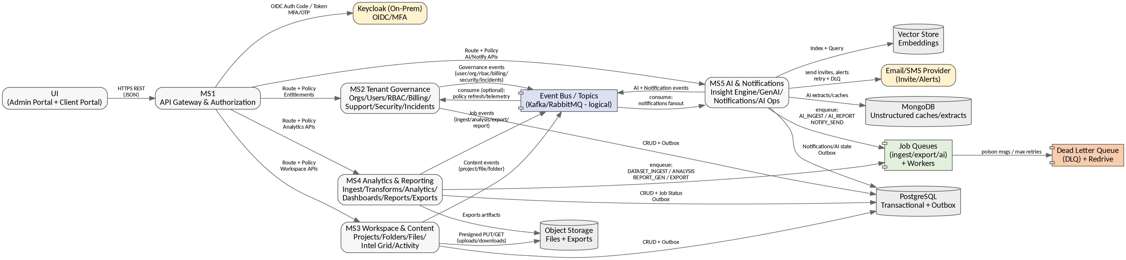
Figure 1. Event Backbone Topology

4. Event Envelope Standard
All events share a common envelope with schema versioning and correlation support. Payload is event-type specific.

4.1 Standard Envelope (JSON)
{
"eventId": "uuid",
"eventType": "PROJECT_PUBLISHED",
"schemaVersion": "1.0",
"occurredAt": "2025-12-23T14:30:00Z",
"producedBy": "MS3",
"tenant": { "orgId": "uuid", "projectId": "uuid|null" },
"actor": { "userId": "uuid|null", "userType": "JC_ADMIN|JC_PM|CLIENT_ADMIN|CLIENT_EDITOR|CLIENT_VIEWER|SYSTEM" },
"correlationId": "uuid",
"idempotencyKey": "uuid|null",
"payload": { },
"meta": { "traceId": "string", "sourceIp": "string|null" }
}

4.2 Required Fields
Field | Description | Notes
eventId | Unique event instance identifier | Used for deduplication ledger by consumers.
eventType | Stable event code | Never renamed; create new code if semantics change.
schemaVersion | Payload schema version | Backward-compatible evolution via versioning.
tenant | Org/project context | Mandatory for business events.
actor | Initiator (user/system) | Supports system/worker-generated events.
correlationId | End-to-end trace key | Links UI request, API calls, DB writes, jobs, notifications.
payload | Event-specific properties | Schema defined per event type.

5. Topic and Queue Taxonomy
Topics are grouped by domain; queues are grouped by worker type. Names are illustrative.
Domain | Topic Prefix | Representative Topics
Governance | aithor.gov.* | aithor.gov.user, aithor.gov.org, aithor.gov.rbac, aithor.gov.ticket, aithor.gov.pending
CMS / Help Content | aithor.cms.* | aithor.cms.content
Billing | aithor.bill.* | aithor.bill.subscription, aithor.bill.invoice, aithor.bill.payment
Security/Incidents | aithor.sec.* | aithor.sec.alert, aithor.sec.incident, aithor.sec.policy
Workspace Content | aithor.content.* | aithor.content.project, aithor.content.folder, aithor.content.file, aithor.content.activity
Collaboration | aithor.collab.* | aithor.collab.comment, aithor.collab.tag, aithor.collab.share, aithor.collab.bookmark
Jobs (Analytics/Exports/Reports) | aithor.job.* | aithor.job.ingest, aithor.job.analysis, aithor.job.export, aithor.job.report
AI / Insight Engine | aithor.ai.* | aithor.ai.index, aithor.ai.job, aithor.ai.prompt
Notifications | aithor.notify.* | aithor.notify.created, aithor.notify.email

Queues (Workers)
Queue | Primary Work | Producer | Worker/Consumer
q.dataset_ingest | Dataset ingest pipeline | MS3 → MS4 | MS4 worker
q.analysis_job | Data cleaning/transforms/analytics | MS4 | MS4 worker
q.export_render | Export artifact rendering | MS4 | MS4 worker
q.report_generate | Report Studio generation | MS4 | MS4 worker
q.ai_ingest | Extraction + embedding index | MS3 → MS5 | MS5 worker
q.ai_job | AI job execution (insight/report) | MS5 | MS5 worker
q.notify_email | Email delivery with retries | MS5 | MS5 worker
dlq.* | Poison messages/events | Broker/worker | Ops + controlled redrive

6. Domain Event Diagrams (End-to-End)
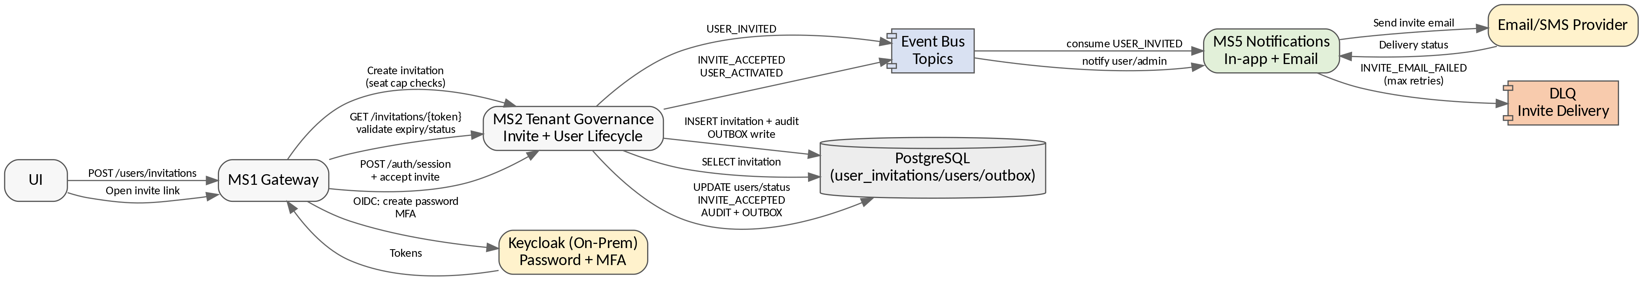
Figure 2. Invitation and Onboarding Events

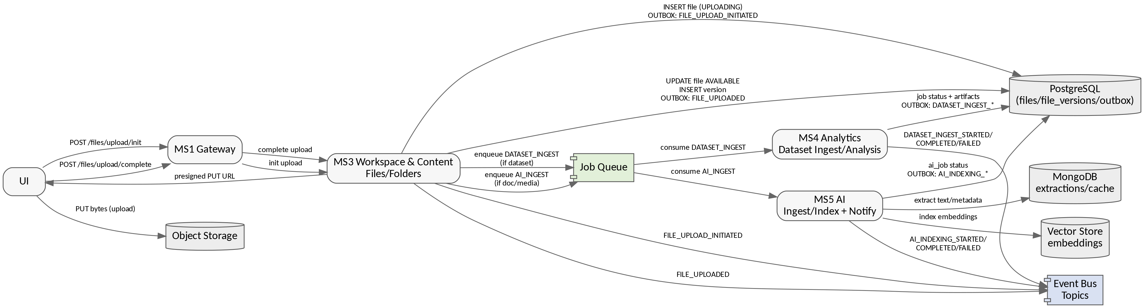
Figure 3. File Upload → Ingestion → AI Indexing Events

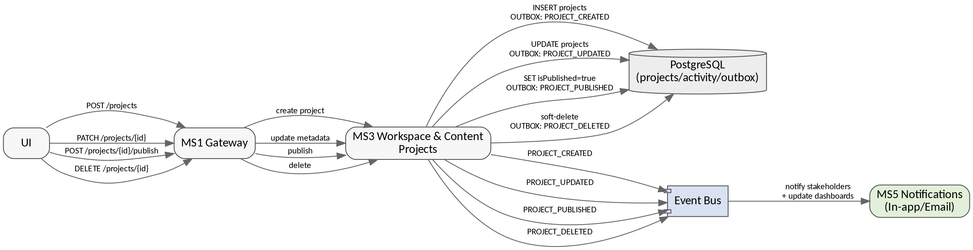
Figure 4. Project Lifecycle and Publish Visibility Events

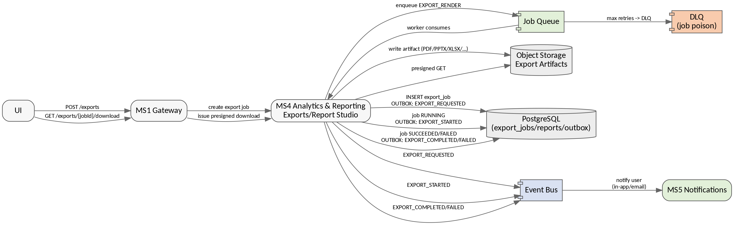
Figure 5. Exports/Report Studio Job Events

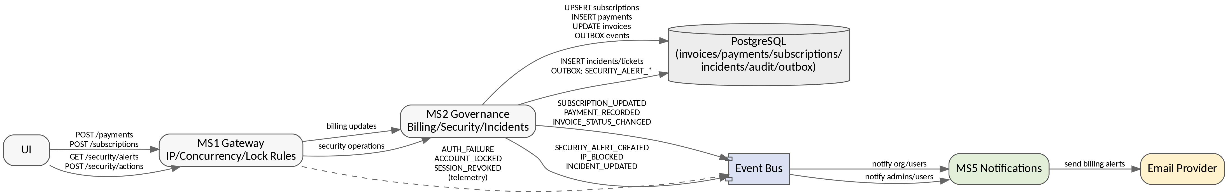
Figure 6. Billing, Subscription, Security, and Incident Events

Figure 7. Collaboration (Comments/Tags/Shares) + Intel Grid Bookmarking Events

Figure 8. CMS Content + Pending Requests + Tickets Events

7. Event Catalog (Full Coverage)
This catalog is expanded to align with the complete feature surface. Each entry includes a classification so readers understand whether it is a mandatory domain event, optional domain event, or audit-only telemetry.

Authentication
Event Type | Category | Class | Producer | Primary Consumers | Trigger | Key Payload Fields (representative)
AUTH_SESSION_STARTED | Authentication | Audit-only | MS1 | Ops dashboards | Login/initiate called | userId?, orgId?, ip, device, result

Authentication/Security
Event Type | Category | Class | Producer | Primary Consumers | Trigger | Key Payload Fields (representative)
SESSION_REVOKED | Authentication/Security | Mandatory Domain Event | MS1 | MS2 (audit optional), Ops dashboards | Session revoked (concurrency/security/manual) | sessionId, reason, userId, orgId

Governance
Event Type | Category | Class | Producer | Primary Consumers | Trigger | Key Payload Fields (representative)
USER_INVITED | Governance | Mandatory Domain Event | MS2 | MS5 | Invitation created | invitationId, email, userType, roleIds, expiresAt
INVITE_ACCEPTED | Governance | Mandatory Domain Event | MS2 | MS5 | Invite accepted | invitationId, userId, acceptedAt
USER_STATUS_CHANGED | Governance | Mandatory Domain Event | MS2 | MS5 | User status updated (Active/Expired/Revoked/etc.) | userId, oldStatus, newStatus, reason
ORG_CREATED | Governance | Mandatory Domain Event | MS2 | MS5 (optional) | Company/organization created | orgId, name, createdBy
ORG_UPDATED | Governance | Mandatory Domain Event | MS2 | MS5 (optional) | Company/organization updated | orgId, changes
ORG_DELETED | Governance | Mandatory Domain Event | MS2 | MS5 (optional) | Company/organization deleted | orgId, deletedAt
ROLE_CREATED | Governance | Mandatory Domain Event | MS2 | MS1 (cache invalidation optional) | Role created | roleId, name
ROLE_UPDATED | Governance | Mandatory Domain Event | MS2 | MS1 (cache invalidation optional) | Role updated | roleId, changes
ROLE_PERMISSIONS_UPDATED | Governance | Mandatory Domain Event | MS2 | MS1 (cache invalidation optional) | Permission matrix updated | roleId, permissions[]
ROLE_DELETED | Governance | Mandatory Domain Event | MS2 | MS1 (cache invalidation optional) | Role deleted | roleId, deletedAt
PENDING_REQUEST_CREATED | Governance | Mandatory Domain Event | MS2 | MS5 (optional) | Pending request created | requestId, type, createdBy
PENDING_REQUEST_UPDATED | Governance | Mandatory Domain Event | MS2 | MS5 (optional) | Pending request updated | requestId, status, notes
PENDING_REQUEST_RESOLVED | Governance | Mandatory Domain Event | MS2 | MS5 (optional) | Pending request resolved | requestId, resolution

Billing
Event Type | Category | Class | Producer | Primary Consumers | Trigger | Key Payload Fields (representative)
SUBSCRIPTION_UPDATED | Billing | Mandatory Domain Event | MS2 | MS5, MS1 (cache invalidation optional) | Plan/status/expiry changed | orgId, planId, status, expiresAt
INVOICE_STATUS_CHANGED | Billing | Mandatory Domain Event | MS2 | MS5 | Invoice status changed | invoiceId, orgId, status, dueDate
PAYMENT_RECORDED | Billing | Mandatory Domain Event | MS2 | MS5 | Payment recorded (partial/full) | paymentId, invoiceId, amount, currency, method

Security
Event Type | Category | Class | Producer | Primary Consumers | Trigger | Key Payload Fields (representative)
SECURITY_ACTION_REQUESTED | Security | Mandatory Domain Event | MS2 | Ops dashboards | Admin triggers security action (block IP/unblock/etc.) | actionType, actor, target, reason
SECURITY_ALERT_CREATED | Security | Mandatory Domain Event | MS2 | MS5 | Security alert created | alertId, type, ip, at
INCIDENT_UPDATED | Security | Mandatory Domain Event | MS2 | MS5 | Incident lifecycle updated | incidentId, status, notes
SECURITY_POLICY_UPDATED | Security | Mandatory Domain Event | MS2 | MS1 (policy cache), Ops dashboards | Policy changed (IP allowlist, concurrency) | policyKey, oldValue, newValue, effectiveAt

Workspace Content
Event Type | Category | Class | Producer | Primary Consumers | Trigger | Key Payload Fields (representative)
PROJECT_CREATED | Workspace Content | Mandatory Domain Event | MS3 | Ops dashboards | Project created | projectId, name, createdBy
PROJECT_UPDATED | Workspace Content | Mandatory Domain Event | MS3 | Ops dashboards | Project updated | projectId, changes
PROJECT_PUBLISHED | Workspace Content | Mandatory Domain Event | MS3 | MS5 | Project published | projectId, publishedAt
PROJECT_DELETED | Workspace Content | Mandatory Domain Event | MS3 | Ops dashboards | Project deleted/archived | projectId, deletedAt
PROJECT_DUPLICATED | Workspace Content | Mandatory Domain Event | MS3 | Ops dashboards | Project duplicated | sourceProjectId, newProjectId, actor
PROJECT_PINNED | Workspace Content | Optional Domain Event | MS3 | Ops analytics (optional) | Project pinned | projectId, actor
PROJECT_UNPINNED | Workspace Content | Optional Domain Event | MS3 | Ops analytics (optional) | Project unpinned | projectId, actor
FOLDER_CREATED | Workspace Content | Mandatory Domain Event | MS3 | Audit/ops | Folder created | folderId, projectId, name, parentFolderId
FOLDER_UPDATED | Workspace Content | Mandatory Domain Event | MS3 | Audit/ops | Folder updated | folderId, changes
FOLDER_DELETED | Workspace Content | Mandatory Domain Event | MS3 | Audit/ops | Folder deleted | folderId, projectId
FILE_UPLOAD_INITIATED | Workspace Content | Mandatory Domain Event | MS3 | Ops dashboards | Upload initialized | fileId, fileName, sizeBytes, type
FILE_UPLOADED | Workspace Content | Mandatory Domain Event | MS3 | MS4, MS5, ops dashboards | Upload completed | fileId, version, storageKey, mimeType
FILE_UPDATED | Workspace Content | Mandatory Domain Event | MS3 | Audit/ops | File metadata updated | fileId, changes
FILE_DELETED | Workspace Content | Mandatory Domain Event | MS3 | Audit/ops | File deleted | fileId, deletedAt
FILE_DOWNLOADED | Workspace Content | Audit-only | MS3 | Audit logs/ops | File download link issued / download audited | fileId, actor, ip, at

Collaboration/Intel Grid
Event Type | Category | Class | Producer | Primary Consumers | Trigger | Key Payload Fields (representative)
INTEL_ITEM_BOOKMARKED | Collaboration/Intel Grid | Optional Domain Event | MS3 | MS5 (optional) | Intel item bookmarked | itemId, actor, orgId/projectId
INTEL_ITEM_UNBOOKMARKED | Collaboration/Intel Grid | Optional Domain Event | MS3 | MS5 (optional) | Intel item unbookmarked | itemId, actor

Collaboration
Event Type | Category | Class | Producer | Primary Consumers | Trigger | Key Payload Fields (representative)
COMMENT_ADDED | Collaboration | Mandatory Domain Event | MS3 | MS5 (optional) | Comment created on project/file/report | commentId, entityType, entityId, textRef, actor
COMMENT_DELETED | Collaboration | Mandatory Domain Event | MS3 | MS5 (optional) | Comment deleted | commentId, entityType, entityId, actor
TAG_ADDED | Collaboration | Mandatory Domain Event | MS3 | Ops analytics (optional) | Tag added | entityType, entityId, tag, actor
TAG_REMOVED | Collaboration | Mandatory Domain Event | MS3 | Ops analytics (optional) | Tag removed | entityType, entityId, tag, actor
SHARE_LINK_CREATED | Collaboration | Mandatory Domain Event | MS3 | MS5 (optional) | Share link created | shareId, entityType, entityId, expiresAt, actor
SHARE_LINK_REVOKED | Collaboration | Mandatory Domain Event | MS3 | MS5 (optional) | Share link revoked | shareId, entityType, entityId, actor

Analytics/Reporting
Event Type | Category | Class | Producer | Primary Consumers | Trigger | Key Payload Fields (representative)
DASHBOARD_CREATED | Analytics/Reporting | Mandatory Domain Event | MS4 | Audit/ops | Dashboard created | dashboardId, name, projectId, actor
DASHBOARD_UPDATED | Analytics/Reporting | Mandatory Domain Event | MS4 | Audit/ops | Dashboard updated | dashboardId, changes
DASHBOARD_DELETED | Analytics/Reporting | Mandatory Domain Event | MS4 | Audit/ops | Dashboard deleted | dashboardId, deletedAt
REPORT_CREATED | Analytics/Reporting | Mandatory Domain Event | MS4 | Audit/ops | Report entity created | reportId, name, projectId, actor
REPORT_UPDATED | Analytics/Reporting | Mandatory Domain Event | MS4 | Audit/ops | Report entity updated | reportId, changes
REPORT_DELETED | Analytics/Reporting | Mandatory Domain Event | MS4 | Audit/ops | Report entity deleted | reportId, deletedAt

Jobs
Event Type | Category | Class | Producer | Primary Consumers | Trigger | Key Payload Fields (representative)
DATASET_INGEST_REQUESTED | Jobs | Mandatory Domain Event | MS4 | Ops dashboards | Ingest job requested | jobId, fileId, requestedAt
DATASET_INGEST_STARTED | Jobs | Mandatory Domain Event | MS4 | Ops dashboards | Ingest started | jobId, startedAt
DATASET_INGEST_COMPLETED | Jobs | Mandatory Domain Event | MS4 | MS5 (notify), UI dashboards | Ingest completed | jobId, artifacts[]
DATASET_INGEST_FAILED | Jobs | Mandatory Domain Event | MS4 | MS5 (notify), ops dashboards | Ingest failed | jobId, errorCode, retryable
ANALYSIS_JOB_REQUESTED | Jobs | Mandatory Domain Event | MS4 | Ops dashboards | Analysis run requested | jobId, datasetId, operations[]
ANALYSIS_JOB_STARTED | Jobs | Mandatory Domain Event | MS4 | Ops dashboards | Analysis started | jobId, startedAt
ANALYSIS_JOB_COMPLETED | Jobs | Mandatory Domain Event | MS4 | UI dashboards | Analysis completed | jobId, outputs[]
ANALYSIS_JOB_FAILED | Jobs | Mandatory Domain Event | MS4 | MS5 (notify), ops dashboards | Analysis failed | jobId, errorCode, retryable
EXPORT_REQUESTED | Jobs | Mandatory Domain Event | MS4 | Ops dashboards | Export requested | jobId, sourceType, sourceId, format
EXPORT_STARTED | Jobs | Mandatory Domain Event | MS4 | Ops dashboards | Export started | jobId, startedAt
EXPORT_COMPLETED | Jobs | Mandatory Domain Event | MS4 | MS5 (notify), UI dashboards | Export completed | jobId, artifactKey, sizeBytes
EXPORT_FAILED | Jobs | Mandatory Domain Event | MS4 | MS5 (notify), ops dashboards | Export failed | jobId, errorCode, retryable
EXPORT_REDRAFT_REQUESTED | Jobs | Optional Domain Event | MS4 | Ops dashboards | Export redraft requested | oldJobId, newJobId, reason
REPORT_GENERATION_REQUESTED | Jobs | Mandatory Domain Event | MS4 | Ops dashboards | Report generation requested | jobId, reportId, templateVersion
REPORT_GENERATION_STARTED | Jobs | Mandatory Domain Event | MS4 | Ops dashboards | Report generation started | jobId
REPORT_GENERATION_COMPLETED | Jobs | Mandatory Domain Event | MS4 | MS5 (notify), UI dashboards | Report generation completed | jobId, artifactRef
REPORT_GENERATION_FAILED | Jobs | Mandatory Domain Event | MS4 | MS5 (notify), ops dashboards | Report generation failed | jobId, errorCode, retryable
REPORT_REDRAFT_REQUESTED | Jobs | Mandatory Domain Event | MS4 | Ops dashboards | Report redraft requested | reportId, newDraftVersion, reason

AI
Event Type | Category | Class | Producer | Primary Consumers | Trigger | Key Payload Fields (representative)
AI_INGEST_REQUESTED | AI | Mandatory Domain Event | MS5 | Ops dashboards | AI ingest requested | jobId, fileId
AI_INGEST_STARTED | AI | Mandatory Domain Event | MS5 | Ops dashboards | AI ingest started | jobId
AI_INDEXING_COMPLETED | AI | Mandatory Domain Event | MS5 | Ops dashboards | AI indexing completed | jobId, vectorChunks
AI_JOB_FAILED | AI | Mandatory Domain Event | MS5 | Ops dashboards | AI job failed | jobId, errorCode, retryable
AI_PROMPT_FAILURE | AI | Mandatory Domain Event | MS5 | Ops dashboards | Prompt execution failure | conversationId, errorCode, reason
AI_QUERY_REQUESTED | AI | Audit-only | MS5 | Audit/ops (optional) | User submitted an AI query | conversationId, actor, queryRef
AI_FEEDBACK_RECORDED | AI | Mandatory Domain Event | MS5 | Ops analytics | User feedback on AI output | conversationId, rating, reasonCode

AI/Insights
Event Type | Category | Class | Producer | Primary Consumers | Trigger | Key Payload Fields (representative)
INSIGHT_CREATED | AI/Insights | Mandatory Domain Event | MS5 | UI dashboards | Insight created | insightId, projectId, type, actor

Notifications
Event Type | Category | Class | Producer | Primary Consumers | Trigger | Key Payload Fields (representative)
INVITE_EMAIL_SENT | Notifications | Mandatory Domain Event | MS5 | Ops dashboards | Invite email sent | invitationId, deliveryId, channel
INVITE_EMAIL_FAILED | Notifications | Mandatory Domain Event | MS5 | Ops dashboards | Invite email failed after retries | invitationId, errorCode, retryCount
NOTIFICATION_CREATED | Notifications | Mandatory Domain Event | MS5 | UI | In-app notification created | notificationId, type, title, audience
NOTIFICATION_EVENT_RECEIVED | Notifications | Mandatory Domain Event | MS5 | Ops dashboards | Notification event received for processing | eventId, type
NOTIFICATION_EMAIL_SENT | Notifications | Mandatory Domain Event | MS5 | Ops dashboards | Email sent | notificationId, deliveryId
NOTIFICATION_EMAIL_FAILED | Notifications | Mandatory Domain Event | MS5 | Ops dashboards | Email failed after retries | notificationId, errorCode, retryCount
NOTIFICATION_MARKED_READ | Notifications | Audit-only | MS5 | Audit/ops | Notification marked read | notificationId, userId, at

CMS
Event Type | Category | Class | Producer | Primary Consumers | Trigger | Key Payload Fields (representative)
CONTENT_ITEM_CREATED | CMS | Mandatory Domain Event | MS2 | MS5 (optional) | FAQ/Guide/Article created | contentId, type, title, actor
CONTENT_ITEM_UPDATED | CMS | Mandatory Domain Event | MS2 | MS5 (optional) | FAQ/Guide/Article updated | contentId, changes
CONTENT_ITEM_PUBLISHED | CMS | Mandatory Domain Event | MS2 | MS5 (optional) | FAQ/Guide/Article published | contentId, publishedAt
CONTENT_ITEM_ARCHIVED | CMS | Mandatory Domain Event | MS2 | MS5 (optional) | FAQ/Guide/Article archived | contentId, archivedAt

Support
Event Type | Category | Class | Producer | Primary Consumers | Trigger | Key Payload Fields (representative)
TICKET_CREATED | Support | Mandatory Domain Event | MS2 | MS5 (optional) | Ticket created | ticketId, orgId, severity, createdBy
TICKET_UPDATED | Support | Mandatory Domain Event | MS2 | MS5 (optional) | Ticket updated | ticketId, status, notes
TICKET_ASSIGNED | Support | Mandatory Domain Event | MS2 | MS5 (optional) | Ticket assigned | ticketId, assigneeId
TICKET_CLOSED | Support | Mandatory Domain Event | MS2 | MS5 (optional) | Ticket closed | ticketId, closedAt

8. Coverage Map: API Write Endpoints → Events
The table below maps every write endpoint listed in the API Contract to an event (or an explicit audit-only classification). This provides a strict, checkable alignment point across the document set.

8.1 Endpoint Coverage (rows 1–20)
Method | Path | Mapped Events | Class
DELETE | /api/v1/companies/{orgId} | ORG_DELETED | MANDATORY
DELETE | /api/v1/files/{fileId} | FILE_DELETED | MANDATORY
DELETE | /api/v1/folders/{folderId} | FOLDER_DELETED | MANDATORY
DELETE | /api/v1/projects/{projectId} | PROJECT_DELETED | MANDATORY
PATCH | /api/v1/companies/{orgId} | ORG_UPDATED | MANDATORY
PATCH | /api/v1/dashboards/{dashboardId} | DASHBOARD_UPDATED | MANDATORY
PATCH | /api/v1/files/{fileId} | FILE_UPDATED | MANDATORY
PATCH | /api/v1/folders/{folderId} | FOLDER_UPDATED | MANDATORY
PATCH | /api/v1/projects/{projectId} | PROJECT_UPDATED | MANDATORY
PATCH | /api/v1/users/{userId}/status | USER_STATUS_CHANGED | MANDATORY
POST | /api/v1/ai/feedback | AI_FEEDBACK_RECORDED | MANDATORY
POST | /api/v1/ai/ingest/file | AI_INGEST_REQUESTED | MANDATORY
POST | /api/v1/ai/query | AI_QUERY_REQUESTED | AUDIT_ONLY
POST | /api/v1/analysis/run | ANALYSIS_JOB_REQUESTED | MANDATORY
POST | /api/v1/auth/start | AUTH_SESSION_STARTED | AUDIT_ONLY
POST | /api/v1/companies | ORG_CREATED | MANDATORY
POST | /api/v1/dashboards | DASHBOARD_CREATED | MANDATORY
POST | /api/v1/datasets/{fileId}/ingest | DATASET_INGEST_REQUESTED | MANDATORY
POST | /api/v1/exports | EXPORT_REQUESTED | MANDATORY
POST | /api/v1/files/upload/complete | FILE_UPLOADED | MANDATORY

8.2 Endpoint Coverage (rows 21–38)
Method | Path | Mapped Events | Class
POST | /api/v1/files/upload/init | FILE_UPLOAD_INITIATED | MANDATORY
POST | /api/v1/folders | FOLDER_CREATED | MANDATORY
POST | /api/v1/insights | INSIGHT_CREATED | MANDATORY
POST | /api/v1/intel-grid/items/{itemId}/bookmark | INTEL_ITEM_BOOKMARKED, INTEL_ITEM_UNBOOKMARKED | OPTIONAL
POST | /api/v1/notifications/events | NOTIFICATION_EVENT_RECEIVED | MANDATORY
POST | /api/v1/notifications/{notificationId}/read | NOTIFICATION_MARKED_READ | AUDIT_ONLY
POST | /api/v1/payments | PAYMENT_RECORDED | MANDATORY
POST | /api/v1/projects | PROJECT_CREATED | MANDATORY
POST | /api/v1/projects/{projectId}/duplicate | PROJECT_DUPLICATED | MANDATORY
POST | /api/v1/projects/{projectId}/pin | PROJECT_PINNED, PROJECT_UNPINNED | OPTIONAL
POST | /api/v1/projects/{projectId}/publish | PROJECT_PUBLISHED | MANDATORY
POST | /api/v1/rbac/roles | ROLE_CREATED | MANDATORY
POST | /api/v1/reports/generate | REPORT_GENERATION_REQUESTED | MANDATORY
POST | /api/v1/security/actions | SECURITY_ACTION_REQUESTED | MANDATORY
POST | /api/v1/sessions/revoke | SESSION_REVOKED | MANDATORY
POST | /api/v1/subscriptions | SUBSCRIPTION_UPDATED | MANDATORY
POST | /api/v1/users/invitations | USER_INVITED | MANDATORY
PUT | /api/v1/rbac/roles/{roleId}/permissions | ROLE_UPDATED, ROLE_PERMISSIONS_UPDATED | MANDATORY

9. Outbox, Idempotency, Ordering, and Consistency

9.1 Outbox Pattern (Required for Mandatory/Optional Domain Events)
MS2/MS3/MS4/MS5 publish mandatory and optional domain events using an Outbox written in the same transaction as the domain change.
Service | Primary Domain Writes | Outbox Emits (examples)
MS2 | Users/Orgs/RBAC/Billing/CMS/Tickets/Pending/Security | USER_INVITED, ROLE_PERMISSIONS_UPDATED, SUBSCRIPTION_UPDATED, CONTENT_ITEM_PUBLISHED, TICKET_UPDATED
MS3 | Projects/Folders/Files/Collaboration/Intel Grid/Activity | FILE_UPLOADED, PROJECT_DUPLICATED, COMMENT_ADDED, SHARE_LINK_CREATED
MS4 | Ingest/Analysis/Dashboards/Reports/Exports | EXPORT_* , DATASET_INGEST_* , DASHBOARD_UPDATED
MS5 | AI/Insights/Notifications | AI_INDEXING_COMPLETED, AI_PROMPT_FAILURE, NOTIFICATION_CREATED

9.2 Idempotency and Deduplication
- All retryable writes use Idempotency-Key at the API Gateway and domain service.
- Events include eventId and correlationId. Consumers maintain a processed-event ledger keyed by eventId + consumerGroup.
- Job events use jobId as a stable entity identifier; redrive retains jobId; redraft creates a new jobId.

9.3 Ordering Guidance
- Recommended partition keys: orgId for governance/billing/security; projectId for content/collaboration; jobId for job lifecycles.
- Ordering is only guaranteed within a partition; consumers must tolerate out-of-order arrival across partitions.

10. DLQ + Redrive + Operational Dashboards
DLQ and redrive rules are consistent with the Error Handling Strategy. Operational dashboards referenced in requirements are fed by the mandatory job and AI failure events, plus DLQ counters.
Dashboard/Need | Primary Signals | Events Included
Queue Errors & Job Failures | DLQ counters, job failure rates | DATASET_INGEST_FAILED, ANALYSIS_JOB_FAILED, EXPORT_FAILED, REPORT_GENERATION_FAILED, AI_JOB_FAILED
Prompt Failures | Prompt runtime failures | AI_PROMPT_FAILURE
Data Uploads In Progress | Upload state transitions | FILE_UPLOAD_INITIATED, FILE_UPLOADED (+ file state in DB)
AI Activity Logs | AI job lifecycle + insight creation | AI_INGEST_STARTED, AI_INDEXING_COMPLETED, AI_JOB_FAILED, INSIGHT_CREATED

11. Redraft Strategy for Derived Artifacts
Redraft intentionally generates a new artifact/job (new jobId or new draftVersion). This is distinct from retry/redrive.
Artifact | Redraft Request Event | Lifecycle Events | Notes
Report Studio outputs | REPORT_REDRAFT_REQUESTED | REPORT_GENERATION_STARTED/COMPLETED/FAILED | Persist inputs snapshot + draftVersion.
Exports | EXPORT_REDRAFT_REQUESTED | EXPORT_STARTED/COMPLETED/FAILED | New jobId; keep old artifact per retention.
AI outputs | (optional) AI_REDRAFT_REQUESTED | AI job lifecycle events | Persist promptRevision + source set.

12. Alignment Checklist (Cross-document)
This checklist is the strict alignment assurance point: each functional module has at least one of (a) mandatory/optional domain event(s), or (b) an explicit audit-only classification with persistence location. No module is left implicit.
Module/Feature Area | Evidence in Event Model | Class
Project pin/duplicate | PROJECT_PINNED/UNPINNED, PROJECT_DUPLICATED | Optional + Mandatory
Dashboards CRUD | DASHBOARD_CREATED/UPDATED/DELETED | Mandatory
Reports CRUD + generation | REPORT_CREATED/UPDATED/DELETED + REPORT_GENERATION_* | Mandatory
Intel Grid bookmarks | INTEL_ITEM_BOOKMARKED/UNBOOKMARKED | Optional
Tags/Comments/Share | TAG_* , COMMENT_* , SHARE_LINK_* | Mandatory
Pending requests | PENDING_REQUEST_* | Mandatory
Tickets | TICKET_* | Mandatory
CMS FAQ/Guides/Articles | CONTENT_ITEM_* | Mandatory
AI activity logs + prompt failures | AI_INDEXING_COMPLETED, AI_JOB_FAILED, AI_PROMPT_FAILURE, INSIGHT_CREATED (+ AI_QUERY_REQUESTED audit-only) | Mandatory + Audit-only
Uploads in progress | FILE_UPLOAD_INITIATED/FILE_UPLOADED (+ DB file state) | Mandatory
Notification read states | NOTIFICATION_MARKED_READ (audit-only) | Audit-only

