IILM UNIVERSITY, GREATER NOIDA
School of Computer Science and Engineering

SUMMER INTERNSHIP REPORT

SOCIAL SERVICE AND COMMUNITY
ENGAGEMENT:
ELDERLY CARE AND ANIMAL WELFARE

Submitted To
School of Computer Science and Engineering
IILM University, Greater Noida, Uttar Pradesh

In partial fulfilment of the requirement for the degree of
Bachelor of Technology (B.Tech)

Submitted By
SHOURYA RAI
Roll Number: 25SCS1003001695
B.Tech – Computer Science and Engineering
Specialization: Cloud Computing
3rd Semester | 2nd Year
Academic Session: 2026–27

CANDIDATE'S DECLARATION
I, SHOURYA RAI, Roll Number 25SCS1003001695, hereby declare that the Summer Internship Report titled “Social Service and Community Engagement: Elderly Care and Animal Welfare” has been prepared by me to fulfil the internship requirement of the Bachelor of Technology programme in Computer Science and Engineering at IILM University, Greater Noida.
The report is based on my social-service internship experience of four weeks at Ram Lal Vriddhashram Evam Gaushala (N.G.O.), Agra, Uttar Pradesh. I have presented the activities and learning outcomes honestly and have not claimed the development of any technical or software project as part of this internship. Wherever general background sources have been used, they have been listed in the References section.
I affirm that this report is my own work and has not been submitted to any other institution for the award of any degree or diploma. I shall be solely responsible for any issue arising from incorrect representation or copyright violation in this report.

Signature: __________________________
Student Name: SHOURYA RAI
Roll Number: 25SCS1003001695

ACKNOWLEDGEMENT
I would like to express my sincere gratitude to IILM University, Greater Noida and the School of Computer Science and Engineering for providing me with the opportunity to undertake this summer internship as part of my academic learning. The experience gave me an opportunity to engage with a social-service environment and learn through direct participation.
I am grateful to Ram Lal Vriddhashram Evam Gaushala (N.G.O.), Agra, Uttar Pradesh, for allowing me to participate in activities related to elderly support, animal care, and community service. I sincerely appreciate the guidance, cooperation, and support provided by the people associated with the internship environment.
I am also thankful to everyone who supported and encouraged me during the internship. Their cooperation helped me complete the experience with responsibility and sincerity.
Finally, I express my heartfelt gratitude to my parents for their constant encouragement, blessings, and support.

TABLE OF CONTENTS
Chapter / Section | Page No.
Cover Page | —
1. Candidate's Declaration | i
2. Acknowledgement | ii
3. Internship Completion Certificate | —
4. Internship Description | 1
4.1 Introduction | 1
4.2 Organization Profile | 2
4.3 Internship Context and Social Need | 3
4.4 Internship Objectives | 4
4.5 Scope of the Internship | 5
4.6 Activities Performed | 6
4.7 Social-Service Activity Approach | 9
4.8 Skills Developed | 10
4.9 Key Learning Outcomes | 12
4.10 Challenges and Learning Experience | 14
4.11 Overall Experience | 15
4.12 Conclusion | 16
5. Certificate and Supporting Documents | 17
6. Bibliography/References | 18

3. INTERNSHIP COMPLETION CERTIFICATE
The following is the internship/social-service certificate provided for this internship.
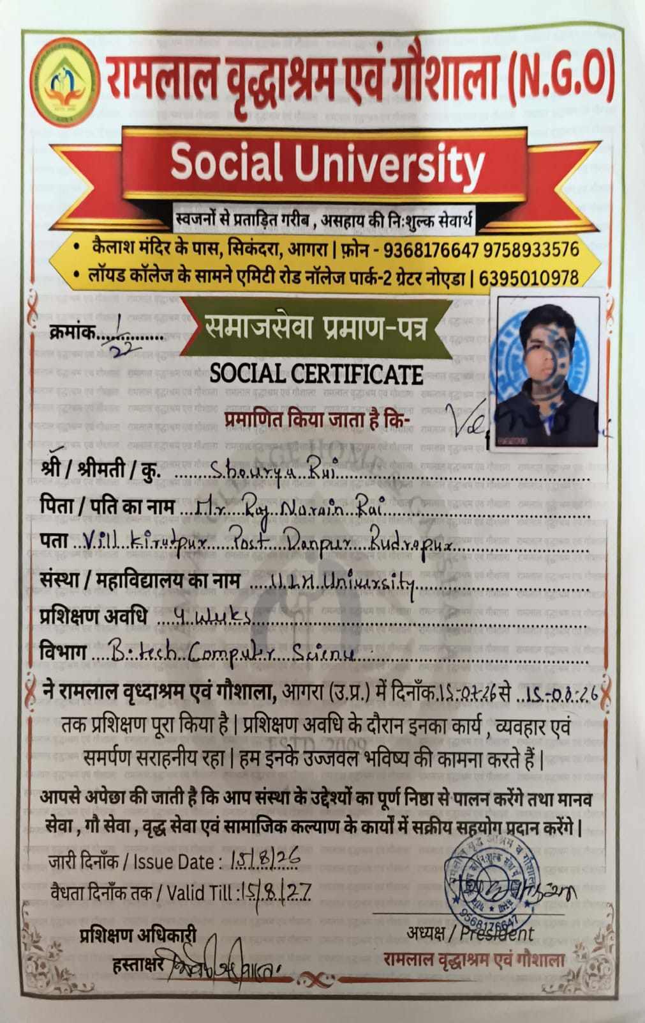

4. INTERNSHIP DESCRIPTION

4.1 Introduction
A summer internship is an important component of experiential learning because it allows a student to engage with an environment beyond the classroom and develop practical understanding through direct participation. Although many internships are associated with technical or industrial work, social-service internships provide another valuable form of experiential learning. They encourage students to understand responsibility, cooperation, empathy, discipline, and the importance of contributing to the well-being of people and communities.
My four-week internship at Ram Lal Vriddhashram Evam Gaushala in Agra, Uttar Pradesh, was a social-service and community-engagement experience focused primarily on the care and feeding of cows, along with support for the elderly residents of the ashram. The internship was not a software-development or technical project. Instead, it involved practical participation in the daily feeding and general upkeep of the cows kept at the gaushala, along with assisting elderly residents in their routine activities.
The experience provided an opportunity to interact directly with elderly people and to participate in the daily routine of caring for cows at the facility. It also helped me understand how regular routine, patience, cleanliness, teamwork, and consistent effort are important in a service-oriented environment.
From an academic perspective, the internship complemented my B.Tech studies by strengthening transferable skills such as communication, time management, responsibility, observation, teamwork, and adaptability. The learning gained from this experience extends beyond technical knowledge and contributes to the broader personal and professional development expected from higher education.

4.2 Organization Profile
The internship was completed at Ram Lal Vriddhashram Evam Gaushala (N.G.O.) in Agra, Uttar Pradesh. Based on my internship experience and the information available to me during the internship, the environment involved activities related to elderly care, cow care, and community service.
The premises included a gaushala environment where a large number of cows were kept and cared for on a daily basis. Alongside the cow-care activities, the internship environment included interaction with and support for elderly residents of the ashram.
This report does not attempt to provide unverified historical, administrative, legal, or registration details about the organization. The organization profile presented here is limited to the aspects directly relevant to my internship experience and the activities described in this report.

4.3 Internship Context and Social Need
Elderly care is an important area of social responsibility because older people may require varying levels of support with routine activities, comfort, communication, and daily living. Respectful interaction, patience, and attention to individual needs are essential when providing assistance. International public-health guidance also emphasizes person-centred and supportive approaches to the well-being of older people and the importance of social and care environments that respect dignity and functional ability.
Animal welfare is also an important area of responsible community participation. Cow care in particular involves attention to basic needs such as appropriate feeding, safe surroundings, humane handling, and regular observation. The World Organisation for Animal Health describes animal welfare in relation to the physical and mental state of animals and the conditions in which they live. My internship gave me practical exposure to the routine effort and consistency involved in feeding and caring for cows.
Community service connects individual effort with wider social needs. Even simple and routine activities can become meaningful when they are performed consistently and responsibly. The internship therefore provided a practical setting in which I could understand how patience, cooperation, discipline, and participation contribute to a service-oriented environment.

4.4 Internship Objectives
- To support elderly residents in selected daily activities and routine tasks.
- To participate responsibly in the daily feeding and general care of cows at the gaushala.
- To develop empathy, compassion, patience, and respect through direct service experience.
- To improve teamwork and communication while participating in shared daily responsibilities.
- To develop a stronger understanding of personal and social responsibility.
- To learn the importance of discipline, cleanliness, and consistency in a service environment.
- To gain meaningful community-service experience beyond regular academic coursework.

4.5 Scope of the Internship
The scope of my internship was limited to the social-service activities in which I personally participated. It included assistance to elderly residents, support with their daily routines, participation in cow feeding and general care, support for cleanliness and maintenance of surroundings, and participation in routine community-service activities.
The internship did not involve the independent provision of medical treatment, veterinary treatment, financial management, organizational administration, software development, research experiments, or any other activity not described in my internship experience. This report therefore focuses on the practical support and learning activities that were actually part of the internship.

4.6 Activities Performed

4.6.1 Elderly Care Activities
A part of my internship involved assisting elderly residents of the ashram with their daily routine. My role was to remain available for general assistance whenever required and to help wherever needed.
The experience taught me that respectful communication is essential in an elderly-care setting. Assistance should be provided with patience, dignity, and awareness of individual needs. Through direct interaction, I developed a stronger appreciation for empathy, responsibility, and respectful behaviour toward senior citizens.

4.6.2 Cow Care Activities
The main part of my internship involved the daily feeding and general care of cows kept at the gaushala. This included helping prepare and distribute fodder, ensuring the cows had access to water, and supporting the general upkeep of the area where they were kept.
The experience provided practical understanding of the effort and consistency involved in caring for a large number of animals on a daily basis. It reinforced the importance of responsibility, cleanliness, routine, and teamwork. I did not perform any veterinary or medical procedures; my role was limited to feeding and general care support.

4.6.3 General Social-Service Activities
In addition to elderly support and cow-care activities, I participated in general social-service tasks such as supporting cleanliness and helping maintain the surroundings of the facility.
These responsibilities demonstrated that community service is often built around regular and practical work. Maintaining a clean and orderly environment is an important shared responsibility, particularly where people and animals are cared for on a daily basis.

4.7 Social-Service Activity Approach
The internship did not follow a formal scientific or software-development methodology. Instead, my practical approach can be represented as: Observation → Understanding Daily Needs → Participation → Assistance → Reflection and Learning.
Observation: I first observed the daily environment and routine so that I could understand the nature of the work and the responsibilities involved.
Understanding Daily Needs: I learned to pay attention to the routine requirements of the cows and the general needs of the elderly residents within the scope of my assigned activities.
Participation: I participated directly in elderly-support, cow-feeding, cleanliness, and community-service activities.
Assistance: I provided practical assistance wherever required within the responsibilities of my internship.
Reflection and Learning: I reflected on the experience and identified the personal skills and values strengthened through the internship.

4.8 Skills Developed
Empathy: Direct interaction with elderly residents helped me better understand the importance of compassion and respectful support.
Patience: Routine service activities, especially the daily feeding of cows, required calmness, consistency, and the ability to work without rushing.
Responsibility: Assigned activities had to be completed carefully and with awareness of their effect on daily routines.
Teamwork: Many activities were carried out in a shared environment, reinforcing the importance of cooperation.
Communication: Interaction with elderly residents and others involved in daily activities improved my ability to communicate respectfully.
Time Management: Balancing different responsibilities during the day encouraged better organization of time and tasks.
Social Awareness: The internship increased my awareness of the needs of elderly people, animals, and service-oriented communities.
Discipline and Cleanliness: Daily routines highlighted the value of consistency, orderly work, and maintaining clean surroundings.
Community-Service Experience: The internship provided direct experience of contributing time and effort to activities intended to support others.

4.9 Key Learning Outcomes
Understanding Elderly Care: I gained a clearer understanding of the patience, respect, and regular support involved in assisting senior citizens.
Patience and Empathy: Direct interaction strengthened my ability to listen, assist patiently, and respond with greater empathy.
Cow-Care Exposure: I gained practical exposure to the daily feeding and general care of cows at the gaushala.
Teamwork: Participation in a shared service environment reinforced the importance of cooperation and coordinated effort.
Communication: The internship improved my confidence in communicating respectfully in a practical, service-oriented setting.
Social Responsibility: I developed a stronger understanding of how individual participation can contribute to community welfare.
Routine and Discipline: Regular activities demonstrated the importance of consistency, cleanliness, and disciplined daily work.
Value of Community Service: The experience showed that meaningful learning can come from contributing directly to the well-being of people and animals.

4.10 Challenges and Learning Experience
Maintaining patience and consistency was an important learning requirement. Service activities are often routine-based, and meaningful contribution depends on regular attention rather than one-time effort.
Another challenge was adapting to a hands-on, non-technical environment that was different from my normal academic coursework. I needed to observe the daily routine, understand my role, and participate responsibly.
Managing different responsibilities within the four weeks also required attention to time and priorities. Supporting elderly residents and participating in the daily cow-care routine required flexibility and a willingness to help where needed.
I also learned that responsible participation in cow-care activities requires care, awareness, and respect for the animals. My learning came primarily through practical participation and observation rather than through formal technical training.

4.11 Overall Experience
The four-week internship was a meaningful and enriching experience. It gave me an opportunity to work in an environment centred on care, welfare, and community participation. The experience was different from my regular B.Tech coursework and therefore contributed a valuable practical dimension to my personal development.
Working with elderly residents strengthened my understanding of patience, empathy, respect, and responsibility. Participating in the daily feeding and care of cows taught me the importance of consistency, cleanliness, teamwork, and attention to routine.
Overall, the internship improved my confidence and helped me appreciate the value of contributing positively through practical service. The experience reinforced that education can develop not only academic knowledge but also personal values and transferable skills that are useful in many areas of life.

4.12 Conclusion
My summer internship at Ram Lal Vriddhashram Evam Gaushala (N.G.O.), Agra, was a valuable experience in social service and community engagement. The internship provided practical exposure to elderly support, the daily feeding and care of cows, cleanliness, routine responsibilities, and participation in a service-oriented environment.
The experience strengthened important personal qualities such as empathy, patience, responsibility, teamwork, communication, time management, discipline, and social awareness. It also gave me a deeper appreciation for the value of community service and for the positive role that consistent individual effort can play in supporting people and animals.
As a B.Tech student in Computer Science and Engineering with a specialization in Cloud Computing, I recognize that professional development is broader than technical ability alone. This internship helped me develop human-centred and transferable qualities that complement academic learning. I consider the internship a meaningful learning experience that has contributed to my personal growth and understanding of social responsibility.

5. CERTIFICATE AND SUPPORTING DOCUMENTS
The internship/social-service certificate issued for my participation is included in this report as the primary supporting document (see Section 3). The certificate has been inserted without alteration.
A photograph taken at the time of receiving the certificate from the organization is included below as further supporting documentation.
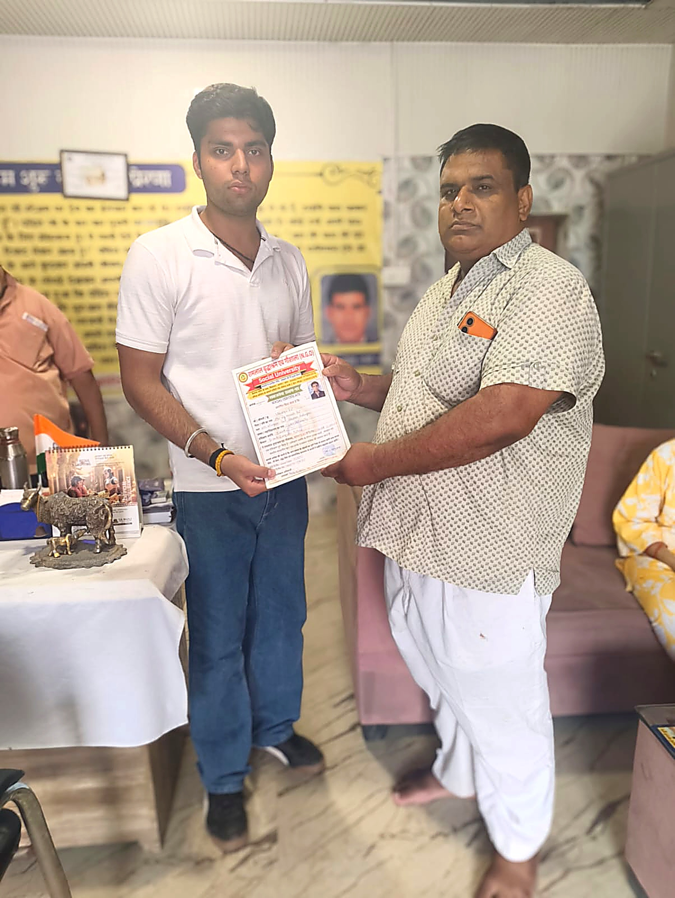
No fictional photographs, screenshots, attendance records, supervisor letters, technical project artifacts, or other proof documents have been created for this report. Any additional supporting documents should only be added if they are genuine and available.

6. BIBLIOGRAPHY/REFERENCES
1. World Health Organization. “Ageing.” World Health Organization. https://www.who.int/health-topics/ageing
2. World Health Organization. “Providing access to long-term care for older people.” World Health Organization. https://www.who.int/health-topics/ageing/providing-access-to-long-term-care-for-older-people
3. World Organisation for Animal Health (WOAH). “Animal Welfare.” https://www.woah.org/en/what-we-do/animal-health-and-welfare/animal-welfare/
4. Ram Lal Vriddhashram Evam Gaushala (N.G.O.). Social Service / Internship Completion Certificate issued to Shourya Rai.

