PROJECT REPORT
on
STUDENT PERFORMANCE PREDICTION
SYSTEM USING MACHINE LEARNING

at
SIRCL TECH PVT LTD, SIRSA

Submitted in partial fulfilment of the requirements for the award of degree of
Your Course Name
of
College Name, CityName

Submitted by:
YOUR NAME
24049409

DEPARTMENT NAME
College Name, Address

ACKNOWLEDGEMENT

I would like to express my sincere gratitude to everyone who helped me complete my internship project successfully. I am thankful to SIRCL TECH PVT LTD, SIRSA for providing me the opportunity to work on a practical project in Python, Data Analysis, Artificial Intelligence and Machine Learning.
I sincerely thank my project mentor, Mr. Rai Singh, CTO, for his valuable guidance, technical support and encouragement during the entire period of my project work. His supervision helped me understand the complete project development process from Python programming and data handling to model training and web app development.
I also express my heartfelt gratitude to my internship supervisor, Ms. Priyanka, for her continuous support, feedback and motivation throughout the training period. I am thankful to the Principal, Head of the Department and faculty members of Khalsa College for Women, Ludhiana for providing academic support and guidance.
Finally, I would like to thank my parents and friends for their constant encouragement and support during the completion of this project report.

Your Name
24049409

DECLARATION

I, Your Name, a student of Bachelor of Computer Applications - Semester 5 of Khalsa College for Women, Civil Lines, Ludhiana, hereby declare that the project report entitled "STUDENT PERFORMANCE PREDICTION SYSTEM USING MACHINE LEARNING" is a bonafide work carried out by me during my internship at SIRCL TECH PVT LTD, SIRSA.
This project has been developed under the guidance of my mentor and has not been submitted to any other University or Institute for the award of any other degree or diploma.

Signature:
Name of the Student : Your Name
Roll No. : 24049409
Date :

COMPANY PROFILE

SIRCL TECH PVT LTD is an IT-based organization located in Sirsa, Haryana. The company provides software development, technical training, internship programs and project-based learning opportunities for students in modern technologies. The organization focuses on building practical software solutions and preparing students for industry-oriented development work.
The company works in domains such as web application development, database-driven software, cloud deployment, data analysis, automation, Artificial Intelligence and Machine Learning. It provides students with hands-on exposure to programming, project planning, debugging, testing and documentation.
During the internship, students are trained with a practical approach. They learn programming concepts, work with real datasets, develop mini projects, and understand how software solutions are planned and implemented in an industry environment. The training methodology focuses on problem solving, coding practice, project development and report preparation.
SIRCL TECH PVT LTD helps bridge the gap between academic learning and industry expectations by providing practical training in technologies such as Python, AI/ML, Data Analysis, Web Development and database systems. The internship program enables students to apply classroom concepts to real project scenarios and develop professional confidence.

INDEX
CHAPTERS | PAGE NO.
1. Introduction | 6-8
1.1 Project Overview | 6
1.2 Problem Statement | 7
1.3 Objectives | 7
1.4 Scope & Applications | 7-8
2. Literature Review & Analysis | 9-10
2.1 Existing Systems | 9
2.2 Limitations | 9
2.3 Proposed Approach | 10
2.4 Feasibility Study | 10
3. System Design | 11-12
3.1 System Architecture | 11
3.2 Dataset Description | 11
3.3 Feature Description | 12
3.4 Tools & Technologies | 12
4. Methodology | 13-14
4.1 Data Collection & Preprocessing | 13
4.2 Exploratory Data Analysis | 13
4.3 Feature Engineering | 13
4.4 Model Selection & Training | 13-14
4.5 AI/ML Integration | 14
5. Implementation | 15-21
5.1 Libraries & Environment | 15
5.2 Module Building | 15
5.3 Code Implementation | 15-20
5.4 Dataset Design | 20-21
6. Results & Discussion | 22-26
6.1 System Performance | 22
6.2 Evaluation Metrics | 22
6.3 Output Visualization | 23-24
6.4 Result Interpretation | 25-26
7. Conclusion & Future Scope | 27-28
7.1 Summary of Work | 27
7.2 Key Findings | 27
7.3 Limitations | 27
7.4 Future Improvements | 27-28
Bibliography | 29

CHAPTER 1 - INTRODUCTION
In the present educational environment, institutions generate a large amount of student data through attendance records, examination marks, assignments and academic activities. However, this data is often stored in spreadsheets or files and is not used effectively for prediction or decision-making. Teachers and administrators may identify weak students only after final results are declared, which reduces the possibility of early improvement.
The Student Performance Prediction System using Machine Learning has been developed as a Python-based project to analyze student academic data and predict student performance. The system uses data analysis, visualization and machine learning techniques to understand patterns in student records and generate useful predictions such as expected final marks, pass/fail result and performance category.
The project applies important concepts learned during the internship, including Core Python, File Handling, SQLite basics, NumPy, Pandas, Matplotlib, Seaborn, Scikit-learn, model saving with Joblib and Streamlit application development. It demonstrates the complete workflow of a beginner-level AI/ML project, starting from dataset preparation and ending with a simple web-based prediction interface.
The system focuses on student-related features such as attendance percentage, study hours, previous marks and assignment score. These features are used by machine learning models to predict final marks and result status. The project also includes visual analysis through charts, which helps identify the relationship between academic habits and student performance.

1.1 Project Overview
The Student Performance Prediction System using Machine Learning is a Python-based data analysis and prediction project. It is designed to help users understand student academic patterns and predict performance using machine learning models. The system works on a structured CSV dataset containing student information such as Student ID, name, gender, course, attendance, study hours, previous marks, assignment score, final marks and result.
The project performs several major operations. First, it loads the dataset using Pandas. Then it cleans the data by handling missing values, removing duplicate records and validating numerical columns. After cleaning, the system performs Exploratory Data Analysis (EDA) using Pandas, Matplotlib and Seaborn to identify trends and relationships in the dataset.
Machine learning models are then trained using Scikit-learn. Linear Regression is used for predicting final marks, while Logistic Regression, Decision Tree and Random Forest are used for predicting pass/fail results. K-Means Clustering is also applied to group students into categories based on academic performance patterns. The best models are saved using Joblib and integrated into a Streamlit application.
The Streamlit interface allows the user to enter values such as attendance, study hours, previous marks and assignment score. Based on these inputs, the system predicts final marks, result status and performance category such as Excellent, Good, Average or Needs Improvement.

1.2 Problem Statement
Educational institutions maintain student records such as attendance, previous marks, assignment scores and final results. Although this data is useful, it is often analyzed manually. Manual analysis is time-consuming and may not reveal hidden patterns in student performance. Teachers may not be able to identify students at risk until the final examination result is declared.
The following problems are commonly observed in traditional academic analysis systems:
- Student data is mostly stored in spreadsheets without intelligent analysis.
- There is no automated system to predict student performance in advance.
- Weak students are often identified late, after poor results are already declared.
- Manual result analysis does not clearly show the impact of attendance and study hours.
- Existing systems usually provide marks storage but not machine learning based prediction.
- Teachers need a simple tool to understand performance patterns and support decision-making.
To overcome these problems, the proposed system uses Python and machine learning to analyze student data and predict academic outcomes. It provides a practical solution for early performance analysis and demonstrates how AI/ML concepts can be applied in the education domain.

1.3 Objectives
The main objectives of the Student Performance Prediction System using Machine Learning are as follows:
- To collect and prepare student academic data in CSV format.
- To clean the dataset by handling missing values, duplicates and invalid records.
- To perform exploratory data analysis on attendance, study hours, marks and results.
- To create visualizations that explain student performance patterns.
- To train machine learning models for marks prediction and pass/fail classification.
- To compare different models such as Linear Regression, Logistic Regression, Decision Tree and Random Forest.
- To apply K-Means Clustering for grouping students based on performance characteristics.
- To save trained models using Joblib for future use.
- To develop a simple Streamlit web application for entering student details and showing predictions.
- To prepare a complete project suitable for BCA internship submission and viva.

1.4 Scope & Applications
The scope of this project covers student data analysis, performance prediction and machine learning based academic decision support. The system is designed for educational and training purposes and can be used to demonstrate how data science can improve academic analysis.
Scope of the system:
- Student dataset loading and preprocessing using Python.
- Data cleaning and validation using Pandas.
- Exploratory Data Analysis using charts and statistical summaries.
- Final marks prediction using regression models.
- Pass/Fail prediction using classification models.
- Student grouping using clustering techniques.
- Simple prediction interface using Streamlit.
Applications of the system:
- Used by teachers to identify students who may need additional support.
- Used by institutions for academic performance analysis.
- Used as an educational project to demonstrate AI/ML workflow.
- Used by students to understand the relationship between study habits and results.
- Used as a base project for future college-level intelligent academic systems.

CHAPTER 2 - LITERATURE REVIEW & ANALYSIS

2.1 Existing Systems
Existing academic record systems mainly focus on storing and displaying student information. Many institutions use spreadsheets, manual registers or simple database applications to maintain attendance and examination marks. These systems are useful for record keeping but they do not provide intelligent prediction or pattern analysis.
Some learning management systems provide dashboards and reports, but they usually require paid platforms or institutional setup. Such systems may not be suitable for small training institutes or student internship projects. In many cases, the data is not used for machine learning based prediction.
Traditional result management systems provide basic operations such as adding student records, entering marks and generating results. However, they do not use algorithms to predict future performance or classify students into risk categories. This creates a need for a simple and practical ML-based academic analysis system.

2.2 Limitations
- Manual systems are time-consuming and depend heavily on human observation.
- Spreadsheet-based analysis may not reveal hidden relationships in student data.
- Existing systems generally do not predict final marks or pass/fail result.
- Most systems do not include visual data analysis for attendance and marks trends.
- Commercial platforms may be costly and complex for small institutions.
- There is limited support for beginner-level AI/ML learning and project demonstration.

2.3 Proposed Approach
The proposed system uses a practical machine learning approach to analyze student data and predict academic performance. The project starts with a CSV dataset and performs data cleaning, EDA, visualization, model training, model evaluation and deployment through a Streamlit web application.
The proposed system includes the following features:
- Data loading from CSV file using Pandas.
- Data cleaning by handling missing values and duplicate rows.
- Exploratory Data Analysis using statistical summaries and visualizations.
- Linear Regression model for predicting final marks.
- Classification models for predicting Pass/Fail result.
- Random Forest model for improved prediction accuracy.
- K-Means Clustering for grouping similar students.
- Joblib-based model saving and loading.
- Streamlit-based web interface for real-time prediction.

2.4 Feasibility Study
Technical Feasibility: The system is technically feasible because it is developed using Python and open-source libraries. Pandas, NumPy, Matplotlib, Seaborn and Scikit-learn provide all necessary tools for data processing, visualization and machine learning. Streamlit provides a simple way to build a user interface without complex web development.
Economic Feasibility: The system is economically feasible because it does not require paid software, cloud services or commercial APIs. Python, VS Code, Jupyter Notebook and all required libraries are freely available. The project can be developed and demonstrated on a normal computer.
Operational Feasibility: The system is operationally feasible because it provides a simple workflow. Users can load the dataset, train models and use the Streamlit interface to get predictions by entering student details. The interface is easy to understand and suitable for students, teachers and project evaluation.

CHAPTER 3 - SYSTEM DESIGN

3.1 System Architecture
The architecture of the Student Performance Prediction System follows a modular machine learning pipeline. The system begins with student data collection and ends with prediction output through the Streamlit web interface.
Step | Layer | Description
1 | Dataset Layer | Student data is stored in CSV format with academic attributes.
2 | Preprocessing Layer | Data is cleaned, validated and prepared for analysis.
3 | EDA Layer | Charts and statistical summaries are generated.
4 | Machine Learning Layer | Regression, classification and clustering models are trained.
5 | Model Storage Layer | Trained models are saved using Joblib.
6 | Application Layer | Streamlit app accepts input and displays predictions.

System workflow:
Student Dataset → Data Cleaning → EDA → Feature Selection → Model Training → Model Evaluation → Model Saving → Streamlit Prediction App

3.2 Dataset Description
The dataset used in the system contains structured student academic records. It is stored in CSV format and includes features related to attendance, study habits, previous academic performance and final result. The dataset is suitable for regression, classification and clustering tasks.
Column | Description
StudentID | Unique identification number assigned to each student.
StudentName | Name of the student.
Gender | Gender of the student.
Course | Course such as BCA, B.Tech, MCA or B.Sc IT.
Attendance | Attendance percentage of the student.
StudyHours | Average daily study hours.
PreviousMarks | Marks obtained in the previous examination.
AssignmentScore | Assignment score obtained by the student.
FinalMarks | Final examination marks.
Result | Pass or Fail status based on final marks.

Dataset rules:
- Attendance should be between 0 and 100.
- Study hours should be between 1 and 8.
- Marks should be between 0 and 100.
- Result is marked Pass if FinalMarks is greater than or equal to 40.
- The dataset can be extended with more student records in future.

3.3 Feature Description
Feature | Description
Dataset Loading | Loads student_performance.csv into a Pandas DataFrame.
Data Cleaning | Handles missing values, duplicate records and invalid values.
Data Analysis | Calculates averages, counts, summaries and course-wise performance.
Visualization | Displays charts such as bar chart, histogram, scatter plot and heatmap.
Marks Prediction | Predicts final marks using Linear Regression.
Result Prediction | Predicts Pass/Fail result using classification models.
Student Clustering | Groups students with similar academic patterns using K-Means.
Model Saving | Stores trained models in .pkl files using Joblib.
Streamlit App | Provides browser-based form for real-time prediction.

3.4 Tools & Technologies
Tool / Technology | Purpose
Python 3.x | Main programming language used for project development.
NumPy | Used for numerical operations and array handling.
Pandas | Used for data loading, cleaning and manipulation.
Matplotlib | Used for basic data visualization.
Seaborn | Used for advanced EDA charts and heatmaps.
Scikit-learn | Used for training regression, classification and clustering models.
Joblib | Used for saving and loading trained models.
Streamlit | Used to create a simple web application interface.
CSV | Used as the dataset storage format.
VS Code / Jupyter | Used for writing and testing Python code.

CHAPTER 4 - METHODOLOGY

4.1 Data Collection & Preprocessing
The data collection process begins with preparing or loading a student performance dataset in CSV format. The dataset contains academic and behavioural attributes such as attendance, study hours, previous marks, assignment score and final marks. These attributes are used to understand and predict student performance.
After loading the dataset, preprocessing is performed to improve data quality. Missing values are identified using Pandas functions. Numeric missing values can be filled using mean or median values. Duplicate records are removed to avoid repeated entries. Invalid values such as attendance greater than 100 or negative marks are corrected or filtered.
The cleaned dataset is saved as cleaned_student_performance.csv so that the same data can be used for EDA and model training. Preprocessing ensures that the machine learning models receive accurate and consistent input data.

4.2 Exploratory Data Analysis (EDA)
Exploratory Data Analysis is performed to understand the structure and patterns of the student dataset. It helps identify relationships between features such as attendance, study hours, previous marks and final marks. EDA also helps detect outliers, performance gaps and trends.
The analysis includes pass/fail count, average marks, gender-wise performance, course-wise performance, marks distribution and correlation between numerical features. Charts such as bar charts, histograms, scatter plots, box plots and heatmaps are used to present the findings visually.

4.3 Feature Engineering
Feature engineering involves selecting useful input columns for model training. In this project, Attendance, StudyHours, PreviousMarks and AssignmentScore are selected as important input features because they have a direct relationship with student academic performance.
The target variables are FinalMarks for regression and Result for classification. The Result column is converted into numeric form using Label Encoding so that classification models can process it. These features are then divided into training and testing sets using train_test_split.

4.4 Model Selection & Training
Different machine learning algorithms are used to solve different prediction tasks. Linear Regression is selected for predicting numeric final marks. Logistic Regression, Decision Tree and Random Forest are selected for predicting Pass/Fail results. K-Means is selected for unsupervised grouping of students.
Model | Purpose
Linear Regression | Predicts FinalMarks as a numeric value.
Logistic Regression | Predicts Pass or Fail result.
Decision Tree | Creates rule-based classification decisions.
Random Forest | Combines multiple trees for better classification performance.
K-Means Clustering | Groups students into similar performance clusters.

In the sample evaluation used for this report, the Linear Regression model produced MAE of approximately 5.06, RMSE of approximately 5.85, and R2 score of approximately 0.73. The Random Forest classification model produced accuracy of approximately 0.92 on the test set.

4.5 AI/ML Integration
The AI/ML integration is completed by saving trained models using Joblib and loading them inside the Streamlit application. When the user enters student data through the app, the saved model receives the input values and generates predictions. The predicted marks are also converted into a performance category such as Excellent, Good, Average or Needs Improvement.
This integration demonstrates how machine learning models can be used outside a notebook and presented through a user-friendly web interface. It completes the full AI/ML project workflow from data to deployment.

CHAPTER 5 - IMPLEMENTATION

5.1 Libraries & Environment
The project was implemented using the following development environment:
Environment | Description
Operating System | Windows 10/11
Programming Language | Python 3.x
IDE | Visual Studio Code / Jupyter Notebook
Package Manager | pip
Dataset Format | CSV
Application Interface | Streamlit

Library | Purpose
pandas | Data loading, cleaning and manipulation
numpy | Numerical computing
matplotlib | Basic visualizations
seaborn | Advanced EDA charts
scikit-learn | Machine learning models and evaluation
joblib | Model saving and loading
streamlit | Web application interface
os | File and folder handling

5.2 Module Building
The system was developed using a modular approach. Each module performs a specific task and is connected with the overall machine learning workflow.
- Dataset Generation and Loading Module: Creates or loads student_performance.csv.
- Data Cleaning Module: Cleans missing values, duplicate records and invalid data.
- EDA and Visualization Module: Generates summaries and charts from the cleaned dataset.
- Model Training Module: Trains regression, classification and clustering models.
- Model Saving Module: Saves trained models using Joblib.
- Streamlit Application Module: Provides input form and displays prediction output.

5.3 Code Implementation
The following important code sections represent the implementation of the Student Performance Prediction System. The actual project is organized into data, notebooks, models, app and reports folders.

5.3.1 Importing Required Libraries
import os
import joblib
import numpy as np
import pandas as pd
import matplotlib.pyplot as plt
import seaborn as sns
from sklearn.model_selection import train_test_split
from sklearn.preprocessing import LabelEncoder, StandardScaler
from sklearn.linear_model import LinearRegression, LogisticRegression
from sklearn.tree import DecisionTreeClassifier
from sklearn.ensemble import RandomForestClassifier
from sklearn.cluster import KMeans
from sklearn.metrics import accuracy_score, confusion_matrix, classification_report
from sklearn.metrics import mean_absolute_error, mean_squared_error, r2_score

5.3.2 Loading Student Dataset
import pandas as pd
# Load student performance dataset
file_path = "data/student_performance.csv"
df = pd.read_csv(file_path)
print("First 5 Records:")
print(df.head())
print("Dataset Shape:", df.shape)
print("Column Names:", df.columns)

5.3.3 Data Cleaning
# Check missing values
print(df.isnull().sum())
# Fill numeric missing values with median
numeric_cols = ["Attendance", "StudyHours", "PreviousMarks", "AssignmentScore", "FinalMarks"]
for col in numeric_cols:
df[col] = df[col].fillna(df[col].median())
# Fill categorical missing values
categorical_cols = ["StudentName", "Gender", "Course", "Result"]
for col in categorical_cols:
df[col] = df[col].fillna("Unknown")
# Remove duplicate records
df = df.drop_duplicates()
# Validate ranges
df = df[(df["Attendance"] >= 0) & (df["Attendance"] <= 100)]
df = df[(df["StudyHours"] >= 1) & (df["StudyHours"] <= 8)]
df = df[(df["FinalMarks"] >= 0) & (df["FinalMarks"] <= 100)]
# Save cleaned dataset
df.to_csv("data/cleaned_student_performance.csv", index=False)
print("Cleaned dataset saved successfully.")

5.3.4 Exploratory Data Analysis
import pandas as pd
# Load cleaned dataset
df = pd.read_csv("data/cleaned_student_performance.csv")
print("Summary Statistics:")
print(df.describe())
print("Pass/Fail Count:")
print(df["Result"].value_counts())
print("Average Final Marks:", df["FinalMarks"].mean())
print("Average Attendance:", df["Attendance"].mean())
# Course-wise average marks
course_avg = df.groupby("Course")["FinalMarks"].mean()
print(course_avg)

5.3.5 Visualization Code
import matplotlib.pyplot as plt
import seaborn as sns
# Pass/Fail Count
sns.countplot(data=df, x="Result")
plt.title("Pass and Fail Student Count")
plt.show()
# Final Marks Distribution
sns.histplot(df["FinalMarks"], bins=10, kde=True)
plt.title("Final Marks Distribution")
plt.show()
# Study Hours vs Final Marks
sns.scatterplot(data=df, x="StudyHours", y="FinalMarks", hue="Result")
plt.title("Study Hours vs Final Marks")
plt.show()
# Correlation Heatmap
sns.heatmap(df[["Attendance", "StudyHours", "PreviousMarks", "AssignmentScore", "FinalMarks"]].corr(), annot=True)
plt.title("Correlation Heatmap")
plt.show()

5.3.6 Linear Regression for Marks Prediction
from sklearn.model_selection import train_test_split
from sklearn.linear_model import LinearRegression
from sklearn.metrics import mean_absolute_error, mean_squared_error, r2_score
features = ["Attendance", "StudyHours", "PreviousMarks", "AssignmentScore"]
X = df[features]
y = df["FinalMarks"]
X_train, X_test, y_train, y_test = train_test_split(
X, y, test_size=0.2, random_state=42
)
model = LinearRegression()
model.fit(X_train, y_train)
predictions = model.predict(X_test)
mae = mean_absolute_error(y_test, predictions)
rmse = mean_squared_error(y_test, predictions) ** 0.5
r2 = r2_score(y_test, predictions)
print("MAE:", mae)
print("RMSE:", rmse)
print("R2 Score:", r2)

5.3.7 Logistic Regression for Result Prediction
from sklearn.preprocessing import LabelEncoder
from sklearn.linear_model import LogisticRegression
from sklearn.metrics import accuracy_score, confusion_matrix, classification_report
le = LabelEncoder()
df["ResultEncoded"] = le.fit_transform(df["Result"])
X = df[["Attendance", "StudyHours", "PreviousMarks", "AssignmentScore"]]
y = df["ResultEncoded"]
X_train, X_test, y_train, y_test = train_test_split(
X, y, test_size=0.2, random_state=42
)
log_model = LogisticRegression(max_iter=1000)
log_model.fit(X_train, y_train)
result_pred = log_model.predict(X_test)
print("Accuracy:", accuracy_score(y_test, result_pred))
print("Confusion Matrix:")
print(confusion_matrix(y_test, result_pred))
print(classification_report(y_test, result_pred))

5.3.8 Decision Tree and Random Forest
from sklearn.tree import DecisionTreeClassifier
from sklearn.ensemble import RandomForestClassifier
# Decision Tree model
dt_model = DecisionTreeClassifier(random_state=42, max_depth=4)
dt_model.fit(X_train, y_train)
dt_pred = dt_model.predict(X_test)
print("Decision Tree Accuracy:", accuracy_score(y_test, dt_pred))
# Random Forest model
rf_model = RandomForestClassifier(n_estimators=100, random_state=42)
rf_model.fit(X_train, y_train)
rf_pred = rf_model.predict(X_test)
print("Random Forest Accuracy:", accuracy_score(y_test, rf_pred))
# Feature importance
importance = pd.DataFrame({
"Feature": X.columns,
"Importance": rf_model.feature_importances_
})
print(importance.sort_values(by="Importance", ascending=False))

5.3.9 K-Means Clustering
from sklearn.preprocessing import StandardScaler
from sklearn.cluster import KMeans
cluster_features = df[["Attendance", "StudyHours", "PreviousMarks", "FinalMarks"]]
scaler = StandardScaler()
scaled_data = scaler.fit_transform(cluster_features)
kmeans = KMeans(n_clusters=3, random_state=42, n_init=10)
df["Cluster"] = kmeans.fit_predict(scaled_data)
print(df[["StudentName", "Attendance", "StudyHours", "FinalMarks", "Cluster"]].head())
cluster_summary = df.groupby("Cluster")[["Attendance", "StudyHours", "FinalMarks"]].mean()
print(cluster_summary)

5.3.10 Model Saving Using Joblib
import joblib
import os
os.makedirs("models", exist_ok=True)
# Save trained models
joblib.dump(model, "models/marks_prediction_model.pkl")
joblib.dump(rf_model, "models/result_prediction_model.pkl")
joblib.dump(le, "models/result_label_encoder.pkl")
print("Models saved successfully.")
# Load model again
loaded_model = joblib.load("models/marks_prediction_model.pkl")
new_prediction = loaded_model.predict([[85, 4.5, 72, 18]])
print("Predicted Marks:", new_prediction[0])

5.3.11 Streamlit Application Code
import streamlit as st
import joblib
import numpy as np
st.set_page_config(page_title="Student Performance Prediction", layout="centered")
st.title("Student Performance Prediction System")
st.write("Enter student academic details to predict final marks and result.")
# Load saved models
marks_model = joblib.load("models/marks_prediction_model.pkl")
result_model = joblib.load("models/result_prediction_model.pkl")
label_encoder = joblib.load("models/result_label_encoder.pkl")
attendance = st.number_input("Attendance Percentage", min_value=0, max_value=100, value=80)
study_hours = st.number_input("Study Hours Per Day", min_value=1.0, max_value=8.0, value=4.0)
previous_marks = st.number_input("Previous Marks", min_value=0, max_value=100, value=70)
assignment_score = st.number_input("Assignment Score", min_value=0, max_value=20, value=15)
if st.button("Predict Performance"):
input_data = np.array([[attendance, study_hours, previous_marks, assignment_score]])
predicted_marks = marks_model.predict(input_data)[0]
result_encoded = result_model.predict(input_data)[0]
result = label_encoder.inverse_transform([result_encoded])[0]
if predicted_marks >= 85:
category = "Excellent"
elif predicted_marks >= 70:
category = "Good"
elif predicted_marks >= 50:
category = "Average"
else:
category = "Needs Improvement"
st.success(f"Predicted Final Marks: {predicted_marks:.2f}")
st.info(f"Predicted Result: {result}")
st.warning(f"Performance Category: {category}")

5.4 Dataset Design
The project uses a CSV dataset instead of a full database. This keeps the project simple and suitable for a beginner-level machine learning implementation. The dataset can later be connected with a database if the system is expanded.
Column | Description
StudentID | Unique identification number assigned to each student.
StudentName | Name of the student.
Gender | Gender of the student.
Course | Course such as BCA, B.Tech, MCA or B.Sc IT.
Attendance | Attendance percentage of the student.
StudyHours | Average daily study hours.
PreviousMarks | Marks obtained in the previous examination.
AssignmentScore | Assignment score obtained by the student.
FinalMarks | Final examination marks.
Result | Pass or Fail status based on final marks.

Sample dataset records:
ID | Name | Gender | Course | Attendance | Study Hours | Previous | Assignment | Final | Result
1 | Student 001 | Female | B.Sc IT | 48 | 4.2 | 62 | 12 | 52 | Pass
2 | Student 002 | Male | B.Tech | 80 | 5.2 | 71 | 17 | 71 | Pass
3 | Student 003 | Female | BCA | 65 | 6.2 | 77 | 20 | 75 | Pass
4 | Student 004 | Male | BCA | 82 | 5.5 | 61 | 10 | 66 | Pass
5 | Student 005 | Female | B.Tech | 68 | 1.4 | 57 | 17 | 46 | Pass
6 | Student 006 | Female | BCA | 59 | 4.8 | 47 | 15 | 44 | Pass
7 | Student 007 | Female | B.Sc IT | 58 | 6.5 | 20 | 13 | 51 | Pass
8 | Student 008 | Female | B.Sc IT | 68 | 4.3 | 38 | 17 | 53 | Pass

CHAPTER 6 - RESULTS & DISCUSSION

6.1 System Performance
The Student Performance Prediction System successfully performs data loading, data cleaning, exploratory data analysis, model training, model evaluation and prediction through a Streamlit web application. The system works with structured student data and produces useful insights about academic performance.
The Linear Regression model predicts final marks based on attendance, study hours, previous marks and assignment score. The classification models predict whether a student is likely to pass or fail. The Random Forest model provides stable classification performance because it combines the decision-making power of multiple decision trees.
The system also provides visual outputs that help understand the data. The charts show the distribution of marks, pass/fail count, relationship between study hours and marks, and correlation between academic features.

6.2 Evaluation Metrics
Metric | Purpose | Sample Result
MAE | Measures average absolute error in marks prediction. | 5.06
RMSE | Measures square-root average prediction error. | 5.85
R2 Score | Shows how well regression model explains marks variation. | 0.73
Accuracy | Measures correct Pass/Fail predictions. | 0.92
Confusion Matrix | Shows actual and predicted class comparison. | Generated
Classification Report | Shows precision, recall and F1-score. | Generated

The evaluation results show that the selected features are useful for predicting student performance. Attendance, study hours, previous marks and assignment score together provide meaningful input to the machine learning models.

6.3 Output Visualization
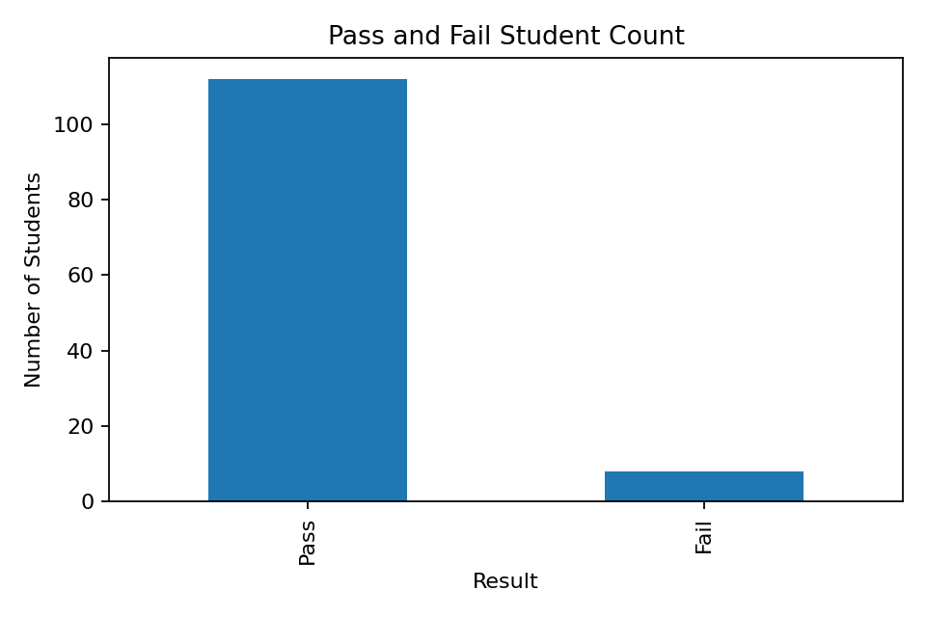
Figure 6.3.1: Pass and Fail Student Count
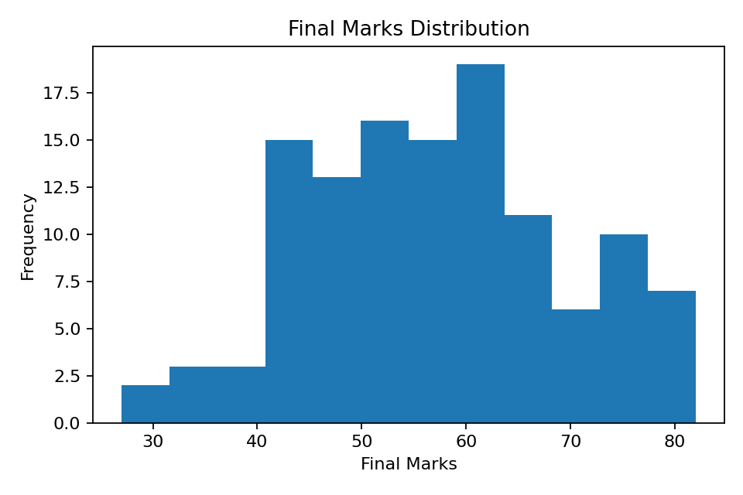
Figure 6.3.2: Final Marks Distribution
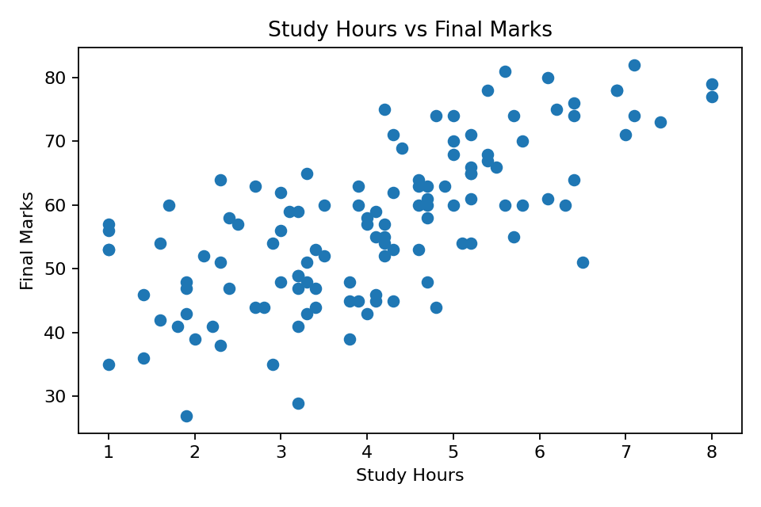
Figure 6.3.3: Study Hours vs Final Marks
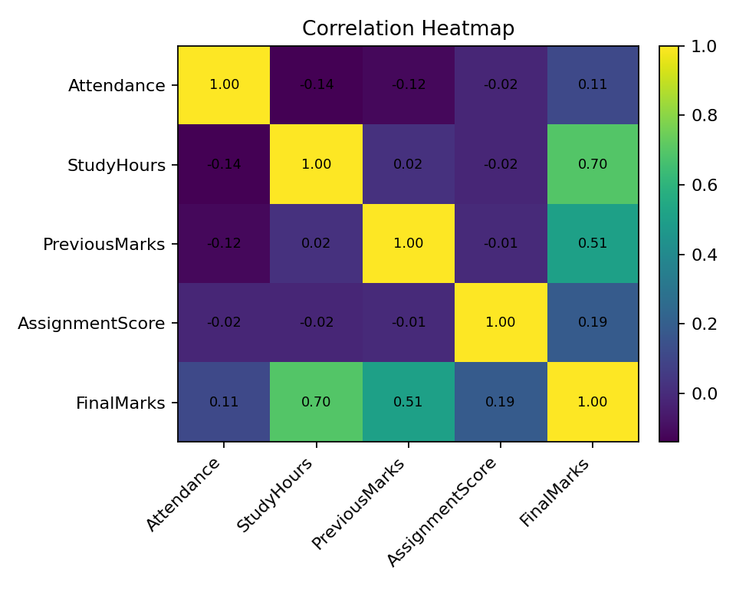
Figure 6.3.4: Correlation Heatmap
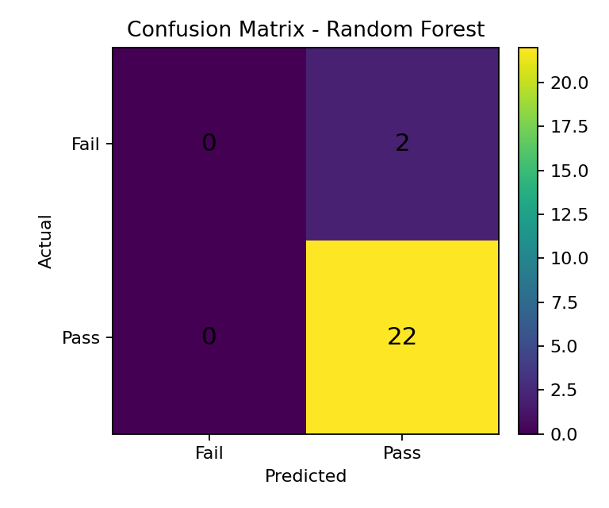
Figure 6.3.5: Confusion Matrix of Random Forest Model
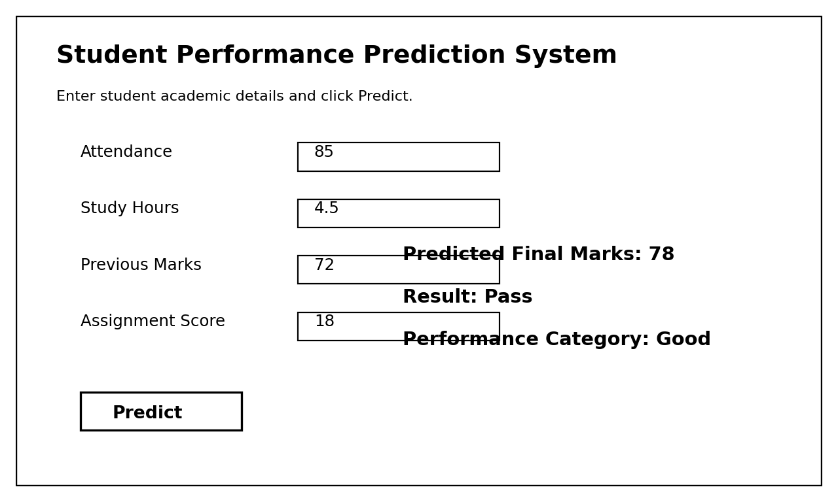
Figure 6.3.6: Streamlit Prediction App Screen

6.4 Result Interpretation
The results obtained from the system show that machine learning can be applied effectively to academic data. The regression model predicts approximate final marks, while the classification model predicts the result category. The system can help identify students who may need improvement before final examinations.
The visual analysis indicates that students with higher attendance, better previous marks and more study hours generally achieve better final marks. The correlation heatmap supports the relationship between academic features and final performance. The confusion matrix shows that the classifier is able to separate pass and fail cases effectively for the sample dataset.
The Streamlit application makes the project easy to demonstrate. Instead of running code manually, the user can enter student details in a browser interface and receive predictions instantly. This makes the project more suitable for college submission and viva demonstration.
Overall, the project successfully combines Python programming, data handling, data visualization, machine learning and web app development into a complete beginner-level AI/ML system.

CHAPTER 7 - CONCLUSION & FUTURE SCOPE

7.1 Summary of Work
The Student Performance Prediction System using Machine Learning was successfully designed and implemented as a Python-based academic prediction project. The project applies concepts of Core Python, data analysis, visualization, machine learning and Streamlit app development.
The system loads student data from a CSV file, cleans the dataset, performs exploratory analysis, trains multiple machine learning models and provides predictions through a simple web interface. The project demonstrates the practical application of AI/ML in the education domain.
The project helps understand how student performance can be affected by attendance, study hours, previous marks and assignment score. It also shows how machine learning models can support academic analysis and early identification of students who may need support.

7.2 Key Findings
- Python is suitable for building beginner-friendly AI/ML projects because of its rich library support.
- Pandas and NumPy are effective for loading, cleaning and processing student datasets.
- Matplotlib and Seaborn help visualize performance patterns clearly.
- Attendance, study hours and previous marks are important indicators of academic performance.
- Linear Regression can be used to predict numeric final marks.
- Random Forest provides stable results for Pass/Fail classification.
- K-Means Clustering can group students into different performance categories.
- Streamlit provides a simple way to convert an ML model into a usable web app.

7.3 Limitations
- The prediction accuracy depends on the quality and size of the dataset.
- The system currently uses limited academic features only.
- Real student behaviour may depend on many external factors not included in the dataset.
- The project currently uses CSV files instead of a full database system.
- The Streamlit app is designed for demonstration and not for large-scale institutional deployment.
- The model may need retraining when new student records are added.

7.4 Future Improvements
- Add a larger real college dataset for better model accuracy.
- Add more features such as internal test marks, practical marks, project score and behaviour score.
- Connect the system with SQLite or PostgreSQL database instead of CSV storage.
- Add teacher login and student dashboard modules.
- Add AI-based improvement suggestions for weak students.
- Deploy the Streamlit app online for remote access.
- Add PDF report generation for individual student performance.
- Use advanced ML models and hyperparameter tuning for improved prediction.

BIBLIOGRAPHY
- Python Software Foundation. Python 3 Documentation.
- McKinney, W. Python for Data Analysis. O'Reilly Media.
- Pedregosa, F., Varoquaux, G., Gramfort, A., et al. Scikit-learn: Machine Learning in Python. Journal of Machine Learning Research.
- Géron, A. Hands-On Machine Learning with Scikit-Learn, Keras and TensorFlow. O'Reilly Media.
- Pandas Development Team. Pandas Documentation.
- NumPy Developers. NumPy Documentation.
- Matplotlib Development Team. Matplotlib Documentation.
- Seaborn Development Team. Seaborn Documentation.
- Scikit-learn Developers. Scikit-learn User Guide.
- Streamlit Documentation. Streamlit User Guide.
- Joblib Documentation. Model Persistence in Python.
- Khalsa College Internship Training Notes and Python AI/ML Practical Work.

