

REMOTE BORNE CONTROL
Step-by-Step Client Guide
Operator User Manual — 16.1.0 — AVL Document

Application: | Remote Borne Control (RBM)
Supplier: | AVL
Client: | Renault Group
Version: | 16.1.0
Author: | RAISSI Nabil

. Purpose of This Guide

V16.1 Release Update
Version 16.1 aligns the delivery with the current RBM behavior: P/Q and CosPhi setpoints are validated against Pn, reactive power is limited to +/-11000 var, and CosPhi 0 is rejected. Test Sequence supports validated CSV import and Save as CSV. The delivery build checks required runtime files before reporting success.

About This Document
• Provide a complete, clear operator guide that can be used directly in the field.
• Follow a quick-start approach: simple, clear, and focused on test-bench use.
• Each numbered step corresponds to a specific action in the RBM interface.

Table of Contents
. Purpose of This Guide 2
Table of Contents 2
1. Application Overview 3
2. Prerequisites and Initial Checks 3
3. Configure Network Access if Required 4
4. Connect to the Charging Station 4
5. Browse Grid Code Files 5
6. Upload a Configuration File from the PC 5
7. Load the Test Configuration into GridCodes.properties 6
8. Edit a File 7
9. Restart Services 8
10. Send a P / Q Setpoint 8
11. Send a CosPhi Setpoint 9
12. Use the Energy Manager PRO Window if Required 9
13. Check Temperature / Derating and SoC 10
14. Open the Integrated SSH Terminal 11
14.1 Automated Test Sequence 11
15. Use Debug Logs 12
16. Change the Theme if Required 13
17. End of Test and Best Practices 13
18. Troubleshooting and Support Information 14
Quick Summary 14

1. Application Overview
The main screen brings together the complete workflow: Grid Code file navigation, charging-station control actions, and real-time monitoring through the logs.

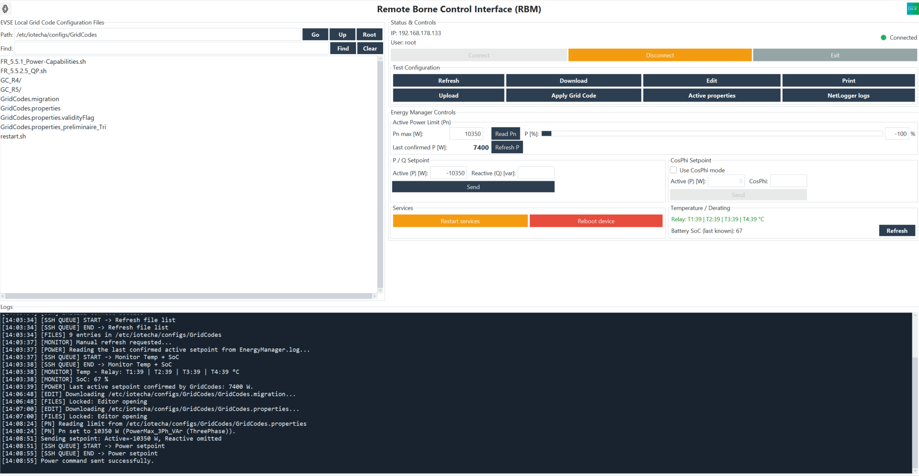
Figure 1 — Application Overview
Connected main screen with the file browser, actions on the right, and logs at the bottom.

Zone | Usage
Left area | Navigate through the Grid Codes folder and select files.
Right area | Main actions: connection, upload, configuration loading, P/Q, CosPhi, and services.
Bottom panel | Real-time logs for tracking actions and diagnosing issues.
Top menu | Access to advanced functions: Debug, Energy, Network, Terminal, and Help.

2. Prerequisites and Initial Checks
Before starting a test, check the following:
• The PC must be on the same network as the charging station.
• The IP address, SSH username, and password must be known.
• The Grid Code file to be loaded must be available on the PC.
• If required by the test bench, make sure the vehicle is in the correct state before restarting services or sending a setpoint.
• Confirm that the local export folder is writable and has enough free space for downloaded files and logs.
• Have the target EVSE host-key fingerprint available from the EVSE owner before the first connection.
Recommended Check Before Testing
• Check the Logs area at the bottom of the window after each important action.
• Run only one action at a time: upload, load configuration, restart services, then send the setpoint.
• Check the selected file name before editing or loading a configuration.

3. Configure Network Access if Required
1 Open Network → Network config.
2 Check the IP address, username, password, port, and remote path.
3 Click Save. If the IP address, port, or credentials changed, RBM restarts before connecting to the new target.
4 Select a writable Local path. This folder is used for downloaded, exported, and printed files.
5 Reopen Network Configuration and verify the saved values before connecting to a new EVSE.

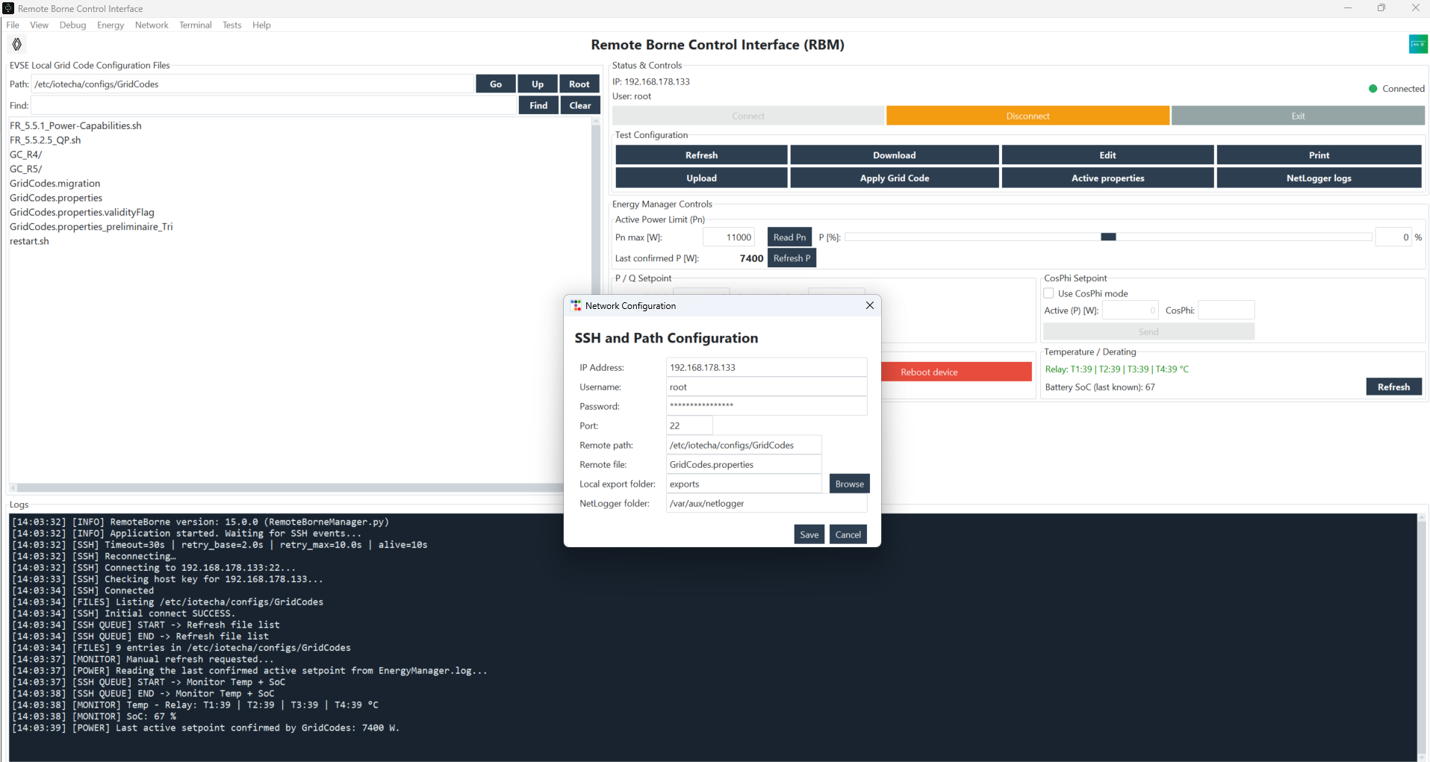
Figure 2 — Network Configuration Window
Network Configuration dialog showing the IP address, SSH credentials, and remote path.

4. Connect to the Charging Station
1 Click Connect.
2 If an SSH host-key verification dialog appears, verify the fingerprint with the EVSE owner before accepting it.
3 Wait until the Connected status appears and make sure the remote file list is loaded.
4 Read the latest log line. Connected and a completed file-list refresh confirm that RBM is ready for the next action.
5 If the status remains Reconnecting, do not click Connect repeatedly. Correct the network configuration or target availability first.

Expected Result
• The status indicator turns green.
• The buttons in the action area become available.
• The logs show the SSH connection and list refresh.

5. Browse Grid Code Files
The list on the left displays the contents of /etc/iotecha/configs/GridCodes. Select a file, then use the buttons or the context menu.
If the folder list is loading, wait for the refresh to complete before selecting Go, Up, or Root again. Do not repeat navigation clicks while a request is pending. Debug Logs uses the SSH host key already approved for the active RBM connection. Use Find to filter the current folder locally while typing. After a short pause, RBM automatically searches the current folder and all subfolders. Enter a word or a wildcard such as *Power*. Click Find or press Enter to start the recursive search immediately; results are grouped by folder and a double-click opens the selected result folder. Use Clear or navigate to another folder to restore the complete list.

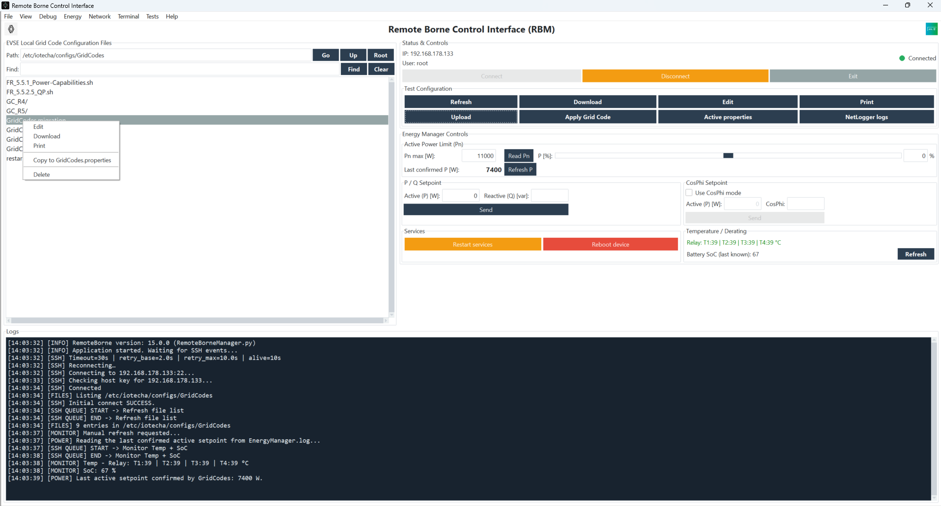
Figure 3 — File List and Context Menu
Grid Codes file selected with the context menu open: Edit, Download, Print, and Copy to GridCodes.properties.

Useful Functions
• Edit opens the selected file directly in the editor.
• Download retrieves a local copy of the selected file.
• Print generates a readable local version.
• Copy to GridCodes.properties quickly loads the selected configuration.

6. Upload a Configuration File from the PC
1 Click Upload Configuration File from PC.
2 Select the file on the PC, then confirm.
3 Wait for the upload to complete and make sure the file appears in the remote list.
4 Use a non-production test file when validating a new configuration. Keep the original file available locally for recovery.
5 If the upload fails, read the SSH error in the Logs area before retrying the transfer once.

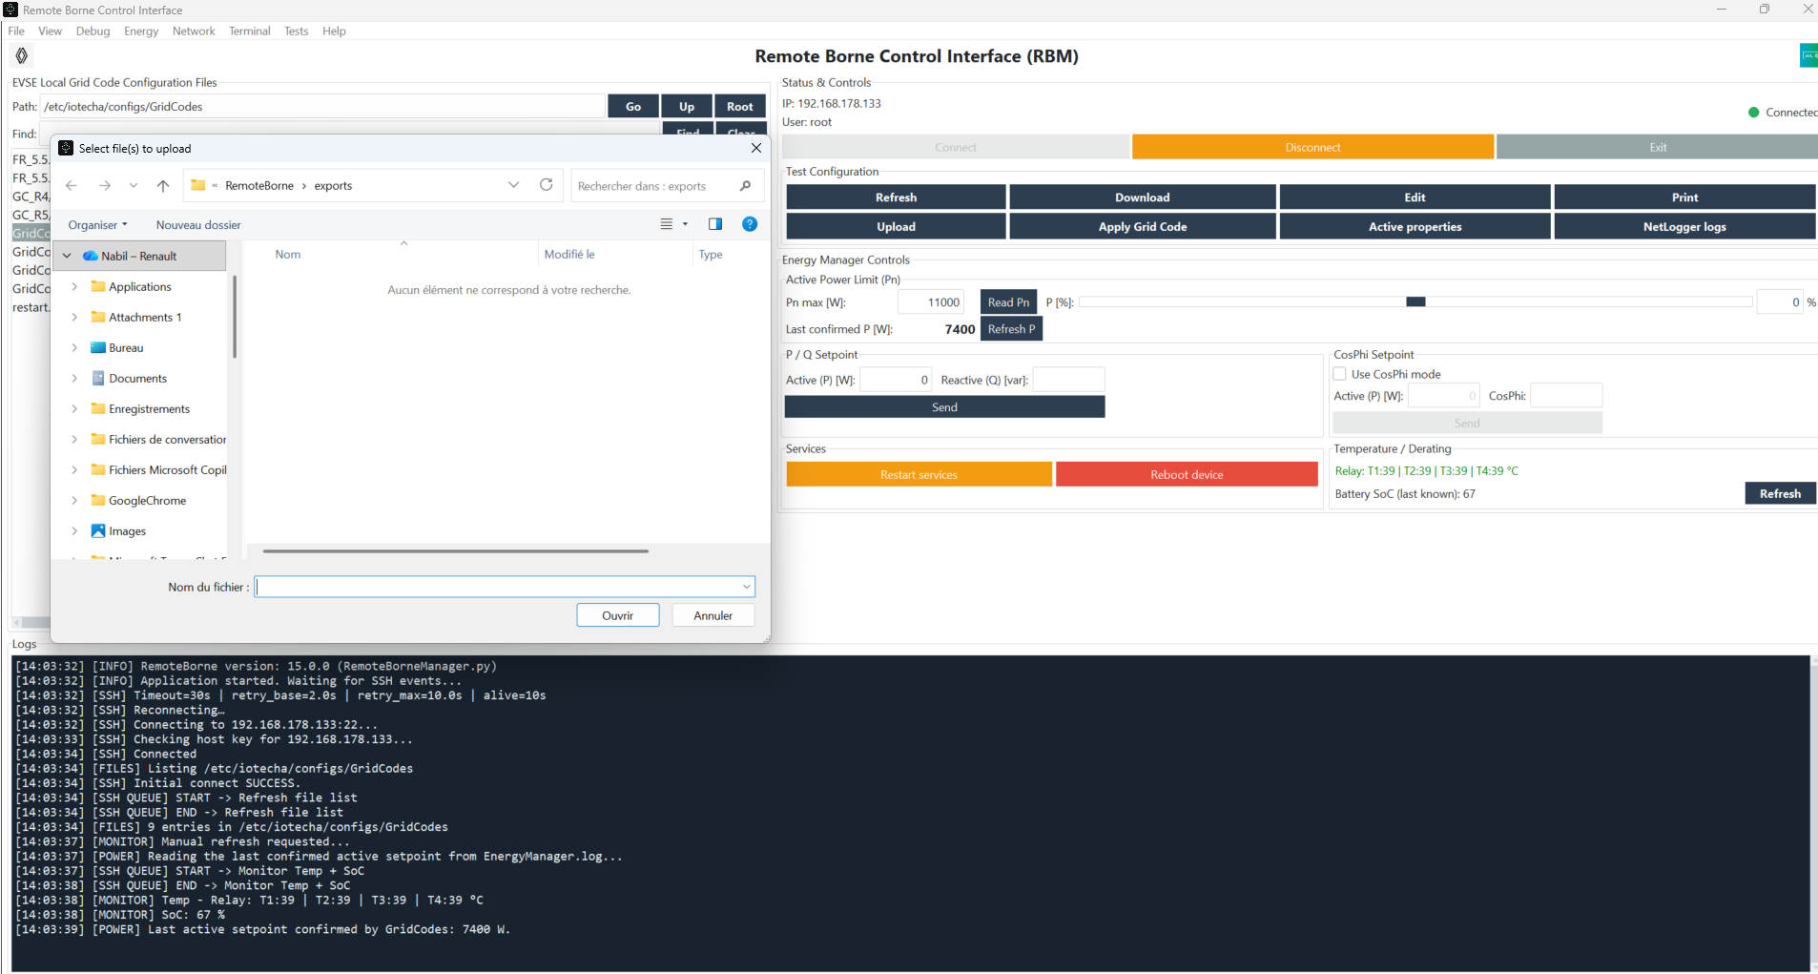
Figure 4 — Selecting a Local File for Upload
Windows File Explorer used to select a Grid Code configuration file on the PC.

Check to Perform
• The file name should then appear in the remote list.
• If the transfer takes time, monitor the logs instead of clicking again.
• Use clear file names to distinguish test variants easily.

7. Load the Test Configuration into GridCodes.properties
1 Select the required file from the list.
2 Click Load Grid Code Configuration, or use Copy to GridCodes.properties from the context menu.
3 Confirm the action if prompted.
4 This action replaces the active GridCodes.properties reference with the selected file. Verify the selected name before confirming.
5 If RBM asks to restart services, first verify that the charging cable is unplugged, then follow the safety dialog.

Effect of This Action
• The contents of the selected file become the active reference configuration.
• Restarting the services is then recommended to apply the change.

8. Edit a File
1 Select the file, then click Edit.
2 The editor opens directly when RBM is connected.
3 Edit the content, then choose Save or Save As.
4 Use Save only when overwriting the selected remote file is intended. Use Save As to keep the original file and create a test variant.
5 After saving a configuration that must become active, use Load Grid Code Configuration and follow the restart procedure when required.

Direct File Editing
The editor opens directly after clicking Edit; no additional password is required.

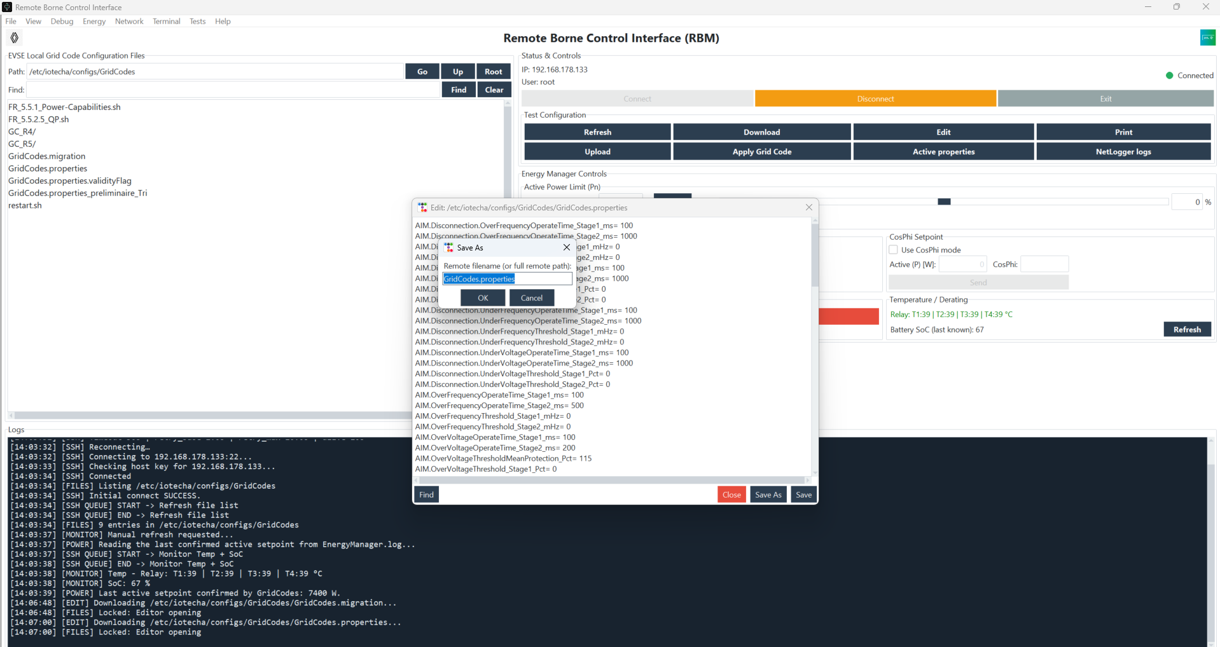
Figure 6 — Save / Export Dialog
Local save dialog used after an export or Save As.

Difference Between Save and Save As
• Save directly overwrites the currently open remote file.
• Save As saves the modified file under a different name.
• Confirm the target file before using Save.

9. Restart Services
1 Verify that the charging cable is unplugged, then click Restart services.
2 Confirm the safety dialog, then wait until the command completes in the logs.
3 Do not send any setpoint until the restart has completed.
4 A successful request is visible only after the final result is written in the Logs area. Do not close RBM or send a second maintenance command while it is running.
5 Reconnect and refresh the file list after a reboot before continuing the test procedure.

When to Use It
• After Load Grid Code Configuration.
• After changing an important configuration file.
• Before validating behavior when required by the test procedure.

10. Send a P / Q Setpoint
1 Set Pn max manually or click Read Pn. Use P [%] to apply a percentage of Pn to the active setpoint.
2 Enter Reactive (Q) [var] only when required by the scenario. Leave the field blank to send the setpoint without a reactive-power option.
3 Click Send, then wait for the result before starting another action.
4 Click Refresh in the Temperature / Derating area and verify that Last confirmed P [W] matches the latest P setpoint accepted in EnergyManager.log.

Figure 7 — P/Q Setpoint on the Main Screen
Main screen with Active Power and Reactive Power values entered and the result visible in the logs.

Typical Example
• A negative active-power value may represent discharging if required by the test scenario.
• If no reactive power is required, leave Reactive (Q) blank so no reactive-power option is sent.
• Check the feedback in the logs after sending the command.

11. Send a CosPhi Setpoint
1 Select Use CosPhi mode.
2 Enter Active (P) [W], then CosPhi.
3 Click Send, then wait for the result before starting another action.
4 If the CosPhi field is blank, RBM uses 1.0 (unity power factor). Wait for the command confirmation in the logs before sending another action.

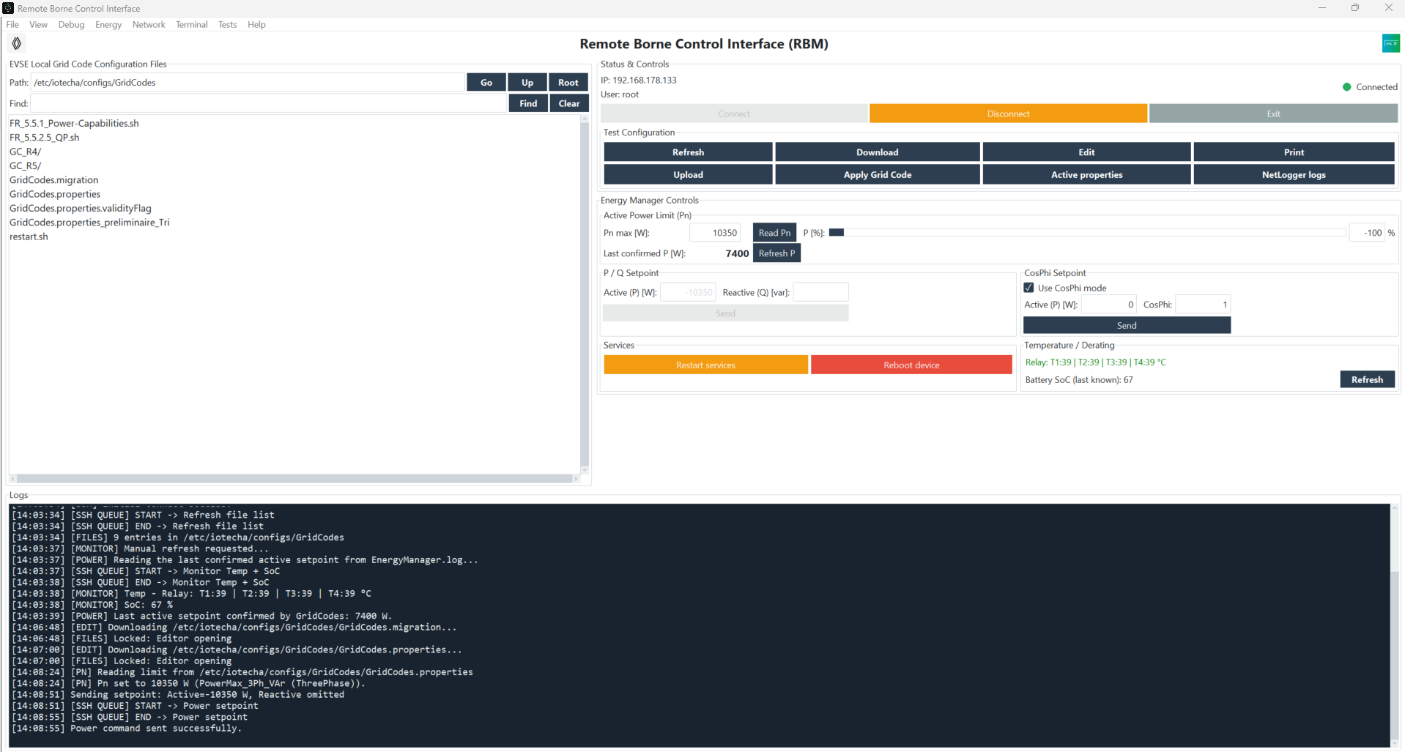
Figure 8 — CosPhi Setpoint on the Main Screen
Main screen with CosPhi mode enabled and a command sent successfully.

Useful Check
• Recheck the CosPhi value before sending.
• Check the logs to make sure the setpoint was accepted.
• Use only values allowed by the test procedure.

12. Use the Energy Manager PRO Window if Required
The Energy Manager PRO window provides a dedicated interface for P/Q and CosPhi testing, including command history.

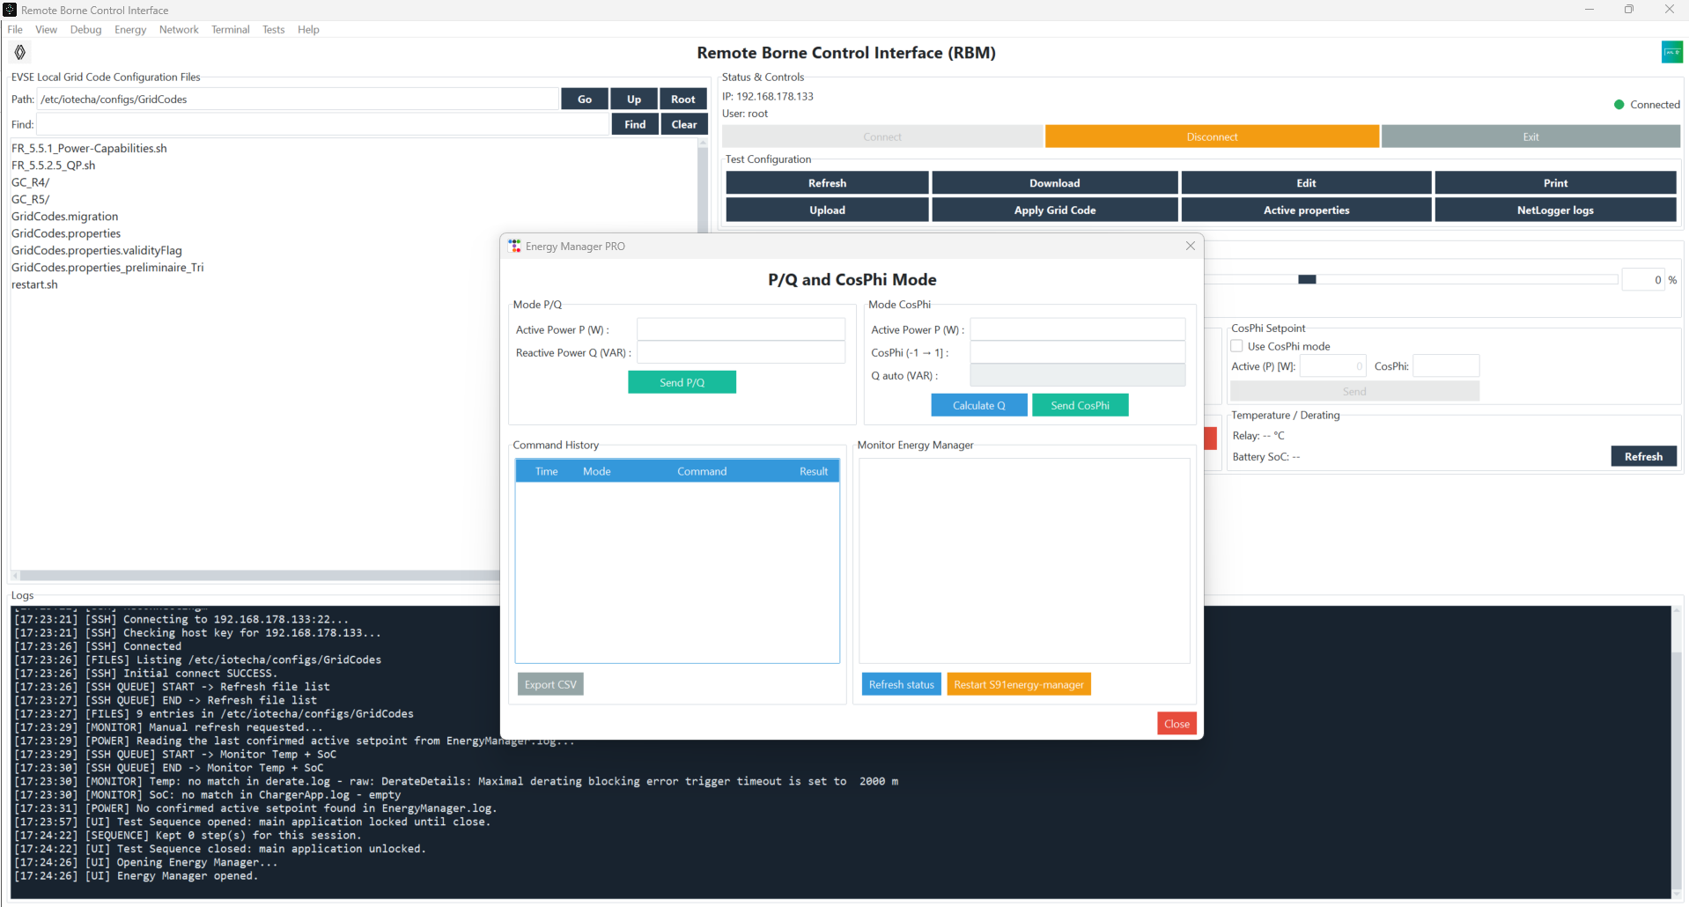
Figure 9 — Energy Manager PRO Window
Energy Manager PRO window with command history and a confirmation pop-up.

When to Prefer This Window
• When you want to track the history of P/Q or CosPhi commands.
• When you want a dedicated screen for Energy Manager testing.

13. Check Temperature / Derating and SoC
The lower-right area refreshes reported temperature, battery SoC, and the last confirmed active P when this information is available from the charging station.
1 Click the refresh button in the Temperature / Derating area.
2 Read the values displayed for Relay, Battery SoC, and Last confirmed P [W].
3 Last confirmed P [W] is parsed from the latest P setpoint accepted in EnergyManager.log. Use Refresh P to reread only this value.
4 Temperature and SoC are diagnostic information from EVSE logs. They support the test but do not replace approved bench measurements.
5 A blank SoC can be normal when no vehicle is connected; it must not prevent the temperature result from being used.

Simple Interpretation
• If temperature data is available, it is displayed directly in the area.
• If SoC is not available in the charging-station logs, the application may display a blank value without freezing.
• The purpose is to support diagnostics, not to replace test-bench measurements.

14. Open the Integrated SSH Terminal
1 Open Terminal → Open Terminal.
2 Make sure the terminal is connected.
3 Use only simple commands such as ls, pwd, or cd.
4 Avoid interactive commands such as vim, nano, or top. Use the terminal for limited diagnostic commands only and record any manual command in the test evidence.

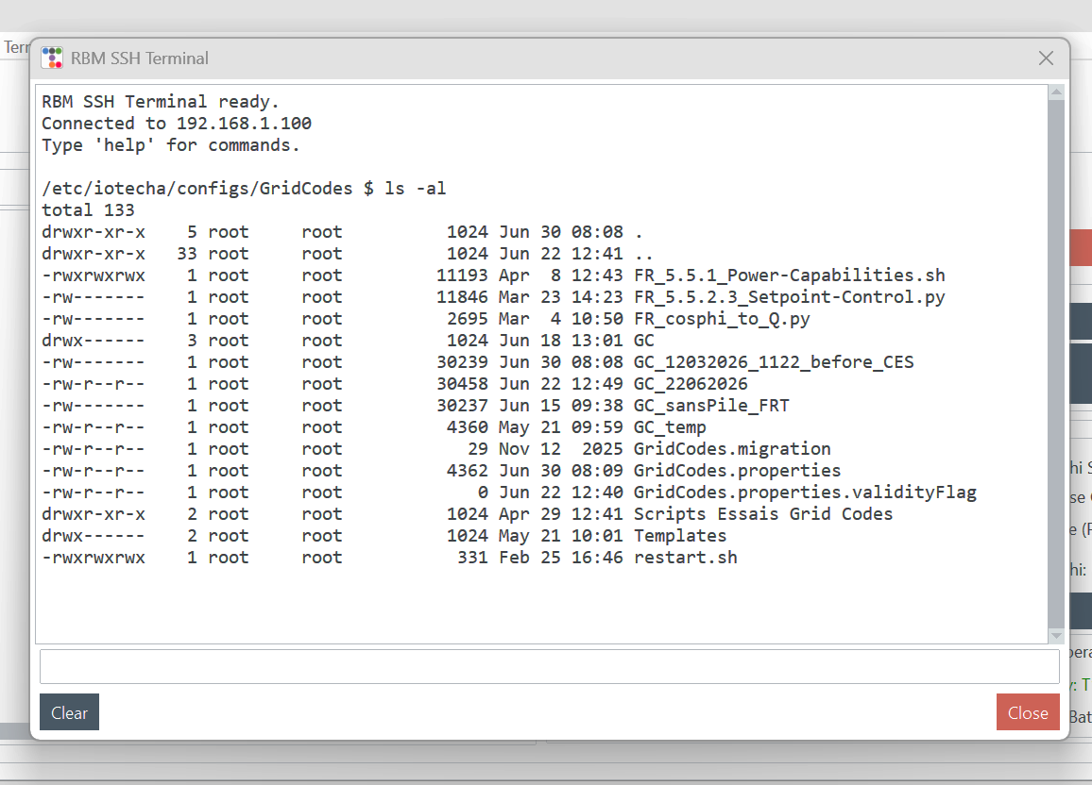
Figure 10 — Integrated SSH Terminal
RBM SSH terminal connected and ready for simple commands.

Intended Limitations
• Interactive commands such as vim or nano are not intended for this tool.
• The terminal is mainly intended for support and occasional diagnostics.

14.1 Automated Test Sequence
1 Select Tests > Test Sequence in the main menu.
2 Add each plateau in the required order. For P/Q, Active Power P and the hold duration are required; Reactive Power Q is optional. Leave Q blank to send P without a reactive-power option.
3 For a CosPhi plateau, enter Active Power P and CosPhi. Leave CosPhi blank to use 1.0. Check the calculated reactive value before starting the sequence.
4 Use Update, Remove, and Move controls to review the rows. Validate the entire scenario and the EVSE test conditions before selecting Start.
5 Test Sequence is modal: while its window is open, RBM blocks access to the main application, including GridCodes changes, manual setpoints, maintenance, Terminal, and Debug logs. Close the window to restore access.
6 One row is sent at a time. Pause freezes the remaining hold time, Resume continues it, and Stop prevents any remaining rows from being sent.
7 A remote command error or an SSH disconnection aborts the remaining sequence. Read the reason in the logs before creating a new scenario. Use the Active Power Helper to read or enter Pn, then use P [%] from -100 to +100 to calculate a plateau value. Save as CSV prompts for a scenario name and location; Import sequence reloads a saved CSV after a full application restart. or an SSH disconnection aborts the remaining sequence. Read the reason in the logs before creating a new scenario. Use Save as CSV to choose a name and location for the prepared sequence, then use Import sequence to reuse it later. Steps remain available only during the current RBM session; after a full application restart, import the saved CSV again.
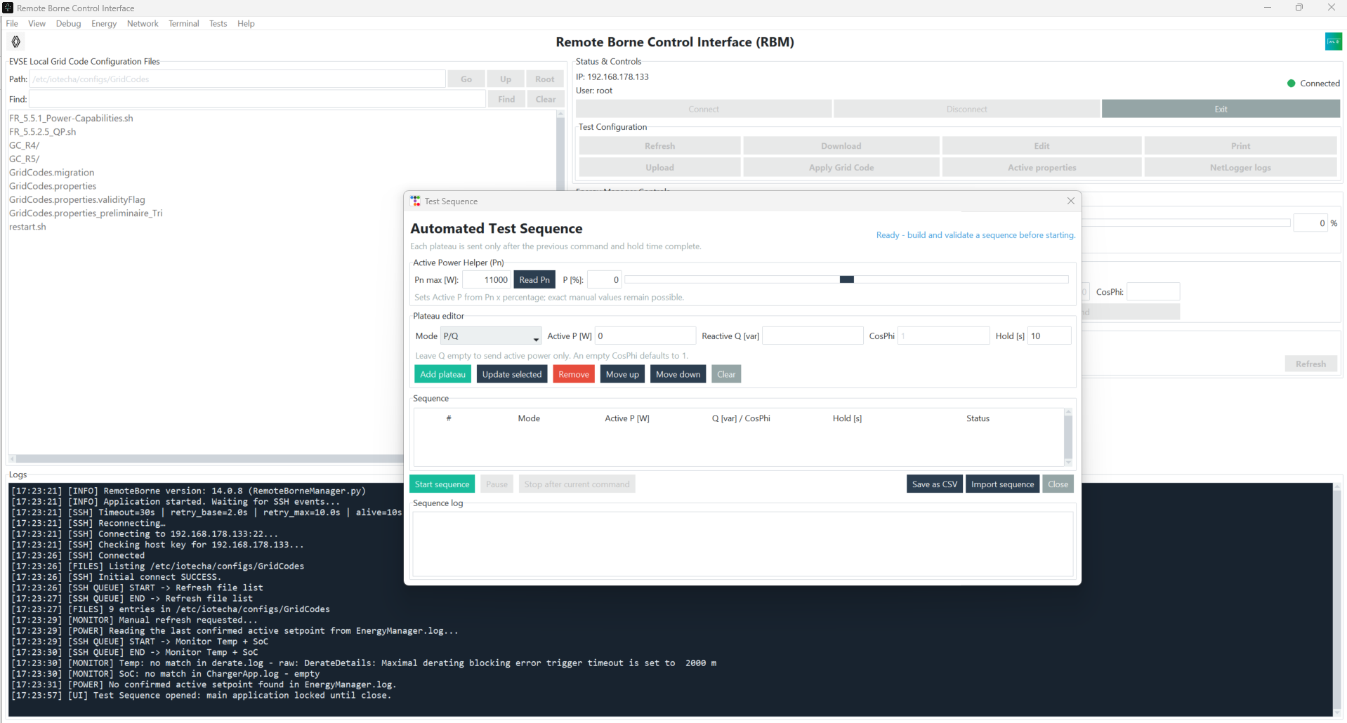
Figure 13. Test Sequence (V16): Pn helper, plateau editor, and CSV scenario actions.
The sequence window is modal. Validate all plateaus and EVSE conditions before Start sequence, then follow the live sequence log until completion or a controlled stop.

15. Use Debug Logs
1 Open Debug, then the log window if detailed diagnostics are required.
2 Select the relevant log: EnergyManager.log, ChargerApp.log, or iotc-meter-dispatcher.log.
3 Use filters and auto-scroll to follow an event in real time.
4 Before closing the window, use Save view when the displayed logs are needed for the validation record or a support request.

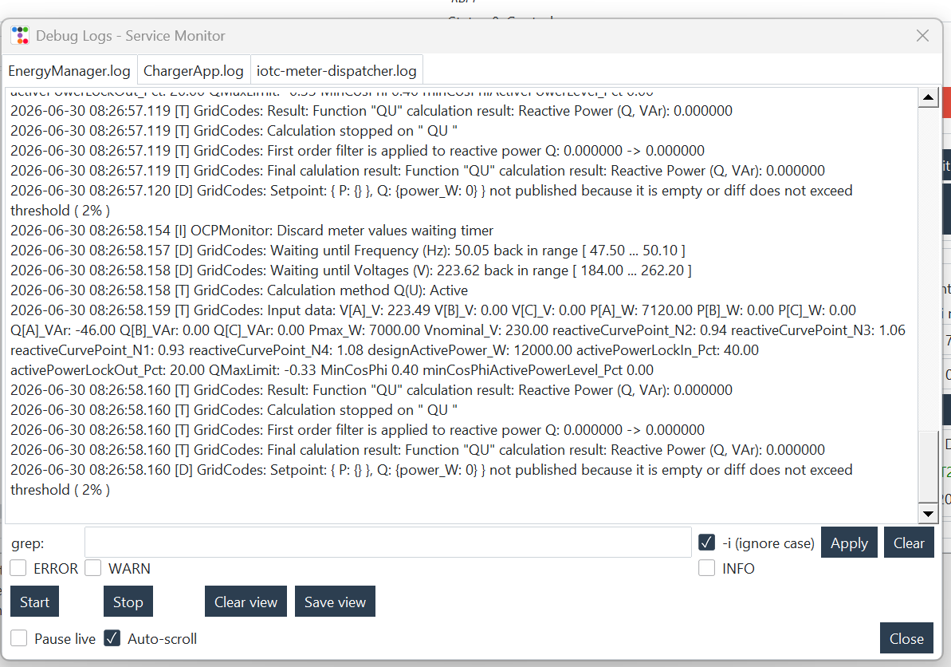
Figure 11 — Debug Logs / Service Monitor
Debug window with log tabs, a filter field, and action buttons.

16. Change the Theme if Required
The View menu lets you select the application's visual theme. This changes only the appearance, not the functionality.

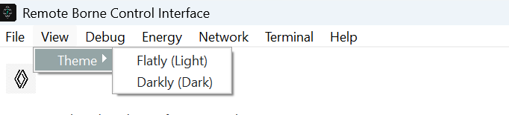
Figure 12 — Theme Selection Menu
View menu with available themes such as Flatly and Darkly.

17. End of Test and Best Practices
• Check the logs to make sure the last action completed successfully.
• Save any useful files locally if a test record is required.
• Click Disconnect before closing the application.
• Use Reboot device only when explicitly allowed by the test procedure and after verifying that the charging cable is unplugged.

18. Troubleshooting and Support Information
• Connection failed or status remains Reconnecting: check the PC network, EVSE IP address, port, and SSH service. Save Network Configuration, then click Connect once and wait for the logs.
• Host-key verification appears: compare the displayed fingerprint with the EVSE owner before accepting it. Reject the key if it cannot be verified.
• Remote file list is empty: click Refresh once. If the logs say that navigation is pending or a list is loading, wait for completion before using Go, Up, or Root.
• A button is disabled or an action is in progress: wait for the corresponding SSH QUEUE END log entry. Do not click again; RBM protects against duplicate commands.
• Temperature is displayed but SoC is blank: this can be normal when no vehicle is connected or the charging-station log has no current SoC. Keep the temperature result and check ChargerApp.log.
• When requesting support, provide the RBM version, time of the event, target IP address, action performed, screenshot, and relevant logs. Never send the SSH password.

Quick Summary
1 Connect to the charging station.
2 Check or correct the Grid Code file.
3 Load the active configuration.
4 Restart Services.
5 Send the P/Q or CosPhi setpoint.
6 Check the logs, temperature, and SoC.

