L1

<https://app.brandmark.io/v2/?name=logo-icon-replacement&iconId=1698817&iconColor%5Bhex%5D=%23e2b236&title=FIRE+TRADE&tagline=AI+Amplified+Trading&nthChar=1&titleFamily=Yantramanav&titleVariant=700&taglineFamily=Fira+Sans+Condensed&taglineVariant=400&titleScale=1.6010826274406345&taglineScale=0.85714285714286&titleColor%5Bhex%5D=%23e2b236&taglineColor%5Bhex%5D=%23e2b236&backgroundColor%5Bhex%5D=%23355387&titleLetterSpace=5&titleLineSpace=1.1&taglineLetterSpace=0&taglineLineSpace=1.1&iconScale=1&score=2.0938854955637&autoScale=false&hideIcon=false&palette%5B%5D=%23355387&palette%5B%5D=%23e2b236&palette%5B%5D=%23e2b236&palette%5B%5D=%23e2b236&palette%5B%5D=%23e2b236&palette%5B%5D=%23e2b236&keywords%5B%5D=Machine+Learning&keywords%5B%5D=Stocks&keywords%5B%5D=Trading&keywords%5B%5D=Artificial+Intelligence&keywords%5B%5D=Amplify&keywords%5B%5D=Profit&keywords%5B%5D=Business&color_styles%5B%5D=default>



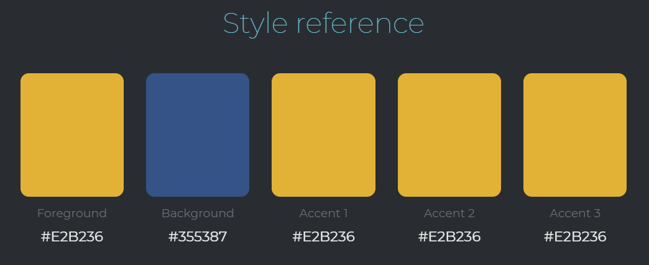

L2

<https://app.brandmark.io/v2/?name=logo-color&color1%5Bhex%5D=%23b7d9a3&color2%5Bhex%5D=%232e8f0d&color3%5Bhex%5D=%2381c525&color4%5Bhex%5D=%2365b700&nth1=4&nth2=9&nth3=0&nth4=0&title=FIRE+TRADE&tagline=AI+Amplified+Trading&titleFamily=Montserrat+Light+Alt1&titleVariant=300&taglineFamily=Montserrat&taglineVariant=400&titleScale=1.1289612917818261&taglineScale=0.85714285714286&titleColor%5Bhex%5D=&taglineColor%5Bhex%5D=%23b7d9a3&backgroundColor%5Bhex%5D=%2319191e&titleLetterSpace=5&titleLineSpace=1.1&taglineLetterSpace=4&taglineLineSpace=1.1&iconScale=1&score=1&autoScale=false&palette%5B%5D=%2319191e&palette%5B%5D=%23b7d9a3&palette%5B%5D=%232e8f0d&palette%5B%5D=%2381c525&palette%5B%5D=%2365b700&palette%5B%5D=%235ea71c&palette%5B%5D=%23f1f9e7&keywords%5B%5D=Machine+Learning&keywords%5B%5D=Stocks&keywords%5B%5D=Trading&keywords%5B%5D=Artificial+Intelligence&keywords%5B%5D=Amplify&keywords%5B%5D=Profit&keywords%5B%5D=Business&color_styles%5B%5D=default>



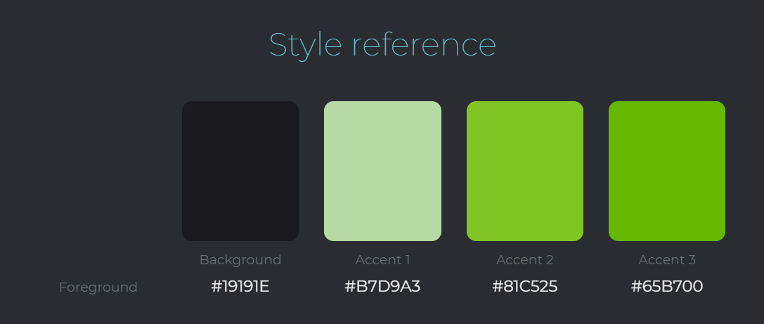

L3

<https://app.brandmark.io/v2/?name=logo-vertical-icon&iconId=779006&iconColor%5Bhex%5D=%231da5cd&title=Fire+Trade&tagline=AI+Amplified+Trading&titleFamily=ITC+Lubalin+Graph&titleVariant=900italic&taglineFamily=Lato&taglineVariant=italic&titleScale=1.3224935656873145&taglineScale=0.85714285714286&titleColor%5Bhex%5D=%231da5cd&taglineColor%5Bhex%5D=%231da5cd&backgroundColor%5Bhex%5D=%23454e46&titleLetterSpace=5&titleLineSpace=1.1&taglineLetterSpace=0&taglineLineSpace=1.1&iconScale=1&score=0.74945411069661&autoScale=false&hideIcon=false&palette%5B%5D=%231da5cd&palette%5B%5D=%23f2f5f3&palette%5B%5D=%23454e46&palette%5B%5D=%239ecc3c&palette%5B%5D=%2336544f&keywords%5B%5D=Machine+Learning&keywords%5B%5D=Stocks&keywords%5B%5D=Trading&keywords%5B%5D=Artificial+Intelligence&keywords%5B%5D=Amplify&keywords%5B%5D=Profit&keywords%5B%5D=Business&color_styles%5B%5D=default>



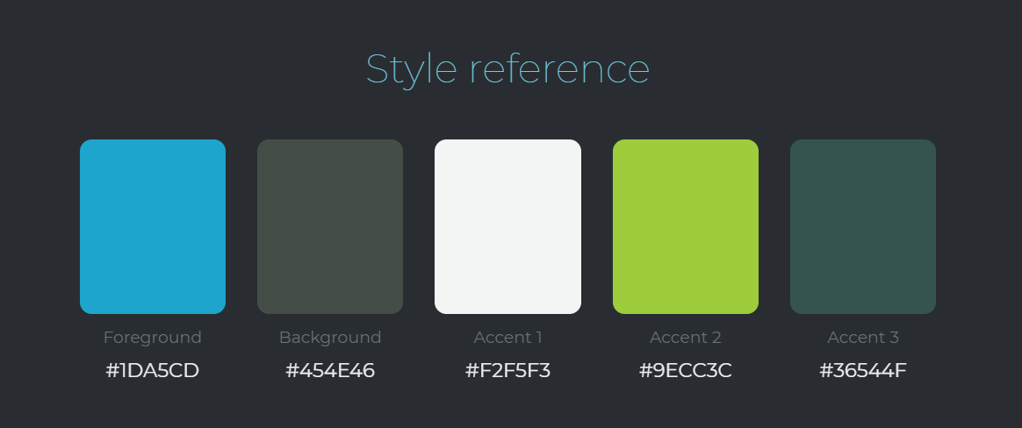

L4

<https://app.brandmark.io/v2/?name=logo-vertical-icon&iconId=1208926&iconColor%5Bhex%5D=%2313add6&title=Fire+Trade&tagline=AI+Amplified+Trading&titleFamily=PF+BeauSans+Pro&titleVariant=900&taglineFamily=Lato&taglineVariant=italic&titleScale=1.3858882409594844&taglineScale=0.85714285714286&titleColor%5Bhex%5D=%2313add6&taglineColor%5Bhex%5D=%2313add6&backgroundColor%5Bhex%5D=%23004a71&titleLetterSpace=5&titleLineSpace=1.1&taglineLetterSpace=0&taglineLineSpace=1.1&iconScale=1&score=1.6694715241174&autoScale=false&hideIcon=false&palette%5B%5D=%23004a71&palette%5B%5D=%2313add6&palette%5B%5D=%2313add6&palette%5B%5D=%2313add6&palette%5B%5D=%2313add6&keywords%5B%5D=Machine+Learning&keywords%5B%5D=Stocks&keywords%5B%5D=Trading&keywords%5B%5D=Artificial+Intelligence&keywords%5B%5D=Amplify&keywords%5B%5D=Profit&keywords%5B%5D=Business&color_styles%5B%5D=default>



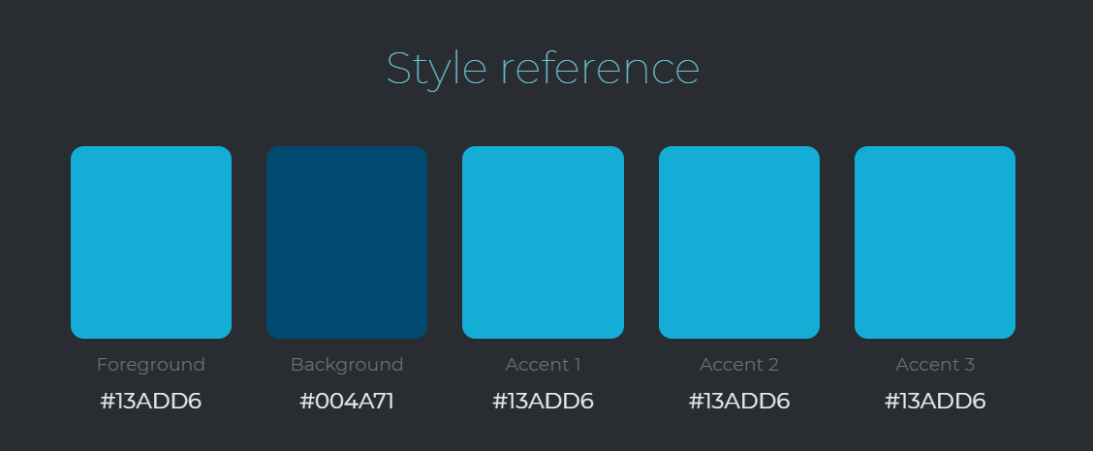

L5

<https://app.brandmark.io/v2/?name=logo-horizontal-icon&iconId=2046068&iconColor%5Bhex%5D=%233ebcdb&title=FIRE+TRADE&tagline=AI+Amplified+Trading&titleFamily=Averta&titleVariant=700italic&taglineFamily=Roboto+Slab&taglineVariant=300&titleScale=1.0272141307097695&taglineScale=0.85714285714286&titleColor%5Bhex%5D=%233ebcdb&taglineColor%5Bhex%5D=%233ebcdb&backgroundColor%5Bhex%5D=%23dae1e4&titleLetterSpace=5&titleLineSpace=1.1&taglineLetterSpace=0&taglineLineSpace=1.1&iconScale=0.8600690223044954&score=1.0824115672052&autoScale=false&hideIcon=false&iconSpace=1&palette%5B%5D=%233ebcdb&palette%5B%5D=%235b6962&palette%5B%5D=%23dae1e4&palette%5B%5D=%23faf7f8&palette%5B%5D=%232c79bf&keywords%5B%5D=Machine+Learning&keywords%5B%5D=Stocks&keywords%5B%5D=Trading&keywords%5B%5D=Artificial+Intelligence&keywords%5B%5D=Amplify&keywords%5B%5D=Profit&keywords%5B%5D=Business&color_styles%5B%5D=default>

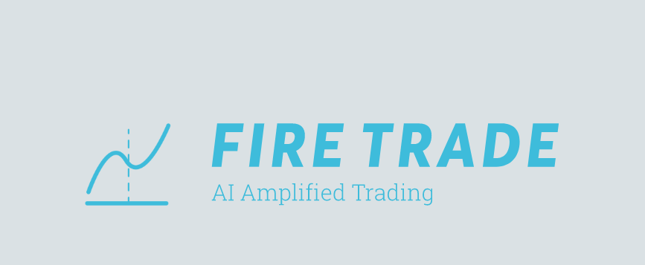

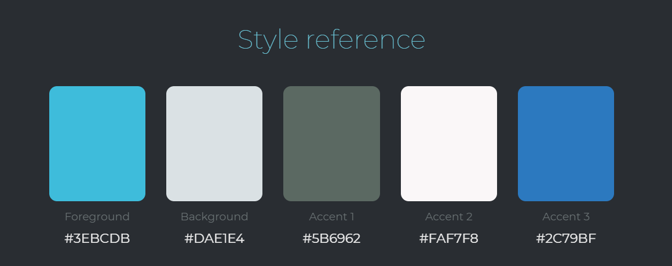

L6

<https://app.brandmark.io/v2/?name=logo-vertical-icon&iconId=889520&iconColor%5Bhex%5D=%2324c8ec&title=Fire+Trade&tagline=AI+Amplified+Trading&titleFamily=Frank+Ruhl+Libre&titleVariant=500&taglineFamily=Fanwood+Text&taglineVariant=italic&titleScale=1.9324676869105035&taglineScale=0.85714285714286&titleColor%5Bhex%5D=%2324c8ec&taglineColor%5Bhex%5D=%2324c8ec&backgroundColor%5Bhex%5D=%23646a88&titleLetterSpace=0&titleLineSpace=1.1&taglineLetterSpace=0&taglineLineSpace=1.1&iconScale=1&score=0.85941079021829&autoScale=false&hideIcon=false&palette%5B%5D=%2324c8ec&palette%5B%5D=%23424989&palette%5B%5D=%23646a88&palette%5B%5D=%23fafaf9&palette%5B%5D=%231a2757&keywords%5B%5D=Machine+Learning&keywords%5B%5D=Stocks&keywords%5B%5D=Trading&keywords%5B%5D=Artificial+Intelligence&keywords%5B%5D=Amplify&keywords%5B%5D=Profit&keywords%5B%5D=Business&color_styles%5B%5D=default>

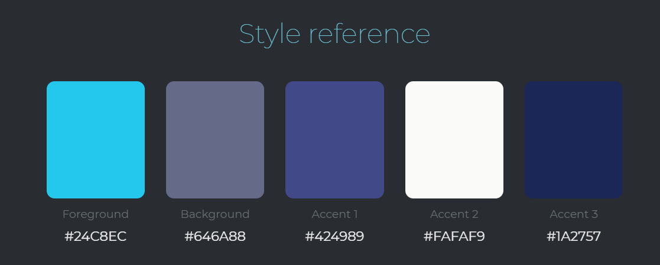

L7

<https://app.brandmark.io/v2/?name=logo-vertical-icon&iconId=528403&iconColor%5Bhex%5D=%23fcf3f3&title=Fire+Trade&tagline=AI+Amplified+Trading&titleFamily=Alice&titleVariant=regular&taglineFamily=Open+Sans&taglineVariant=regular&titleScale=1.6218038806835142&taglineScale=0.85714285714286&titleColor%5Bhex%5D=%23feac37&taglineColor%5Bhex%5D=%23feac37&backgroundColor%5Bhex%5D=%23002a51&titleLetterSpace=0&titleLineSpace=1.1&taglineLetterSpace=0&taglineLineSpace=1.1&iconScale=1&score=1.3477588045865&autoScale=false&hideIcon=false&palette%5B%5D=%23002a51&palette%5B%5D=%23feac37&palette%5B%5D=%23fcf3f3&palette%5B%5D=%23f9e299&palette%5B%5D=%23f6d44e&keywords%5B%5D=Machine+Learning&keywords%5B%5D=Stocks&keywords%5B%5D=Trading&keywords%5B%5D=Artificial+Intelligence&keywords%5B%5D=Amplify&keywords%5B%5D=Profit&keywords%5B%5D=Business&color_styles%5B%5D=default>

