**PROGRAM DEVELOPMENT IN A GRAPHICAL ENVIRONMENT**

420-203-RE

**MIDTERM EXAM**

**TIME: 2 Hours 20 Minutes**

**RULES:**

1. Respect the college cheating and plagiarism policies: both the cheater and the person who provided the material will get zero.
2. Do not share your work with anyone even after the period of the exam.
3. No messaging apps should be open.
4. No Emails app should be open.
5. No Cell Phones.
6. In case the teacher has a concern you should comply with the teacher’s instructions and stop working, resume, or submit the exam as instructed.

**Submission Format:**

* Submit through Omnivox, Lea.
* You may submit the ‘.java’ files only, or the full project.

1. Write a JavaFX program, using dynamic programming or FXML, that allows a user to search for a specific Client in a list of Clients and displays the information of the first client that matches the search. The layout and style is of your choice and could be kept to a minimum.

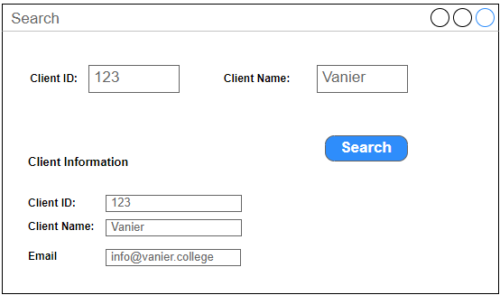

**Time: 50 Mins**

* 1. The interface must be similar to the one presented in the image, search fields, with a search button, and search result fields that display the entry found through the search.
  2. Use the MVC architectural pattern for the implementation where the Client is the model class.
  3. Create the necessary packages to separate the Models, Views, and Controllers into separate packages.
  4. A Client has an ID, a First Name, Last Name, and an email.
  5. Multiple Client objects are stored in an ArrayList.
  6. The search may be done by Client ID or Client Name, or both. In case both values are specified, both values must match the corresponding values of a Client instance.
  7. The search should be case insensitive.
  8. Set the title of the window to “Search”.
  9. If no matches are found a message is displayed to the user “No matches found.”

1. Write a JavaFX program that allows a user to choose to apply a scale transform to either a circle or a rectangle by switching scenes.

**Time: 45 Mins**

* 1. The program must have a main page with two buttons “Scale Circle” and “Scale Rectangle” when either button is pressed the scene switches to the corresponding scene with the appropriate shape.
  2. when first displayed the circle or rectangle scene draws an initial shape.
  3. The circle or rectangle scene will present the user with text fields to enter the values for a scale transform and that uses the constructor: Scale(double x, double y, double pivotX, double pivotY)
  4. Once the user clicks on a “Scale” button the shape is scaled according to the values entered by the user.
  5. The program should have the circle and rectangle each in their appropriate panes, not all code will be put in the main Application class.

1. Write a JavaFX program that uses a TimeLineAnimation to make a filled circle move in a diagonal as illustrated by the image below. Note that the gray circles are for illustrating the movement, only one circle is supposed to show during the animation.

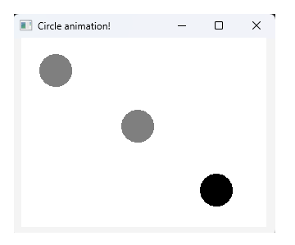

**Time: 45 Mins**

* 1. You may find the sample TimeLine Animation code implemented in class joined to the exam.