**Purification, Labeling and Activity Assay Of Cytolysin A Show Potency and Lipid Phase Dependent Kinetics**

Vivek Rai a and Sandhya S. Visweswariah b

a Department of Biotechnology, Indian Institute of Technology Kharagpur, Kharagpur, [vivekrai@iitkgp.ac.in](mailto:vivekrai@iitkgp.ac.in)

b Department of Molecular Reproduction, Development and Genetics, Indian Institute of Science, Bangalore, [sandhya@mrdg.iisc.ernet.in](mailto:sandhya@mrdg.iisc.ernet.in)

**ABSTRACT**

Cytolysin A (ClyA; also known as HlyE or SheA) is a novel, pore forming toxin of bacterial origin that acts as a potent virulence factor aiding in pathogenesis. Although, ClyA is a part of wider class of PFTs originating from distinct sources and having diverse structures, it can be broadly classified into the α-toxin family based on the secondary structure element spanning the lipid membrane. Recently, the soluble and pore structure of ClyA have been solved using X-Ray crystallography, revealing a radical conformation transition between the two structures. Upon insertion, ClyA undergoes a transformation involving almost 55% of its residues, reducing the core four-helix bundle in the monomer to an elongated three helix bundle. In an ongoing work characterizing a region of ClyA, the solvent exposed C-terminus has been found to tightly regulate the pore formation and channel activity of the toxin. In this current work, we discuss the methods to purify, label and test the activity of unlabeled and labeled ClyA Q56C mutant toxin. Interestingly, we also observe a lipid phase dependent kinetics of the toxin with the Calcein release assays. This study will pave way for further imaging and kinetic studies crucial for understanding the underlying mechanism of large conformational changes and role of important structural regions of the toxin.

1. **INTRODUCTION**

Pore forming toxin are a class of proteins that are able to disrupt the crucial lipid barrier between a cell and its surrounding environment, resulting in unregulated efflux of ions and important molecules such as ATP, toxin influx or induction of apoptosis.(Pradeep's paper 1-4). A rather diverse set of these proteins have been reported, majority of them being bacterial in origin e.g., *E. coli* Cytolysin A, *Staphylococcus aureus* alpha-hemolysin, *Vibrio cholerae* Cytolysin, although examples in sea anemones (equinatoxin II), mushrooms (Flammutoxin) and mammals (Perforin) also exist. Besides their potent role as virulence factors aiding in pathogenesis of the bacteria like pneumolysin and α-hemolysin, they are also known to participate in diverse cellular functions.

This ubiquitous presence of proteins, however, is very contrasting to the amount of details present for them. Fortunately, crystal structure elucidation and biochemical analyses have revealed intriguing information about the structure and function correlation of the PFTs. Unlike other membrane proteins which are inserted into the membrane upon synthesis, these proteins are made in water-soluble form, and switch to a distinct conformational state upon exposure to membrane. This induces the further assembly and oligomerization of monomers, followed by an insertion into the membrane and its permeabilization. The ability of PFTs to exist in this bi-stable state (membrane and aqueous) is suggestive of the extensive conformational pliability and possibly a consequence of their unknown unique folds.

The pores derived from the soluble pore-forming proteins can be classified broadly into alpha and beta toxins based on the secondary structure elements that span the membrane. The structure of the pores in latter class have remained a mystery for long due to failed attempt at obtaining low resolution crystal structure.

b.

a.

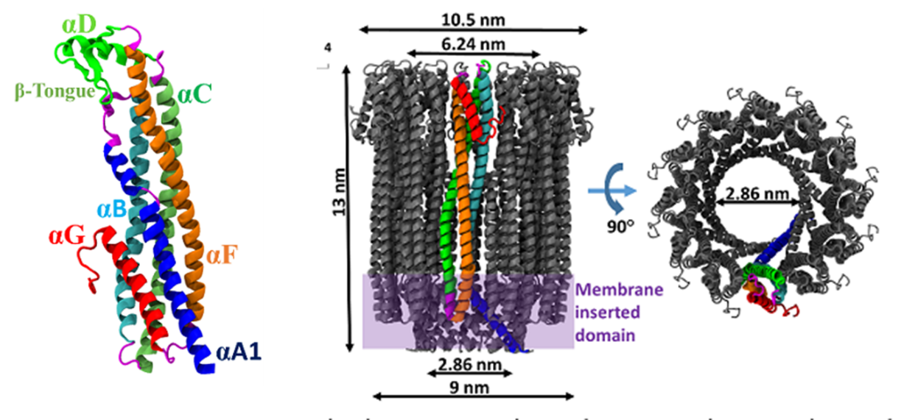

**Figure 1.** The monomer (**a**) and protomer (**b**) are shown in ribbon representation. The secondary structure elements are highlighted, each in a separate colour, from the N (blue) to the C (red) terminus.

However, recently, the high resolution structures for both the monomer1 and the pore-complex2 of ClyA (34 kDa) were made available; essentially making it the only α-PFT with such privileges. ClyA is present in the genome of *E. coli* and orthologs of the protein exist in *Salmonella enterica, Serovars typhi* and *paratyphi,* and *Shigella flexneri*. In addition, the fact that membrane binding and oligomerisation of this toxin can be induced *in vitro*, makes it an ideal candidate for investigating the assembly mechanism.

A comparison of the ClyA promoter and monomer structure revealed a conformational transformation of almost 55% of total residues, one of the largest known till date. Upon exposure to membrane, the core four-helix bundle in monomer is reduce to an elongated three-helix bundle, yet preserving the overall helical nature. The monomers then assemble to form an iris-like barrel structure, typically consisting of 12 subunits. Initial reports proposed a sequential assembly mechanism of the ClyA monomer, thought to occur through three main stages – membrane binding, conformation change and oligomerization, and pore formation and insertion; as shown in figure xx.

These ideas were further probed using several sensitive approaches like two-focus fluorescence correlation spectroscopy (2f-FCS)3, stopped-flow circular dichroism (CD) and photo-induced crosslinking4. Recently, use of single-molecule Forster resonance energy transfer (FRET) has elucidated a mechanism suggesting a non-sequential assembly of protomers where higher oligomers are shown to form mainly by the dimerization of smaller oligomers, majority of them ranging from tetramers to octamers. These studies emphasized that while a dodecameric complex was resolved using crystal structures, the octameric and 13-meric assembly of monomers as seen in electron microscopy images, can be a result of the inherent non-sequential mechanism of the assembly.

In the current work, we purify and investigate a mutant ClyA protein, having its glutamine residue at 56th position replaced by cysteine. This potency of this protein is investigated before and after labeling with a fluorophore dye and activity is ascertained using calcein leakage and hemolytic assay. We also observe that the ClyA protein shows a lipid phase dependent kinetics suggesting a strong interaction with its neighboring lipid environment. This interaction could provide more insight into the structure, stability and function modulation of the toxin.

1. **METHODS**

**2.1. Recovery, amplification and verification of His-ClyA Q56C plasmid**

Plasmid encoding His-ClyA Q56C sequence was obtained from Dr. xx on Whatman 3 mm filter paper. These pET11a plasmids were recovered by washing the paper with TE buffer (pH 8.0) and then used for heat-shock transformation of DH10 beta *E. coli* strain (available in the lab). After spread plating and overnight growth, a single colony was picked up and used to inoculate 3 ml of LB media. The media was left in a shaker incubator at 180 rpm for 12 hours of growth. Plasmids were then extracted from the culture using alkaline lysis method (mini preparation) and stored in TE buffer (pH 8.0) containing 20 ug/ml of DNase free RNase A.

To verify that the amplified plasmid indeed had our target insert, a double restriction digestion was performed using the NdeI and BamHI restriction enzymes for 5' (CAT) and 3' (GGATCC) sites immediately flanking the insert sequence. 2X Tango buffer, and 2 fold excess of NdeI and BamHI each were chosen for reaction mixture based on the recommendations of Double Digest tool. After three hours of incubation at 37*C, a 1% Agarose gel was run to confirm the presence of insert.

**2.2. Expression, purification and characterization of His-ClyA Q56C and His-ClyA**

**Expression**

Plasmids (pET11a, Merck Millipore) extracted in previous step were used to transform *E.coli* BL21 endo- cells (available in lab), spread plated and left for overnight growth at 37*C. The colonies obtained after 12 hours were scratched off the agar surface and grown in Terrific Broth (Pronadisa) media at 37*C, 180 rpm in a shaker incubator. Once the OD600 of the culture reached around 2, protein expression was induced by addition of 500 um of isopropyl thiogalactopyranoside (IPTG) for 12 h at 16*C.

**2.2.1. Purification** Cells were lysed by sonication in buffer containing 100 mM Tris–HCl (pH 8.0), 20 mM b-mercaptoethanol, 100 mM NaCl, 1 mM benzamidine, 2 mM PMSF (Phenylmethylsulfonyl fluoride) and 10% glycerol. Centrifugation was carried out at 30 000 g and the cell-free extract was interacted with nickel–nitrilotriacetic acid beads. Beads were washed with buffer containing 100 mM Tris–HCl (pH 8.0), 20 mM β-mercaptoethanol, 500 mM NaCl, and 20 mM imidazole to remove nonspecific proteins on the beads. His6 ClyA Q56C was eluted in buffer containing 100 mM Tris–HCl (pH 8.0), 20 mM b-mercaptoethanol, 100 mM NaCl, 300 mM imidazole, 10% glycerol. The purified protein was concentrated with an Amicon 8050 concentrator (Danvers, MA) ultrafiltration unit equipped with a regenerated nitrocellulose filter (Millipore Corp., Bedford, MA) with a molecular mass cut-off of 10 kDa. This high concentration of reducing agent (β -mercaptoethanol) was necessary only for the mutant protein because of an extra cysteine mutation. The ClyA WT protein could be purified in buffers containing only 5 mM of β -Me.

**2.2.2. Gel filtration** Gel filtration was carried out in buffer containing 100 mM Tris-Hcl (pH 8.0), 20 mM β-mercaptoethanol, 100 mM NaCl and 10% glycerol on an AKTA fast protein liquid chromatography system (GE Healthcare) using a Superose 12 column (GE Healthcare). The run was performed at 4*c at a flow rate of xx and three peaks were observed. The fractions collected corresponding to highest peak were most likely to contain our monomeric protein.

**2.2.3. Verification** The eluted fractions were run on a 12% poly-acrylamide gel in the Tris-Glycine-SDS buffer. Electrophoresis was carried out at 200 V (constant voltage) for one hour. The gel was stained by Coomassie stain solution (0.1% Coomassie Brilliant Blue R-250, 30% methanol and 10% glacial acetic acid) and destained using a solution containing 30% methanol and 10% acetic acid until the bands became visible. Protein concentration was estimated by Bradford protein assay.

**2.3. Hemolytic activity**

Rabbit erythrocytes were washed and a packed volume was diluted 1:100 v/v in 1x PBS (pH 7.3; 10 mM; Phosphate Buffer Saline). Varying concentrations of ClyA Q56C were added to 1 ml of this suspension and placed in shaking incubator at 37*C for 1 h. Cells were pelleted by centrifugation at 5000 rpm for 1 minute and hemoglobin released in the supernatant was quantified by spectrophotometric detection at 570 nm.

**2.4. Calcein leakage assay**

**2.4.1. Preparation of small unilamellar vesicles (SUVs)**

Small unilamellar vesicles (SUVs) were formed by the gentle hydration method. A solution of DOPC/Cholesterol (1:1, 10 mM; Avanti Polar Lipids) dissolved in chloroform was taken in a cleaned glass vial. This solution was then placed in a vacuum desiccator till all the organic solvent was expelled to yield a thin lipid film. The lipid film was hydrated by addition of pre-warmed Mili-Q water and xx mM Calcein and left to swell overnight (aging). This resulted in formation of cloudy solution consisting of multilamellar vesicles (MUVs). For downsizing of the MUVs, the cloudy suspension was subjected to sonication using probe sonicator (Branson Ultrasonics, 400 W) at 30% amplitude for 2 min (2 sec pulse and 2 sec rest), resulting in slightly hazy transparent solution. Often, using a sonicator tends to release titanium particles in the solution, which were removed by centrifugation at 13000 rpm for 10 minutes. 100 μl of the supernatant was run through a G50 coarse bead packed column to remove the free dye and collect fractions containing SUVs. These SUVs were used for further experiments. The same method was followed for preparing SUVs from DPPC[1]: DOPC[2]: Cholesterol (1:1:1, 10 mM; Avanti Polar Lipids) mixture and DPPC: Cholesterol (1:1, 10 mM; Avanti Polar Lipids) mixture.

**2.4.2. Testing the vesicles** To test whether Calcein has actually been incorporated inside the vesicles in a concentration that self-quenches, a fraction of vesicles was disrupted by adding Triton X (source?) while other was kept as control. The fluorescence values were then measured and compared to each other. A significant increase of the value for disrupted vesicles indicate proper self-quenching behavior of the Calcein dye inside the vesicles. Additionally, a dynamic light scattering experiment (Malvern Zetasizer uV) was also performed to estimate the mean vesicle size.

**2.4.3. Incubation with protein** The vesicles (100 μl) were incubated with 5 μg of both the ClyA and ClyA Q56C for all three types of vesicles (DPPC: DOPC: Cholesterol, DPPC: Cholesterol, DOPC: Cholesterol), along with positive and negative controls, and leakage was monitored at 520 nm with 490 nm excitation wavelength using a Tecan micro plate reader (Infinite M200 PRO).

**2.5. Labeling the protein**

Before labeling, the protein had to be dialysed and made free of any reducing agents that might interfere with the labeling process. A micro dialyzer (Pierce System 500) containing standard buffer was used to remove the reducing agent from 150 μl of protein sample and yield protein suitable for labeling reaction. In the next step, Cy3 dye (Life Technologies) dissolved in xx was added at a molar ratio of p:q of dye:protein to label the first cysteine residue. The reaction was performed at 22 C for 30 min and quenched by the addition of DTT (100 mM final concentration).The protein was concentrated to a final concentration of 20-50 mM and the unreacted dye was removed by Vivaspin 10 kDa molecular weight cut-off centrifugal filter (Vivaproducts). The activity of labeled protein was monitored using the Calcein leakage assay by excitation using 550 nm laser line.

1. **RESULTS**

**3.1. Expression and purification of ClyA, ClyA Q56C**

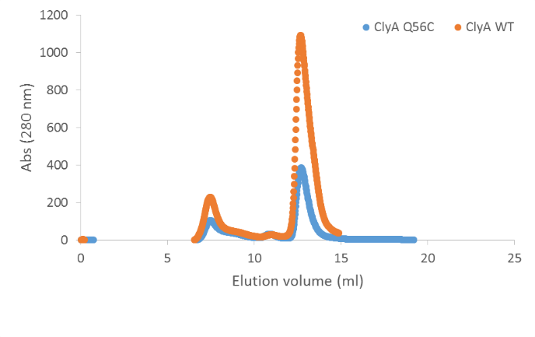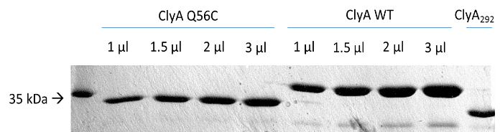ClyA and ClyA Q56C mutant were purified to homogeneity by nickel affinity chromatography. The mutant protein did not show any dramatic decrease in yield compared to C-terminal mutants, suggesting no structural instability within the protein due to mutation. Size-exclusion chromatography of both the proteins revealed a single prominent monomer peak indicating no aberrant aggregation products as observed in Fig. 2(b). A Bradford protein assay on both samples gave a concentration of 1 mg/ml concentration for ClyA and .42 mg/ml for ClyA Q56C respectively which was subsequently used for all further experiments.

b.

a.

**Figure 2.** (**a**) SDS-PAGE of different volumes of purified protein used to verify our Bradford protein estimation values. (**b)** A size-exclusion chromatography of ClyA WT and ClyA Q56C showing three peaks and approximate comparision of yield obtained.

**3.2. Hemolytic activity of ClyA Q56C**

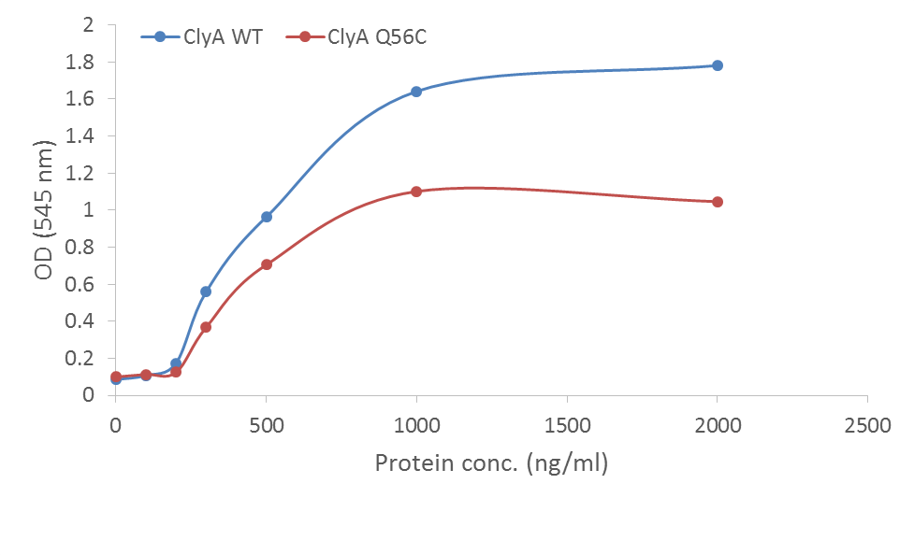

**Figure 3.** A comparison of pore-forming activity of ClyA WT and ClyA Q56C as assessed by hemolysis assay.

Activity of ClyA and ClyA Q56C were assessed by hemolysis assay on RBC erythrocytes. A dose of 0.1 μg – 2 μg/ml was tested for both of the proteins and dose response curve was plotted. From the curves, it can be seen that both proteins show similar pattern of lysis with critical activity concentration around 200 – 250 ng/ml for lysis to ensue. This also conforms to the experiments reported in literature and those previously performed within the lab. Clearly, It can be understood that the dose response curve that the Q56C mutation in ClyA has not compromise hemolytic activity and can be put forth for labeling.

**3.3. A labeled and potent toxin ClyA Q56C – Cy3**

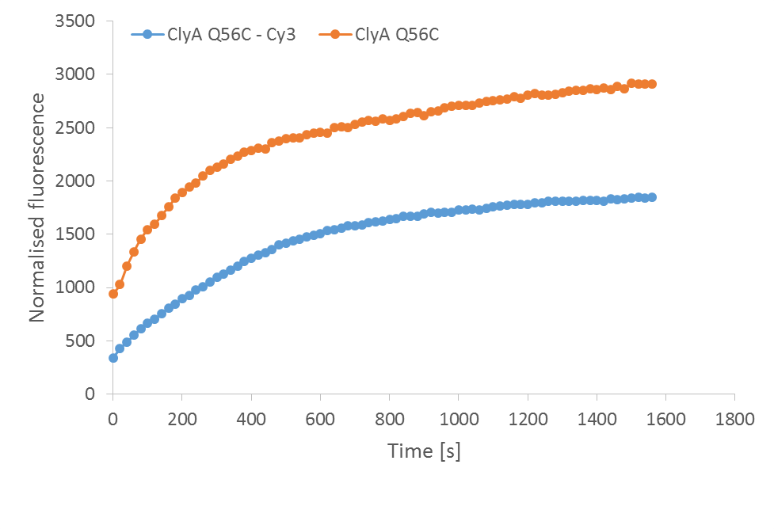

**Figure 4.** An activity assay of ClyA Q56C and its labeled variant ClyA Q56C – Cy3 measured by monitoring calcein leakage from DPPC: DOPC: Cholesterol vesicles over a period of time.

After labeling the mutant protein with Cy3 dye, the activity was monitored by a calcein leakage assay. The toxin was incubated with DPPC: DOPC: Cholesterol vesicles and similar activity could be observed as show in Fig pq. This established that our labeled protein is potent and exhibits activity as observed before for wild-type ClyA and unlabeled ClyA Q56C.

**3.4. Lipid phase dependent kinetics of ClyA**

The pore forming ability of both the proteins was also assessed using a calcein release assay. There have been numerous studies that established a protein structure and function modulation by the co-existence of different phases, as regulated by the dynamic composition of the lipid membrane. In an attempt to study such effects, we prepared lipid vesicles with two distinct lipid compositions. One containing a DOPC: Cholesterol mixture (a two component system) and other containing DPPC in addition (a three component system). Both the purified proteins, ClyA WT and ClyA Q56C, were tested for activity by monitoring a time-dependent response in terms of calcein leakage from the two types of vesicles.

[ Figure of ClyA WT in DPPC/DOPC, fit equation ]

**Figure 5.**

As can be seen from the figure 5, ClyA WT protein when incubated with two different kind of lipid vesicles, shows two distinct activity pattern. The activity in DOPC: Cholesterol two component vesicles shows a double exponential behavior with quick rise (fast time constant) followed by plateau of activity (slow, while activity in DPPC:DOPC:Cholesterol three component vesicles shows a gradual exponential rise in the activity.

[Figure of ClyA 56C in DPPC/DOPC]

**Figure 6.**

Next, the mutant protein was tested in the similar setup and calcein leakage from the vesicles was monitored. Surprisingly, the mutant protein exhibits very low activity in DOPC: Cholesterol two component vesicles but shows a similar exponential kinetics with the DPPC: DOPC: Cholesterol vesicles, as can be seen in figure 6.

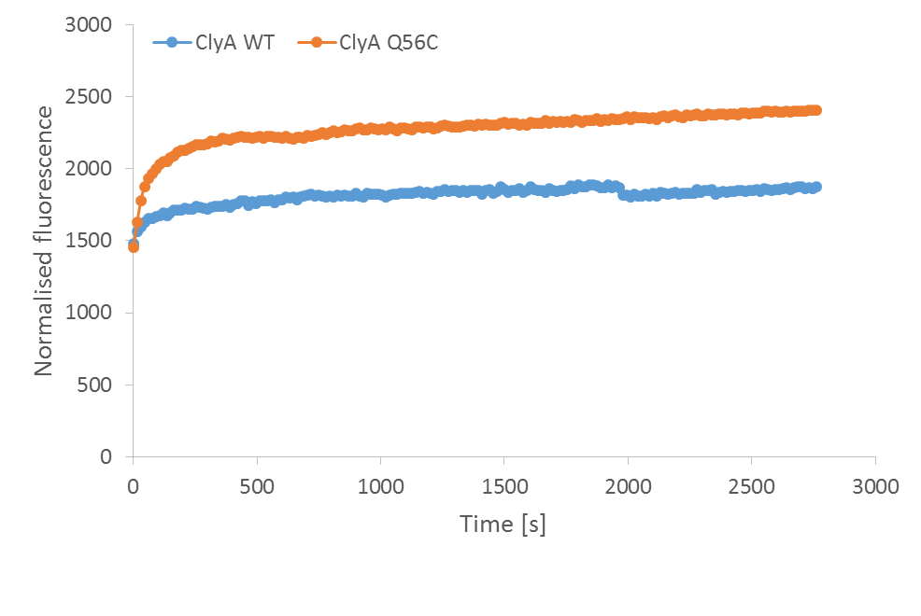

**Figure 7.** An activity comparison between ClyA WT and ClyA Q56C with lipid vesicles prepared by DPPC: Cholesterol mixture.

The distinction between the activities of the proteins seems to surface from these data but to further strengthen our observations, we incubate the ClyA WT protein with DPPC: Cholesterol two component vesicles and monitor the calcein leakage. The observations are shown in Fig. 7.

1. **DISCUSSION**

ClyA exists in bistable states which allows us to purify and study the soluble monomeric form, but on exposure to membrane, undergo drastic conformational changes and oligomerize to form a pore. This conformation change encompasses some intriguing features wherein the helix α-G and its extending C-terminal loop, though do not form any inter-protomer contacts or undergo any conformations change, tightly regulate the pore activity. The role of this region was characterized in detail by Pradeep *et al.*, using biochemical and molecular dynamics simulations, where they suggest a mechanism involving partial unfolding of the protein into a molten globule state, before refolding into the other conformation. The deletion of C-terminus seems to compromise this activity by affecting the unfolding landscape of the ClyA monomer. These suggestions, although, inspired from careful biochemical analyses, are prominently *in silico* predictions for which no direct and observable evidence has yet been reported. To fill this gap, Pradeep *et al.,* tried generating several cysteine mutants of the protein suitable for tagging with a fluorophore and examining directly on cells or supported bilayers, but none of the mutations could preserve the toxin activity. Meanwhile, in an independent parallel work, Benke *et al.,* prepared two stable cysteine mutations of ClyA i.e., ClyA Q56C and ClyA Q56C E252C for their assembly dynamics study (cite). We identified these mutants as an attractive option for our further studies and procured the plasmid clones for the same from the authors. These plasmid were duly transformed into cloning strains, amplified and extracted using mini-preparation. After verification for the correct insert of around 930 kb size, we transformed the vectors into protein expression strains, induced expression and purified the final protein using gel filtration and affinity chromatography.

In order to ensure that the purified proteins are active, a dose response curve was plotted by incubating different concentrations of protein against fixed volume of rabbit erythrocytes. From the hemolysis results, we can see that both proteins have similar activity and almost same critical concentration for the activity to ensue.

Further, to obtain a time-dependent activity of the mutant protein, in comparison with the wild-type, we prepared a small unilamellar lipid vesicles with calcein at self-quenching concentration inside them. Based on the previous experiments of ClyA WT with DOPC: Cholesterol supported bilayer, we prepared SUVs out of equimolar concentration of DOPC and Cholesterol. However, we had learned from increasing number of reports pointing to the existence of lipid domains that lipid membrane composition can significantly modulate the protein structure and function, as has been shown for several members of the PFT class itself. This presented an exciting opportunity to study similar effects also on the activity of ClyA. In this regard, we prepared SUVs out of equimolar concentration of DPPC, DOPC and Cholesterol (a three component mixture) and obtained calcein leakage data from both. The data obtained clearly showed a distinct behavior of the two proteins with the two different types of vesicles. In the case of DPPC: DOPC: Cholesterol, there is a gradual exponential rise in the leakage (slow time constant) while in the case of DOPC: Cholesterol, there is a steep rise in leakage (characterized by fast constant) followed by a plateau (slow time constant) in activity. ClyA Q56C, however, shows similar kinetics as that of wild-type with DPPC vesicles but very low activity with DOPC vesicles. There doesn't seem to be an apparent reason to explain the low activity of the mutant protein, hence we consider the observations of ClyA WT for our further comments. We hypothesized that this apparent difference in the activity is because of two component versus three component based composition of the vesicles. We test the hypothesis by preparing SUVs using an equimolar DPPC:Cholesterol mixture and perform calcein leakage assay. The data obtained (figure xx) clearly shows that the protein exhibits similar kinetics as that of DOPC: Cholesterol vesicles (fast rise and then plateau), suggesting that it's the three component composition of lipids that is into the play.

The DPPC and DOPC within the DPPC: DOPC: Cholesterol mixture have different melting temperatures, and at physiological temperature distinct domains have been reported in a bilayer formed from these. DPPC having a transition temperature of 41.3 °C exists in a solid-like 'gel' state (Lβ) while DOPC with a transition temperature of –16.5 °C [[39](http://www.ncbi.nlm.nih.gov/pmc/articles/PMC3588056/#b39-ijms-14-03514)] and therefore exists in the fluid like liquid crystalline state (Lβ). The addition of cholesterol further complicates the scenario, but still researchers have managed to show a clear evidence for Ld-Lo two-phase coexistence [40], or Ld-Lo gel three-phase coexistence depending on the temperature. Not surprisingly, the three phase systems mimic biological membrane more closely and, thus, their behavior varies in a complex manner. [41] The two component mixture (DOPC: Cholesterol) on the other hand, adopts a lipid-ordered fluid phase. These observations strengthen previous studies that report a higher degree of protein insertion and extend of permeabilization is vesicles having gel and fluid phases in co-existence [43] for similar PFT called equinatoxin II. This study present first instance of such study for ClyA toxin.

1. **CONCLUSIONS**

The assembly mechanism of PFTs has been significantly explored in literature and researchers have come up with various steps characterizing each and every step in more detail. There have, however, been no direct, observable study of the toxin assembly and oligomerization on the lipid bilayer. We hope that this report will provide sufficient data for preparing efficiently labeled ClyA Q56C - Cy3 toxin, suitable for examinations pertaining to lipid membrane interaction, assembly and spatial selectivity using various imagine and biochemical methods. In fact, C-terminal deletion mutants of this protein can also be used to study and assert the role of C-terminus domain, the crucial role of which has been well studied. Further, the suggestion that ClyA exhibits a lipid phase dependent activity can be used to design supported bilayer systems or used as an inspiration for investigating the dynamics of lipids in immediate vicinity of protein. This insight can provide an impetus to engineering pores for biotechnological applications or help design drugs and therapies to block their function.

**ACKNOWLEDGEMENTS**

I would express my sincerest gratitude to Mr. Pradeep Sathyanarayana for his ineffable efforts in teaching the necessary protocols and always acting as an important support throughout the work duration. His way of approaching problems, designing clever experiments, and being persistent in efforts have been my major guiding principles. I would also like to thank all other lab members who took much efforts in explaining any questions I asked and provided a nourishing environment throughout the stay. Most importantly, it would not have been possible to remain focused and think about the problems I face through various perspectives, without the help of Prof. Sandhya S. Visweswariah. I was privileged to learn her guiding principles, ethics, and vision for pursuing science.

**REFERENCES**

1. Wallace, A. J. et al. E-coli hemolysin E (HlyE, ClyA, SheA): X-ray crystal structure of the toxin and observation of membrane pores by electron microscopy. Cell 100, 265–276 (2000).

2. Mueller, M., Grauschopf, U., Maier, T., Glockshuber, R. & Ban, N. The structure of a cytolytic alpha-helical toxin pore reveals its assembly mechanism. Nature 459, 726–730 (2009).

3. Dertinger, T. et al. Two-focus fluorescence correlation spectroscopy: a new tool for accurate and absolute diffusion measurements. Chemphyschem 8, 433–443 (2007).

4. Fancy, D. A. & Kodadek, T. Chemistry for the analysis of protein-protein interactions: rapid and efficient cross-linking triggered by long wavelength light. Proc. Natl Acad. Sci. USA 96, 6020–6024 (1999).

39. <http://www.ncbi.nlm.nih.gov/pmc/articles/PMC3588056/>

40. <http://www.ncbi.nlm.nih.gov/pmc/articles/PMC2716451/>

41. <http://www.ncbi.nlm.nih.gov/pmc/articles/PMC2642958/pdf/nihms89989.pdf>

43. Barlič; A. et al. Lipid phase coexistence favors membrane insertion of equinatoxin-II; a pore-forming toxin from Actinia equina. J. Biol. Chem. 279; 34209–34216 (2004).

1. DPPtdCho, dipalmitoylphosphatidylcholin
2. DOPtdCho, 1,2-Dioleoyl-sn-glycero-3-phosphocholine