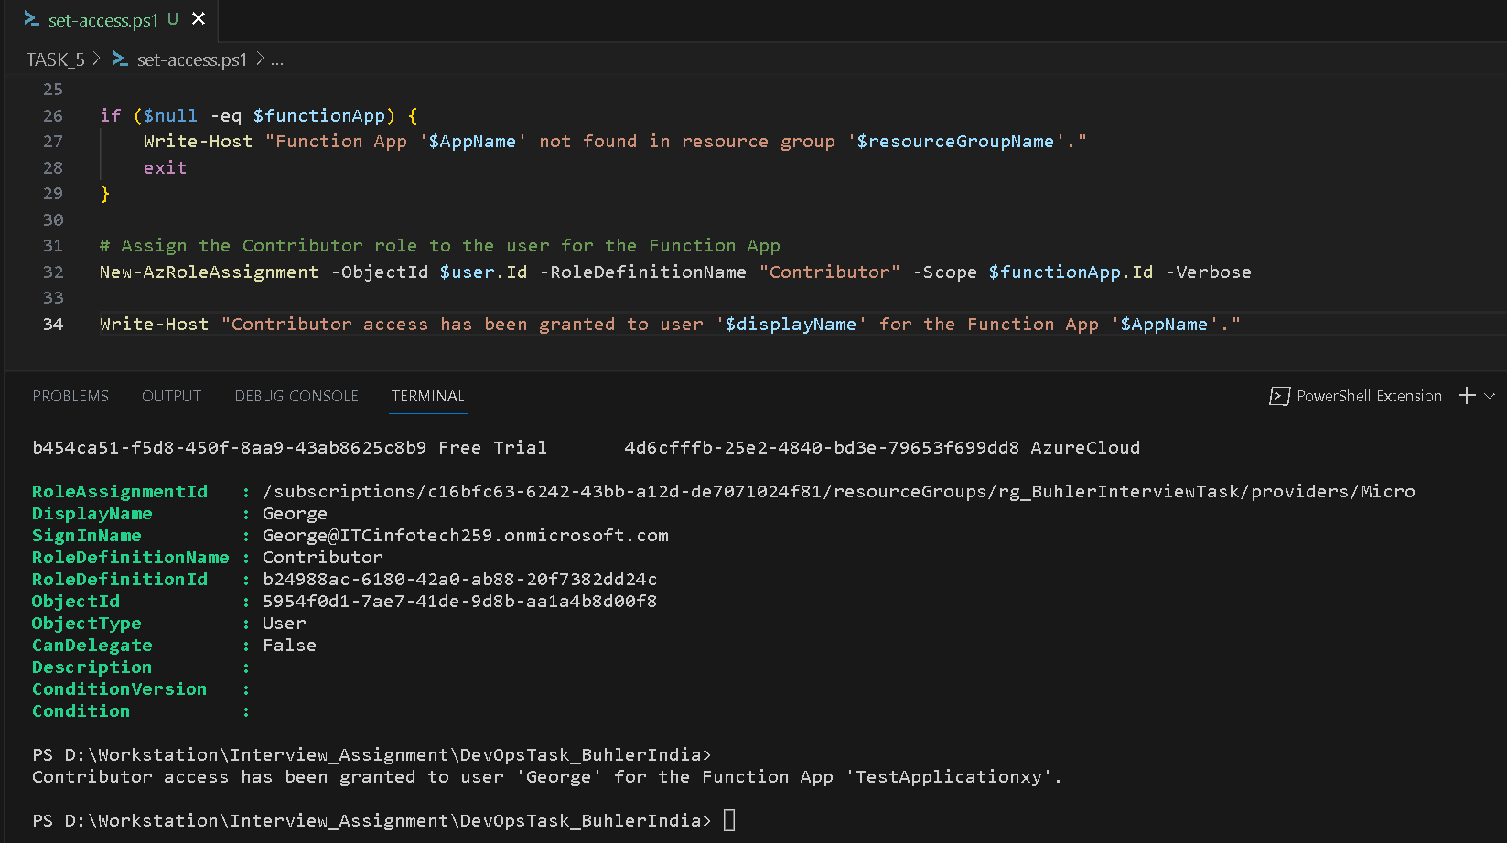

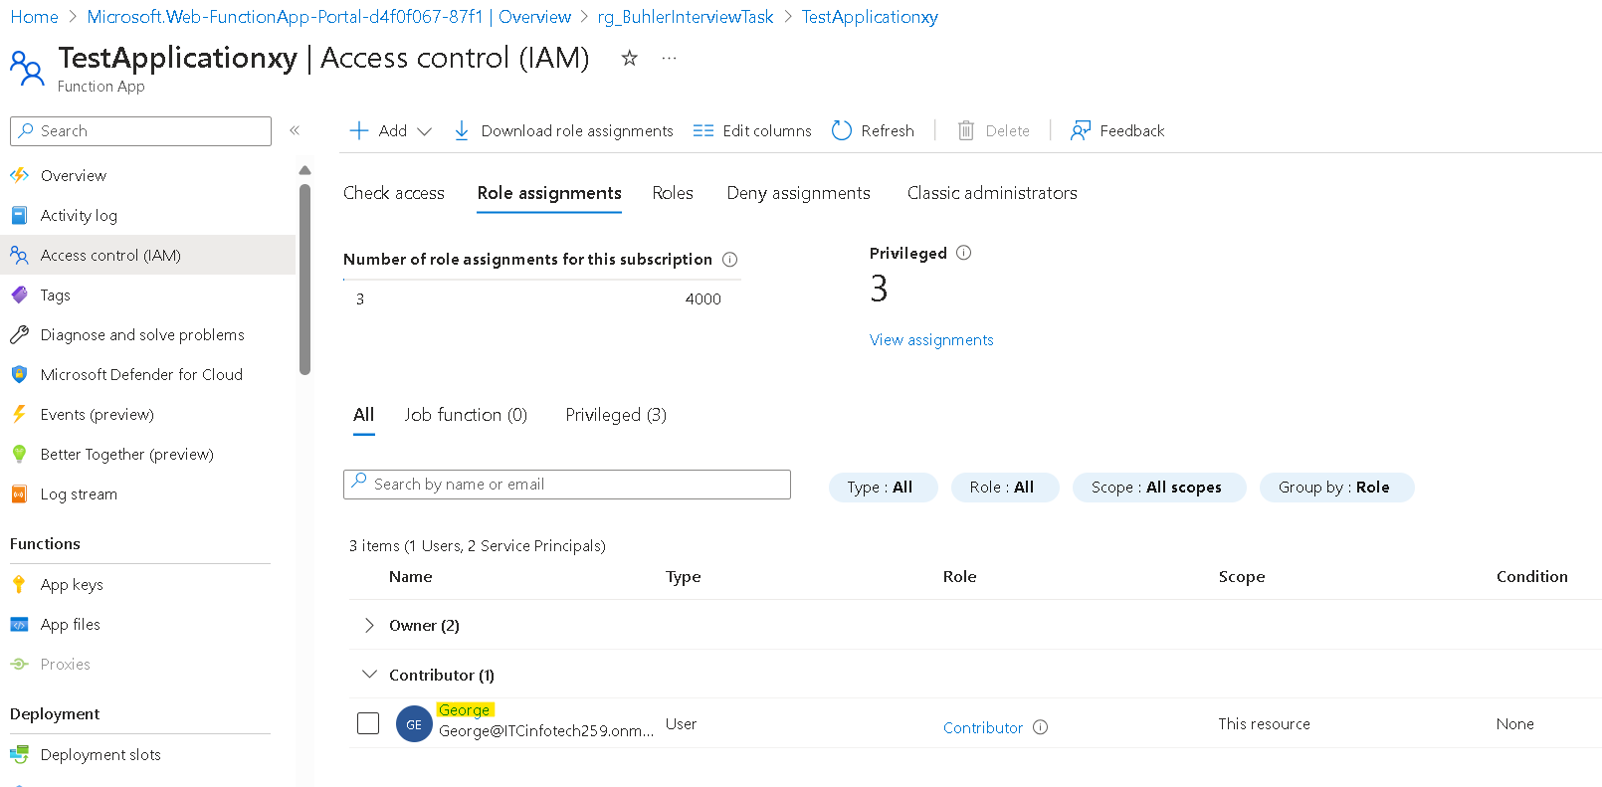

**Suggestions:**

To Provide Temporary access with a time limit we can use [Microsoft Entra Privileged Identity Management](https://learn.microsoft.com/en-us/entra/id-governance/privileged-identity-management/pim-configure) **PIM** as it supports better access visibility and approval workflow with expiry time of access. **Microsoft Entra ID P1/P2 licence is required.**