Practical 7: PHP Form Processing with Server-Side Validation and CSV/JSON File Storage

Problem Definition
To develop a registration or contact form using PHP that processes submitted data through the POST method. Validate and sanitize user inputs on the server side, store valid records in CSV or JSON files, and display appropriate success or error messages. This practical demonstrates basic server-side form processing and file handling.

Key Questions / Analysis / Interpretation
1. Is the form submitted using POST?
Yes, the form uses the POST method to send user data to the PHP server. Unlike the GET method, POST does not display submitted form values directly in the URL. In PHP, submitted values can be accessed using the $_POST superglobal array.
2. Are inputs validated and sanitized server side?
Yes, server-side validation checks whether the submitted data meets the required conditions, such as valid email format, required fields, and correct input length. Sanitization helps remove or handle unwanted characters. These checks are performed in PHP because client-side validation alone can be bypassed.
3. Is file writing handled safely?
Yes, file writing should include proper error handling and appropriate file permissions. Functions such as fopen(), fputcsv(), and fclose() can be used for CSV storage, while file_put_contents() and json_encode() can be used for JSON storage. File locking and input validation help reduce the risk of data corruption and unsafe file handling.
4. Are success and error responses displayed clearly?
Yes, PHP displays a success message after valid data has been stored successfully. If required fields are missing, the input is invalid, or file storage fails, an appropriate error message is displayed. User-provided data should be escaped before being displayed on a webpage.

Output:

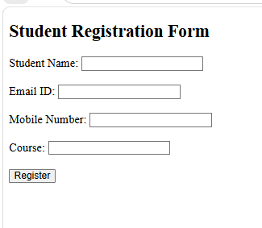

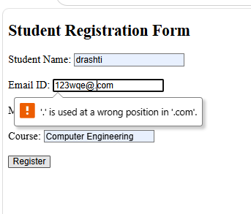

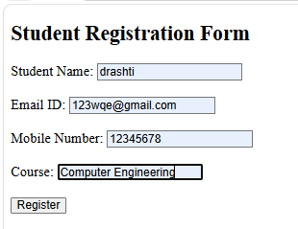

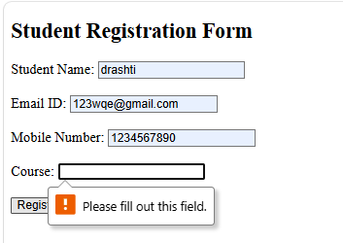

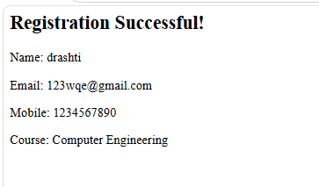

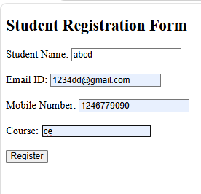

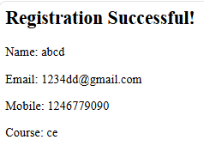

CSV file

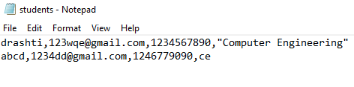

Conclusion
In this practical, a PHP form was used to collect and process user information through the POST method. Server-side validation and sanitization helped ensure that the submitted data was valid, while CSV or JSON file storage allowed records to be saved. Success and error messages made the form easier to use and understand.

