Practical 5
Registration Form with Frontend Validation and User-Friendly Error Handling
Problem Definition : Create a student registration form with HTML5 input types and JavaScript validation for name, email, mobile number, password, confirm password,course, year, gender, and terms acceptance. Use Regular Expression for validations.
- Create a user-friendly registration form.
- Validate user input using JavaScript.
- Display clear error messages.
- Check password strength.
- Make the form accessible and easy to use.
Questions:
1. Are correct input types and attributes used?
Yes. Appropriate HTML5 input types and attributes are used.
Examples:
- type="text" for name
- type="email" for email
- type="tel" for mobile
- type="password" for passwords
- required to make important fields compulsory
- <select> for course and year
- Radio buttons for gender
- Checkbox for terms acceptance

2. Are validation errors displayed near the relevant fields?
Yes. Error messages are displayed immediately below the corresponding input field.
Example:

Email
[ abc.com ]

Enter a valid email address.
This makes it easy for the user to identify and correct the mistake.

3. Is password strength checked?
Yes. Password strength is checked using JavaScript.
The password is checked for:
- Minimum 8 characters
- Uppercase letter
- Number
- Special character
The password is then shown as:
Weak → Medium → Strong
A password-strength bar is also displayed.

4. Is the form accessible using keyboard and screen-reader-friendly labels?
Yes. Each input has a proper <label> connected using the for attribute.
Example:
<label for="email">Email Address</label>

<input type="email" id="email">
This helps screen readers identify the purpose of each field. Standard form controls also allow users to navigate the form using the keyboard.
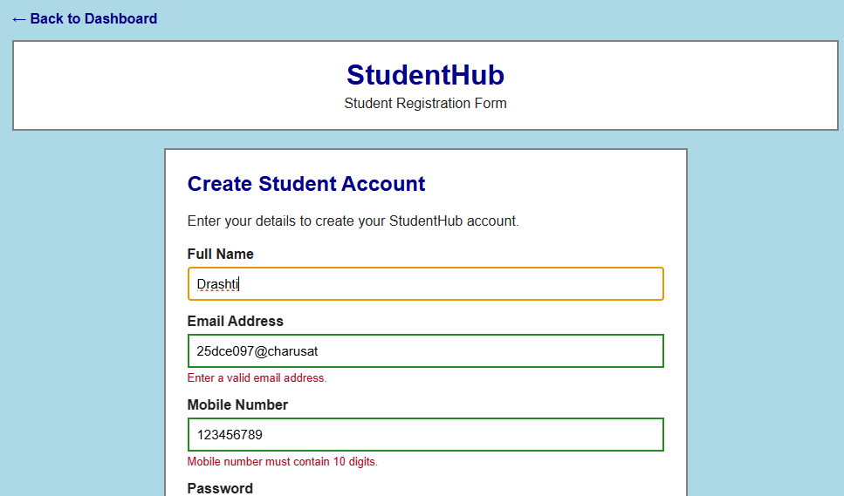
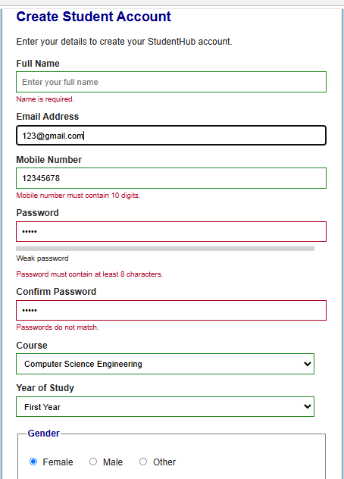
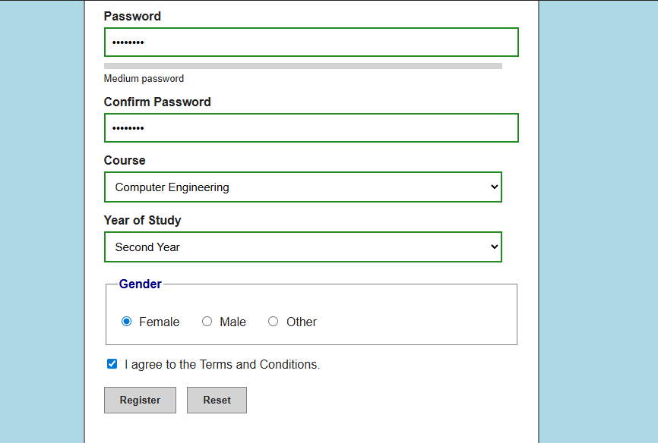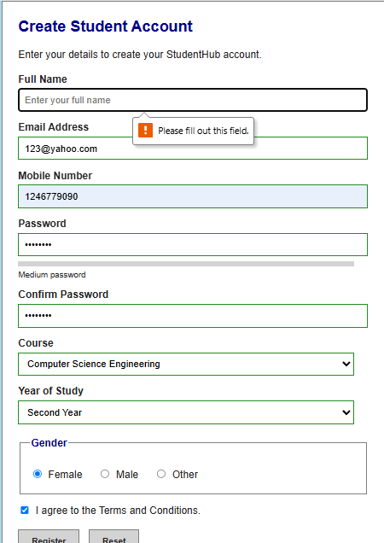

Conclusion :
Practical 5 demonstrates how HTML5 and JavaScript can be used together to create a secure, user-friendly, validated student registration form with Regular Expressions, password-strength checking, clear error handling, and accessibility.

The Code for This all the output Screenshots is uploaded on Github :
https://github.com/raiyanidrashti21-bit/25dce097-Web

