Practical 12: Event Management System Using PHP and MySQL

1. Title
Event Management System Using PHP and MySQL

2. Problem Definition
Develop an Event Management System using PHP and MySQL that allows users to add, view, edit, and delete event details. The system stores event information in a database and displays the available events on a webpage.
The system also supports event categories, dates, descriptions, poster uploads, and event status. Events that have existing registrations cannot be deleted, ensuring database consistency.
This practical is implemented as a standalone module and does not need to be integrated into the Student Hub Portal.

3. Objectives
- To understand database connectivity using PHP and MySQL.
- To perform CRUD operations on event records.
- To insert, display, update, and delete event details.
- To upload and manage event poster images.
- To validate user input and handle errors.
- To use prepared statements for safer database operations.
- To maintain database integrity when events have registrations.

4. Software and Technologies Used
- Frontend: HTML and CSS
- Backend: PHP
- Database: MySQL
- Database Management Tool: phpMyAdmin
- Local Server: XAMPP
- Web Browser: Google Chrome

5. Database Design
Database name: studenthub
Table name: events
Field Name | Description
id | Unique ID of each event
event_name | Name of the event
event_date | Date of the event
description | Details about the event
category | Category of the event
poster | Event poster image filename
status | Event status: open or closed
The id field uniquely identifies each event. The status field indicates whether an event is open or closed.

6. Implementation Description
The Event Management System is implemented using separate PHP files for different operations.

6.1 Database Connection
The db.php file establishes a connection between PHP and the MySQL database. It allows the application to perform database operations.

6.2 Display Events
The index.php file retrieves event records from the database and displays them in a list or table. It also provides options to add, edit, and delete events.

6.3 Add Event
The add_event.php file allows users to enter event details, including the event name, date, description, category, status, and optional poster image. The submitted details are validated and stored in the database.

6.4 Edit Event
The edit_event.php file allows users to modify existing event details. The selected event information is retrieved using its ID, and the updated information is saved in the database.

6.5 Delete Event
The delete_event.php file handles event deletion. Before deleting an event, the system checks whether registrations are associated with it. If registrations exist, deletion is prevented to maintain database integrity.

6.6 Input Validation and Security
The application uses input validation to check the submitted information. Poster uploads are restricted by file type and size. Prepared SQL statements are used for database operations to reduce the risk of SQL injection.

7. Execution Procedure
- Start Apache and MySQL using the XAMPP Control Panel.
- Open phpMyAdmin and verify that the studenthub database and events table exist.
- Save the practical files in C:\xampp\htdocs\StudentWebsite\practical12.
- Open the browser and visit http://localhost/StudentWebsite/practical12/index.php.
- Verify that the event list is displayed.
- Add a new event and check whether it appears in the event list.
- Edit an existing event and verify that the changes are saved.
- Test poster upload functionality, if required.
- Attempt to delete an event and verify the system's response.
- Confirm that events with existing registrations cannot be deleted.

8. Output Screenshots
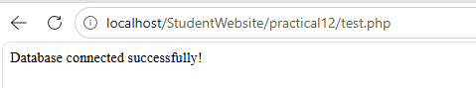
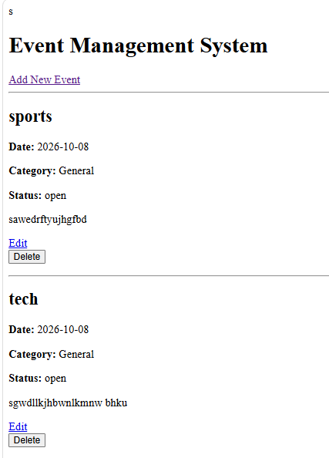

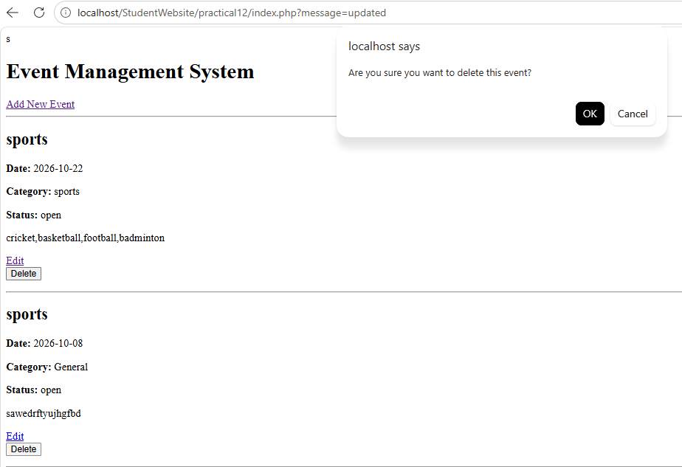

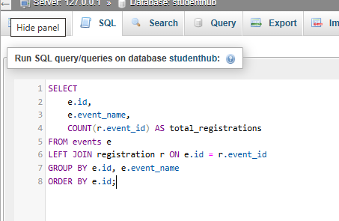

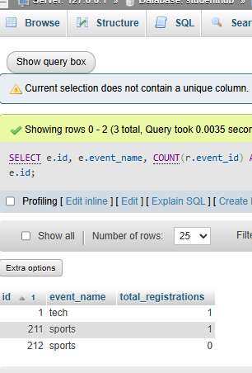
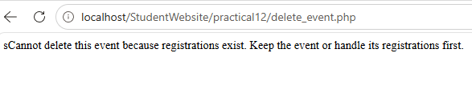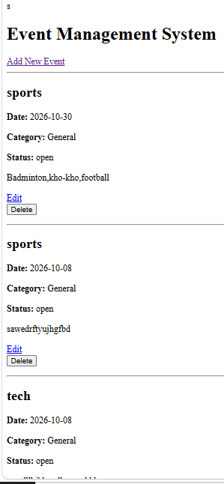
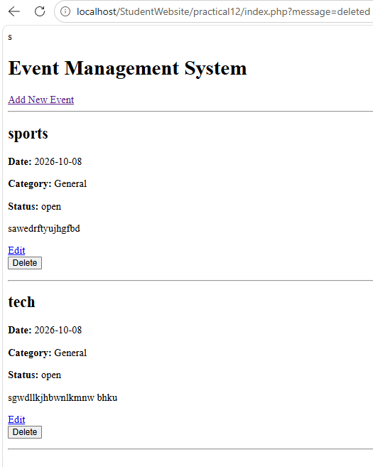
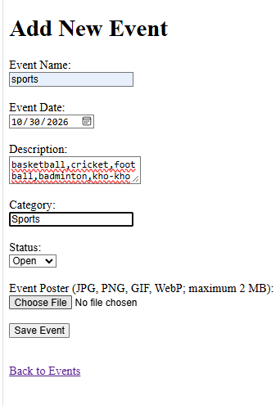

9. Result
The Event Management System was developed successfully using PHP and MySQL. The application supports creating, viewing, updating, and deleting event records. It also provides poster upload functionality, input validation, and protection against deleting events that have existing registrations.
The practical demonstrates the use of database connectivity, CRUD operations, prepared statements, and database integrity in a PHP-based web application.

10. Conclusion
This practical helped demonstrate how PHP interacts with a MySQL database to manage event information. It provided practical experience in performing CRUD operations, validating user input, handling image uploads, and maintaining relationships between database tables. The completed module can operate independently without integration into the Student Hub Portal.
The Code for This all the output Screenshots is uploaded on Github :
https://github.com/raiyanidrashti21-bit/25dce097-Web

