Problem Definition : Create a student management module to add, view, edit, delete, search and
filter student records. All database operations must use MYSQLi
statements and clear success/failure messages.
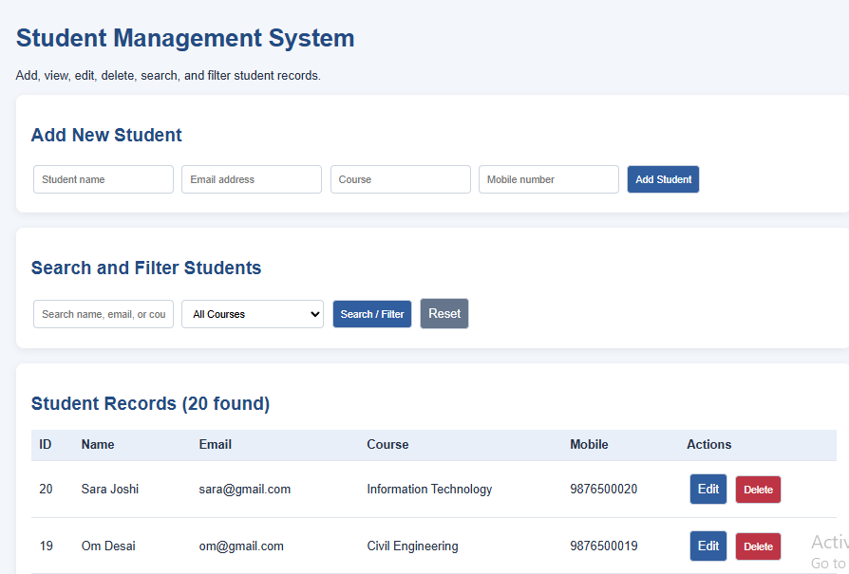
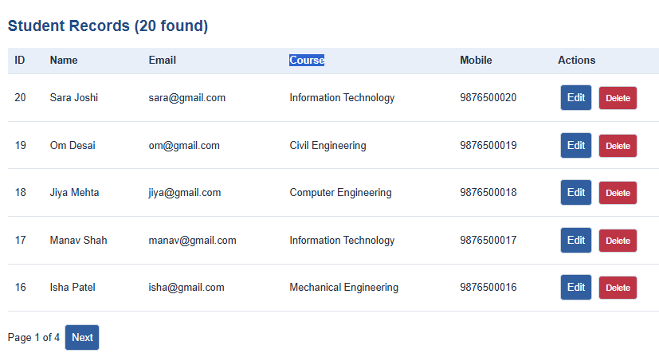
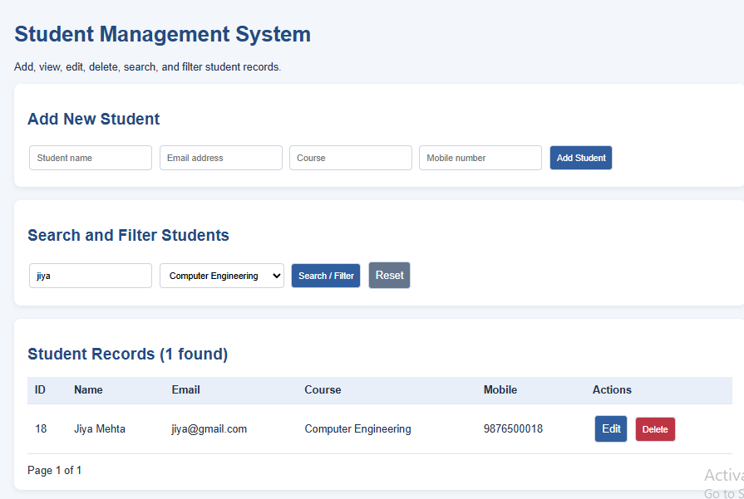
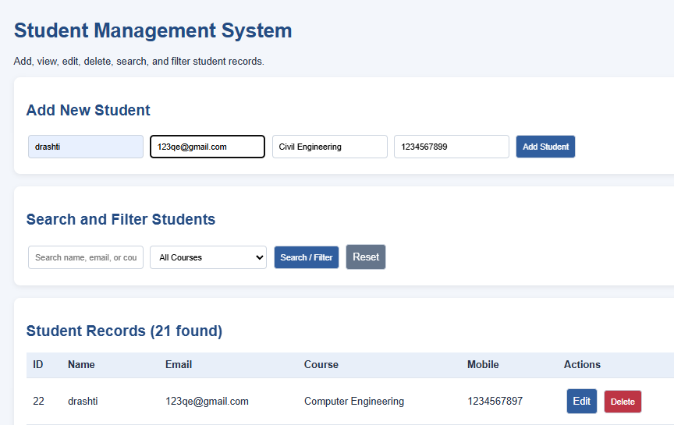
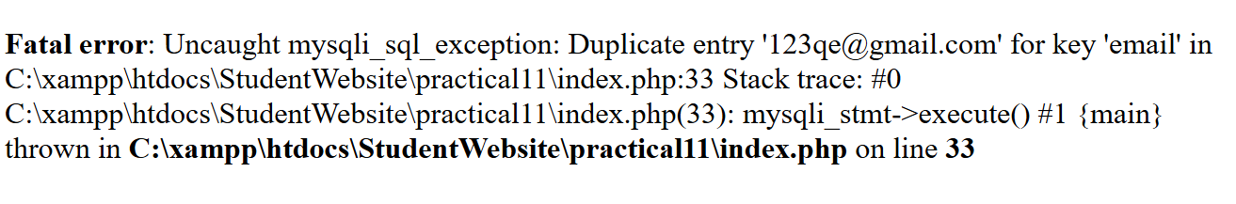
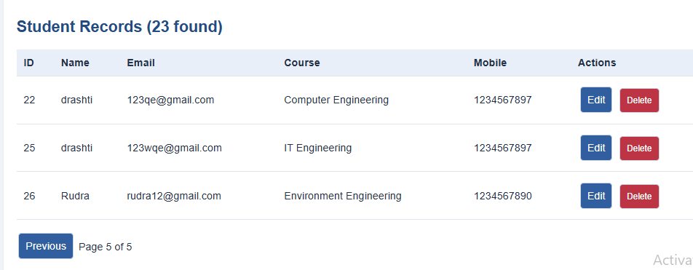
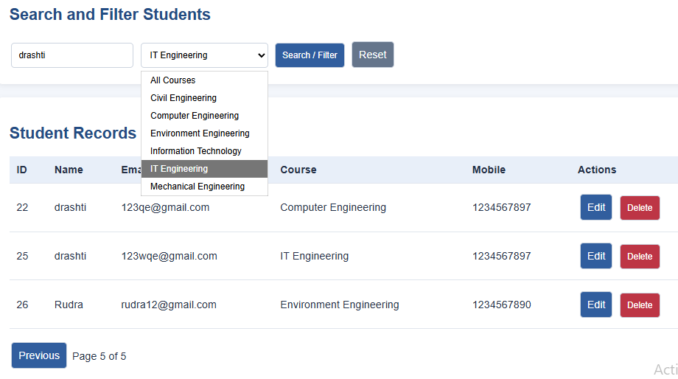
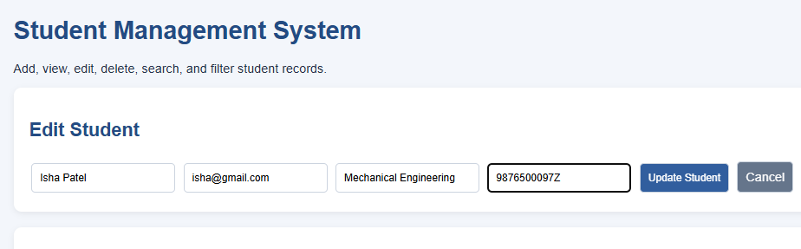

Step 10: Export the SQL database dump
In phpMyAdmin:
- Select the student_management database.
- Click Export.
- Choose Quick and format SQL.
- Click Export or Go, depending on your phpMyAdmin version.
- Save the downloaded .sql file.
This file contains the database structure and records needed to recreate your database.

Step 11: Prepare the final submission
Your submission folder should contain:
Practical11_StudentManagement
db.php
index.php
export.php (if implementing CSV)
student_management.sql
screenshots/
test_cases.docx or test_cases.pdf

Test cases to submit
You can include this table in your practical report.
Test case | Input/action | Expected outcome
TC01 | Add valid student | Student inserted
TC02 | View student list | Records displayed
TC03 | Update student course | Course updated
TC04 | Delete student and confirm | Student removed
TC05 | Search by name/email | Matching records displayed
TC06 | Filter by course | Selected course displayed
TC07 | Submit duplicate email | Error message displayed
TC08 | Search for nonexistent student | No records found
TC09 | Navigate pages | Correct records shown per page
TC10 | Export CSV | CSV file downloaded
Record the actual result for each test after running it. Don't mark tests as passed until you've verified them.

Purpose and conclusion for the practical file
Purpose:
To implement a Student Management System using PHP and MySQLi that performs CRUD operations (Create, Read, Update, Delete), provides search and filtering by name, email, and course, and displays clear success and failure messages. The system also uses prepared statements for database queries, confirms deletion before execution, and supports pagination for managing student records efficiently.
Conclusion:
The Student Management System was implemented using PHP, MySQL, and MySQLi. It supports adding, viewing, editing, and deleting student records, searching and filtering data, and displaying paginated results. Prepared statements, input validation, and delete confirmation help improve the safety and usability of the application. CSV export can be included as an additional feature.
Before submitting: Test the full application in XAMPP, verify that at least 20 records exist, and confirm that add, edit, delete, search, filter, and pagination work. The code is not proof of a working practical until those operations have actually run.
Step 4: Write the database connection code Open db.php and paste this code: Save the file using Ctrl + S. This connects PHP to your existing MySQL database using MySQLi. The default XAMPP configuration usually uses username root with an empty password. ??? What is last part
The last part means that XAMPP usually uses these database login details by default:
- Username: root
- Password: Leave it empty
- Database name: student_management
In your db.php file, this line:
$conn = new mysqli("localhost", "root", "", "student_management");
means:
Code | Meaning
localhost | MySQL is running on your own computer
root | MySQL username
"" | Empty password
student_management | Name of your database
What you need to do: If you haven't changed your MySQL password in XAMPP, leave the code as it is and save the file using Ctrl + S.
If you've set a MySQL password, replace the empty "" with your actual password.
You don't need to type anything extra. The empty quotes are intentional, not a missing piece of code.
The Code for This all the output Screenshots is uploaded on Github :
https://github.com/raiyanidrashti21-bit/25dce097-Web

