Practical 9: Secure User Registration with Database Insert, Duplicate Email Check, and Password Hashing

1. Aim
To develop a secure user registration system using PHP and MySQLi with frontend and backend validation, duplicate email and username checking, and password hashing.

2. Problem Definition
Implement a secure registration system that accepts user details, validates the submitted information, checks for duplicate email addresses and usernames, hashes passwords using PHP's password_hash() function, and stores the registration data in a MySQL database.

3. Objectives
- To connect PHP with a MySQL database using MySQLi.
- To validate user inputs on the frontend and backend.
- To check duplicate email addresses and usernames.
- To store passwords securely using password hashing.
- To insert valid user details into the database.
- To display appropriate success and error messages.

4. Software and Hardware Requirements
Software Requirements:
- XAMPP Server
- PHP
- MySQL
- phpMyAdmin
- Visual Studio Code
- Google Chrome
- HTML, CSS, and JavaScript
Hardware Requirements:
- Computer or laptop
- Minimum 4 GB RAM

5. Database Description
The practical uses a MySQL database to store registered user details.
The database table contains fields such as:
- id: Unique identification number.
- name: Name of the user.
- username: Unique username.
- email: Email address of the user.
- password: Hashed password.
The exact column names depend on the database table created for the practical.

6. Implementation Steps
Step 1: Start XAMPP
Start Apache and MySQL from the XAMPP Control Panel.
Step 2: Open phpMyAdmin
Open http://localhost/phpmyadmin in the browser and select the database created for the StudentWebsite project.
Step 3: Create or Verify the Database Table
Create or verify the registration table with the required fields for user information. Configure the username and email fields to prevent duplicate entries where appropriate.
Step 4: Create the Project Files
Create the required PHP, HTML, CSS, and JavaScript files inside the project directory.
Step 5: Establish the Database Connection
Use PHP MySQLi to connect the application to the MySQL database.
Step 6: Create the Registration Form
Design a registration form that accepts the user's name, username, email address, and password.
Step 7: Perform Frontend Validation
Use HTML validation attributes and JavaScript to check required fields, email format, and password input before submission.
Step 8: Perform Backend Validation
Validate the submitted data again using PHP before performing database operations. Frontend validation alone is not sufficient because it can be bypassed.
Step 9: Check Duplicate Email and Username
Query the database using prepared statements to check whether the submitted email address or username already exists. Display an appropriate message if a duplicate is found.
Step 10: Hash the Password
Use PHP's password_hash() function to generate a secure password hash before storing the password in the database. Never store the original plaintext password.
Step 11: Insert User Details
Use a MySQLi prepared statement to insert the validated user details and hashed password into the database.
Step 12: Display the Result
Display a success message when registration is completed or an appropriate error message when validation or database insertion fails.
Step 13: Test the Registration System
Test the application using valid details, invalid email addresses, empty fields, duplicate usernames, duplicate email addresses, and different password inputs.

7. Program Files
The practical may contain the following files, depending on the implementation:
- db.php – Database connection.
- register.php – Registration form and processing logic.
- style.css – Styling for the registration interface.
- script.js – Frontend validation, if implemented.

8. Output Screenshots
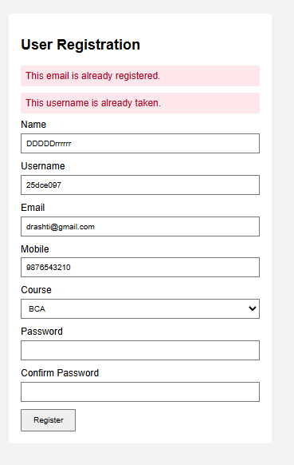
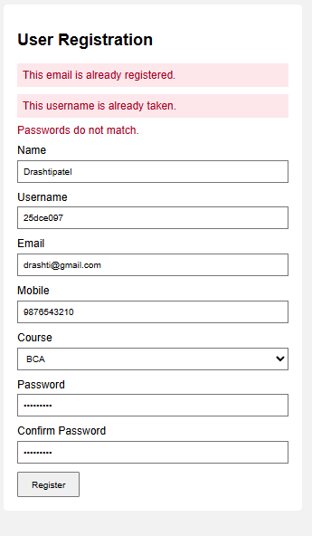
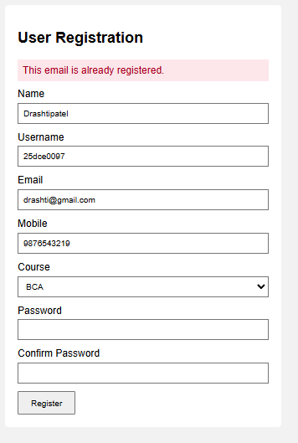
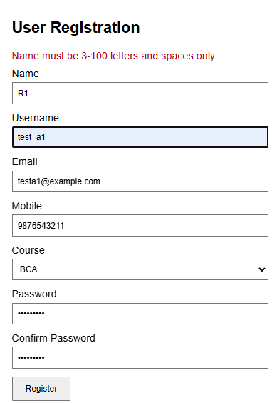
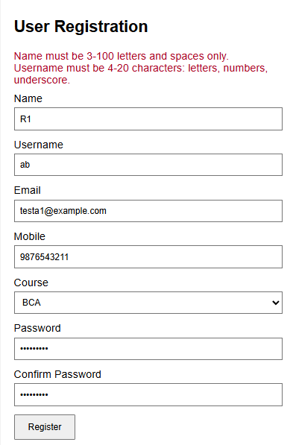
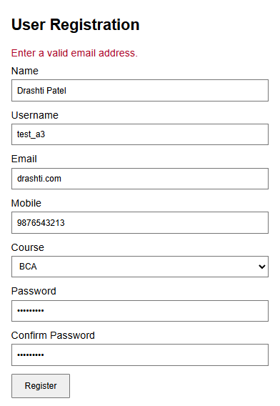
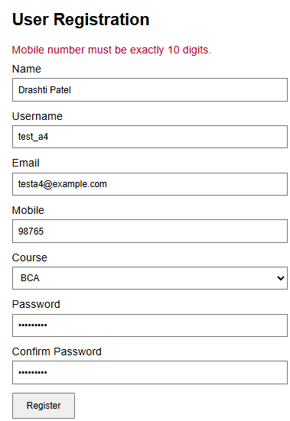
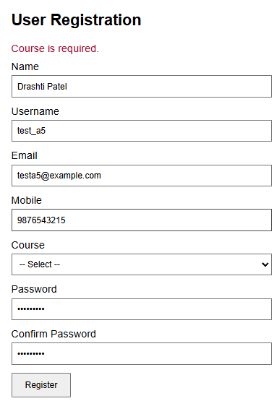
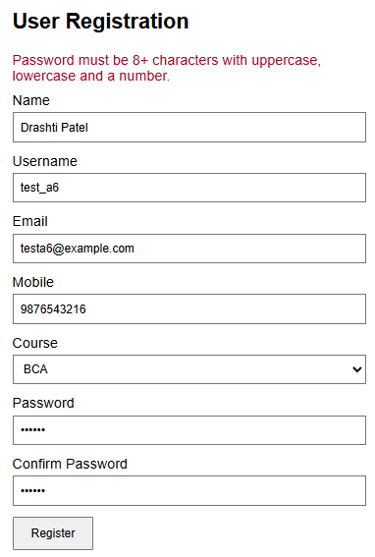

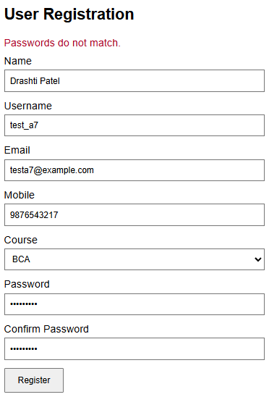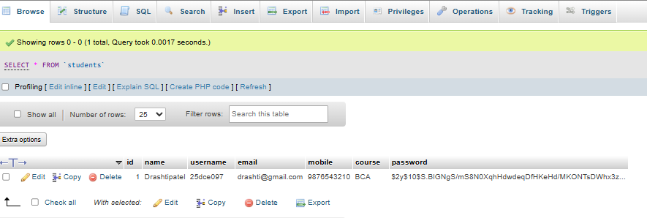
Screenshot 1: Registration Form
[Insert screenshot here]

9. Testing and Results
The registration system is tested using different input conditions.
- Valid user details are accepted.
- Empty or invalid inputs are rejected.
- Duplicate email addresses and usernames are detected.
- Passwords are hashed before being stored.
- Valid user details are inserted into the MySQL database.
- Appropriate success and error messages are displayed.
The system helps protect registration data through server-side validation, prepared statements, duplicate checking, and password hashing.

10. Key Questions and Answers
Q1. Is password_hash() used before storing passwords?
Yes. The function generates a secure password hash that is stored instead of the original password.
Q2. Is duplicate email and username checking implemented?
Yes. The database is checked before inserting a new user record.
Q3. Are frontend and backend validations performed?
Yes. Frontend validation improves usability, while backend validation protects the application against invalid submissions.
Q4. Are prepared statements used?
Yes. Prepared statements help reduce the risk of SQL injection.
Q5. Why should passwords not be stored in plaintext?
Plaintext passwords can be exposed if the database is compromised. Password hashing makes the stored values substantially safer.

11. Applications
- Student registration portals.
- Online admission systems.
- Membership websites.
- User account creation systems.
- E-learning platforms.
- Secure web applications.

12. Learning Outcome
Students learn to implement secure user registration using PHP and MySQLi, validate input on both the frontend and backend, detect duplicate email addresses and usernames, hash passwords securely, and store user details in a database.

13. Conclusion
The secure user registration system was developed using PHP, MySQLi, and frontend technologies. It validates user input, checks for duplicate email addresses and usernames, hashes passwords using password_hash(), and stores valid user details in a MySQL database. The practical demonstrates essential techniques for developing safer registration systems.
The Code for This all the output Screenshots is uploaded on Github :
https://github.com/raiyanidrashti21-bit/25dce097-Web

