Practical 4: JavaScript DOM Manipulation, Event Handling, and UI Interactivity

Problem Definition
To implement dynamic user interface components such as a collapsible FAQ, modal popup, image/content slider, notification banner, hamburger menu, and light/dark theme switcher using JavaScript, HTML5, and CSS3. The objective is to improve user experience through interactive and responsive frontend behaviour.

Questions and Solutions
Q1. How are DOM elements selected and modified?
Solution: DOM elements are selected using methods such as getElementById(), querySelector(), and querySelectorAll(). Their content, styles, attributes, and classes can be modified using JavaScript.
Q2. Are event listeners attached correctly?
Solution: Event listeners are attached using addEventListener(). They respond to user actions such as clicks, button presses, and menu selections to perform the required operations.
Q3. Is localStorage used for remembering theme choice?
Solution: Yes, localStorage stores the user's selected theme in the browser. The saved theme is retrieved when the page reloads, allowing the website to maintain the user's preference.
Q4. Does interactivity improve usability without breaking accessibility?
Solution: Yes. Interactive components improve navigation and usability when implemented correctly. Keyboard accessibility, appropriate labels, visible focus indicators, and proper handling of modal popups help ensure accessibility.

Output :
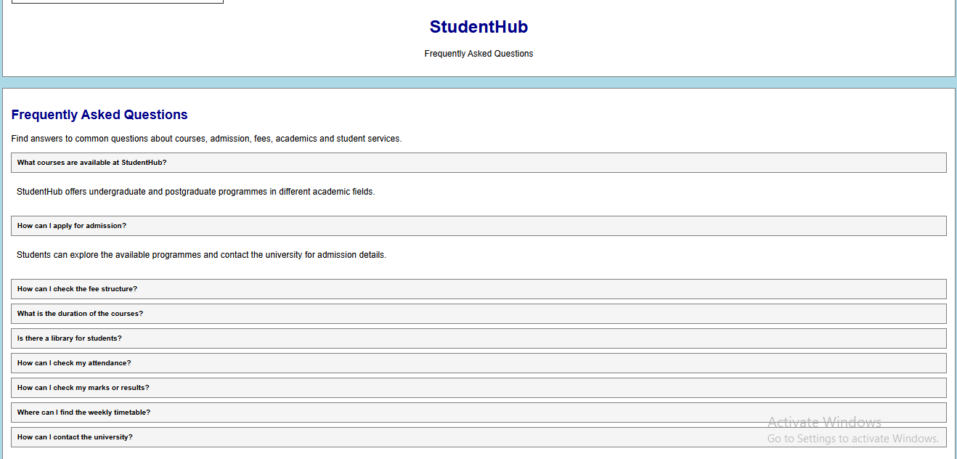

3. Learning Outcomes
- Understand the Document Object Model (DOM) and its role in webpage manipulation.
- Implement JavaScript event handling to respond to user interactions.
- Create interactive UI components such as FAQs, modals, sliders, notification banners, and hamburger menus.
- Use localStorage to save and restore user interface preferences.
- Apply CSS classes and transition effects to improve the appearance and usability of a website.
- Test JavaScript functionality and identify errors using browser developer tools.

4. Conclusion
In this practical, JavaScript was used to manipulate DOM elements, handle user events, and develop interactive user interface components. Features such as collapsible FAQs, modal popups, sliders, notification banners, hamburger menus, and theme switching improved the website's functionality and user experience. The use of localStorage helped preserve user preferences across page reloads. This practical demonstrated how HTML, CSS, and JavaScript work together to create dynamic and user-friendly web applications.
Is this conversation helpful so far?

