Practical 13: PHP JSON API and AJAX/Fetch-Based CRUD Without Page Reload

1. Aim
To develop a PHP JSON API connected to a MySQL database and perform Create, Read, Update, and Delete (CRUD) operations using JavaScript Fetch API without reloading the webpage.

2. Problem Definition
Create PHP JSON API endpoints for students and consume them using the Fetch API. Perform listing, adding, updating, and deleting operations asynchronously. Display appropriate loading, success, and error messages on the frontend.

3. Objectives
- To understand PHP JSON APIs.
- To connect PHP with a MySQL database.
- To implement asynchronous CRUD operations using Fetch API.
- To exchange data between the frontend and backend using JSON.
- To validate user input and handle errors.
- To inspect API requests and responses using the browser Network tab.

4. Software and Hardware Requirements
Software Requirements:
- XAMPP Server
- PHP
- MySQL
- Visual Studio Code
- Google Chrome
- HTML, CSS, and JavaScript
Hardware Requirements:
- Computer or laptop
- Minimum 4 GB RAM
- Internet browser

5. Database Description
The practical uses a MySQL database containing a students table.
The table contains the following fields:
- id: Unique student identification number.
- name: Name of the student.
- email: Email address of the student.
- mobile: Mobile number of the student.
- course: Course selected by the student.

6. Implementation Steps
Step 1: Start XAMPP
Start Apache and MySQL from the XAMPP Control Panel.
Step 2: Create the Project Folder
Create a folder named practical13 inside the StudentWebsite directory located in C:\xampp\htdocs.
Step 3: Create the Database Connection
Create db.php to establish a connection between PHP and the MySQL database.
Step 4: Create the PHP API
Create api.php to handle GET and POST requests, perform database operations, validate inputs, and return JSON responses.
Step 5: Test the API Endpoint
Open the API URL in the browser and verify that the endpoint returns a valid JSON response containing student records.
Step 6: Create the Frontend Interface
Create index.php containing a student registration form and a table to display student records.
Step 7: Apply CSS Styling
Create style.css to improve the appearance of the form, buttons, messages, and student table.
Step 8: Implement Fetch API
Create script.js to send asynchronous requests to the PHP API and process JSON responses.
Step 9: Perform CRUD Operations
Implement the following operations:
- Create: Add a new student to the database.
- Read: Retrieve and display student records.
- Update: Modify an existing student's details.
- Delete: Remove a student record from the database.
These operations are performed without a full-page reload.
Step 10: Test the Network Tab
Open Developer Tools in Google Chrome and select the Network tab. Use the Fetch/XHR filter to monitor requests sent to api.php.
Step 11: Inspect API Responses
Select the api.php request and inspect its Headers, Payload, and Response tabs to verify the request method, submitted data, and JSON response.
Step 12: Validate Input and Handle Errors
Test empty fields, invalid email addresses, incorrect mobile numbers, and unsuccessful requests. Verify that appropriate error messages are displayed.

7. Program Files
The practical contains the following files:
- index.php – Frontend interface.
- db.php – Database connection.
- api.php – PHP JSON API endpoints.
- script.js – Fetch API and CRUD operations.
- style.css – Frontend styling.

8. Output Screenshots
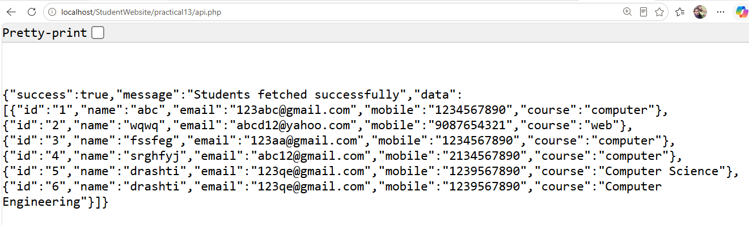
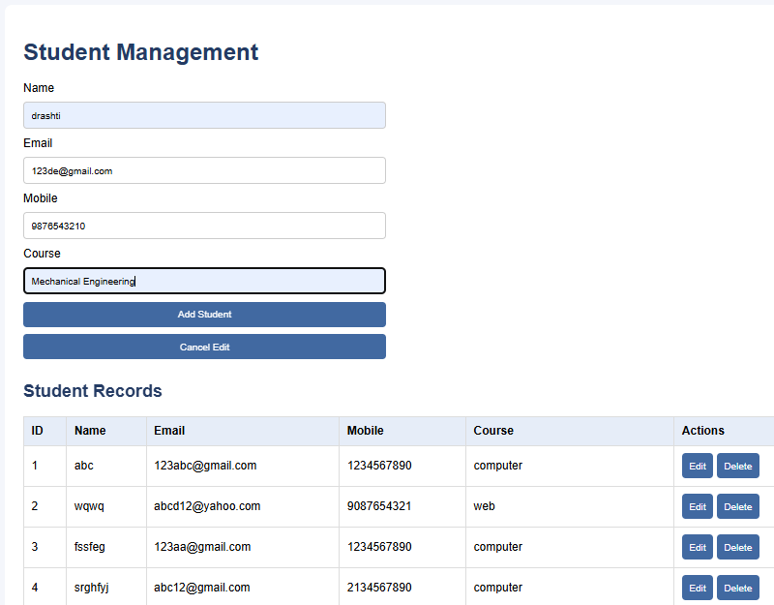
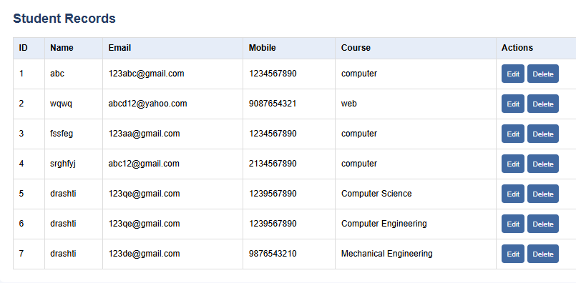
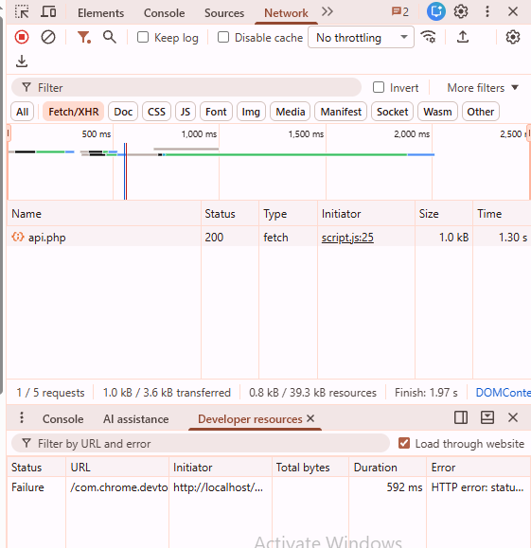
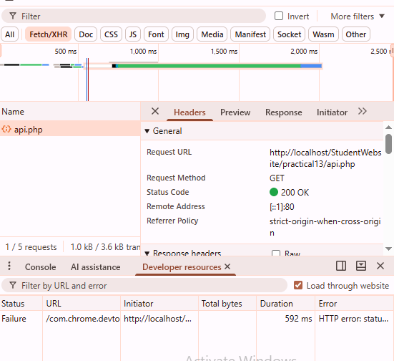
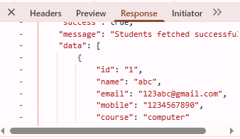

9. Testing and Results
The application is tested using different inputs and CRUD operations.
- Student records are retrieved from the MySQL database.
- New student records are added successfully.
- Existing student details are updated.
- Student records are deleted.
- API requests and JSON responses are inspected through the browser Network tab.
- Input validation and error messages are tested.
The application updates the displayed records without reloading the entire webpage.

10. Key Questions and Answers
Q1. Do PHP endpoints return valid JSON responses?
Yes. The PHP API uses json_encode() to return data in JSON format.
Q2. Are GET and POST requests handled properly?
Yes. GET retrieves student records, while POST handles adding, updating, and deleting records.
Q3. Are loading, success, and error states shown on the frontend?
Yes. JavaScript displays loading indicators and appropriate success or error messages.
Q4. Is input validation performed before database operations?
Yes. Required fields, email addresses, mobile numbers, and student IDs are validated before database modifications.

11. Applications
- Student management systems.
- Online registration portals.
- Interactive dashboards.
- Event management systems.
- API-driven web applications.
- Applications requiring asynchronous database operations.

12. Learning Outcome
Students learn to integrate JavaScript Fetch API with PHP and MySQL, exchange data using JSON, implement asynchronous CRUD operations, validate user inputs, and inspect API requests using browser Developer Tools.

13. Conclusion
The PHP JSON API and Fetch API-based CRUD application was implemented using PHP, MySQL, HTML, CSS, and JavaScript. Student records can be added, viewed, updated, and deleted asynchronously without a full-page reload. The practical demonstrates frontend-backend integration, JSON data exchange, input validation, and API testing through the browser Network tab.
The Code for This all the output Screenshots is uploaded on Github :
https://github.com/raiyanidrashti21-bit/25dce097-Web

