Practical 3
Responsive UI Design using CSS Grid, Flexbox, and Bootstrap/Tailwind
Problem Definition
Design responsive layouts for Home, About, Registration, Dashboard, and Events pages using CSS Grid and Flexbox. Optional to use CSS framework such as Bootstrap or Tailwind. Ensure mobile-first responsiveness.Summary:
In this practical, responsive user interfaces were designed for the Home, About, Registration, Dashboard, and Events pages. CSS Grid and Flexbox were used to arrange the content and create layouts that adjust according to different screen sizes. The pages were designed using a mobile-first approach so that they work properly on mobile, tablet, and desktop devices. Proper typography, spacing, colors, and contrast were also maintained to make the interface simple, readable, and user-friendly.
Questions:
1. How does the layout adapt for mobile, tablet, and desktop screens?
The layout adapts using CSS Grid, Flexbox, and media queries. On mobile screens, the content is arranged mostly in a single column. On tablets, the layout can use two columns, while on desktop screens, multiple columns and wider sections are displayed. This makes the website responsive and prevents content from overflowing.
2. Which layout technique is used and why?
CSS Flexbox and CSS Grid were used. Flexbox was used for arranging elements in a row or column and for proper alignment. CSS Grid was used for creating structured layouts with rows and columns, especially for dashboard and event sections. Both techniques make the layout easier to manage and responsive.
3. Are typography, spacing, colors, and contrast readable?
Yes, proper typography, spacing, colors, and contrast were maintained to improve readability. Clear font sizes were used for headings and normal text, sufficient spacing was provided between elements, and suitable colors with good contrast were selected so that the content is easy to read on different screen sizes.
4. Is the framework used consistently without unnecessary inline CSS?
Yes, the framework was used consistently wherever required. Common classes and external CSS were preferred instead of unnecessary inline CSS. This keeps the HTML code clean, makes the design consistent across all pages, and makes future changes easier.
Dashboard :
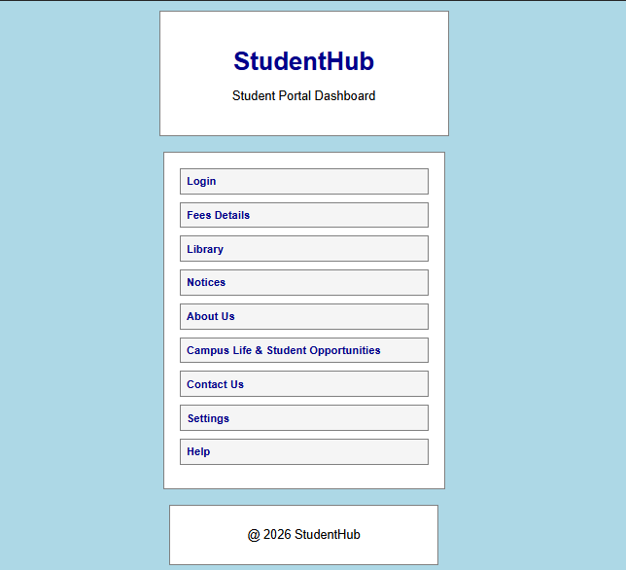
Login :
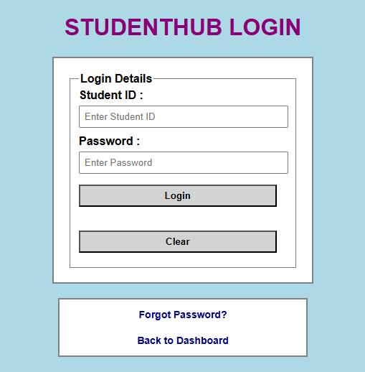

Fees :
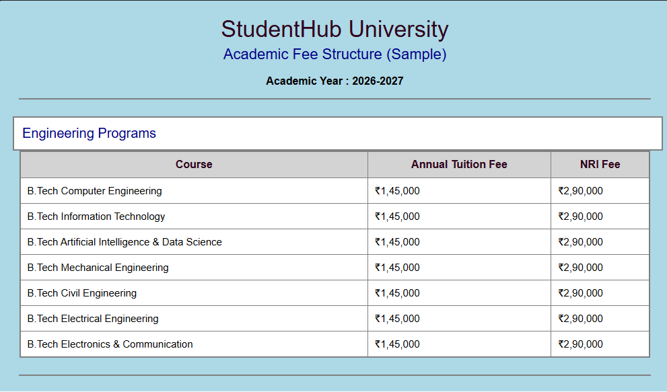
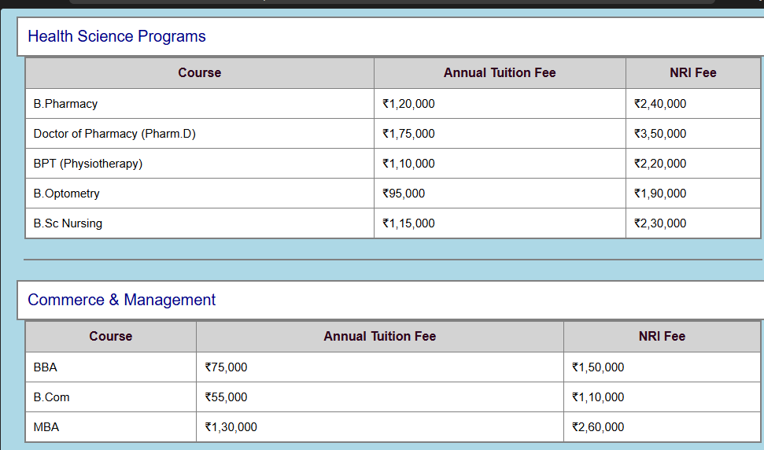
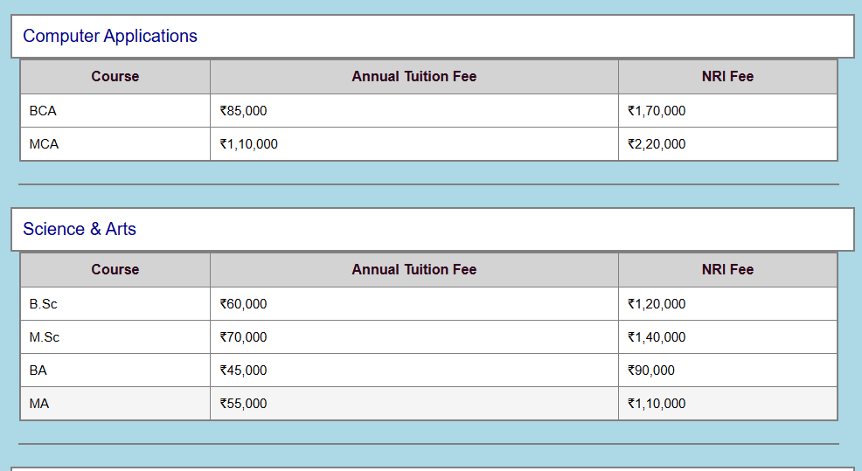
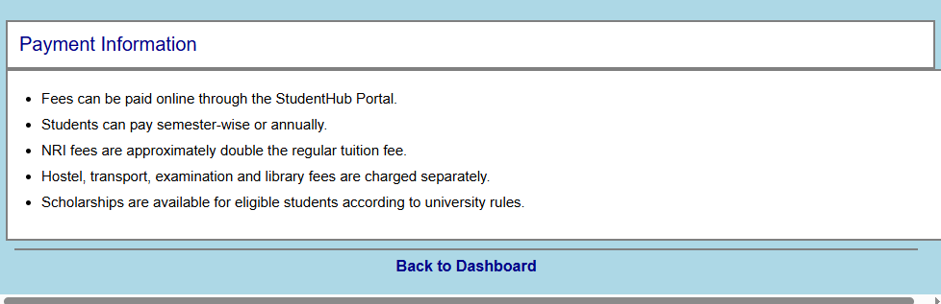

Library :
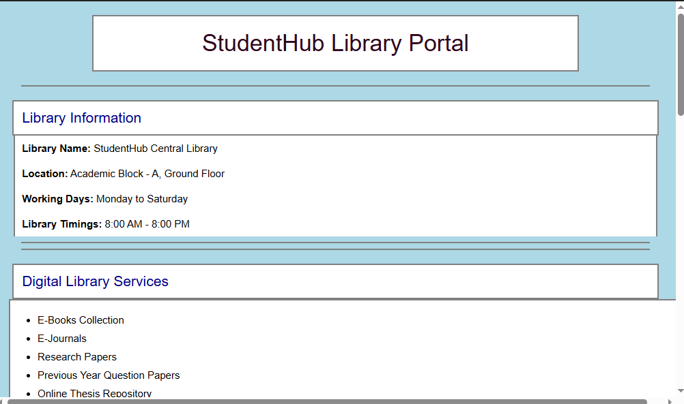
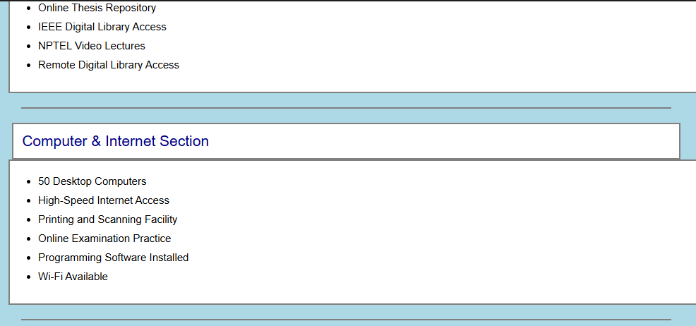
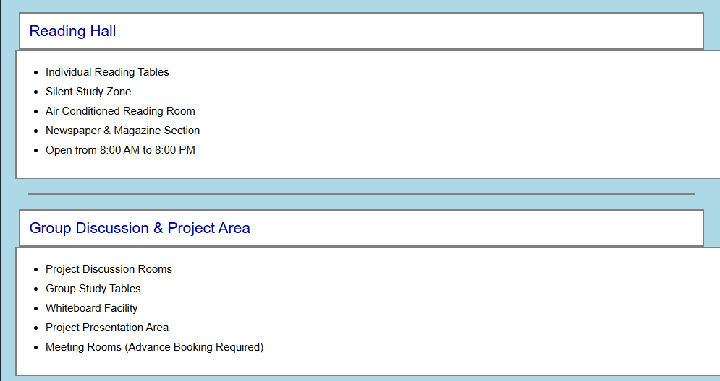
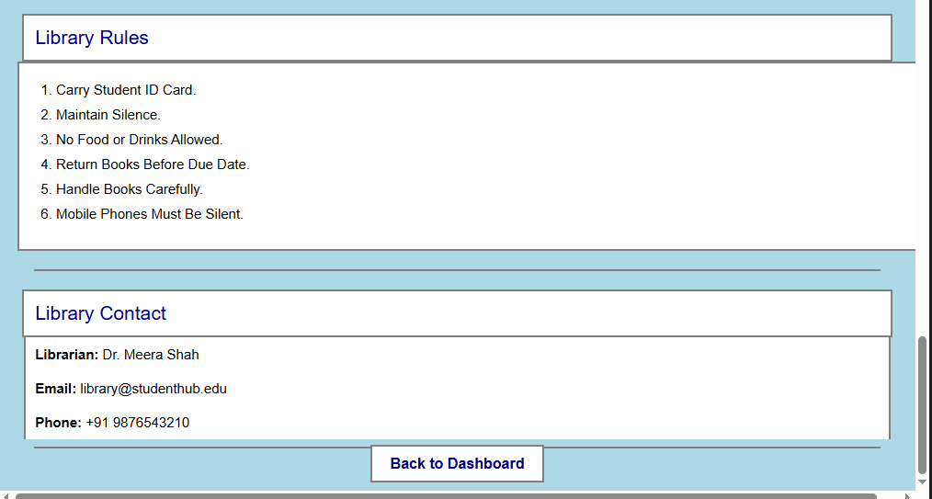

Notices :
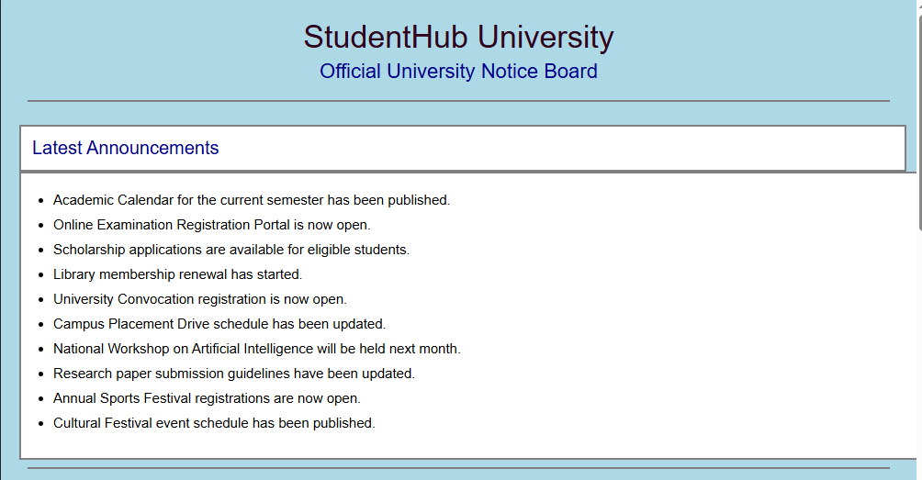
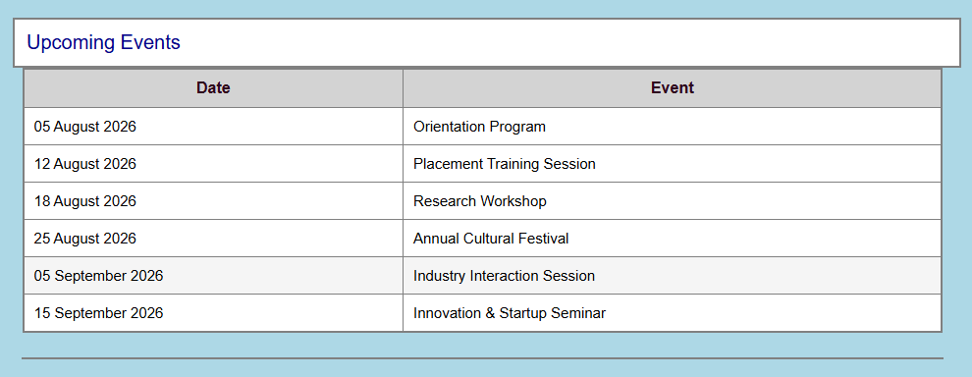
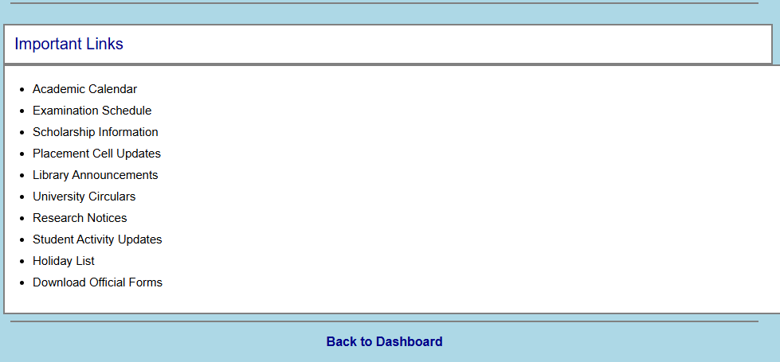
About Us :
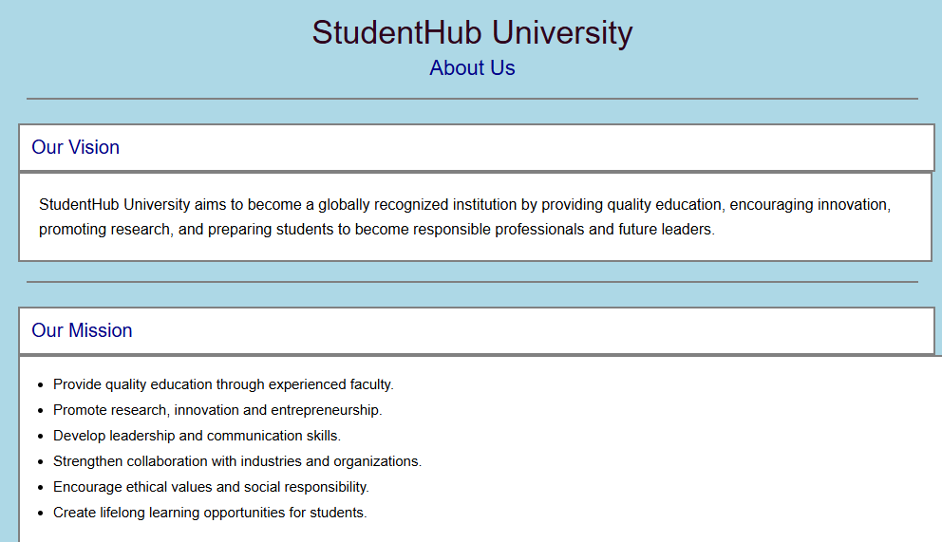
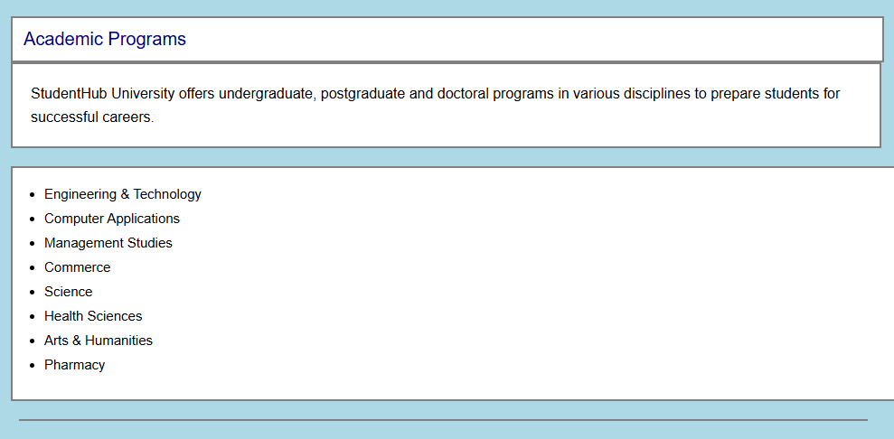
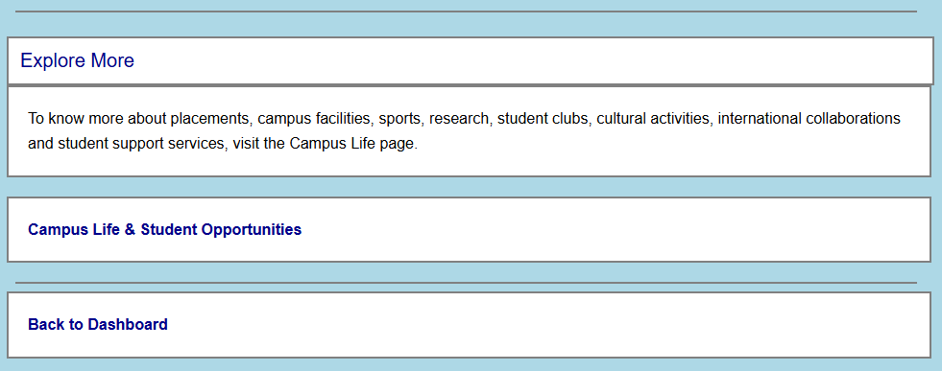

Campus Life :
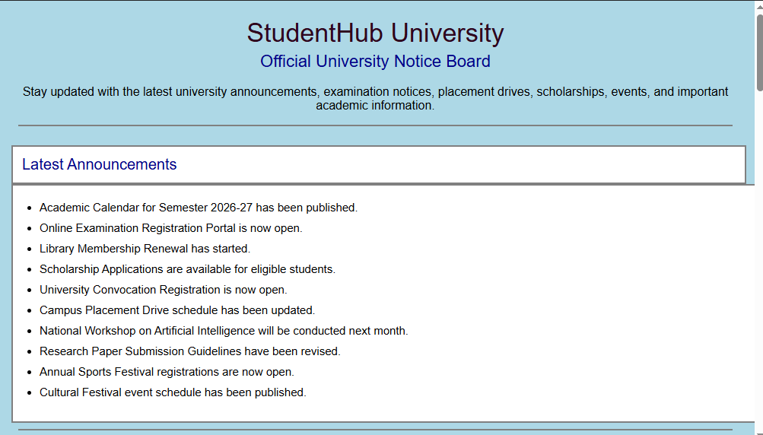
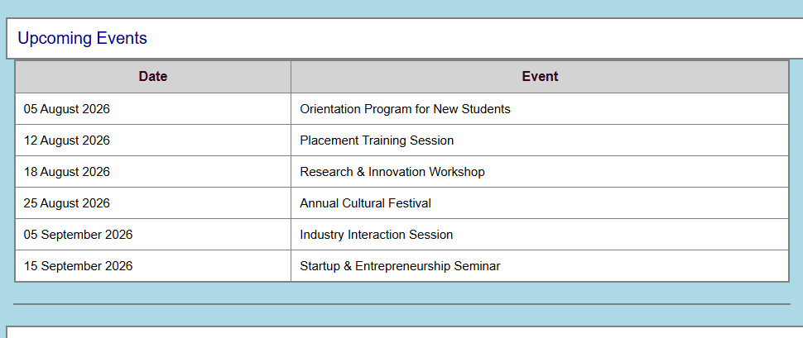
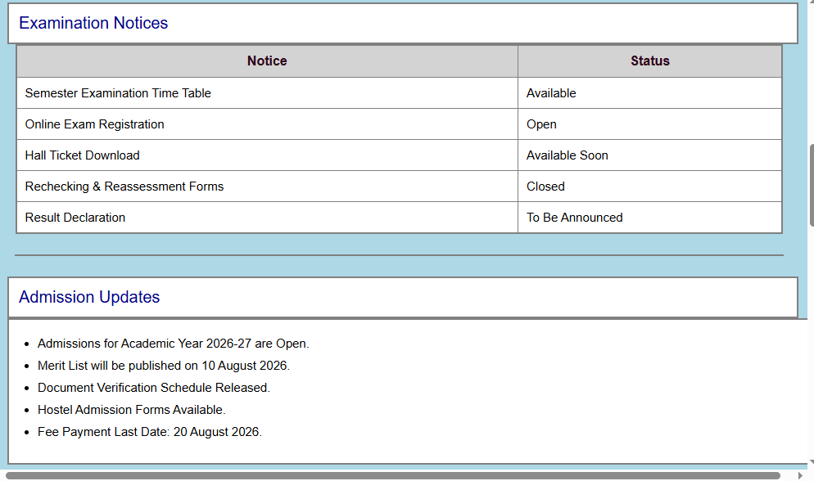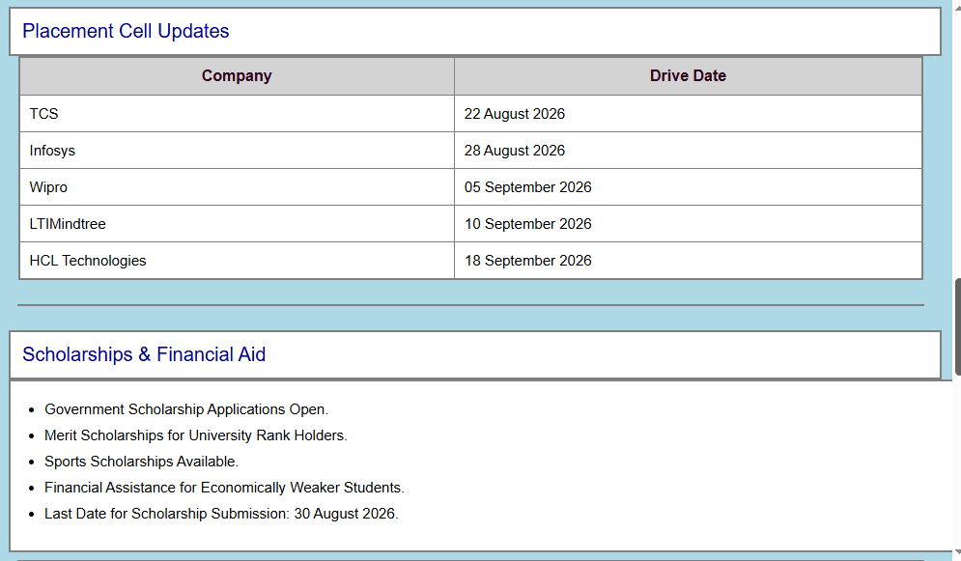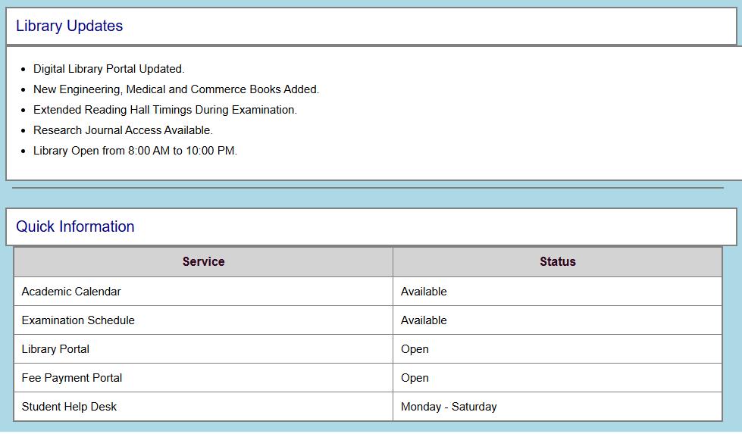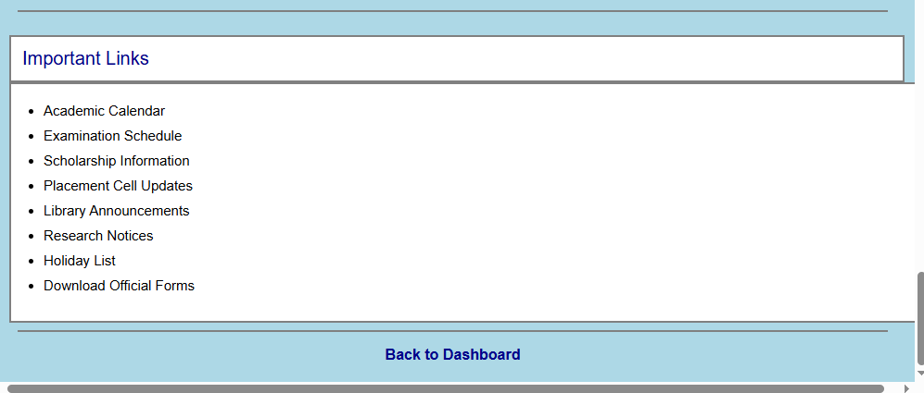
Contact Us :

Settings :
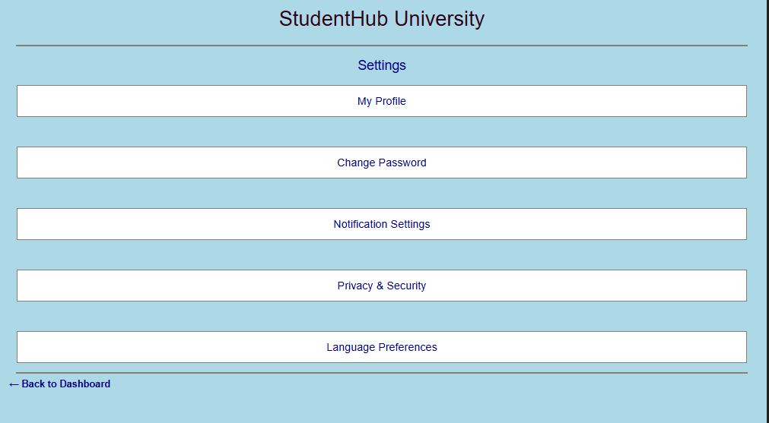
Help :
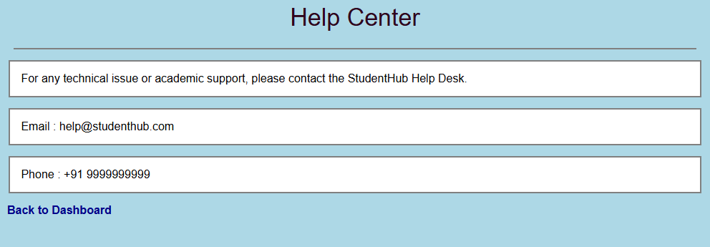
Learning Outcomes:
After completing this practical, students will be able to understand responsive web design and use CSS Grid and Flexbox to create flexible layouts. They will learn how to make webpages suitable for mobile, tablet, and desktop screens. Students will also understand the importance of proper typography, spacing, colors, and contrast and learn to use CSS frameworks consistently without unnecessary inline CSS.
Conclusion:
This practical helped in understanding how responsive layouts are created using CSS Grid, Flexbox, and CSS frameworks. The pages were designed to adjust according to different screen sizes while maintaining proper alignment, spacing, and readability. Responsive design makes the StudentHub Portal more user-friendly and accessible on different devices.
Changes That I made In my webpages :
This Is My Final dashboard picture at first I have A dashboard which was not looking this much Identical So I change my Dashboard design with this.
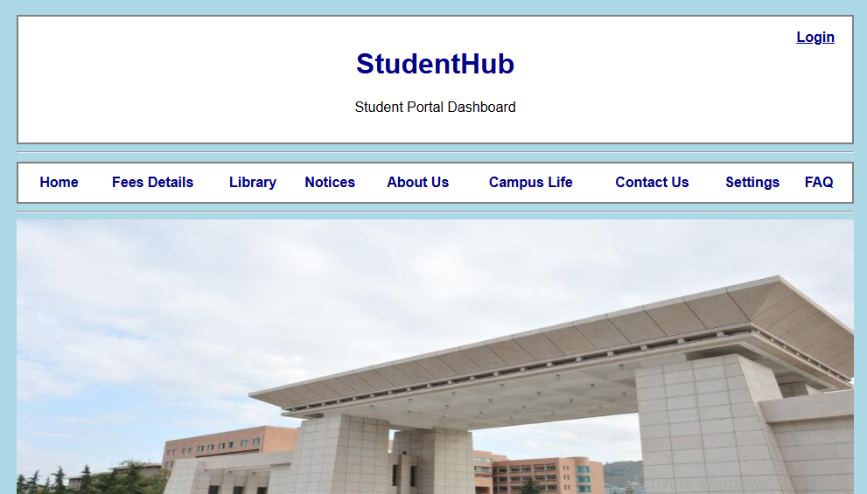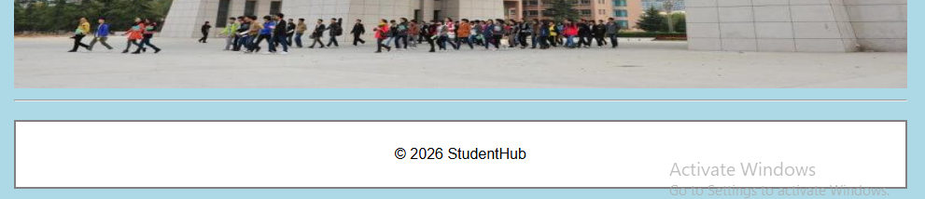

Also I Have changed my other pages In all the pages there is option get back to dashboard which I change with the arrow at top left in each page. Like this :

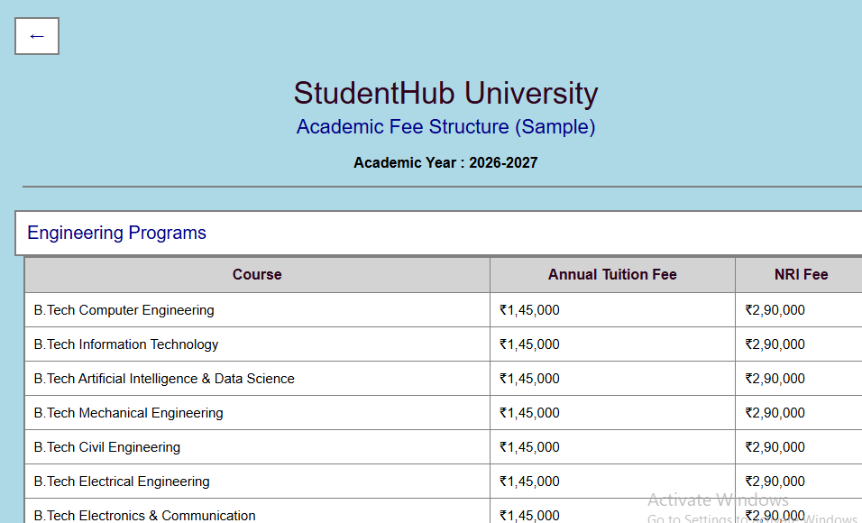
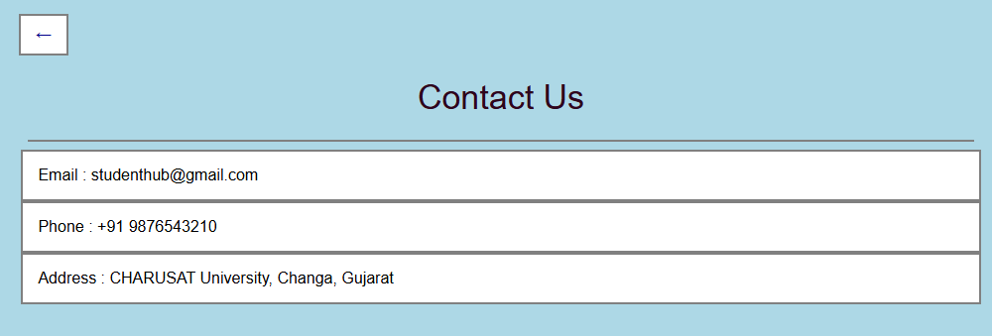

Also I add a second dashboard for the students who already studying in that University .That Second Dashboard looks Like this :

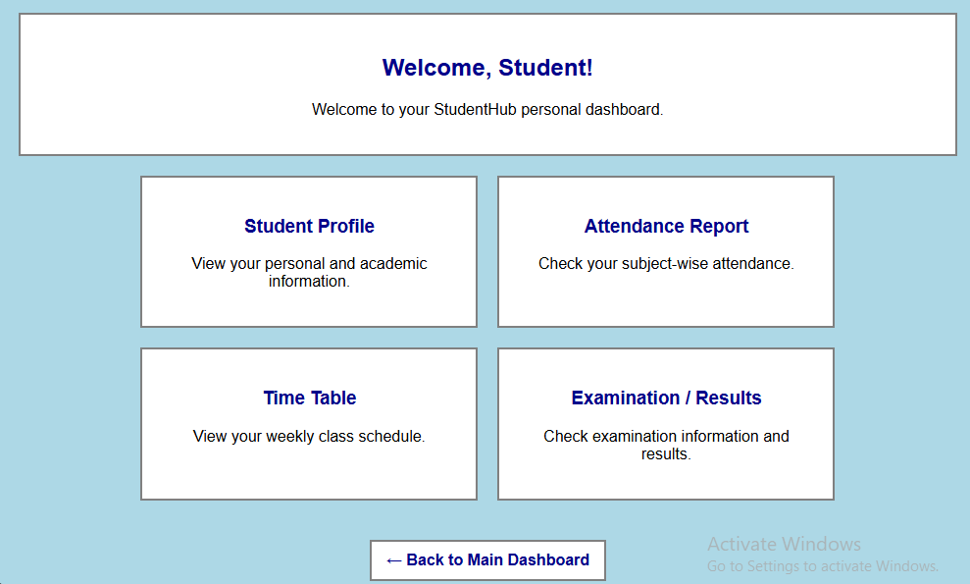

Student Profile :
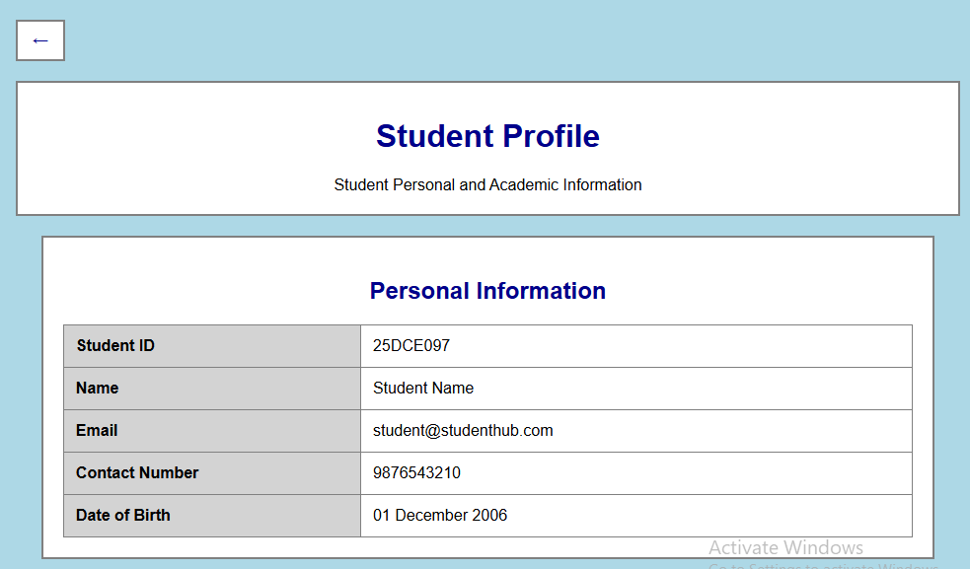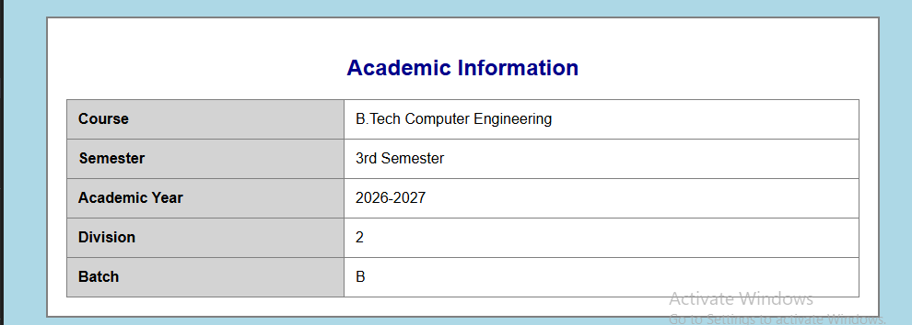

Attandance Report :
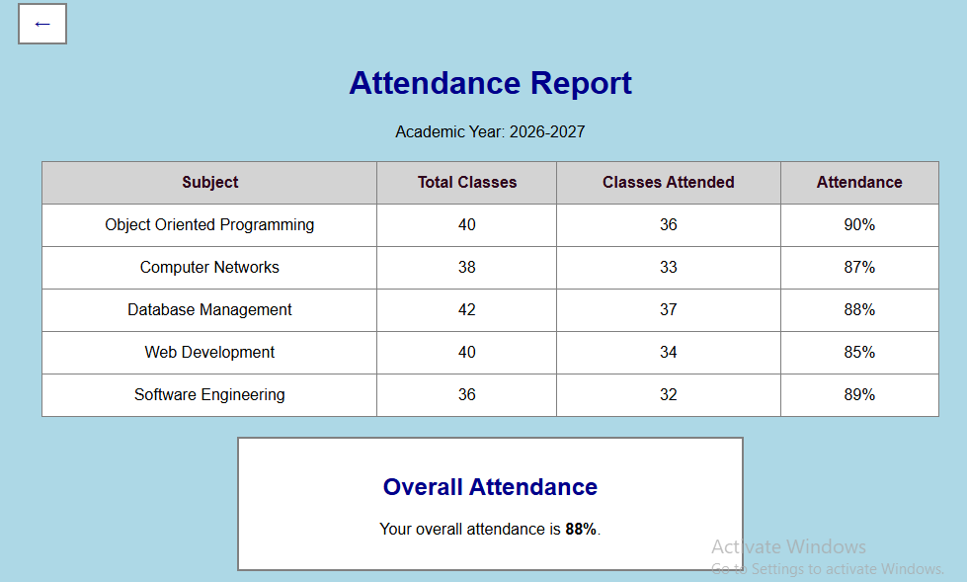
Time Table :
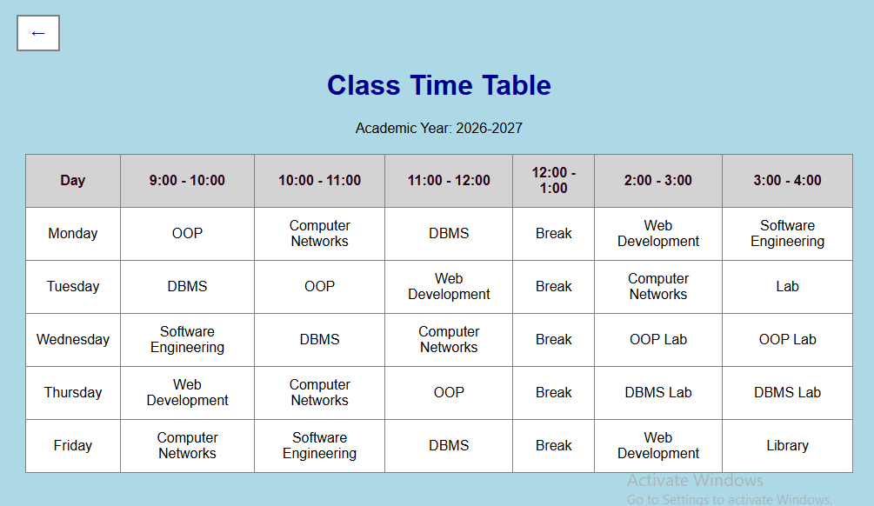

Results :
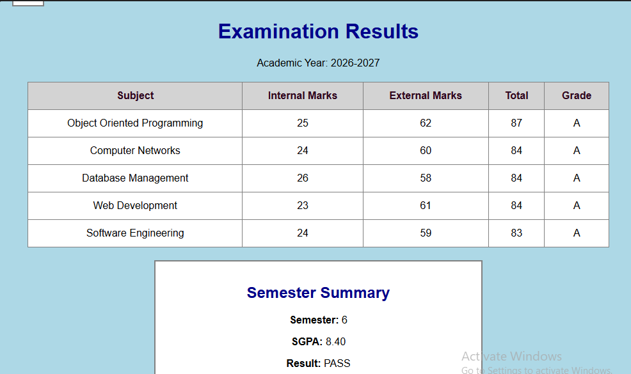

The Code for This all the output Screenshots is uploaded on Github :
https://github.com/raiyanidrashti21-bit/25dce097-Web

